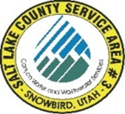
NOTICE OF
REGULAR MEETING
of the Board of Trustees of
SALT LAKE COUNTY SERVICE AREA #3 – SNOWBIRD
to be held on Tuesday January 21st, 2025 at 12:00 P.M.
Join the meeting electronically from the link below.
https://meet.goto.com/392581477
Or dial in using your phone.
United States: +1 (872) 240-3412
Access Code:392-581-477
Dave Richards
Tom Prosek
Chris Bremer

MEETING AGENDA

- Richards Approval December 09th 2024 meeting minutes.

- Carpenter Open and Public meeting laws annual review.

- Carpenter Appointment of Board Chairman/Vice Chairman.

- Carpenter Systems Operations and Development.

- Carpenter Treasurers Report ending December 31st, 2024.

- Richards Approval of December 5th through January 17th, 2025.

Post Date: __________________
Attest: ______________________
Bryauna A. Alderin/ Clerk

