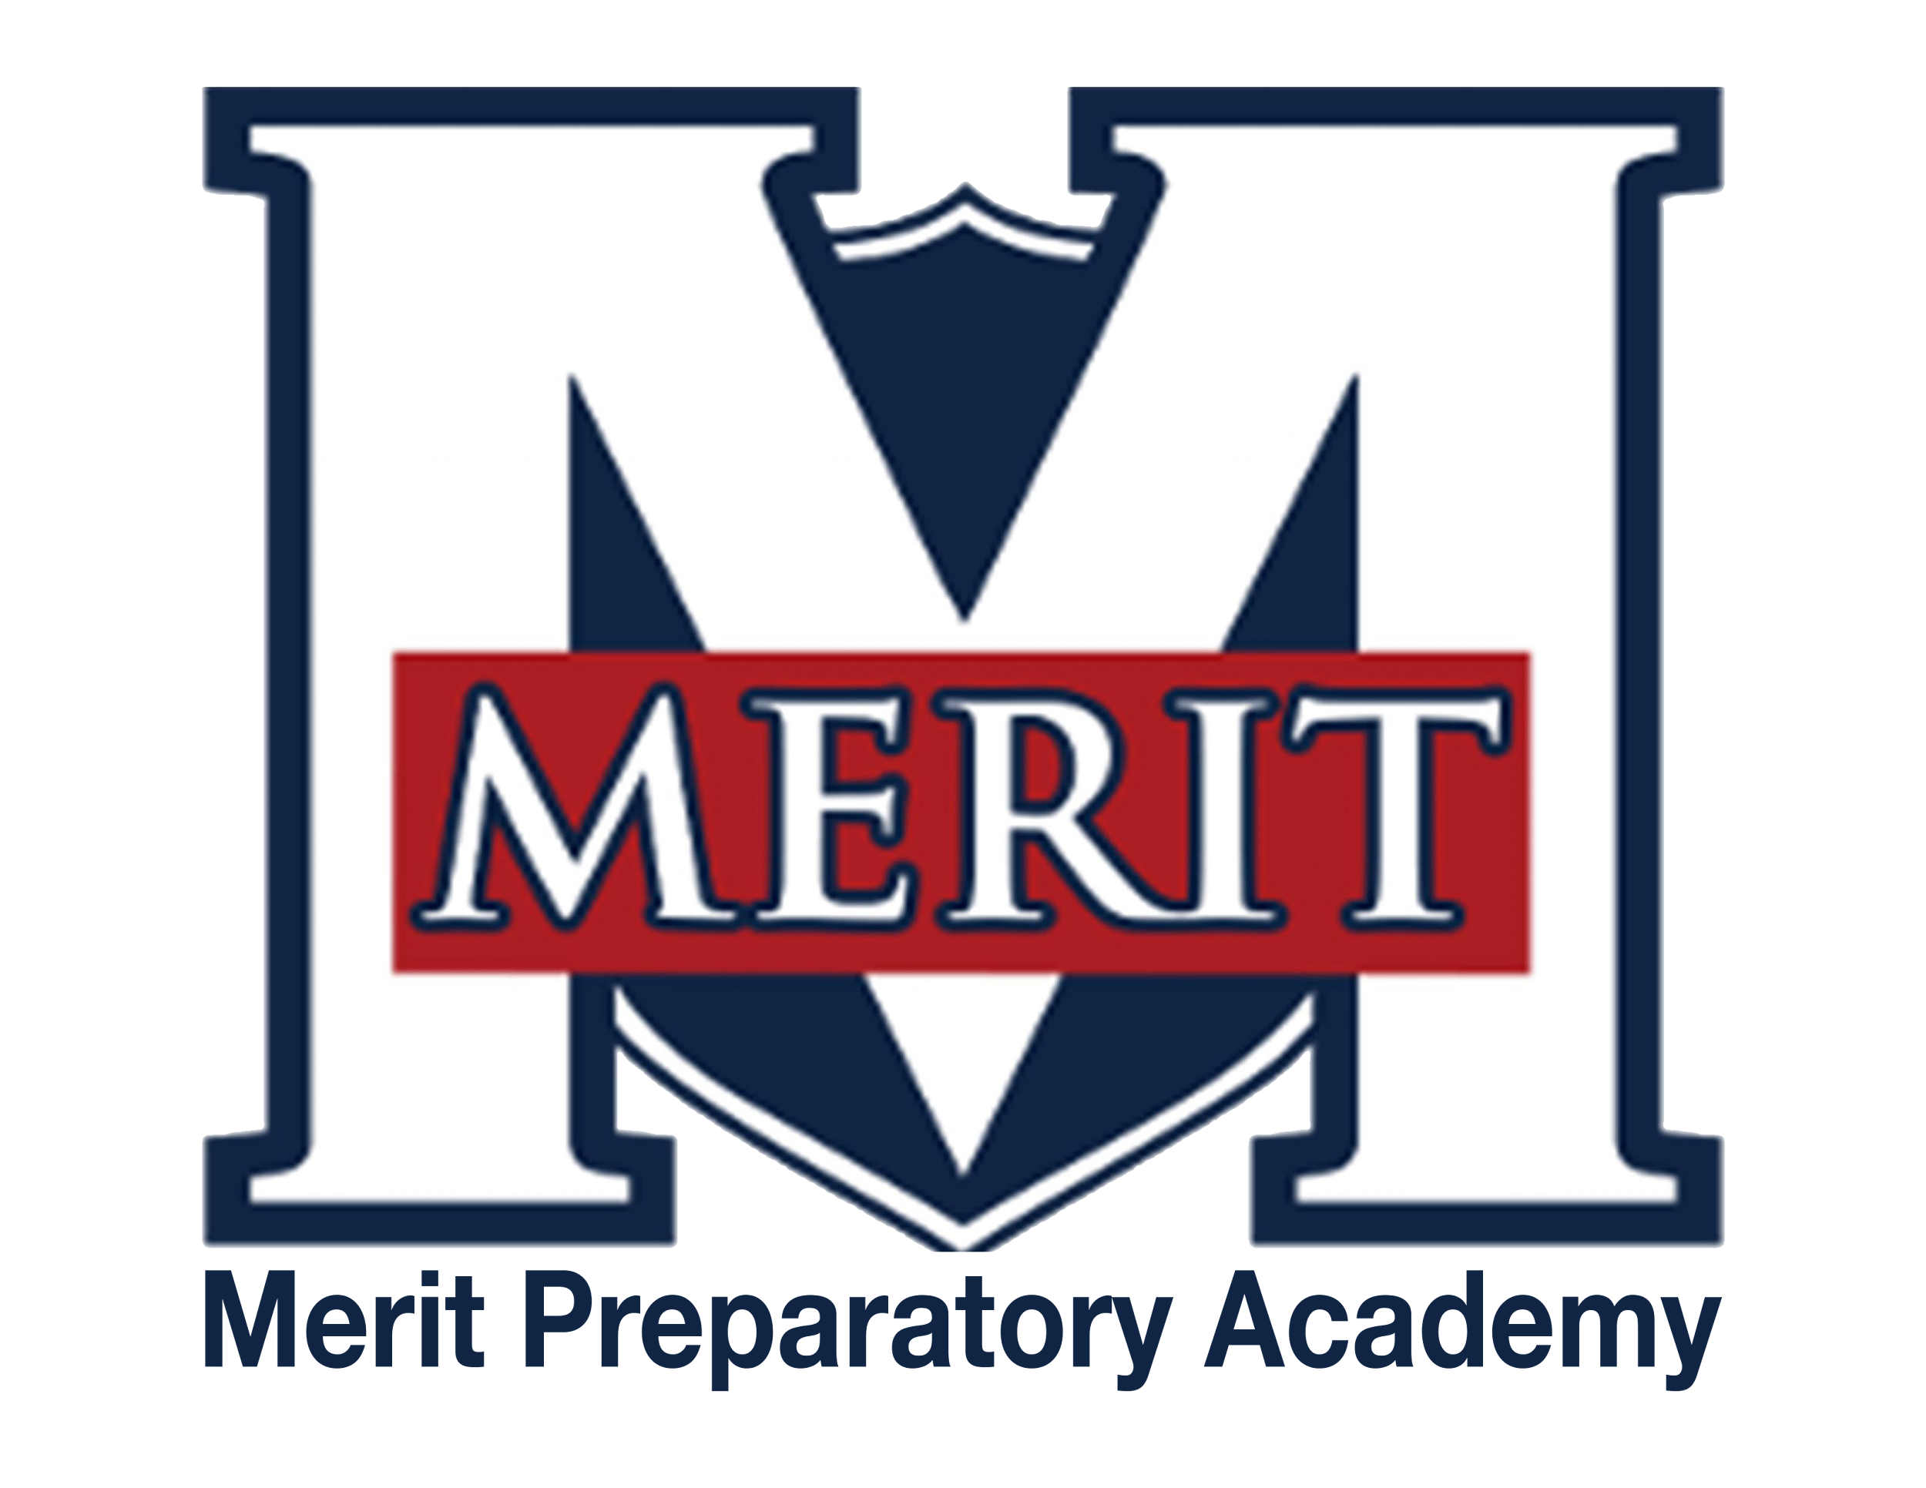
Merit Preparatory Academy
Board Meeting Minutes
November 14, 2024, at 6:30pm
Meeting at 1440 W. Center Street, The Keep

Join us on Zoom:
Https://us06web.zoom.us/j/85040540523?pwd=21vtzlYkTkohlQ2YihbdIlNB0TJeTU.1

- Welcome, Roll Call and Pledge
- 6:33pm
- Attending: Sandra Campbell and Jeanné Condie
- On Zoom: Amy Wiser, Alex Tovmasyan and Angela Bunker
- Not Attending: Rachel Jay and Jeri Mellor

II. Good News from Around the School
- Meritorious Knight award for November– David Wiseman
  - Ashley Clawson was awarded the Meritorious Knight Award for November.
  - She oversees the Renaissance Fair
  - She is an incredible Department Lead
  - Her class is a safe and fun place to learn
- MVP report– Sarah Jones
  - Things are going well
  - Appreciate the help from the Marketing Department and are hoping to get the numbers up for Volunteers
  - Looking for volunteers for the Winter Dance and Poetry Out Loud

III. Reports-
Fiscal and Enrollment Responsibilities
- Finance Report
  - Casey Holmes from Red Apple Financial
    - Met with the Finance Committee on Monday
    - On local we are at 54% which is ahead of Schedule
    - State is about ½ percent low which is normal
    - Federal is lagging behind but this is a reimbursement
    - 7.7% of funds that we have received on Federal is for the Federal Lunch Program and has been collected
    - Salaries are the largest item with 33.1% and is right on target
    - The rest of the line items are lower except for Property because of purchase of Chromebooks
    - Currently projecting net income of $223,000
    - Operating margin 3.41
    - Debt Service 1.25
    - Days Cash on Hand 229
    - The True Up is not added as we are waiting for the State to confirm the True Up numbers before adding them in
    - On 1 October we had 458 students enrolled. Currently we have 454 students enrolled
    - We will be at Hold Harmless this year since our enrollment was lower than last year

  - Finance Committee Report
    - No Additional Information

  - Rylie Lazaga–Spend Plan revisions, second review
    - Links have been fixed on the spreadsheet
    - Slight adjustments to fee for High School Show Choir, Senior Banners, TSA Club and Lord of the Rings Larping Club

- Marketing and QuestTime Reports
  - Stephanie Healey– Marketing
    - Marketing plan for 2024 and 2025
      - November and December are planning months
      - January will start recruiting for new student enrollment
      - Hoping to have an outline for approval for February Student Fair within the next week
      - Social media ads ran for 5 days with 1800 clicks, 1,700 videos played, 24 reactions and 9 shares
      - Shares are very important on social media
      - We are increasing our social media
      - Planning for one ad or boost a week starting in January
      - We are preparing for interest meeting that will start in December
      - Planning a new promotional School video that will be released in January
      - Goal for Enrollment is to cap out at 600 but for August the goal is 550 students enrolled
  - David Wiseman– QuestTime and Curriculum committee report
      - Each Class is coming up with a project for the end of the semester
      - The projects will focus on improving the school
      - QuestTime has taken a big leap forward
      - Seniors have decided to do a student gift instead of a senior prank
      - Service count is around 6,000 hours

Academic Outcomes and Other Strategic Plan Areas
- Director Report
  - Jessica Sitton (not in attendance but report read by Board Chair)
    - Student Performance 2024 testing results data show that we are below the State average in all academic areas
    - Administration is aware of the shortfalls and has set their own goals on improvements
    - Most of the teaches have turned in the Scope and Sequence
    - Purchased and using Quiz In to help prepare the students and teachers for testing
    - Quiz In tracks the gaps in learning and those areas that can be addressed

Charter Fidelity & Adherence to Statute, Rule & Policy
- Policy Committee Report– Angela Bunker
  - Library Policy (revised)
    - Just a few adjustments to the formatting
    - Added that members of the Board can request a review of the material
    - Changed the wording in a couple areas
    - The public will be notified 48 hours in advance
    - Board will be responsible for the record
    - A staff member will be responsible to make sure that the review committee has a copy of the meeting notes
    - Employees will adhere to the policy
  - Teacher Licensure Policy
    - Reviewed and updated the Policy
  - Youth Protection & Suicide Prevention Policy
    - Updated to include Parental Protocols with the new codes from the State Legislature
  - Internet and Network Acceptable Use Policy
with CIPA Compliance
    - This replaces three policies

- Board Director Report– Jeanné Condie
  - Review of Merit Bylaws– sections I-V
    - https://www.meritprepacademy.org/_files/ugd/e544f1_feb4c7b2ca6b40d396a4a40e96ee7fe7.pdf

IV. Public comment- 15 minutes
As per Board procedure, public comment will be limited to 3 minutes per person. Anyone who would like to make a public comment will need to sign up prior to the start of the public comment period. Grievances, complaints, or concerns with individual employees or board members will not be allowed during this time as they must be dealt with by following the Conflict Resolution Policy process, and defamatory statements regarding any individual will not be allowed during an open public meeting.
No Public Comments

V. Action Items
- Vote to approve October 10, 2024 Board Meeting Minutes
  - Motion made by Alex Tovmasyan; seconded by Sandra Campbell: All in favor
- Vote to approve Spend Plan
  - Motion made by Sandra Campbell; seconded by Alex Tovmasyan: All in favor
- Vote to approve Library Policy (revised)
  - Motion made by Alex Tovmasyan; seconded by Sandra Campbell: All in favor
- Vote to approve Teacher Licensure Policy
  - Motion made by Alex Tovmasyan; seconded by Sandra Campbell: All in favor
- Vote to approve Youth Protection & Suicide Prevention Policy
  - Motion made by Alex Tovmasyan; seconded by Sandra Campbell: All in favor
- Vote to approve Internet and Network Acceptable Use Policy with CIPA Compliance
  - Motion made by Alex Tovmasyan; seconded by Sandra Campbell: All in favor

VI. Board Business
- Audit Committee formation
  - Vote to approve Sandra Campbell as the audit committee chair
    - Motion made by Amy Wiser; seconded by Alex Tovmasyan: All in favor

  - Vote to approve Rachel Jay and Alex Tovmasyan as committee members
    - Motion made by Amy Wiser; seconded by Sandra Campbell: All in favor

- Training
  - Land Trust Council training– all have completed
  - Audit training update
    - Sandra, Rachel, and Alex (1&2)
    - Jeri and Amy (1)
  - UAPCS training
    - Jeri report on October training– Marketing and Enrollment
    - Upcoming: November 18, 2024 | 4:30-5:30 pm
Succession Planning: Preparing for School Leadership Transitions
Understand the importance of succession planning and how to prepare for smooth leadership transitions in your school
- Expanding the board and preparing for the future
  - Any leads on new board members?
- Board Calendar
  - The next board meeting will be held on January 9, 2025, at 6:30pm in Merit’s library
  - No board meeting is currently scheduled for December.
  - Board members are responsible to attend the end of year knighting ceremony on May 21, 2025 at 8:30 am, and graduation on May 22, 2025 at 4 pm

VII. Executive Session
- To discuss the character, professional competence, or physical or mental health of an individual.
  - Possible Action from Executive Session

VII. Adjourn - 7:45 pm

