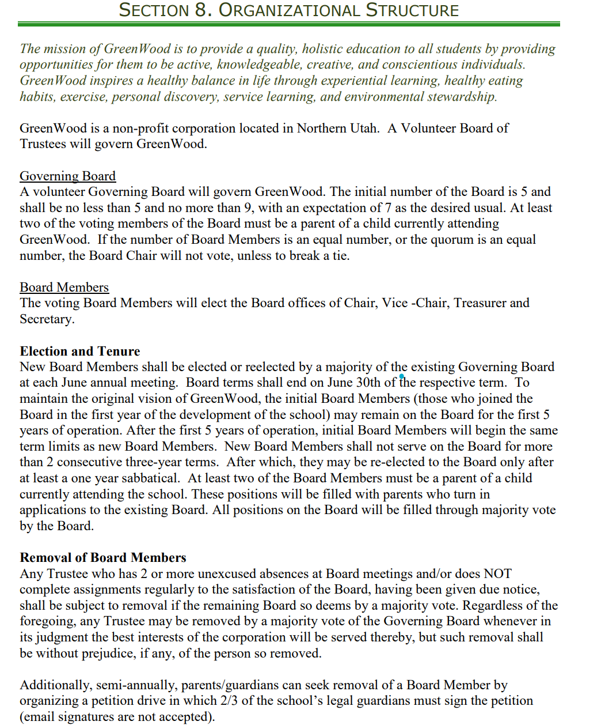

Election and Tenure New Board Members shall be elected or reelected by a majority of the existing Governing Board at each June annual meeting. Board terms shall end on June 30th of the respective term. To maintain the original vision of GreenWood, the initial Board Members (those who joined the Board in the first year of the development of the school) may remain on the Board for the first 5 years of operation. After the first 5 years of operation, initial Board Members will be allowed to serve unlimited 3 year terms which each require re-approval by a majority vote of the existing Governing board begin the same term limits as new Board Members. New Board Members shall not serve on the Board for more than 2 consecutive three-year terms. After which, they may be re-elected to the Board only after at least a one year sabbatical. At least two of the Board Members must be a parent of a child currently attending the school. These positions will be filled with parents who turn in applications to the existing Board. All positions on the Board will be filled through majority vote by the Board.

