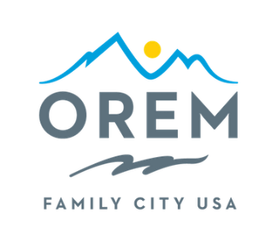
City Council 2025 Retreat
Zermatt Utah
784 W Resort Drive, Midway, UT
January 10-11, 2025

DAY 1
January 10, 2025
12:30 PM Welcome/Agenda Review – by Mayor David Young (Room – Neuchatel)
12:45 PM Review of Team Orem’s Major Accomplishments (Then & Now) – Facilitated by Exec Staff

2:15 PM City Council Roundtable – every council member may share thoughts and ideas

3:15 PM Break
3:30 PM Presentation of General Fund Sustainability by Laura Lewis and Brandon Nelson
4:15 PM Discuss takeaways from ‘Boys in the Boat’ – facilitated by Chris Tschirki
5:00 PM Boards/Commission Assignments - by Mayor Young

5:30 PM Adjourn

City Council 2025 Retreat
Zermatt Utah
784 W Resort Drive, Midway, UT
January 10-11, 2025

DAY 2
January 11, 2025
9:00 AM Presentation of Business Leadership Principles – by Mayor David Young (Room – Neuchatel)
10:00 AM Review and Refine 2025 Areas of Focus – Facilitated by Mayor David Young and Brenn Bybee
10:30 AM Break
10:35 AM Presentation Departmental 2025 Goals and Major Projects– Facilitated by Exec Staff
12:30PM Lunch
1:00 PM Finalize Citywide Goals Associated with Areas of Focus/City Council Roundtable – every council member may share thoughts and ideas

2:30 PM Mayor’s Challenge to Commit – by Mayor David Young

3:00 PM Adjourn

