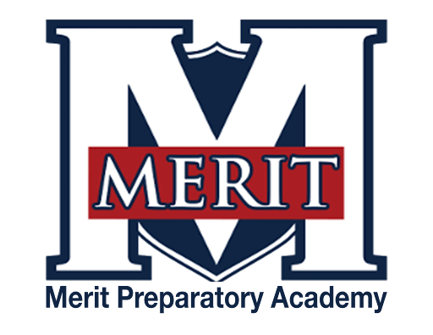
Merit Preparatory Academy
Board Meeting Agenda
January 9, 2025, at 6:30pm
Meeting at 1440 W. Center Street, Merit’s library

Join us on Zoom:
https://us06web.zoom.us/j/83522795713?pwd=FFfJfNfl0ntqFlwwaU7fOU3Zx8HyP3.1

I. Welcome, Roll Call and Pledge

II. Good News from Around the School
- Meritorious Knight award for January– MIke Condie
- MVP report– Sarah Jones
III. Reports-
Fiscal and Enrollment Responsibilities
- Finance Report
  - Casey Holmes from Red Apple Financial
  - Finance Committee Report– Rachel Jay

- Marketing and QuestTime Reports
  - Stephanie Healey– Marketing
  - Jeri Mellor– QuestTime and Curriculum committee report

Academic Outcomes and Other Strategic Plan Areas
- Director Report
  - Mike Condie

Charter Fidelity & Adherence to Statute, Rule & Policy
- Policy Committee Report– Angela Bunker
  - Abusive Behavior, Bullying, Cyberbullying, Harassment, and Hazing Policy
  - Processes and Procedures for Maintaining Property Records and Inventory of Equipment
  - Parental Access to Student Information
  - Exit and Engagement Surveys For Merit Students and their Families

- Board Director Report– Jeanné Condie
  - Charter Agreement Update

IV. Public comment- 15 minutes
As per Board procedure, public comment will be limited to 3 minutes per person. Anyone who would like to make a public comment will need to sign up prior to the start of the public comment period. Grievances, complaints, or concerns with individual employees or board members will not be allowed during this time as they must be dealt with by following the Conflict Resolution Policy process, and defamatory statements regarding any individual will not be allowed during an open public meeting.

V. Action Items
- Vote to approve November 14, 2024 Board Meeting Minutes
- Vote to approve LEA specific licenses for:
  - Eric Lasso- 1 period of Advanced Spanish (Spanish for native speakers)
  - Caleb Jones- 2 periods of Web Development (He was the long term sub for Muthiah)
  - Micah Harps- 1 period Computer Science, 1 Computer Programming, 1 Game Development, 1 Business Office Suites, 2 Financial Literacy, 1 German. (He is Muthiah's replacement)
- Vote to approve the following policies:
  - Abusive Behavior, Bullying, Cyberbullying, Harassment, and Hazing Policy
  - Processes and Procedures for Maintaining Property Records and Inventory of Equipment
  - Parental Access to Student Information
  - Exit and Engagement Surveys For Merit Students and their Families

VI. Board Business
- Board Calendar
  - The next board meeting will be held on February 13, 2025, at 6:30pm in Merit’s library.
  - Board members are responsible to attend the end of year knighting ceremony on May 21, 2025 at 8:30am, and graduation on May 22,2025 at 4pm.

VII. Executive Session
- To discuss the character, professional competence, or physical or mental health of an individual.
  - Possible Action from Executive Session

VII. Adjourn

