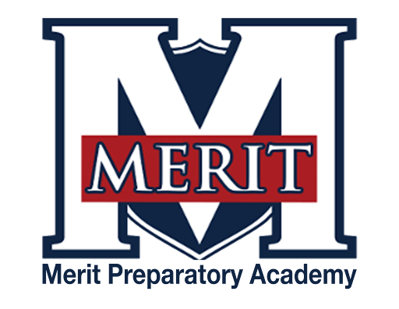
Merit Preparatory Academy
Board Meeting Agenda
January 9, 2025 at 6:30pm
Meeting at 1440 W. Center Street, Merit’s library.

Join us on Zoom:

I. Welcome, Roll Call and Pledge

II. Good News from Around the School
- Meritorious Knight award for November– MIke Condie
- MVP report– Sarah Jones
III. Reports-
Fiscal and Enrollment Responsibilities
- Finance Report
  - Casey Holmes from Red Apple Financial
  - Finance Committee Report
  - Rylie Lazaga–Spend Plan revisions, second review

- Marketing and QuestTime Reports
  - Stephanie Healey– Marketing
  - Jeri Mellor– QuestTime and Curriculum committee report

Academic Outcomes and Other Strategic Plan Areas
- Director Report
  - Mike Condie

Charter Fidelity & Adherence to Statute, Rule & Policy
- Policy Committee Report– Angela Bunker

- Board Director Report– Jeanné Condie

IV. Public comment- 15 minutes
As per Board procedure, public comment will be limited to 3 minutes per person. Anyone who would like to make a public comment will need to sign up prior to the start of the public comment period. Grievances, complaints, or concerns with individual employees or board members will not be allowed during this time as they must be dealt with by following the Conflict Resolution Policy process, and defamatory statements regarding any individual will not be allowed during an open public meeting.

V. Action Items
- Vote to approve November 14, 2024 Board Meeting Minutes

VI. Board Business
- Audit Committee formation
  - Vote to approve Sandra Campbell as the audit committee chair
  - Vote to approve Rachel Jay and Alex Tovmasyan as committee members
- Training
  - Land Trust Council training– who has completed?
  - Audit training update
    - Sandra, Rachel, and Alex (1&2)
    - Jeri and Amy (1)
  - UAPCS training
    - Jeri report on October training– Marketing and Enrollment
    - Report on November 18, 2024 | 4:30-5:30 pm
Succession Planning: Preparing for School Leadership Transitions
Understand the importance of succession planning and how to prepare for smooth leadership transitions in your school.
- Expanding the board and preparing for the future
  - Any leads on new board members?
- Board Calendar
  - The next board meeting will be held on February 13, 2025, at 6:30pm in Merit’s library.
  - Board members are responsible to attend the end of year knighting ceremony on May 21, 2025 at 8:30am, and graduation on May 22,2025 at 4pm.

VII. Executive Session
- To discuss the character, professional competence, or physical or mental health of an individual.
  - Possible Action from Executive Session

VII. Adjourn

