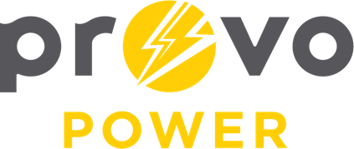
AGENDA
ENERGY BOARD MEETING
PROVO POWER
251 W 800 N
Monday, January 6, 2025
4:00 P.M.

- Welcome & Introductions – Chairman Gary Winterton
- Review & Approval of Minutes – November 4, 2024
- Cybersecurity Report – Jared Curle and Shawn Young
- CIP Project Update – Tad Smallcomb
- Financial Report – Charlie Little
  - Days cash on hand discussion
- KPI Report – Charlie Little
- Solar Report Update – Charlie Little and Scott Bunker
- Manager Report – Scott Bunker
  - 2025 Energy Board calendar
- Calendar & Scheduling
  - Next Board Meeting: March 21st at UMPA Conference

A copy of the agenda was posted in the Civic Center, and the Provo City Library, on January 2, 2025, and also delivered to the Mayor,
City Council Members, required news media, and adjacent cities in
compliance with the Utah Code 52-4-202

