GRANTSVILLE CITY PLANNING COMMISSION

January 13, 2025
PUBLIC NOTICE

The Grantsville City Board of Adjustment will convene at 8:00 p.m. on Monday, January 13, 2025 at 429 East Main Street, Grantsville, UT 84029.

Notice is hereby given in accordance with the provisions of Chapter 1.18(3) of the Grantsville Land Use Development and Management Code that the Grantsville Board of Adjustment will convene on January 13, 2024 at 8:00 p.m. at Grantsville City Hall. The meeting will also be broadcast on Zoom. The purpose of this meeting is to discuss and consider action on the appeal of the denial of the Deseret Meadows Planned Unit Development (PUD). Documentation associated with this hearing and consideration may be requested through email.

Dated this 3rd day of January, 2024.

Shelby Moore
Zoning Administrator
Grantsville City Community & Economic Development

Join Zoom Meeting
https://us02web.zoom.us/j/83582357426
Meeting ID: 835 8235 7426
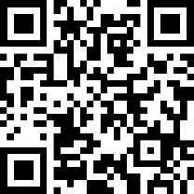

Scan QR code to join Zoom meeting.

