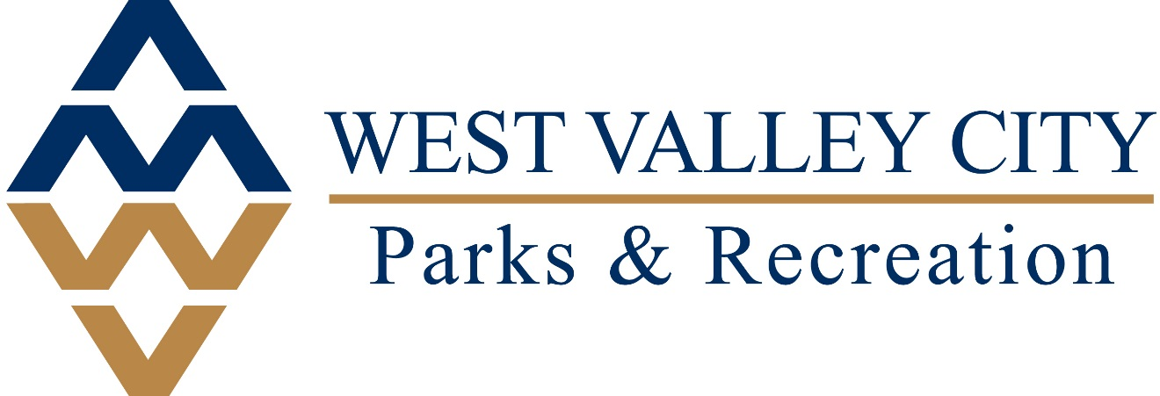

Parks Backflow, Master Valve and Hydrometer Installation

Project #
WVC-PR-PM002

Prepared By
West Valley City Parks and Recreation Department

TITLE PAGE
DOCUMENT 00 01 01
- Summary

The West Valley City Parks and Recreation Department is seeking proposals to replace backflow prevention devices in a number of city parks. In addition, while changing existing backflow prevention devices, a master valve and hydrometer are also to be installed where possible.
Responders to this request for proposals are to review the criteria described in this request and submit a proposal that matches those criteria as closely as possible. All responders must follow the requirements listed herein, have a valid business license, submit proof of insurance if required, and provide a warranty covering workmanship and equipment. Failure to follow any requirement of this request may result in rejection of a proposal.
Any questions should be directed to Dustin Bushnell, Irrigation Supervisor with West Valley Parks and Recreation, 801-509-1933 or dustin.bushnell@wvc-ut.gov. All questions must be requested at least four days (96 hours) prior to closing to enable answers to be posted at least two days (48 hours) before bid closing.
- Submission Requirements

Proposals must be submitted no later than 11:00 AM. local prevailing time, as conclusively established by the clock in the City Recorder’s Office, on January 9, 2025, to the West Valley City Recorder’s Office, Administration, 3600 S. Constitution Blvd., West Valley City, Utah 84119. Proposals will reflect the best and most current information and offer.
All proposals must be submitted by email to Nichole.Camac@wvc-ut.gov in PDF format with the project name in the subject line (“West Valley Parks Backflow Replacement”). All proposals must be signed by an authorized representative of the responder. The signature on the proposal signifies the responder’s intent to comply with the terms, specifications, and conditions set forth in this request, unless specific exceptions are explicitly noted on the face of the proposal.
West Valley City Parks and Recreation reserves the right to reject any or all proposals, to waive any informality or technicality in the City’s sole discretion, or to accept any proposal deemed to be in the best interests of the City.
- Intent of Request for Proposals
The intent of this Request for Proposals is to generally set forth the minimum acceptable requirements for the proposals to be submitted herein. It is the intent of West Valley City Parks and Recreation to choose a proposal based on compliance with the terms of this request. West Valley City Parks and Recreation may choose all, part, or none of the proposals.
- Description of Services and/or Products Required

West Valley City Parks and Recreation is soliciting proposals to replace or move backflow prevention devices in 32 parks in West Valley City. In addition, master valves and hydrometers will be installed, where possible, on properties as listed in Appendix A of this package. Proposals will list whether all items are able to be installed, and pricing will include all materials for installation of listed items in each park. Including wiring of hydrometers and master valves to the controller as required. All proposals must also include repair of any damage caused as a result of the project.
Please be clear and concise in explaining how your proposal meets the requirements outlined below. Include a timetable for start-up and completion of all work as well as other potentially affected facility areas due to the installation process. Work shall be done between November and March.
Proposal Requirements:
  - Appendix A shows each location, what is needed at each location, and specifications for each item
  - Appendix B Shows overhead image of each location and location of needed items
  - Appendix C is bid form
  - In properties with an existing double check valve: replace with same size RP as specified by code, above ground in a protective cage with concrete pad.
  - On properties with existing RP, in ground: remove and re-install RP assembly above ground as specified by code, in a protective cage with concrete pad.
  - On properties requiring the addition of a master valve: Valve should be installed as shown in the detail, utilizing proper sized fittings in a jumbo valve box. Master valve should also be wired to the controller and operate correctly. Master Valve should be Rain Bird PEB in the same size as existing mainline. Control wires should be buried eight to twelve inches deep.
  - On properties requiring the installation of a flowmeter, if possible: flowmeter should be installed as shown in the detail, per manufacturers requirements, and connected to the controller with the manufacturer recommended wire. Communication wires should be buried eight to twelve inches deep.
  - Any damage done to landscape and existing infrastructure is to be repaired by contractor awarded the contract.

Please also include the following information for either proposal:
- Timeline of work
- References for similar jobs (local preferred)
- Warranty information
- Site visits are highly recommended

The selected responders shall enter into a contract with the City, which shall include insurance and indemnification requirements. Commercial general liability insurance covering bodily injury liability and property damage liability with a per-occurrence limit of no less than $3,000,000, and a general aggregate limit no less than $5,000,000 as well as commercial auto insurance covering bodily injury liability and property damage liability with a per-occurrence limit of no less than $2,000,000 are required. Additionally, commercial general liability insurance that covers employer liability in an amount not less than $2,000,000 is also required. A performance bond and payment bond equal to one hundred percent (100%) of the guaranteed maximum price naming West Valley City as a third-party obligee shall be required.
It is recommended that all responders visit the site(s) to evaluate and measure the areas. Please arrange this visit by contacting Dustin Bushnell, Parks and Recreation Irrigation Supervisor, at 801-509-1933 or dustin.bushnell@wvc-ut.gov.

- Criteria for Proposal Evaluation
Only proposals submitted by responsible responders as defined by the City Code will be considered. Proposals will be evaluated according to the following criteria. Proposals will be scored in each area, with the score given the weight indicated below.
- Price (40%)
- Adherence to requested specifications and service (30%)
- Quality of product (10%)
- Warranty (10%)
- Work timeline (10%)
As indicated in the attached Preference Form, certain responders are entitled to preference in the proposal process. Any applicable preferences shall be added to the responder’s score as calculated under the criteria above. For example, a responder who achieves a total score of 80% who qualifies for a 2% preference will have a final score of 82%.

- Other Important Information
The City reserves the right to, in its sole discretion, reject any and all responses to this Request for Proposals. The City reserves the right to, in its sole discretion, waive any requirement set forth in this Request for Proposals. The City reserves the right to, in its sole discretion, cancel this Request for Proposals. The City reserves the right to, in its sole discretion, negotiate with responders prior to final award.

Response to this Request for Proposals is at the responder’s sole risk and expense. The City anticipates selecting one of the responders, but there is no guarantee that any responding proposal will be selected.
It is the City’s policy to encourage equal opportunity in the award of contracts. The City endeavors to do business with responders that share the City’s commitment to equal opportunity and will not do business with anybody who discriminates based on race, religion, color, ancestry, age, gender, sexual orientation, disability, medical condition, or place of birth. The City appreciates in advance the efforts that responders will make and looks forward to participating with responders in the selection process.
All responses to this Request for Proposals are subject to the Governmental Records Access Management Act (“GRAMA”).

BIDDER PREFERENCE FORM

1.1 PREFERENCES

A. The City grants preferences to certain types of bidders. After reviewing the requirements below, please indicate which preferences apply to this bid.

B. City Provider Preference – the City provides a 1% preference to any bidder who is physically located within City limits.

1. Yes No - City Provider preference

C. Other Preferences – the City provides a 1% preference to any bidder who can meet ALL of the following criteria:

1. Program for veteran hiring and recruitment - To meet this criterion, the bidder must maintain an active program to recruit and employ veterans
Yes No
2. Safety – To meet this criterion, the bidder must maintain an active safety training program
Yes No
3. Drug testing – To meet this criterion, the bidder must maintain a drug testing protocol in accordance with applicable law
Yes No
4. Job training – To meet this criterion, the bidder must maintain an active job training program for employees
Yes No
5. Health insurance – To meet this criterion, the bidder must offer health insurance to all full time employees
Yes No
6. Nondiscrimination – To meet this criterion, the bidder must have and enforce a policy prohibiting discrimination in accordance with Title 26 of the West Valley City Municipal Code
Yes No

1.2 OTHER PROVISIONS

- City reserves the right, in its sole discretion, to verify that a bidder qualifies for any preferences which may be claimed above. If a bid claims a preference but does not qualify for that preference, the City reserves the right to refuse to consider that bid.

END OF DOCUMENT 00 43 01

