UCORE Grants Approval Agenda

UCORE Approval
Wednesday, January 10 · 12:00 – 1:00pm
Time zone: America/Denver
Google Meet joining info
Video call link: https://meet.google.com/pxk-prvc-mrf
Or dial: ‪(US) +1 513-480-5019‬ PIN: ‪720 253 568‬#
More phone numbers: https://tel.meet/pxk-prvc-mrf?pin=8960733785777

Welcome
UCORE Scoring Procedure/Volunteer Scoring Committee - Caroline
Introducing grants to be awarded

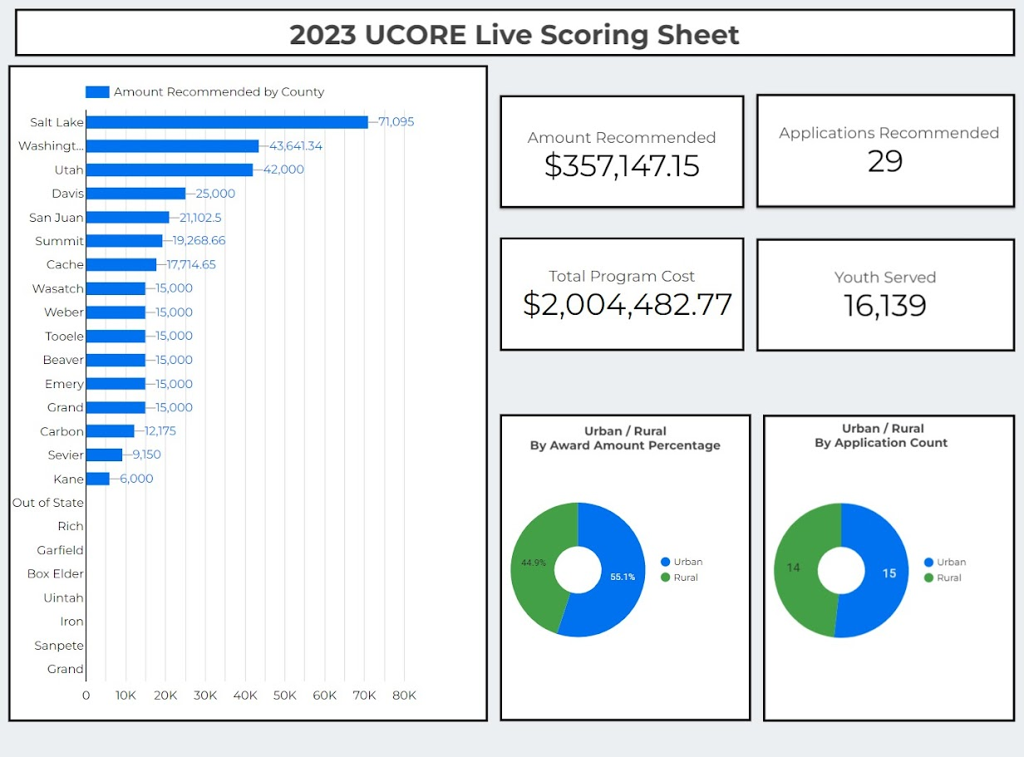

Voting on UCORE grants - Utah Outdoor Infrastructure Advisory Committee

Discussion and vote on RTP volunteer subcommittee - Evan, Patrick

Adjournment

UCORE Subcommittee members:

Jeff Salt | Utah Anglers Coalition
Melissa Mendenhall | Elementary/STEM
Amanda Roland | NPS
James Toledo | Division of Indian Affairs
Eddie Hill | Weber State
Joan Hammer | Box Elder Tourism
Katie Allred | Wasatch Adaptive
Mircea Divricean | Camp K
Teri Davis | PE Specialist
Dan Hemmert | Government
Joshua Paulsen | Industry
Jason Curry | DOR

Grants for Approval:

Average Evaluator Score |  |  |  | Amount Requested | Total Project Cost | Application Title | Organization | County
Overall Average: 38.41 | High | Medium | Low
49.33 | XXX |  |  | $6,095.00 | $16,701.00 | The Mayfly Project | The Mayfly Project | Salt Lake
49 | XX |  |  | $15,000.00 | $34,400.00 | Utah State Park Youth Program | Utah State Parks and Recreation | Weber
48 | XXX |  |  | $15,000.00 | $29,860.48 | Tribal Youth Public Land Stewards: Camp Kwiyamunstsi & Yevingkarere | Zion National Park Forever Project | Washington
48 | XX |  |  | $15,000.00 | $21,449.00 | CCID Outdoor Adventure Program | Center for Creativity, Innovation and Discovery | Cache
47.33 | XXX |  |  | $15,000.00 | $29,071.00 | Ophir Canyon Education Center | Tooele Education Foundation | Tooele
46.67 | XXX |  |  | $15,000.00 | $65,965.00 | 2024 Equal Opportunity Youth Programs in Southeastern Utah | Friends of Arches and Canyonlands Parks | Grand
46 | XXX |  |  | $10,000.00 | $41,962.00 | Cottonwood Canyons Foundation Snowshoe with a Naturalist Program | Cottonwood Canyons Foundation | Salt Lake
45 | X | X |  | $6,000.00 | $7,500.00 | Youth Canyoneering Camp featuring ROAM Outdoor's via ferratta course in Cave Lak | Kanab City Recreation | Kane
44.67 | XXX |  |  | $2,714.65 | $3,499.65 | Backdoor Birding with Binoculars | Edith Bowen Laboratory School | Cache
44.67 | XX | X |  | $10,000.00 | $15,172.00 | Monticello City Ignite Biking Skills Course | Monticello City | San Juan
44 | XX | X |  | $11,102.50 | $32,854.60 | Bears Ears Summer Camp | Friends of Cedar Mesa | San Juan
44 | XX |  | X | $10,000.00 | $49,115.00 | Seven Creeks | Walk Series | Seven Canyons Trust | Salt Lake
44 | XXX |  |  | $15,000.00 | $99,485.00 | YMCA BOLD & GOLD Program | YMCA of Northern Utah | Wasatch
44 | XX | X |  | $15,000.00 | $89,286.00 | Park City Day School Outdoor Education | Park City Day School | Summit
43.33 | XX | X |  | $15,000.00 | $93,019.00 | Healthy Communities and Scholarship | Utah Olympic Legacy Foundation | Utah
43.33 | X | XX |  | $4,268.66 | $8,417.00 | Park City Recreation's Mountain Classroom | Park City Municipal Corporation | Summit
43 | X |  | X | $10,000.00 | $39,381.36 | Lakeside Learning Field Trip Program - Antelope Island State Park | FRIENDS of Great Salt Lake | Davis
42.67 | XX | X |  | $15,000.00 | $21,000.00 | Joe's Valley Climbing Summer Camp | Joe\'s Valley Fest | Emery
42 | XXX |  |  | $15,000.00 | $21,600.00 | Out West: Tracy Aviary’s Equitable Recreation Institute | Tracy Aviary | Salt Lake
42 | XX | X |  | $15,000.00 | $90,940.00 | Children and Youth Adaptive Scuba Diving Program | Just Breathe Adaptive Scuba | Utah
42 | XX | X |  | $13,641.34 | $17,051.68 | St. George Outdoors (City of St. George) | City of St George | Washington
41.33 | XX | X |  | $15,000.00 | $25,000.00 | Summit Journeys 2024 Rural Utah Expansion | Summit Journeys | Washington
40.67 | XX |  | X | $12,175.00 | $13,826.00 | Bears Archery | East Carbon City | Carbon
40.67 | XX | X |  | $15,000.00 | $19,625.10 | Hunter High Goes Outside | Hunter High School | Salt Lake
40.67 | XXX |  |  | $15,000.00 | $22,000.00 | Reducing equity barriers for all students | Davis School District | Davis
40.67 | XX | X |  | $15,000.00 | $1,034,224.00 | Expanding Access to the 2023-24 Wasatch Adaptive Ski & Snowboard Program for You | Wasatch Adaptive Sports | Salt Lake
39.33 | XX | X |  | $9,150.00 | $31,033.00 | Gooseberry Third Grade Outdoor Education Program 2024 | Fishlake National Forest | Sevier
38.67 | XX | X |  | $15,000.00 | $16,000.00 | Minersville Library "Get Outdoors" Program | Minersville Library | Beaver
38.67 | XX | X |  | $12,000.00 | $15,044.90 | Exploring Utah's Indigenous Heritage | Nebo Title VI Indian Education | Utah

Summation:
The Utah Outdoor Infrastructure Advisory Committee voted to approve the recommended UCORE grants to be awarded.

