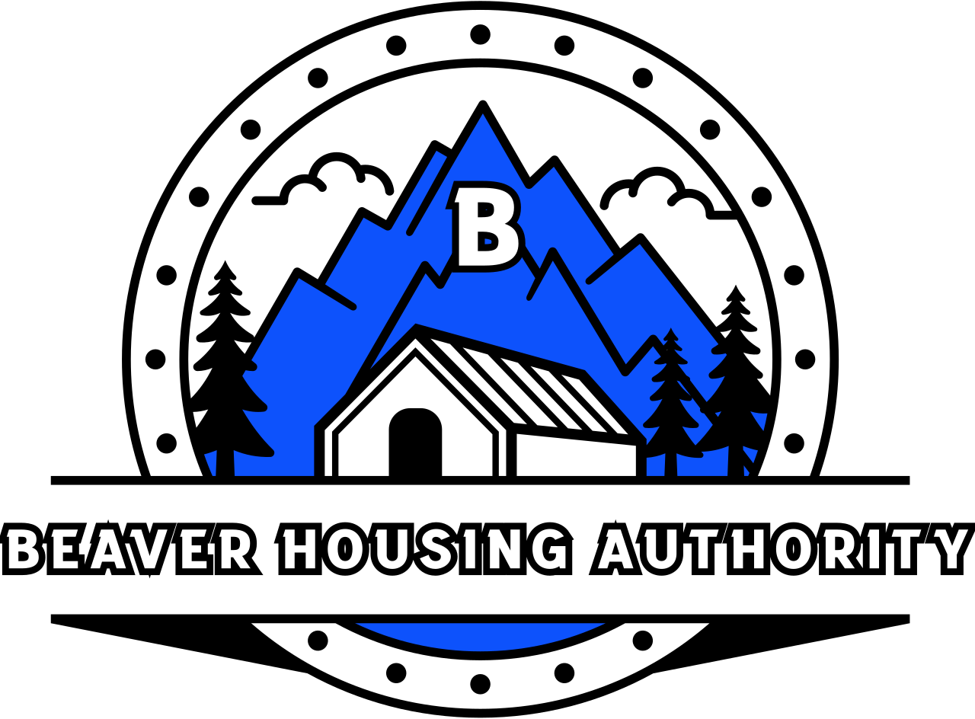
BEAVER HOUSING AUTHORITY
BOARD MEETING AGENDA
December 13, 2024

Welcome

- Prayer
- Attendance
- SEMAP Resolution (Ratify from previous meeting)
- Closed Session
- Adjourn

