Present: Zachary Posner-online (Information Technology), Richard Jaussi (Auditor), Lisa Ashman-online (District Attorney), Hoa Nguyen-online (Council), Megan Hillyard-online (Administrative Services), Talia Butler-online (Public Works), Rashelle Hobbs-online (Recorder), Phil Conder (Treasurer), Katy Fleury-online (Mayor Administration), Reid Demman (Surveyor), Chris Stavros (Assessor), Robin Chalhoub-online (Community Services), Marni Epstein-online (Human Services), Cynthia Archuleta (Sheriff)
Representation Absent: Clerk
Staff Present: Tony Jolley-online, Rina Shipley, Cindy Beck, Andrew Dudley-online, Corey Hess-online, Dean Bullock-online, Lee Wilstead-online, Mark Miller, Mike Bailey-online, Kira Moody, Hillary Boccagno-online, Trevor Hebditch, Cherie Root, Ben Thompson-online, Brandon Allgier-online, Jon Thelen-online, Thomas Yeung-online, Sam Sedivec-online, Kimball Ball-online, Valina Eckley-online, Teddy Arnold-online
TOPIC | POINTS OF INTEREST
Welcome & Remote Meeting Instructions | Chris Stavros opened the meeting.  Trevor Hebditch shared the following slide:  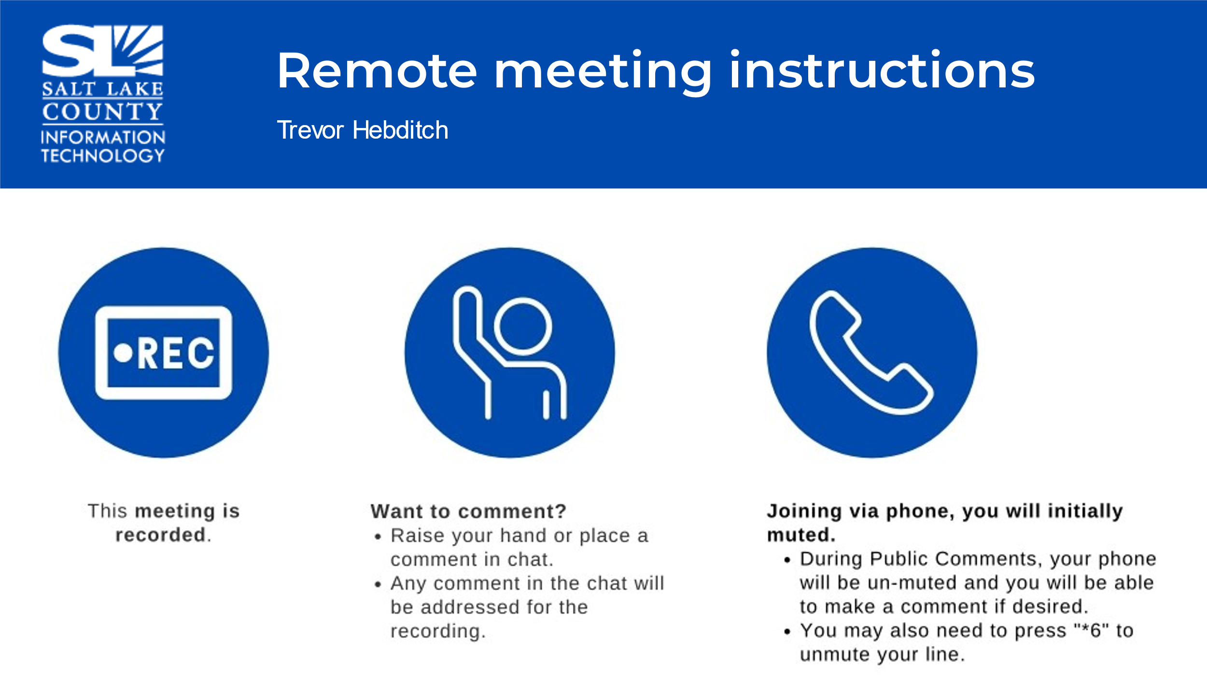
Public Comments  (Chris Stavros) | None.
Approval of minutes from June 27th, 2024, meeting | Motion to approve the minutes by Phil Conder, Richard Jaussi seconds the motion. No discussion.  Motion passed unanimously.
Follow-up Items  (Cherie Root)  IT Shared Services Model  (Zachary Posner)  *Reminder*  The framework that has been built will assist in the decision-making process around where services should live within a centralized framework vs within the agency.  Having a common set of frameworks & standards will help clear up confusion and push back that can occur.  There are excellent resources within some of these agencies that the rest of the County should have access to. | 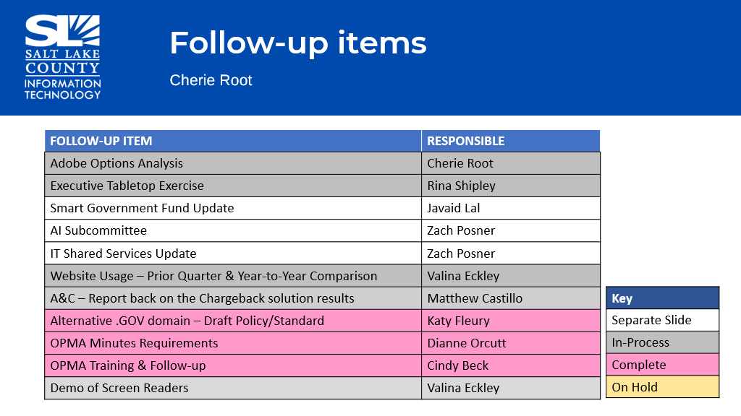  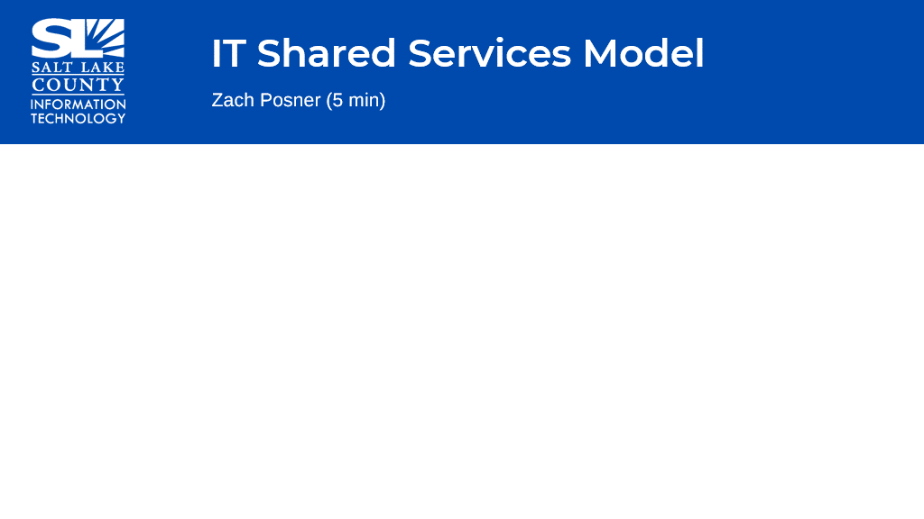  - We continue to work with the library to work out a “workflow” of what a “shared” services model would look like and test it along the way.  - The approach we have come up with is loose enough so that we can deal with unique scenarios.
AI Policy Group (Zachary Posner)  **Members**  Reid Demman  Lisa Ashman  Phil Conder  Kelly Colopy  Zach Posner  Maren Slaugh | 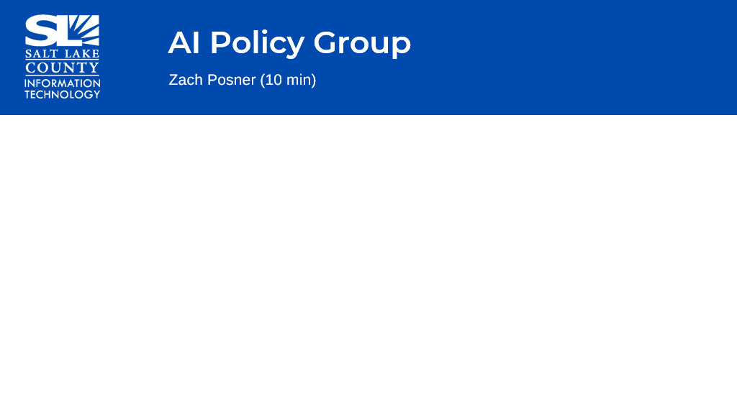  - Created a draft AI Policy for the County.  - Dianne Orcutt has reviewed and made excellent comments.  - Next steps: moving through the working groups in time to present during the October TAB meeting.  - The theme of the policy is that there is personal responsibility around the use of AI, but encourage people to use these tools and find ways to improve the organization.
.gov Update (Zachary Posner) |   - The migration of the website will move forward towards the end of the month.  - This needs to be completed before we start dealing with elections and need to handle some licensing issues with our web provider.
Smart Government Fund Update (Javaid Lal) | 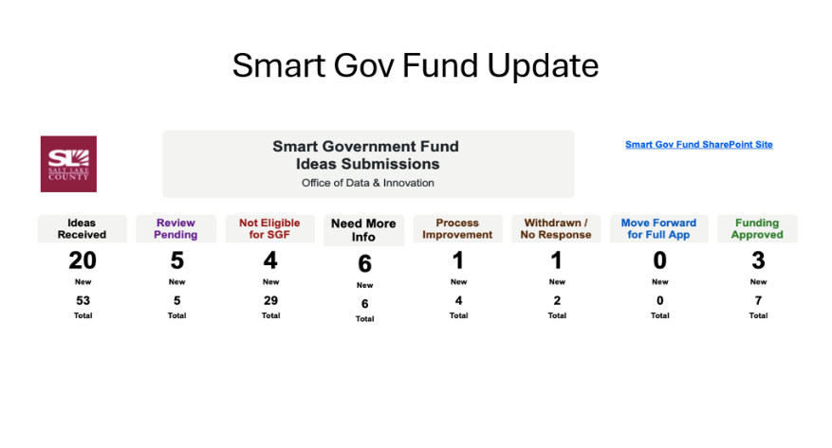  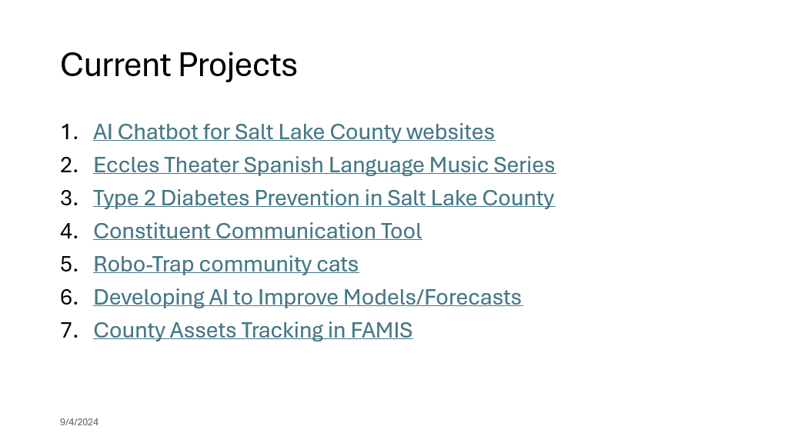  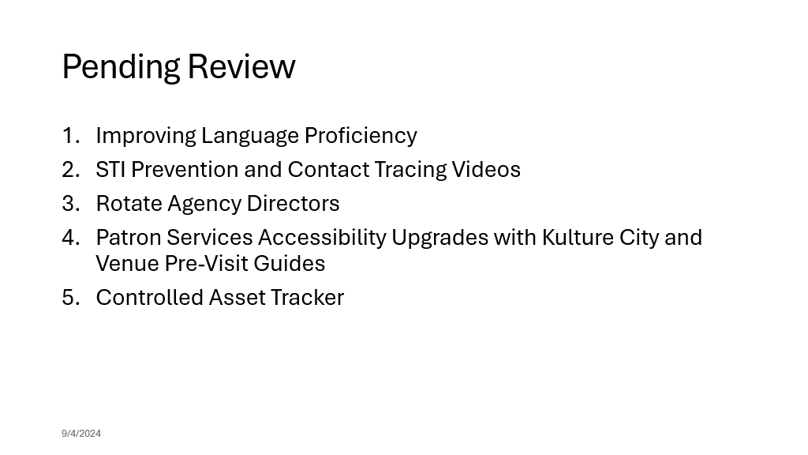
2025 Budget Prioritization  (Tony Jolley/Zachary Posner)  *The working groups: Solutions Working Group and Portfolio Working Group have evaluated the business cases and the total cost of ownership (TCOs) and made their recommendations and scored each accordingly.  The Business Cases are ranked in three categories:  1.Value to the County.  2. Feasibility – how easy is it to complete the project.  3. Risk – perceived risk to the county of NOT doing it. | 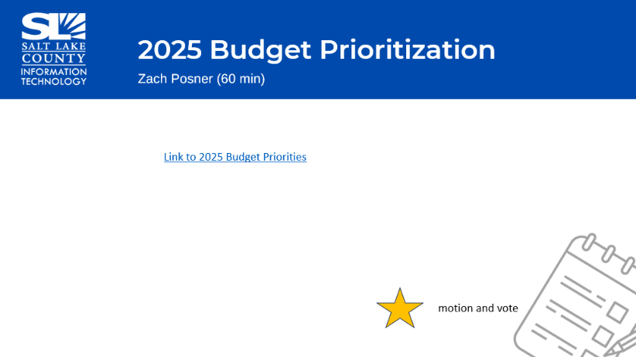  - Reviewed each business case/TCO at a high level for the 2025 Budget year.  - The requests are placed in three groups: General Fund Request, Existing Funding, & Separate Funding.  - General Fund Request – There are 19 business cases in this group. The total ask is approximately $2.5 million dollars. This amount is in line with previous year’s ask across the organization. Here are the names in no particular order:  - 2025 Pcard Auditing Software, 2025 SharePoint Storage Expansion, 2025 Tax Modernization Program (TORUS), Automated Phishing Monitoring, Certificate Management System, Conference Room Equipment/Maintenance, County Privacy Officer, Full Time Hours for IT Office Coordinator Position, Hardware & Software Maintenance Increases, HR Pay Equity Tool, Mainframe Tax Support, NeoGov Multi-Year Funding, Password Management System, PayFactors Contract Extension, Project Manager TL Renewal, Quality Assurance FTE, SLCO Accessibility Compliance Tool, Web Experience Analyst FTE, and ZenCity Multi-Year Funding  - Existing Funding – There are 10 buisness cases in this group not competing for new funding, but competing with personnel (time against other projects). The following buisness cases have existing funding. These are in no particular order:  - Agenda and Minutes Management System, AI Chatbot for Salt Lake County Websites, Caselle Conversion to Cloud, Compliance Assessment System, Concur Travel Management, Enhancement of Application Inventory, ESRI GeoEvent Server, Grants Management Solution, Loan Application & Servicing Software, and Process Flow Diagram Tool Replacement  - Separate Funding – we have 4 business cases and these are ranked based on internal resources. Again, these are listed in no particular order:  - Clark Planetarium POS Rebuild, Fleet Management Software, Secure Ticket Solution, and Integrated Notificatiopn Solution
TAB Priorities | General Fund Requests in TAB Priority order:  Mainframe Tax Support 110 - General Fund  2025 Torus Budget Extension 110 - General Fund  Quality Assurance FTE 110 - General Fund  2025 Hardware & Software Maintenance/Subscription Increases 110 - General Fund & 650 - Telecom  NEOGOV (Performance Management) Multi-year Funding 110 - General Fund  Conference Room Equipment Maintenance Multiple  County Privacy Officer 110 - General Fund  Project Manager TL Renewal 110 - General Fund  Certificate Management System 110 - General Fund  Payfactors Contract Extension 110 - General Fund  HR Pay Equity Tool 110 - General Fund  Automated Phishing Monitoring 110 - General Fund  Password Management System 110 - General Fund  PCard Auditing Software 110 - General Fund  2025 SharePoint Storage Expansion 110 - General Fund  Web Experience Analyst FTE 110 - General Fund  Full Time Hours for IT Office Coordinator 110 - General Fund  SLCO Accessibility Compliance Tool 110 - General Fund  Zencity Multi-year Funding 110 - General Fund  Separate Funding Requests in TAB Priority order:  Fleet Management Software 620 - Fleet Management  Secure Ticket Solution 185 - Arts & Culture  Integrated Notification Solution 360 - Library Fund  Clark Planetarium POS Rebuild 181 - TRCC  Motion to Approve the TAB Ranked Priorities by Richard Jaussi and Phil Conder, seconds the motion.  Aye: Administrative Services, Assessor, Auditor, Community Services, District Attorney, Human Services, Mayor Administration, Public Works, Recorder, Sheriff, Surveyor, Treasurer  Nay: None  Roll Call: Absent Clerk  Motion passed unanimously.
Chair &CIO | 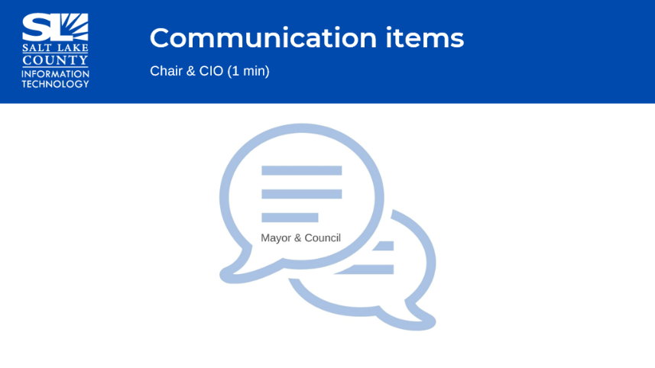  - Mayor’s Finance will be made aware of the TAB rankings of the business cases and ready to discuss in the upcoming budget meetings for 2025.  - The Chair & Vice-Chair can participate in the meetings.  - The CIO (Zachary Posner) mentioned how important the Technology Advisory Board members are to the County. There is a lot of reading and understanding that goes on throughout the meetings all year long. It is a way for the IT Division to share the strategy and needs of the organization in the coming year.
Upcoming Meeting Schedule (Cindy Beck)  *Please note the August sessions are the combined TAB Meeting with GIS Steering Committee. 8/22 meeting not needed, canceled. | 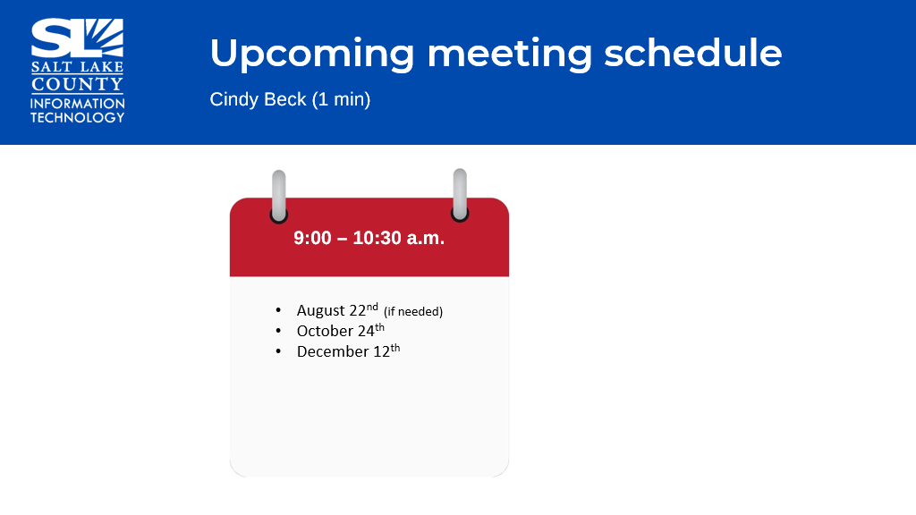
Review Action Items (Cindy Beck)  No action items to report. | 
Next TAB Meeting October 24th, 2024. | 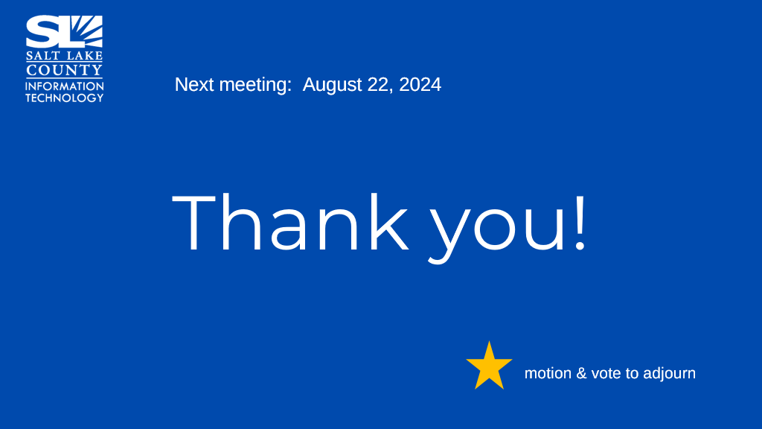  - The meeting was successful with reviewing all business cases & TCOs as well as ranking them. The August 22nd, 2024 TAB meeting will be canceled. A notice will be posted on the Public Website with this change.
End of Session
Submitted by Cindy Beck | It was noted there was no communication items in the chat for this session.

