Exhibit B
Minor Subdivision Application (Instructions)

MINOR SUBDIVISION DEFINITION:
Any subdivision creating not more than three (3) lots, fronting on an existing street, not involving any street or road or the extension of municipal facilities or the creation of any public improvements, and not adversely affecting the remainder of the parcel or adjoining property, and not in conflict with any provision or portion of the General Plan, Official Map, and any regulations established in the Clarkston Town Code.

WHAT TO DO:
Submit this completed checklist and all supporting documents in digital form to the Town’s staff at clarkstonpz@clarkstonutah.org. Pay the application fee outlined in the Town fee schedule. Before applying, you may schedule a pre-application meeting with the Planning Commission to review a concept plan and/or other elements of your application. Please be aware there is a $150.00 Concept Review Fee associated with a pre-application meeting, which is applied to the $300.00 Administrative Fee if you choose to move forward with your plan.

WHAT TO EXPECT:
Town staff will review your application and determine whether it is complete. If your application is complete, or if the Town decides to waive the incomplete requirements, the Planning Commission will review and respond to your application within 30 business days. You may be required to revise your application to conform to Town development standards or to better protect the health and safety of Clarkston Town residents.

The application process for minor subdivisions is governed by Title 11 chapter 9 of the Town’s municipal ordinances. The flowchart below summarizes this process.

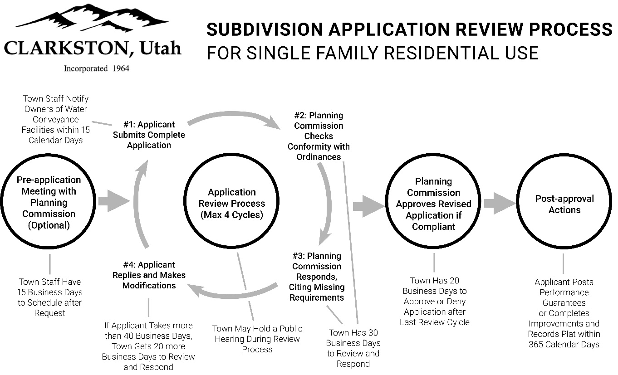
MINOR SUBDIVISION
APPLICATION REVIEW PROCESS


Minor Subdivision Application
For Town Use Only:
Date Accepted: _______________________
Receipt #: ______________________
Amount Paid: ___________________

County Tax Parcel Number: _____________________________

Current Zoning of Property: _____________________________

CONTACT INFORMATION:
Applicant Information  Name: __________________________________________  Phone: _________________________________________  Email: __________________________________________ | Property Owner #1 Information  Name: ______________________________________  Phone: _____________________________________  Email: ______________________________________
Property Owner #2 Information (If Applicable)  Name: _________________________________________  Phone: _________________________________________  Email: __________________________________________ | Property Owner #3 Information (If Applicable)  Name: __________________________________________  Phone: __________________________________________  Email: __________________________________________
Engineer’s Information (If Applicable)  Name: __________________________________________  Phone: _________________________________________  Email: __________________________________________ | Surveyor’s Information (If Applicable)  Name: __________________________________________  Phone: __________________________________________  Email: ___________________________________________
If the property to be subdivided has more than three owners, attach supplemental information for remaining owners.
REQUIRED CONDITIONS:

The following requirements shall be imposed as a condition of approval of a minor subdivision:
- Not more than three (3) parcels shall be created in the minor subdivision.
- The area to be subdivided should be adjacent to existing streets and utilities, and there shall be no dedication of any land for street rights of way or other public purposes required by the needs of the subdivision or planned for in the Town’s General Plan or transportation plan or the applicant’s proposal.
- The minor subdivision shall not require any changes to existing infrastructure.

DOCUMENT CHECKLIST:

- Describe how the property will be used after it is subdivided. Are there underlying/overlying agreements on the property? This application must include citations to specific municipal ordinances that permit the intended use, an approved conditional use permit, or an approved variance.
  - If the intended use is permitted by right under Town ordinances, the land use application must include citations to the specific ordinance(s) that the applicant believes authorizes the intended use.
  - If the intended use requires a conditional use permit or is otherwise conditioned on Town approval, the land use application must include an approved, Town-issued permit authorizing the intended use. Should an applicant seek a use permit concurrently with a related subdivision application, the subdivision application shall be considered incomplete until the use permit is issued.
  - If the intended use is prohibited under Town ordinances and requires a variance, the land use application must include an approved, Town-issued variance authorizing the intended use. Should an applicant seek a variance concurrently with a related subdivision application, the subdivision application shall be considered incomplete until the variance is issued.
  - If the intended use requires a rezoning, the applicant must obtain the rezoning before submitting an application. Should an applicant seek a rezoning concurrently with a related subdivision application, the subdivision application shall be considered incomplete until the rezoning is effectuated.

- A record of survey map that illustrates the boundaries and acreage of the parcel(s).
- A legal metes-and-bounds description that describes the parcels illustrated by the survey map.
- Additional information must include:
a _____ Existing street layouts
b _____ Location and size of water utilities
c _____ North Arrow
- Proof of approval by the culinary water authority, roads department and the local fire department.
Signatures:
Water Department: ___________________________________________________________________
Roads Department: _________________________________________________________________
Fire Department: _____________________________________________________________________
- Does any portion of the property/site reside in a flood zone? A FEMA Flood Insurance Rate Map (FIRM) should be utilized.

- Certifications, including:
  - An affidavit from the applicant certifying that the submitted information is true and accurate (ON PAGE 5).
  - The signature of each owner of record on the survey signifying approval of this minor subdivision (ON PAGE 6).
  - A Title Report or Title Insurance Policy for the land to be subdivided verifying property ownership.
  - A Tax Clearance Certificate from the state indicating that all taxes, interest, and penalties owing on the land have been paid.

  - Certification that the surveyor:
    - Holds a license in accordance with Utah Code 58-22; and
    - Either
      - Has completed a survey of the property described in accordance with state requirements and has verified all measurements; or
      - Has referenced a record of survey map of the existing property boundaries and verified the locations of the boundaries; and
    - Has placed monuments as represented.
- Payment of the subdivision application fee. The fee is due when you submit the application, according to the most recent Clarkston Town fee schedule.
Concept Plan Review: $150.00 (optional)
Administrative Fee: $300.00
Water Dedication Fee: $3000.00 per new lot
*Developer is responsible for any attorney and engineering fees associated with a Minor Subdivision that exceeds the Minor Subdivision fee. *

RESTRICTIONS ON FURTHER SUBDIVISION WITHOUT PLAT:
Real property that has been subdivided as a minor subdivision under this section, both the parent parcel and the parcel which was subdivided from the parent parcel, may not be further subdivided pursuant to a minor subdivision for two (2) years from the submission of the original application for minor subdivision. Any further subdivision of any property that has been subdivided pursuant to a minor subdivision must be completed in accordance with this Title, and all property that was part of the minor subdivision must be included in, and be made part of, the plat and application for any subsequent subdivision.

APPLICANT’S AFFIDAVIT – SUBDIVISION APPLICATION
County Tax Parcel Number of Property to Be Subdivided: ____________________________________________

I, ___________________________________________ (applicant/agent name), certify under penalty of perjury that this application and all information submitted as a part of this application are true, complete, and accurate to the best of my knowledge. Should any of the information or representations submitted in connection with this application be incorrect or untrue, I understand that Clarkston Town may rescind any approval or take any other legal or appropriate action. I also acknowledge that I have reviewed the applicable sections of the Clarkston Town Subdivision Ordinance and that items and checklists contained in this application are basic and to the minimum requirements only and that other requirements may be imposed to ensure compliance with municipal ordinances and approved standards and specifications. Additionally, I agree to pay all fees associated with this application, as set by the currently adopted Clarkston Town Consolidated Fee Schedule.

Signed:
______________________________________________  Applicant/Agent | _____________________________  Date

Subscribed and sworn to before me:
______________________________________________  Notary Public | _____________________________  Date

Notary Seal:

PROPERTY OWNER’S CONSENT – MINOR SUBDIVISION APPLICATION

County Tax Parcel Number of Property to Be Subdivided:

_______________________________________________________________

We certify under penalty of perjury that we are the sole owners of the property proposed to be subdivided and that we have thoroughly reviewed the minor subdivision application. We hereby consent to this minor subdivision application contingent on Town approval of the application. We further consent to agents of the Town entering onto the subject property for the purpose of making any inspections required by this application or related improvements.

Signed:
______________________________________________  Property Owner #1 | ____________________________  Date

______________________________________________  Property Owner #2 (if applicable) | _____________________________  Date
______________________________________________  Property Owner #3 (if applicable) | _____________________________  Date

Subscribed and sworn to before me:
______________________________________________  Notary Public | _____________________________  Date

Notary Seal:

