Salt Lake County NMTC Inc. Board Meeting Minutes
Monday, November 25, 2024 – 12:30 PM – 1:00 PM
WebEx – Electronic Meeting Only

- Welcome Introduction and Citizen Input – Wayne Cushing, Board Member
Trustees Present:
Darrin Casper, SLCO NMTC, Inc. Board President and County Deputy Mayor of Finance and Administration/Chief Financial Officer
K. Wayne Cushing, SLCO NMTC, Inc. Board Member and County Treasurer
Laurie Stringham, SLCO NMTC, Inc. Board Member and County Council Chair
Other Attendees:
Greg Folta, Finance and Payroll Director, Mayor’s Financial Administration
Krystalyn Jensen, Internal Services Manager, Mayor’s Financial Administration
Emily Holt, Attorney for SLCo Foundation, Parsons Behle & Latimer
Isaac Higham, Senior Policy Advisor to Councilman Arlyn Bradshaw
Ross Keogh, Attorney for SLCO NMTC Inc., Parsons Behle & Latimer
Sheila Srivastava, County Treasurer Elect
Andrew Roberts, Mayor’s Chief of Staff
Absent:
Jenny Wilson, SLCO NMTC, Inc. Board Chair and County Mayor
Open Public Hearing – Citizen Comments
Board Member Cushing opens the meeting to public comment, which there were none.

- 2024 Adjusted Budget – SLCo Downtown Health Clinic LLC – Greg Folta
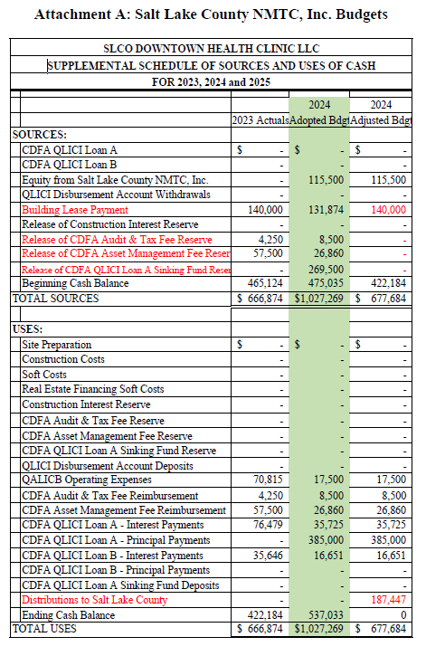
Mr. Folta shared the 2024 Adjusted Budget and the 2025 Budget. The SLCo Health Clinic LLC was funded in 2017. The 7-year NMTC compliance period ended this year, so the financing was unwound in late June 2024. The LLC is currently in the process of being closed out to be legally dissolved. The remaining funds will be transferred to Salt Lake County. There is an adjustment for the lease payment because it was about $9,000 more than what was budgeted. The Reserve funds used to facilitate the unwind were already in the cash balance, and also used other funds to unwind the financing.
The adjusted budget includes $187,000 being transferred back to the County Health Fund, which was not originally in the adopted budget and will need to be added as an expense for 2024. There is no proposed budget for 2025.

- 2025 Budget – Kearns Library LLC – Greg Folta
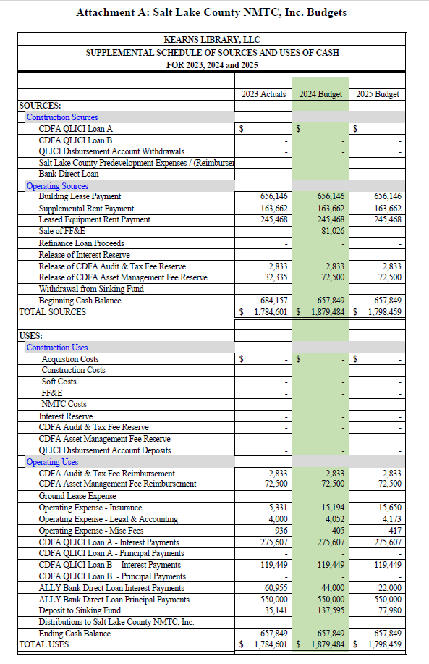
The Kearns Library was funded in 2019 so this will unwind in 2026 and will transfer back to the county at that point. There are no adjustments for 2024, and the budget is similar for 2025. The county library fund is making the lease payment to Kearns Library LLC. The LLC uses those payments to pay interest, principal, and other expenses as shown in the budget.

- 2025 Budget – Salt Lake County NMTC, Inc. – Greg Folta
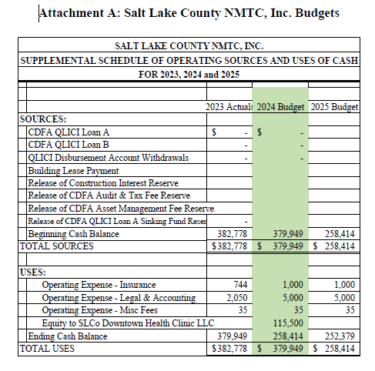
NMTC Inc used $115,000 to facilitate the wind down of the SLCo Downtown Health Clinic in 2024. This account is generally used to pay expenses related to all entities that are not applicable to one LLC. This fund has $6,035 budgeted in 2025 for general expenses.
Mr. Cushing asks if there are any others to review. Mr. Folta confirms there is none. Mr. Cushing asks for a motion to approve budgets and adjustments. Ms. Stringham makes the motion, Mr. Cushing and Ms. Stringham both agree. Motion passes.

- Other Business/Schedule next Board Meeting
Mr. Cushing entertains a motion to set up the next board meeting for December 10, 2024, at 6:00pm. Ms. Stringham makes the motion, the motions passes with Mr. Cushing and Ms. Stringham in agreeance.

Meeting adjourned.

