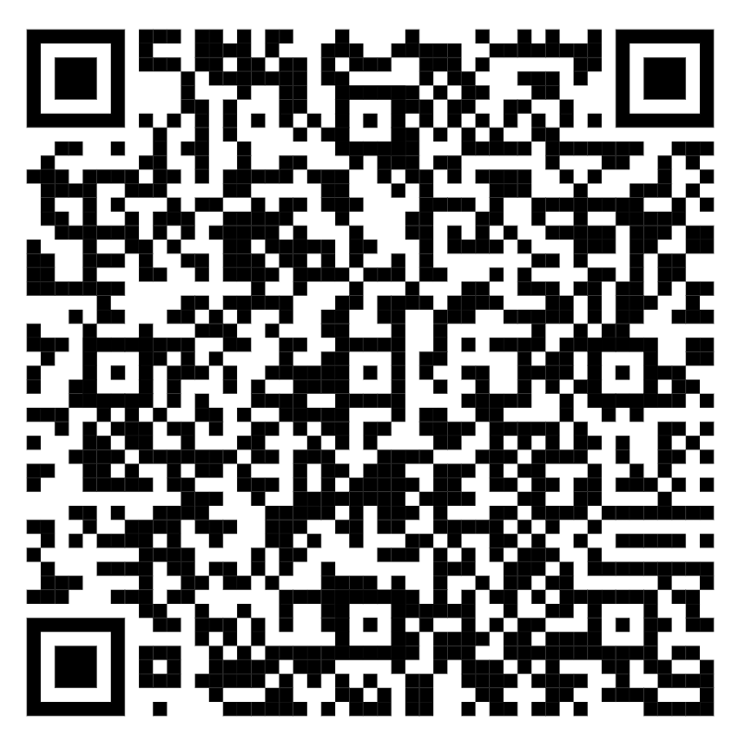 | SALT LAKE COUNTY  Salt Lake County NMTC, Inc.  Meeting Agenda | 2001 So. State Street Salt Lake City, UT 84190

Tuesday, December 10, 2024 6:00 PM Salt Lake County Council Chambers

Upon request and with three working days’ notice, the board will provide free auxiliary aids and services to qualified individuals (including sign language interpreters, alternative formats, etc.). For assistance, please call (385) 468-7500 – TTY 711.
Members of the Board May Participate Electronically.

This meeting will be simulcast electronically via Webex Webinars. The Board will also broadcast live-streams of the meeting on Facebook Live, which may be accessed at http://www.facebook.com/slcocouncil/, and through Cisco Webex, which may be accessed at:

https://slco.webex.com/weblink/register/rc230bd7a672beb02c94f34e88258b8f4

Individuals wishing to comment electronically must access the meeting using the Webex link above by the beginning of the “Citizen Input” portion of the meeting. Comments will be limited to three minutes per individual unless otherwise approved by the Board. If an individual is unable to attend the meeting, they may also email their comments to krjensen@saltlakecounty.gov by 10:00 AM the day of the meeting to have those comments distributed to the Board and read into the record at the appropriate time.

The first time you join via the link may take longer to get through the set-up steps. Please plan accordingly. Please include "Resident" ahead of your first name when you join the meeting, or you will not be identified as wanting to give comment.

- Welcome - Introduction
Board Chair Jenny Wilson
- Approval of Meeting Minutes
- Open Public Hearing - Citizen Input
- Board Comments
- Close of Public Hearing
- Discussion and Approval of Salt Lake County NMTC, Inc. Resolution, 2025 Budgets and 2024 Adjusted Budgets
A Resolution of the Governing Board of the Salt Lake County NMTC, Inc., Adopting the Annual Budgets Required for Fiscal Year 2025 and adjustments to the 2024 budgets; Approving and Providing for the Necessary Sources to Fund the Budgets; and Related Matters. | 2024-1
Attachments: Budget Resolution
Supplemental Schedules for
Kearns Library, LLC
SLCO Downtown Health Clinic LLC
Salt Lake County NMTC, Inc.

- Adjournment

