

SALT LAKE COUNTY
2001 South State Street Salt Lake City, UT 84114
(385) 468-7500 TTY 711

Meeting Minutes

Tuesday, November 19, 2024

9:00 AM

Room N2-800

Board of Equalization

Board of Equalization Meeting Minutes November 19, 2024

CALL TO ORDER

Present

Chair Laurie Stringham, Board Member Suzanne Harrison,

Board | Member | Jim Bradley, Board | Member | Arlyn Bradshaw,
Board | Member | Ann Granato, Board | Member | Sheldon Stewart,

Absent Call In

PUBLIC COMMENT
and Vice Chair Dea Theodore Board Member Dave Alvord
Board Member Aimee Winder Newton

There was no public comment.

APPROVAL OF BOE MINUTES
  - Acceptance of BoE minutes for November 5, 2024 24-2305
Attachments: 110524 BoE minutes Presenter: Richard Jaussi, Chief Deputy, Auditor
Board Member Bradley and Board Member Winder Newton were absent for the vote.
A motion was made by Board Member Granato, seconded by Board Member Harrison, that this agenda item be approved. The motion carried by a unanimous vote.

APPROVAL OF ASSESSOR AND HEARING OFFICER RECOMMENDATIONS
  - Approval of Assessor and Hearing Officer Recommendations 24-2327
Attachments: 111924 Weekly Counts
111924 BoE Weekly Report 111924 BoE Value Adjustments
Presenter: Brad Neff, Tax Administrator

Board Member Winder Newton was absent for the vote.
A motion was made by Board Member Harrison, seconded by Board Member Stewart, that this agenda item be approved. The motion carried by a unanimous vote.

APPROVAL OF SIGNIFICANT ADJUSTMENTS

  - Significant Adjustments 24-2328
Attachments: 111924 Significant Adj Image Presenter: Brad Neff, Tax Administrator
Board Member Winder Newton was absent for the vote.
A motion was made by Board Member Bradshaw, seconded by Board Member Harrison, that this agenda item be approved. The motion carried by a unanimous vote.

LATE APPEALS
  - Late Appeals 24-2322
Attachments: 111924 Late Appeals
Presenter: Brad Neff, Tax Administrator Action Requested: Approve attached list
Board Member Winder Newton was absent for the vote.
A motion was made by Vice Chair Theodore, seconded by Board Member Bradshaw, to approve the attached list. The motion carried by a unanimous vote.

EXEMPT PROPERTY RECOMMENDATIONS

  - Recommendations on Exempt Property for Tax Year 2024 24-2323
Attachments: 111924 Exempt Property
Presenter: Richard Jaussi, Chief Deputy Auditor Action Requested: Approve attached list
A motion was made by Board Member Harrison, seconded by Vice Chair Theodore, to approve the attached list. The motion carried by a unanimous vote.

ADJOURN

THERE BEING NO FURTHER BUSINESS to come before the Board of Equalization at this time, the meeting was adjourned.

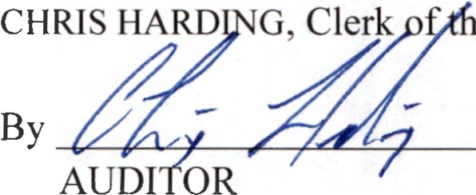
e Board of Equalization

