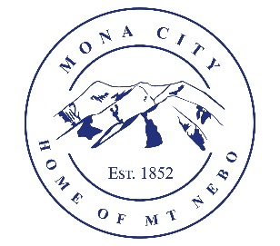
Mona City
435-623-4913
www.monautah.gov
20 West Center Street Mona, Utah

Mona City Council Meeting Agenda
Tuesday, December 10, 2024
Mona City Building – 20 West Center
7:00 p.m.

- Pledge
- Prayer
- Approval of November 26, 2024, Public Hearing and City Council Meeting Minutes
- Approval of Ordinance 2024-13: Land Use Ordinance Updates (see the Mona City Website for a complete copy of the updates).
- Director of Finance
  - Approval of Finances
- Gas & Water & Roads
- Sewer
- Council Reports
- Public Comment
- Adjournment

CERTIFICATE OF POSTING
This agenda is hereby properly advertised on this 5th day of December 2024 by posting copies in the following places: the Mona City Office, on the Mona City website at monautah.gov, at the United States Post Office Mona City Branch, and on the Utah Public Notice Website at www.utah.gov/pmn/index.html.

_____________________________________
Alicia Hills, Mona City Recorder

Upon Request, in compliance with the Americans with Disabilities Act, reasonable accommodations for individuals with disabilities will be provided. For assistance, please call 435-623-4913.

