BEAVER HOUSING AUTHORITY
BOARD MEETING AGENDA
November 26, 2024
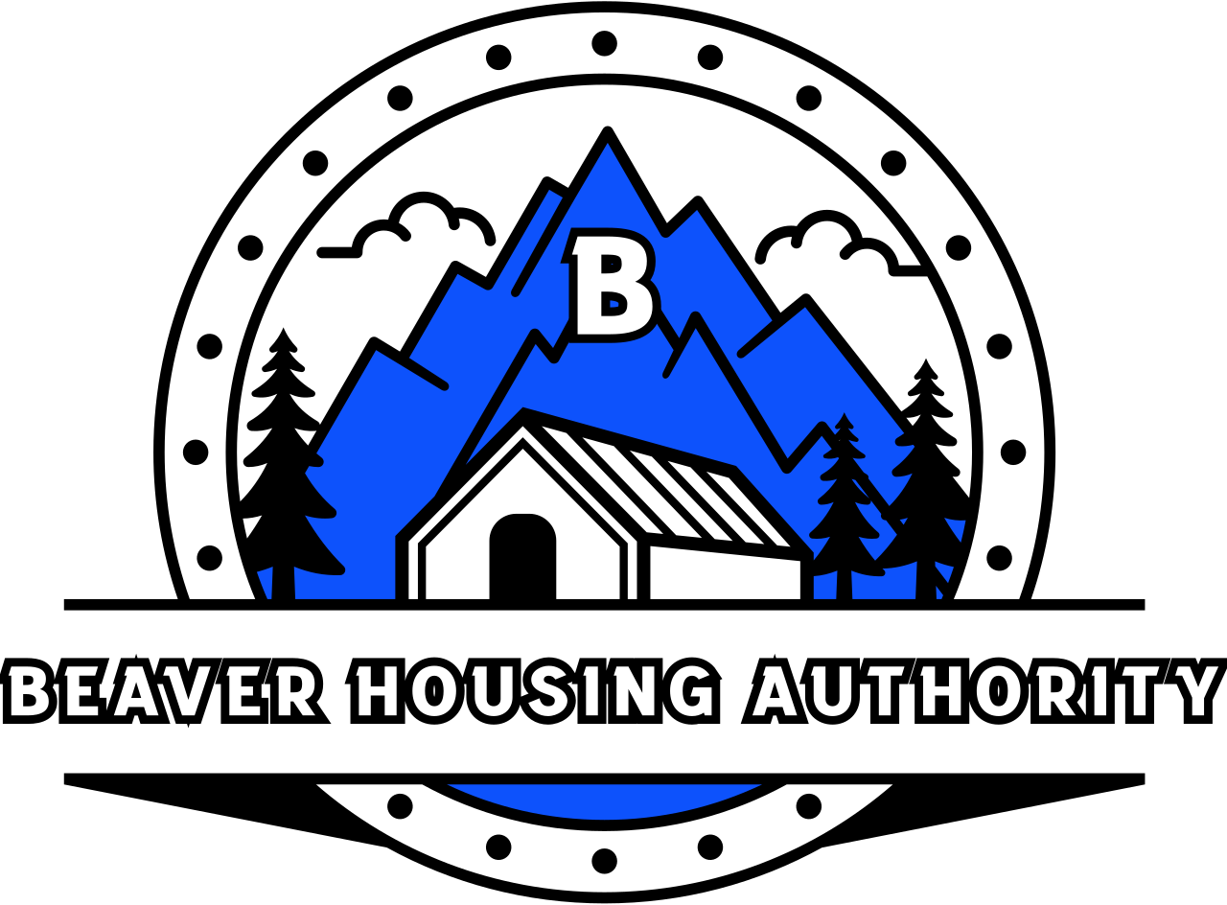
Welcome

- Prayer
- Attendance
- SEMAP Resolution
- Other Business
- Adjourn

