MINUTES OF WOOD HILLS CITY, UTAH, PLANNING COMMISSION MEETING HELD ON SEPTEMBER 18, 2024

On September 18, 2024, the planning commission held a regularly scheduled public meeting. The meeting commenced at 7:05pm. Present were Planning Commissioners Severin Johnson, Simin Kirschman, John Stout, and Wayne Frandsen. Commissioners Lori Thomas and Larry Henry were excused. The invocation was offered by Commissioner Kirschman and Commissioner Stout lead in the Pledge of Allegiance. Following the pledge, time was given for any public comment, but none was made.
Item 5 on the agenda was approval of the last planning commission meeting held on August 21, 2024. Chairman Frandsen called for a motion to be made to approve the minutes. Commissioner Johnson made a motion to approve the minutes, which motion was seconded by Commissioner Stout. All voted in favor of approving the minutes.
Item 6 on the agenda was a proposal to approve the final plat for Bell View Subdivision, Phase B. No one representing Bell View Subdivision was present at the meeting, however, Chairman Frandsen suggested that the Commission move forward to review the proposal and determine whether it should be approved or not. Chairman Frandsen gave an overview of the proposal. Note: there were two emails which Chairman Frandsen sent out to the Commissioners that explained the background on this matter. They are inserted below. In summary, the Subdivision Developer has had fill dirt dumped on the site since 2019, without approval from the city as not Final Plat had been approved. It is estimated that approximately 20 feet of fill dirt had been dumped on the site and particularly where the access road will be placed. The city engineer has suggested an alternative to removing all the fill dirt where the road is to be placed, has written to the developer on the matter, and that is what is under consideration. Most recently the final plat was approved with the condition of removing all of the fill dirt. An alternative is now under consideration by the planning commission and the city council.
(Below email sent on 8/28/2024)
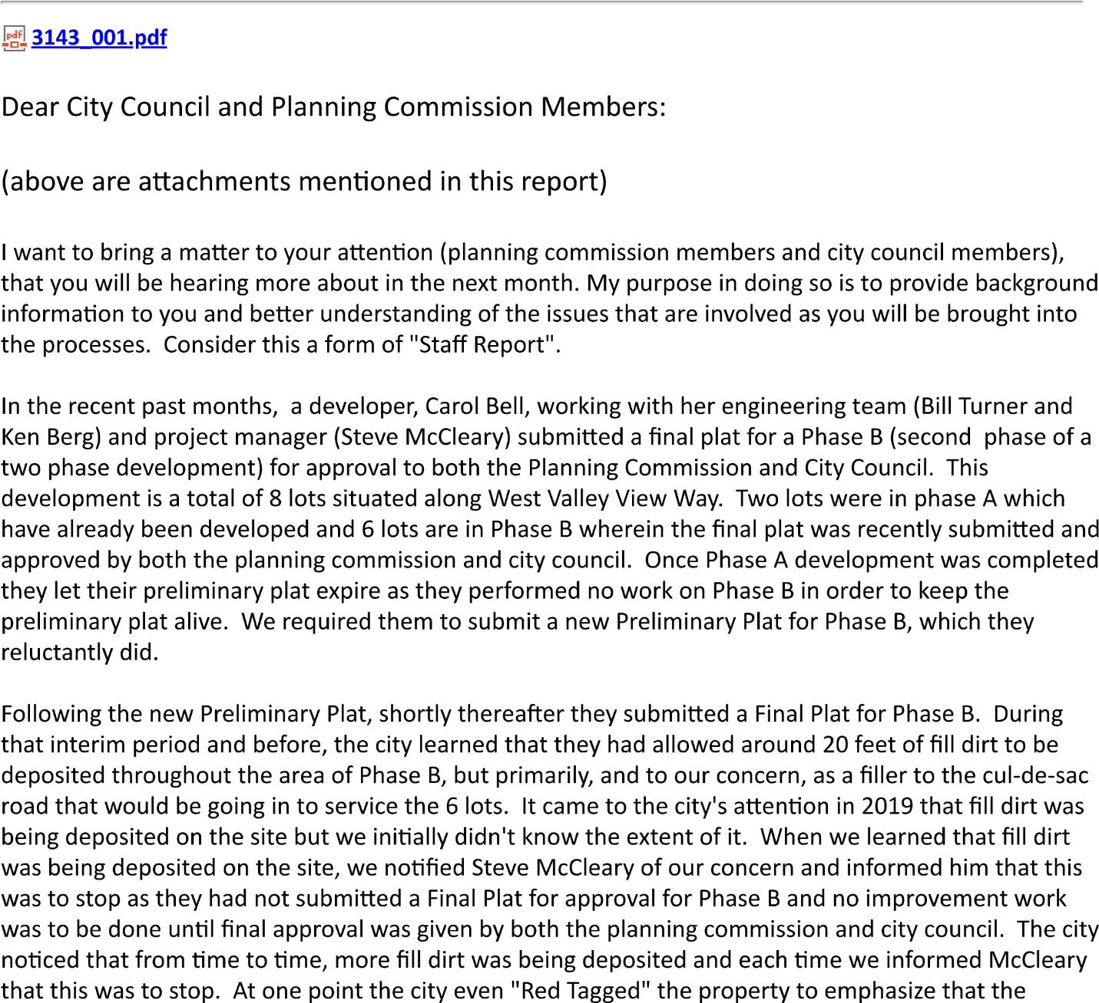
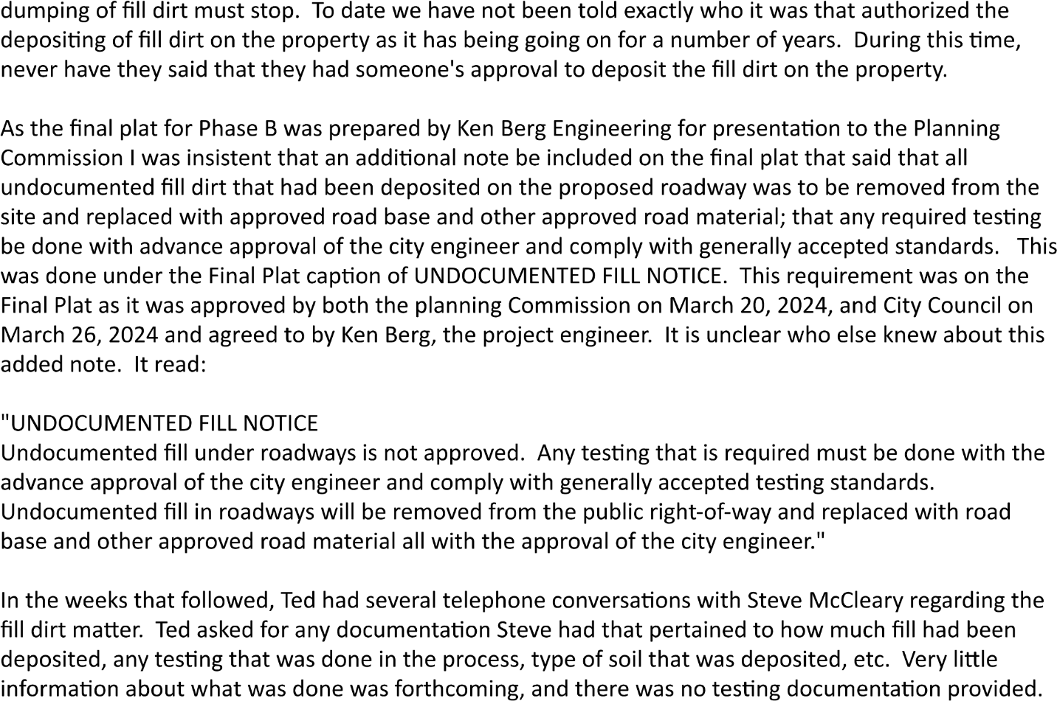
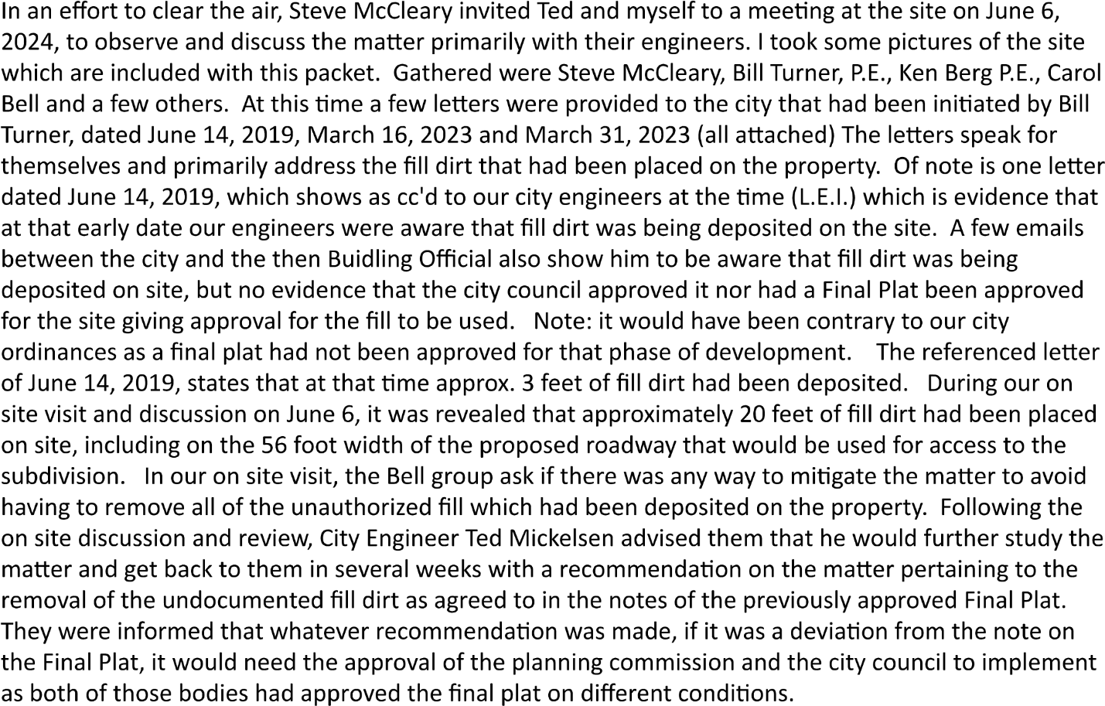
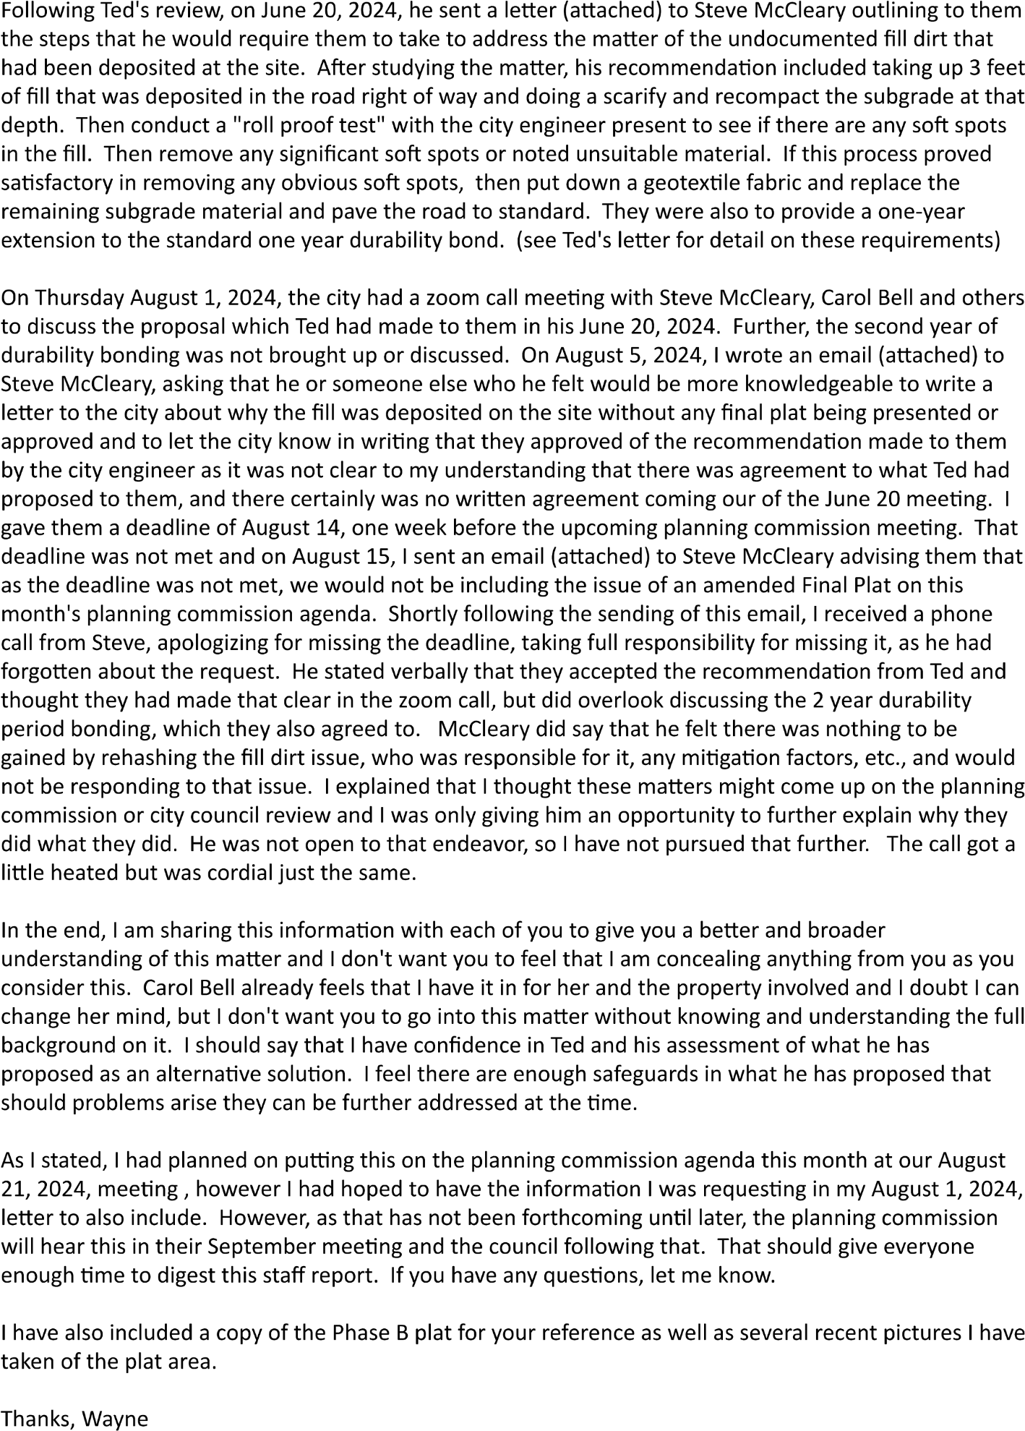

(Below email sent 9/12/2024)
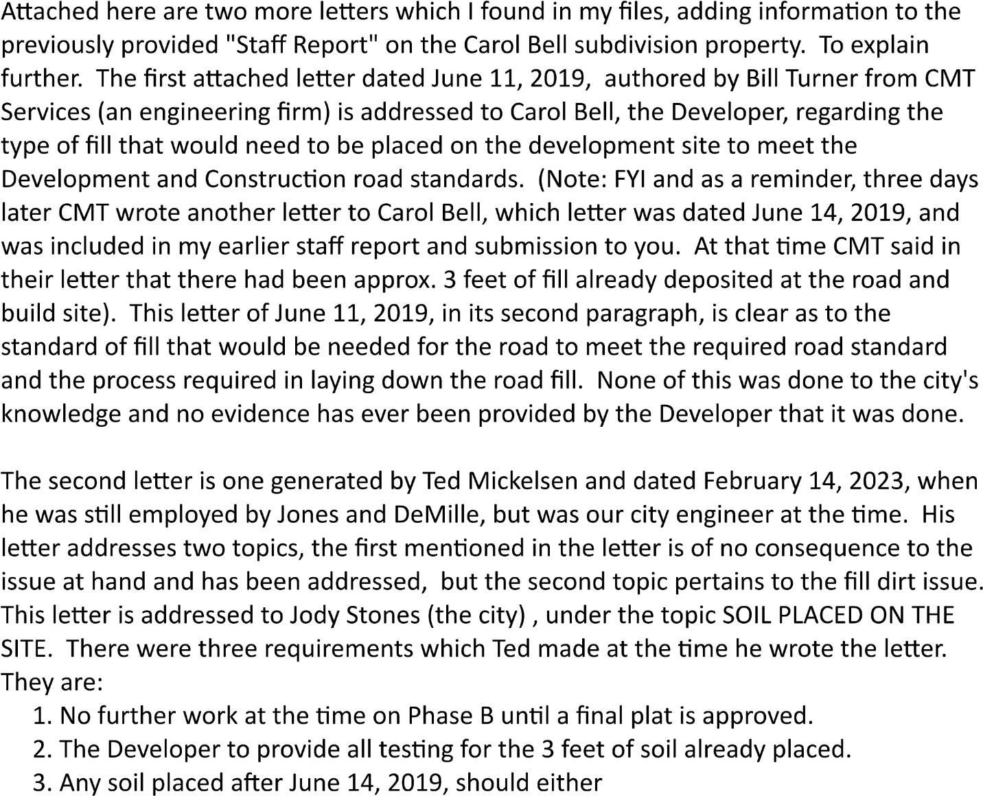
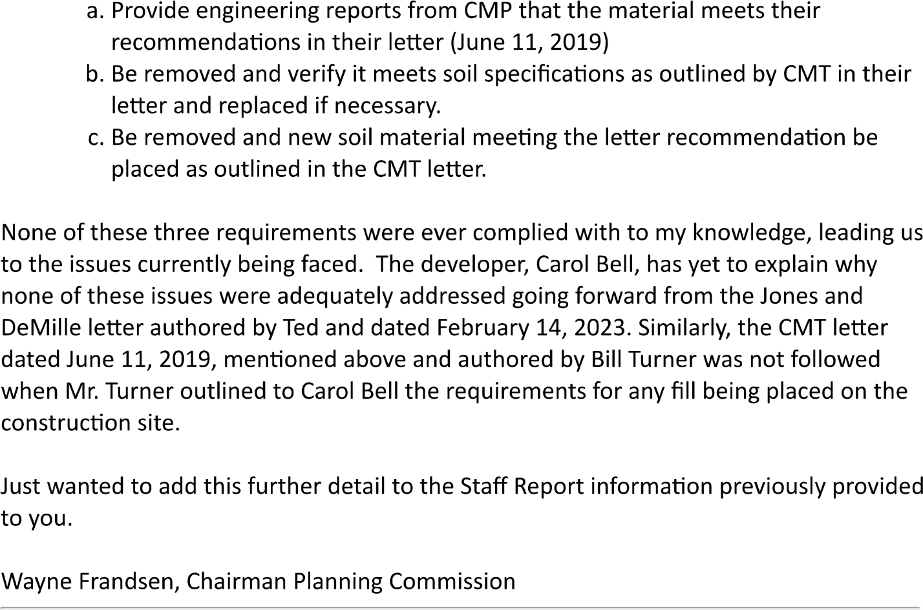
Continuing minutes
Chairman Frandsen gave an overview of the above letters and memorandums, then invited the city engineer Ted Michelsen to give a presentation on his proposal to Steve McCleary, Project Manager representing the Bell View Subdivision. (see included letter referenced above). The planning commission members had a number of questions for Ted about his proposal in order to feel assured that what he was proposing would be sufficient to detect any problems with the fill which had been placed where the road was to go. Following these discussions the planning commissioners had further discussions amongst themselves regarding the issue under consideration. The primary concern was whether the sufficiency of the work yet to be done would discover any weak areas in the fill dirt which had been placed. Following the discussion, Commissioner Johnson made a motion to accept the proposal made by the city engineer, as contained in his letter to Mr. McCleary on the matter. Following the motion, Commissioner Stout seconded it, and all commissioners voted in favor of the proposal. This recommendation will be forwarded to the city council for their consideration as their review of the matter.
Note: While the planning commission did not specifically review the matter of whether building permits may not be able to be issued due to a number of factors in this phase of the subdivision development, the city council did review it and agreed that the following statement should be included on the final plat, so that it reads: “ The approval and recordation of this subdivision plat does not guarantee or assure a building permit can or will be issued. All lots in this subdivision must complete soil exploration and percolation tests and obtain approval of individual septic systems from the Utah County Health Department before a building permit can be issued by Woodland Hills City. If acceptable soil conditions are not found in a large enough area for a drain field within each lot, then a septic system will not be approved, and a building permit will not be issued for that lot.”

Item number 7 on the agenda was to be a discussion of City code 10.11.8. There was some confusion about the proper city code being sited, as it appeared to be in error. As such any discussion about the matter was tabled.
Item 8 on the agenda was an update of the General Plan being reviewed by a committee comprised of a number of city residents. A survey is in the process of being completed and tabulated after which further work is planned.
Item 9 on the agenda was an update of the new Three Bridges Development which is underway in the City of Salem, but adjoining Woodland Hills City borders. The city has had several discussions with the developers on matters of mutual interest such as water systems, relocating of our mail boxes and the salt shed, drainage studies, a possible zone change for a few of the homes that may be located in our city limits, a fee paid to the city by the developer for the houses built in our city limits. These are ongoing discussions with no definitive outcomes yet.
As there was no further business to consider a motion was made to adjourn. All voted in favor and the meeting was adjourned around 8:30pm.
Wayne B. Frandsen, Chairman

