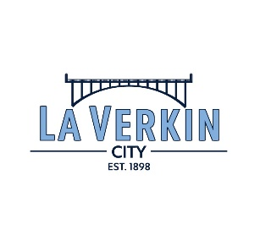
City of LaVerkin
435 North Main St., LaVerkin Utah, 84745
(435) 635-2581 Fax (435) 635-2104
LA VERKIN CITY
2024 MEETING SCHEDULE

City Council: 1st & 3rd Wednesday of each month at 6:00 p.m. at 111 S. Main
January 1 January 15
February 5 February 19
March 5 March 19
April 2 April 16
May 7 May 21
June 4 June 18
July 2 July 16
August 6 August 20
September 3 September 17
October 1 October 15
November 5 November 19
December 3 December 17

Planning Commission: 2nd & 4th Wednesday of each month at 6:00 p.m. at 111 S. Main
January 8 January 22
February 12 February 26
March 12 March 26
April 9 April 23
May 14 May 28
June 11 June 25
July 9 July 23
August 13 August 27
September 10 September 24
October 8 October 22
November 12 November 26
December 10 December 24

Board of Adjustment: 2nd Tuesdays as needed at 6:00 p.m. at 111 S. Main

Water Board: 4th Thursday at 3:00 p.m. at 435 N Main
February 27
June 26
October 23

Nancy Cline
City Recorder

