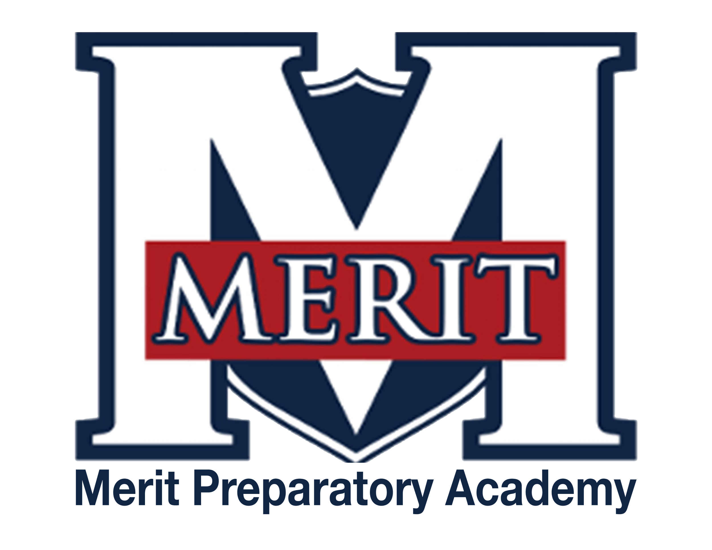
Merit Preparatory Academy
Board Meeting Minutes
October 10, 2024 at 6:30pm
Meeting at 1440 W. Center Street, Room 221

Join us on Zoom:
https://us06web.zoom.us/j/82560288867?pwd=WhOkcndQRcOb3K1UC9rhNbDcTZuKby.1

- Welcome, Roll Call and Pledge
- Started meeting at 6:34pm
In Attendance: Jeanné Condie, Jeri Melor, Rachel Jay, Sandra Campbell, Alex Tovmasyan, Amy Wiser
On Zoom: Angela Bunker

II. Good News from Around the School
- Meritorious Knight award for October– Mike Condie
- Sydney Salmans is awarded October’s Meritorious Knight award. She is new to the school and is in her first year teaching. She is great at connecting with the students and maintains good standards. We are impressed with all she does, and Mike and Jessica are so happy to have her on the team.
- MVP report– Sarah Jones
  - This is a busy time of year, but things are going well
  - We have been able to fill all the volunteer assignments
  - The messaging going out is good but there is a need for more volunteers
  - Sports especially need volunteers for ticket sales
III. Reports-
Fiscal and Enrollment Responsibilities
- Finance Report
  - Casey Holmes from Red Apple Financial
    - Finance Committee met on 8 October
    - Things are looking good
    - The Local State and Federal revenue streams are within the targeted amounts
    - Local is at 40% of forecast amount, State is at 25% and Federal is a reimbursement and will always be behind
    - The Bond on the building requires that we have a 1.1 times liabilities and more than 30 days on hand. We are looking very good
    - Projected $265,00 at end of year but this number will change with the State’s true up
  - Finance Committee Report– Rachel Jay
    - Nothing to add
  - Rylie Lazaga–Spend Plan revisions, first review
    - A few line items have changed
    - More clubs have been added
    - The largest change are the fees for the A cappella Choir, Senior Choir, and Junior Choir fees
    - Will vote on this in November

- Marketing and QuestTime Reports
  - Stephanie Healey– Marketing
Stephanie was not in attendance
  - Jeri Mellor– QuestTime and Curriculum committee report
      - Things are going good
      - There needs to be more training for the teachers
      - Hundreds of assignments have already been turned in which is a great sign.
      - This program is still considered to be in the pilot stage

Academic Outcomes and Other Strategic Plan Areas
- Director Report
  - Mike Condie
    - The safety updated to the school should be completed by the end of October
    - We have used every penny of the safety grant
    - The culture and climate within the school is better than it has been in past years. People are noticing a marked difference
    - TSSA grant
      - The amount of the Teacher and Student Success Act Plan (TSSA) Grant is $168,530
      - The division of the funds were discussed per the spreadsheet provided to the Board
      - Spreadsheet information
        - Personnel retention- $8,426.50 (performance-based bonuses)
        - Teacher Stipends: $77,000 / year (remaining: $15,691.50 in FY25 TSSA funds)
        - Team Leader Stipends: $16,000 total
        - Team Leader Stipends: $2,000 each, with 8 teams = $16,000
        - (Stipend or Salary Lines in the Budget in the past)
        - New Teacher Support: Stipends: $16,000 total
        - New Teacher Coach: $5,000
        - 11 New Teacher Mentors: $1,000 each, with 11 = $11,000
        - Other Stipends: $45,000 total
        - Canvas: $1000
        - Grants: $5000
        - Math Data: $5000
        - Website: $5000
        - Knighting: $1000
        - Sterling Scholar: $1000
        - Fundraising: $1000
        - Quest: $10,000
        - DECA: $1000
        - TSA: $1000
        - HS StuCo: $2000
        - JH StuCo: $2000
        - Theater Performance: $6000
        - Music Performance: $2000
        - Dance Performance: $2000
        - After-School Programs
        - After-School Attendance School:
        - 2 Professional Teachers x $40 / hour x 2 hours/week x 36 weeks = $5,760
        - Quest Curriculum- $9,931.50
        - Sub Total Remaining in TSSA Funds: $0
      - End of first term report

Charter Fidelity & Adherence to Statute, Rule & Policy
- Policy Committee Report– Angela Bunker
  - Dress Code Policy
    - Discussion on wearing of hats
    - Identified what hats are permitted
    - Need to enforce Prom dress code
    - Clarification on some of the wording since it could have different meanings
    - Are we lowering standards by allowing students to wear baseball hats?

  - Attendance Policy
    - Small changes to the wording
    - The scale for attendance school has been changed to reflect that it is up to the administration to implement what will be required
    - Verification for tracking if a student attended an event as part of the requirement to make up attendance was addressed
  - Dropout Prevention and Recovery
    - Slight wording changes
    - School Counciler will monitor dropout prevent/recovery
    - Will be looking for early warning signs
    - Once student has enrolled in another school Merit will no longer track that student
  - Supervision of Students in School-Sponsored Activities Policy
    - Outlined the responsibilities and conduct of those that supervise after school activities
  - Library Policy
    - Will do a soft opening of the library
    - Is following the State requirements for a library
    - Books are being cataloged and reviewed
    - Policy is from the State
    - Formatting of policy will be changed to be consistent with all other policies
- Board Director Report– Jeanné Condie
  - Utah Charter Access Point (UCAP) Projections– 500 for FY 26
  - Audit Committee
    - Purpose
      - The committee will review the financial service companies
    - Formation
      - Sandra Campbell would like to be on the committee
      - There will need to be a few others on the committee
  - Comprehensive Review
  - Land Trust Council
    - October 20 requirements
      - Enter the Council Membership and Principal Assurance
      - Identify that the Board serves as the Charter Trust Land Council
      - Review:
        - The current School LAND Trust Plan
        - Implementation of the prior school year's plan
        - The Teacher and Student Success Act Plan (TSSA)

IV. Public comment- 15 minutes
As per Board procedure, public comment will be limited to 3 minutes per person. Anyone who would like to make a public comment will need to sign up prior to the start of the public comment period. Grievances, complaints, or concerns with individual employees or board members will not be allowed during this time as they must be dealt with by following the Conflict Resolution Policy process, and defamatory statements regarding any individual will not be allowed during an open public meeting.

V. Action Items
- Vote to approve September 12, 2024, Board Meeting Minutes
  - Motion made by Rachel Jay; seconded by Sandra Campbell: All in favor
- Vote to approve TSSA grant plan
  - Motion made by Rachel Jay; seconded by Sandra Campbell: All in favor
- Vote to approve Dress Code Policy
  - Motion made by Rachel Jay; seconded by Sandra Campbell: All in favor
- Vote to approve Attendance Policy
  - Motion made by Rachel Jay; seconded by Sandra Campbell: All in favor
- Vote to approve Drop Out Prevention and Recovery
  - Motion made by Rachel Jay; seconded by Sandra Campbell: All in favor
- Vote to approve Supervision of Students in School-Sponsored Activities Policy
  - Motion made by Rachel Jay; seconded by Sandra Campbell: All in favor
- Vote to approve Library Policy
  - Motion made by Rachel Jay; seconded by Sandra Campbell: All in favor

VI. Board Business
- Training
  - Review New Board Member training for Sandra and Alex, Open and Public Meetings for Amy and Rachel - Completed
  - Audit training for Sandra and Alex
  - Share training from UAPCS on Effective Governance
    - Who can attend the upcoming training and report back to the board?
    - October 14, 2024 | 4:30-5:30 pm – Jeri Mellor
Charter School Success: The Board's Role in Marketing and Enrollment
Explore strategies for board members to actively support marketing and enrollment efforts, helping your school grow and thrive.
    - November 18, 2024 | 4:30-5:30 pm - Alex
Succession Planning: Preparing for School Leadership Transitions
Understand the importance of succession planning and how to prepare for smooth leadership transitions in your school.
    - December 9, 2024 | 4:30-5:30 pm – Rachel Jay
Financial Essentials for Charter School Board Members
Gain a clear understanding of financial oversight and responsibilities, including budgeting, financial health indicators, and long-term financial planning for charter schools.
  - Video about School Land Trust Program
    - https://schools.utah.gov/schoollandtrust/index
    - USBE Charter Land Trust training
      - Monday, October 21st @ 7 pm
      - Tuesday, October 29th @ 2 pm
      - Wednesday, November 6th @ 2 pm
      - Thursday, November 14th @ 6 pm
- Expanding the board and preparing for the future
  - Would like to add at least 2 to 3 more members
- Board Calendar
  - The next board meeting will be held on November 14, 2024, at 6:30pm in Merit 219
  - No board meeting is currently scheduled for December
  - Board members are responsible to attend the end of year knighting ceremony on May 21, 2025 at 8:30am, and graduation on May 22,2025 at 4pm

VII. Executive Session
- To discuss the character, professional competence, or physical or mental health of an individual.
  - Possible Action from Executive Session

VII. Adjourn -9:02pm

