
CITY COUNCIL MEETING
Minutes
Tuesday October 15, 2024

Council Chambers 7505 South Holden Street
Midvale, Utah 84047

MAYOR: Mayor Marcus Stevenson

COUNCIL MEMBERS: Council Member Paul Glover
Council Member Bonnie Billings - Excused Council Member Dustin Gettel
Council Member Bryant Brown Council Member Heidi Robinson

STAFF: Matt Dahl, City Manager; Rori Andreason, HR Director/City Recorder; Charlie Cressall, Deputy City Recorder; Garrett Wilcox, City Attorney; Glen Kennedy, Public Works Director; Nate Rockwood, Assistant City Manager; Mariah Hill, Administrative Services Director; Adam Olsen, Community Development Director; Wendelin Knobloch, Planning Director; Laura Magness; Communications Director; Erinn Summers, Project/Policy Manager; Meggie Troili, RDA Project Manager; Chief April Morse, UPD; Chief Brad Larson, UFA; and Joshua Short, Jr. Network Administrator.
.

6:00 p.m. – WORKSHOP
- Unified Fire Authority Budget Presentation (15-20 minutes)
[Chief Dominic Burchett, UFA; Tony Hill, UFA CFO; Rachel Anderson, Salt Lake Valley Law Enforcement Service Area (SLVLESA) Administrator]
Rachel Anderson explained the purpose of the tax increase. The funds are needed to upgrade stations, maintain the increasing costs of service, keep appropriate levels of staffing, and maintain the minimum account balance required by law. It is necessary due to increasing cost factors, which are Inflation, capital replacement costs, increase in wages, and an increase in building construction costs. She discussed the proposed increase and explained that the increase is spread out over several years instead of a larger one-time increase.
Chief Burchett and Tony Hill also discussed the need for the proposed budget increase as well as the financial analysis completed for this purpose.


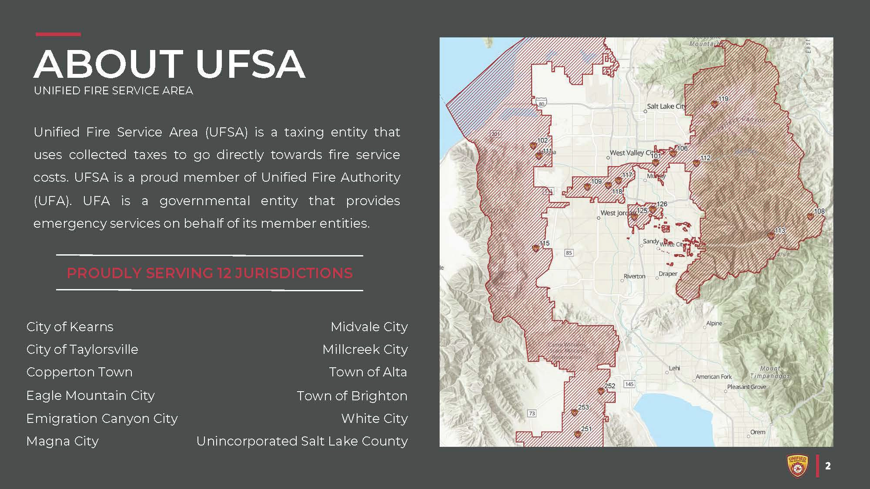

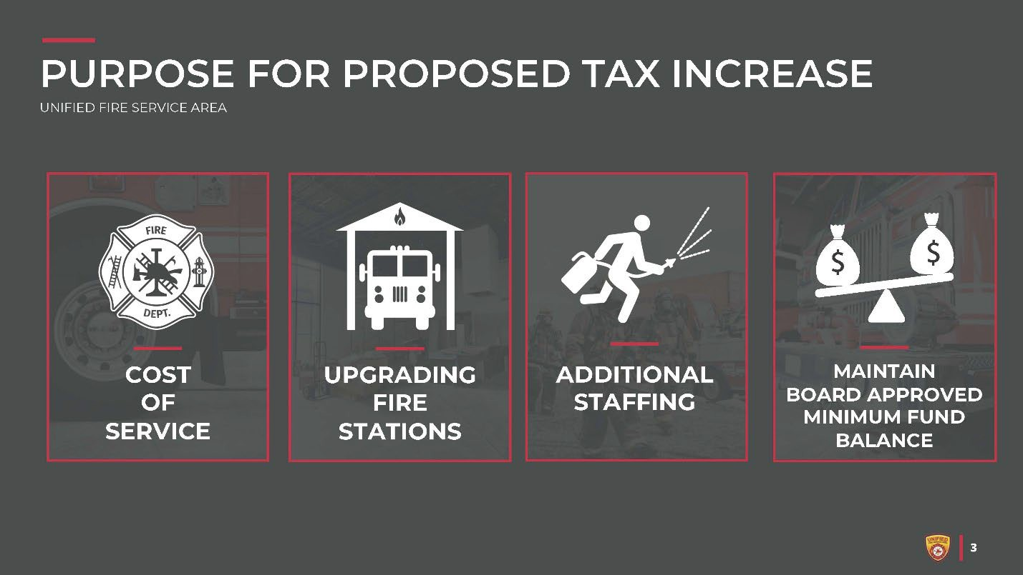
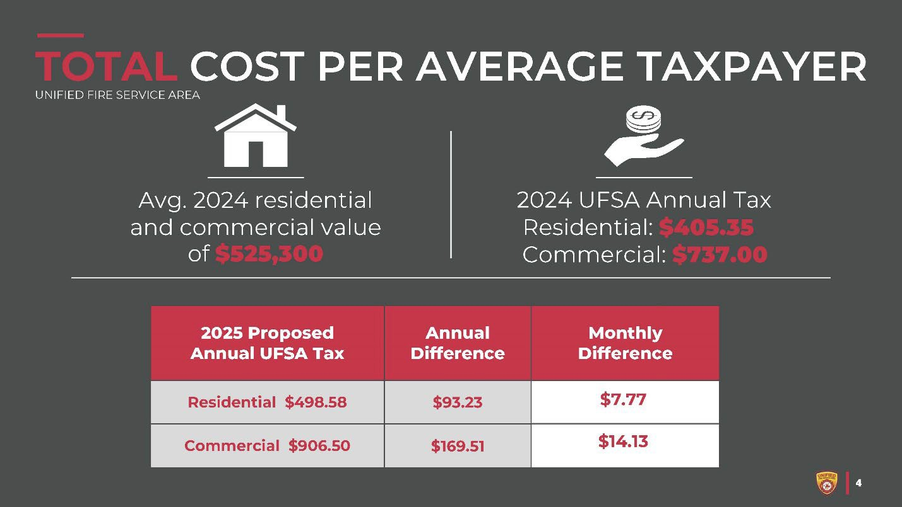

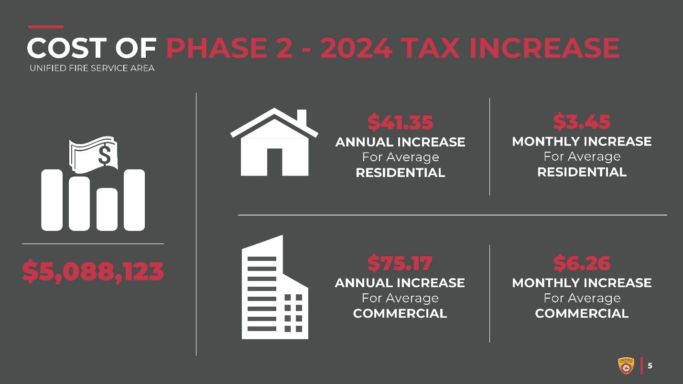
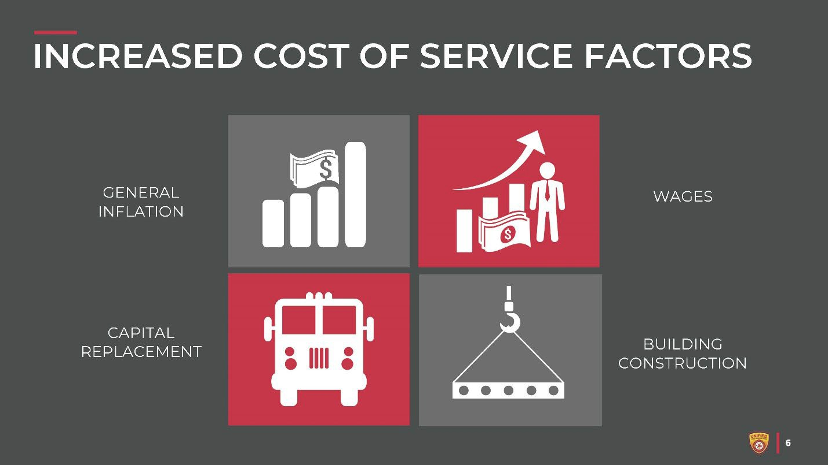

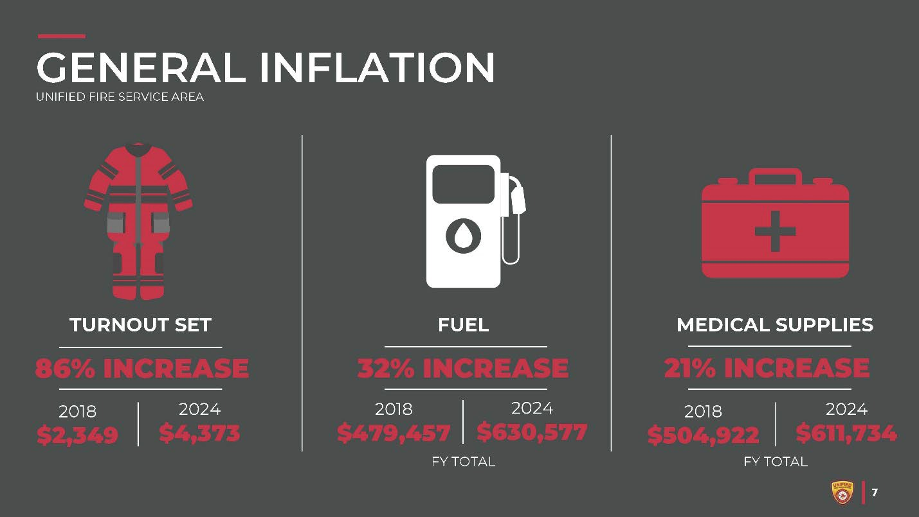
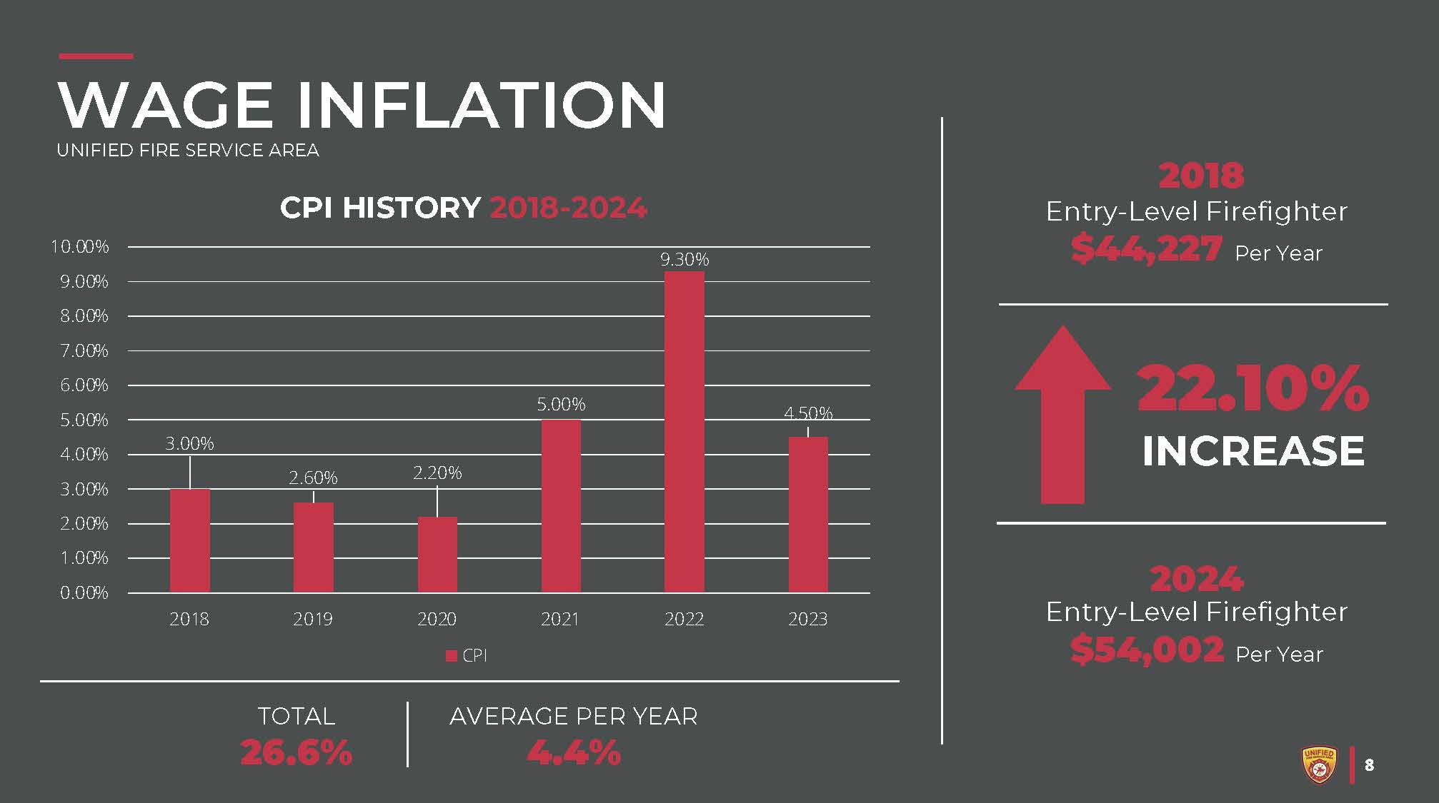

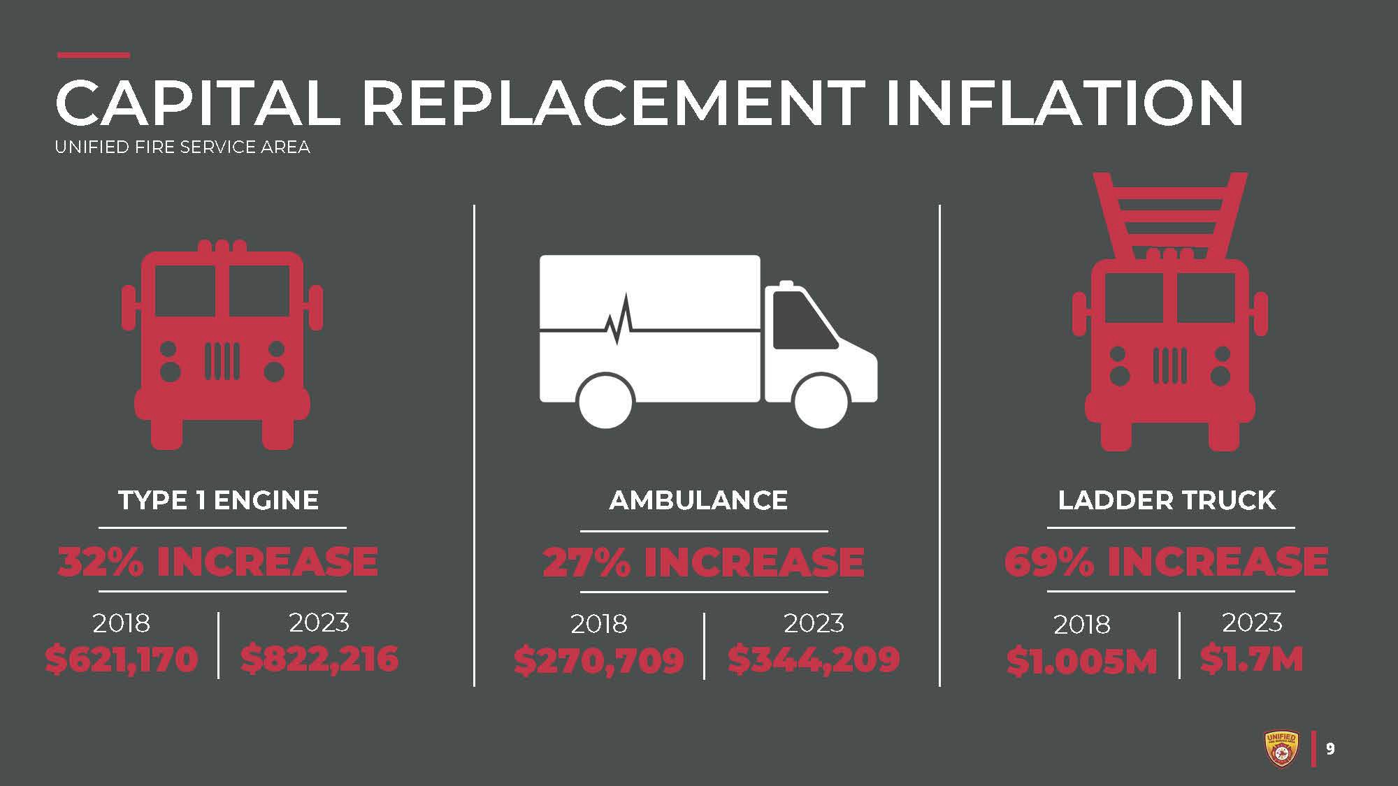


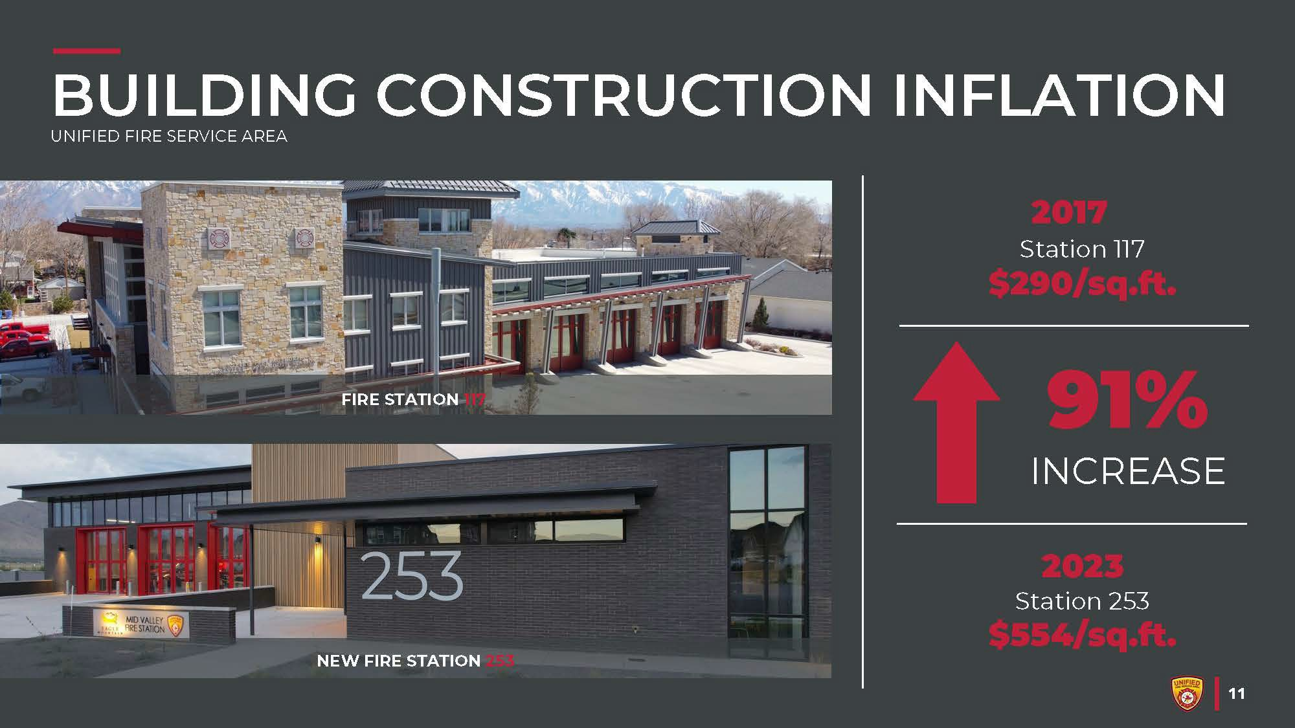
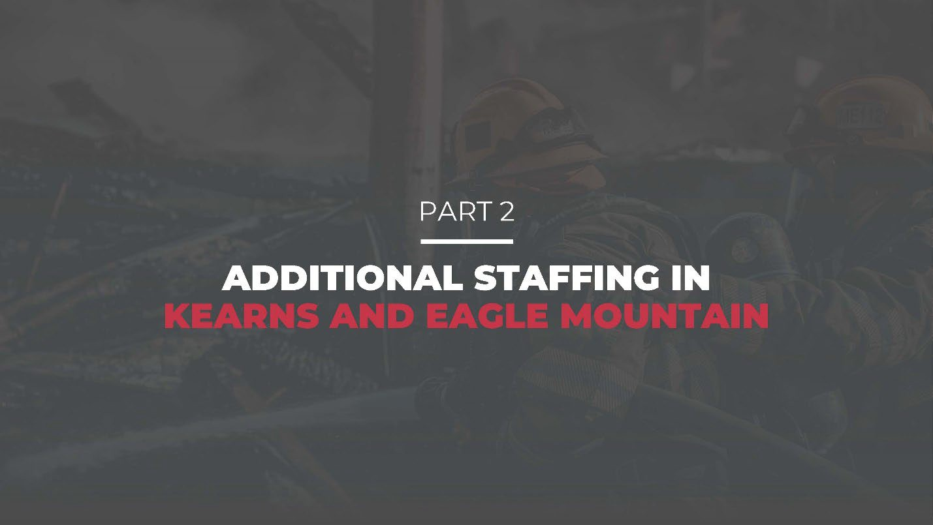

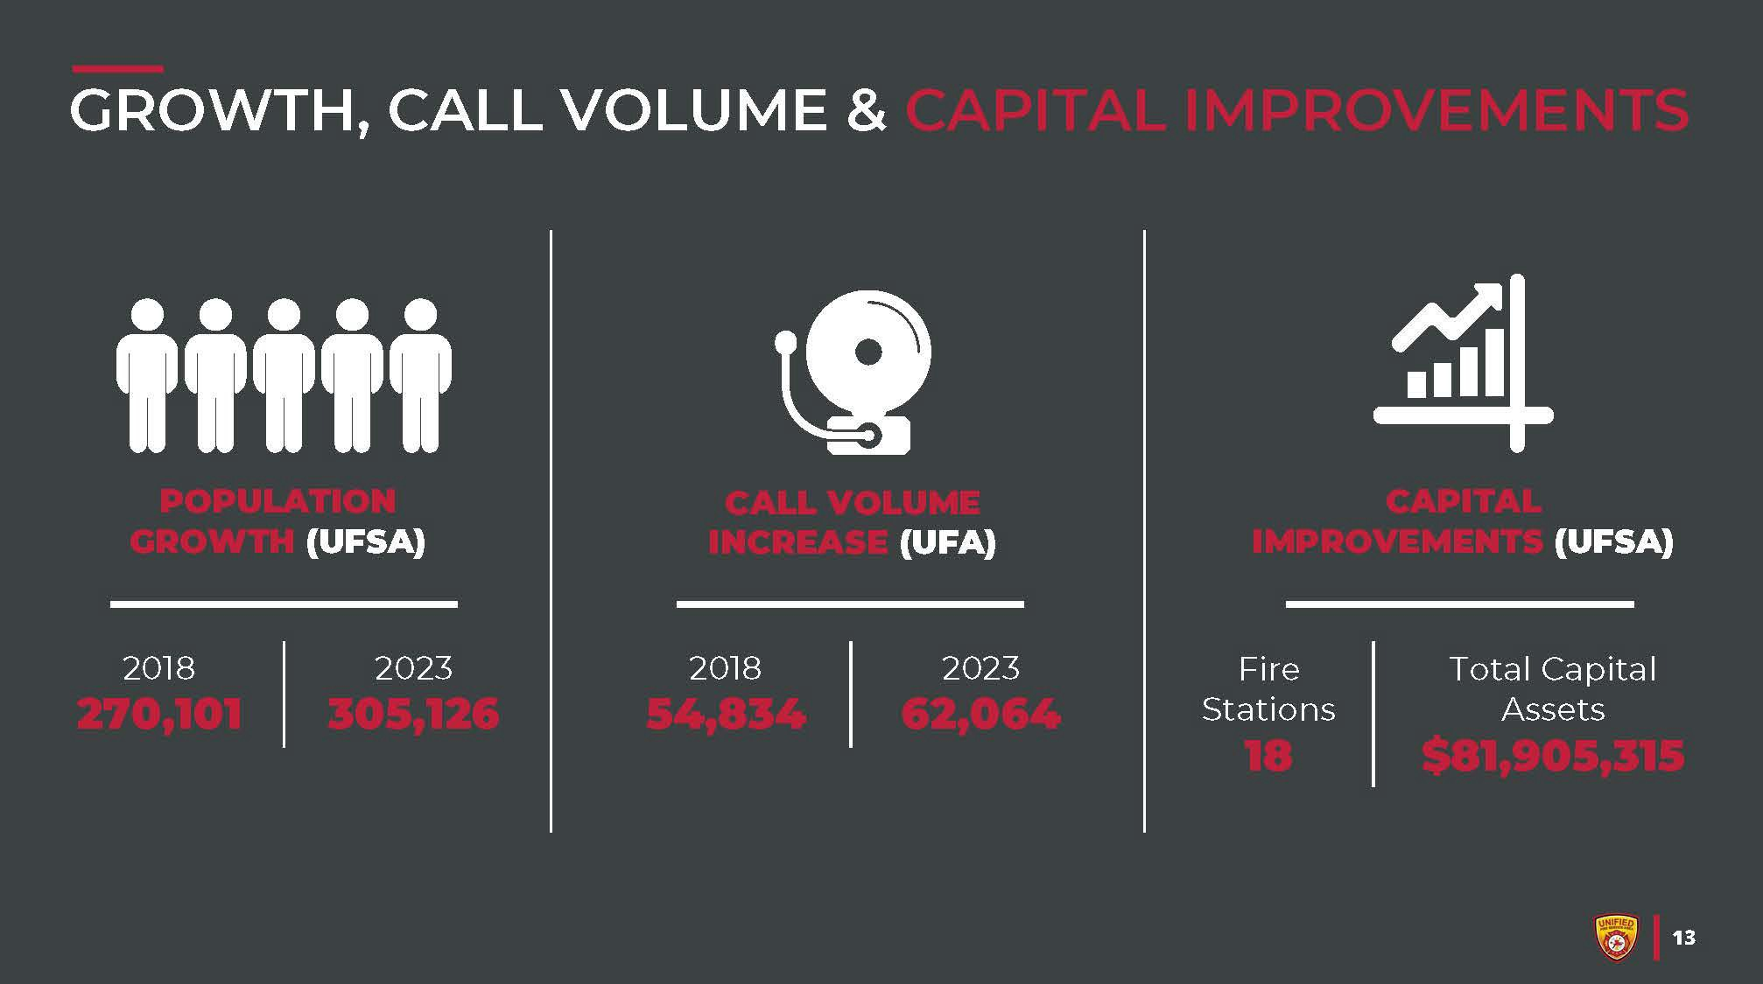
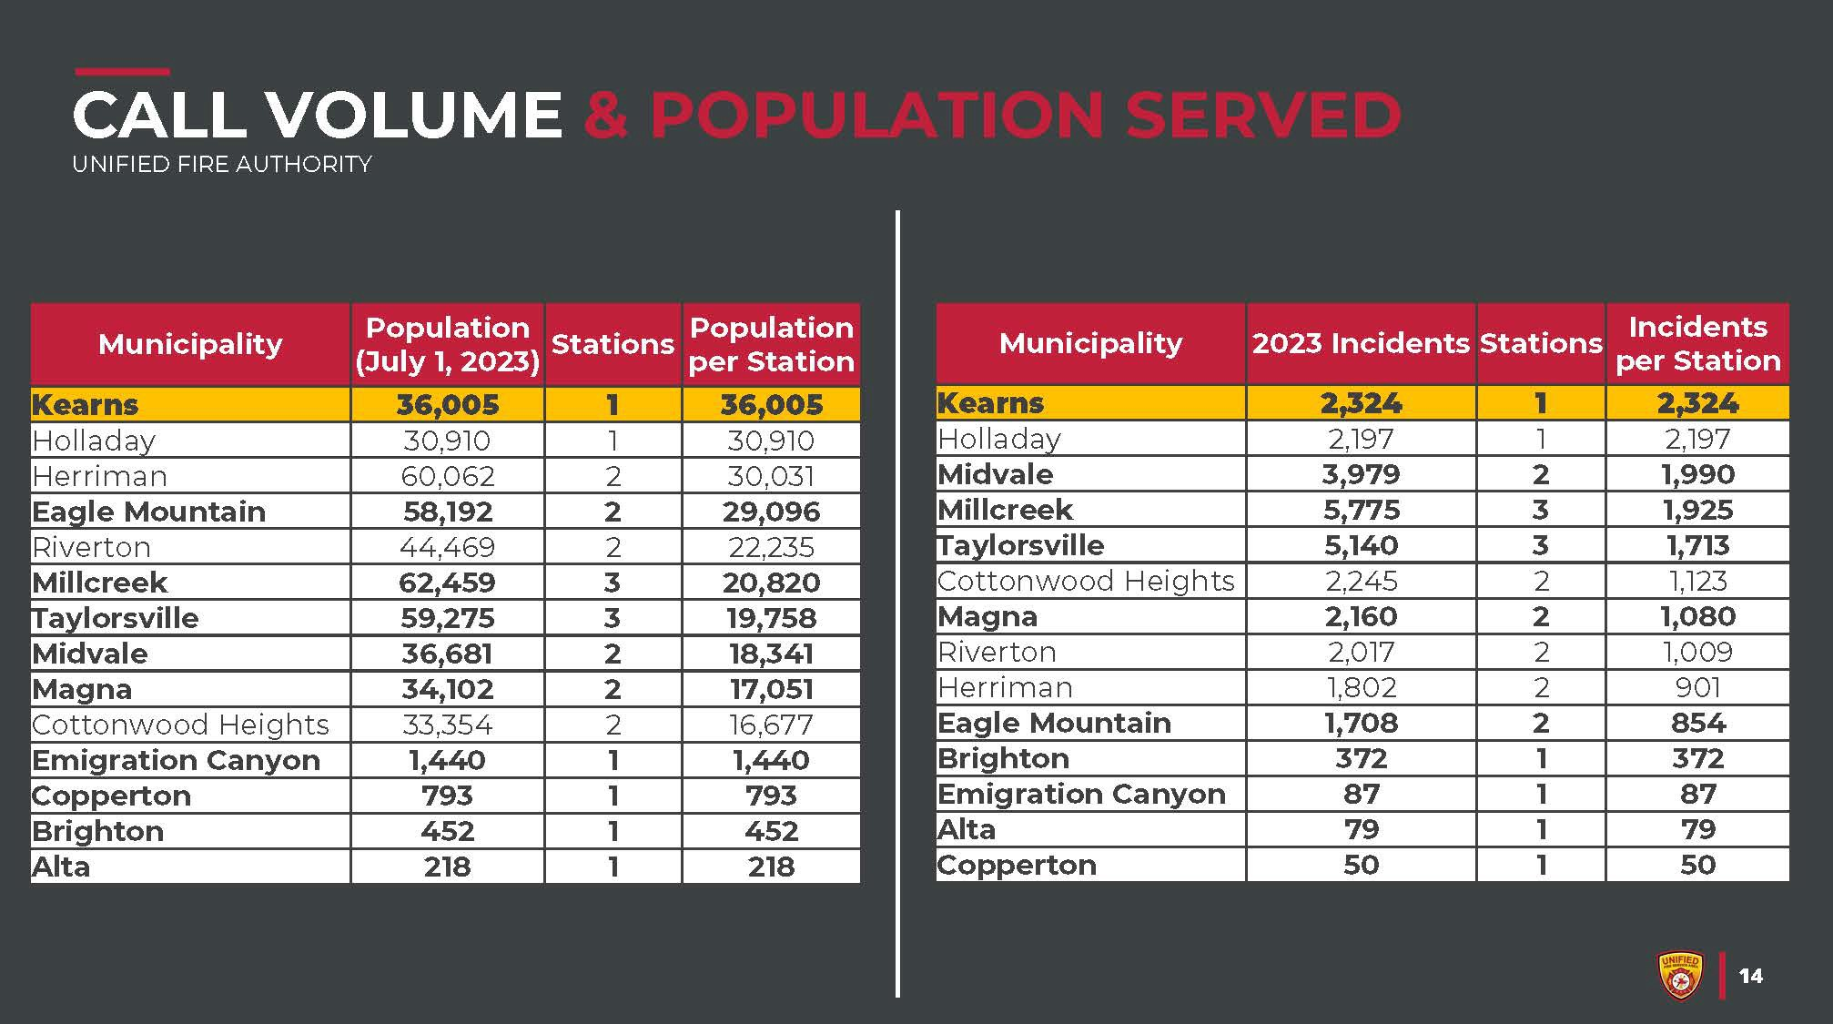

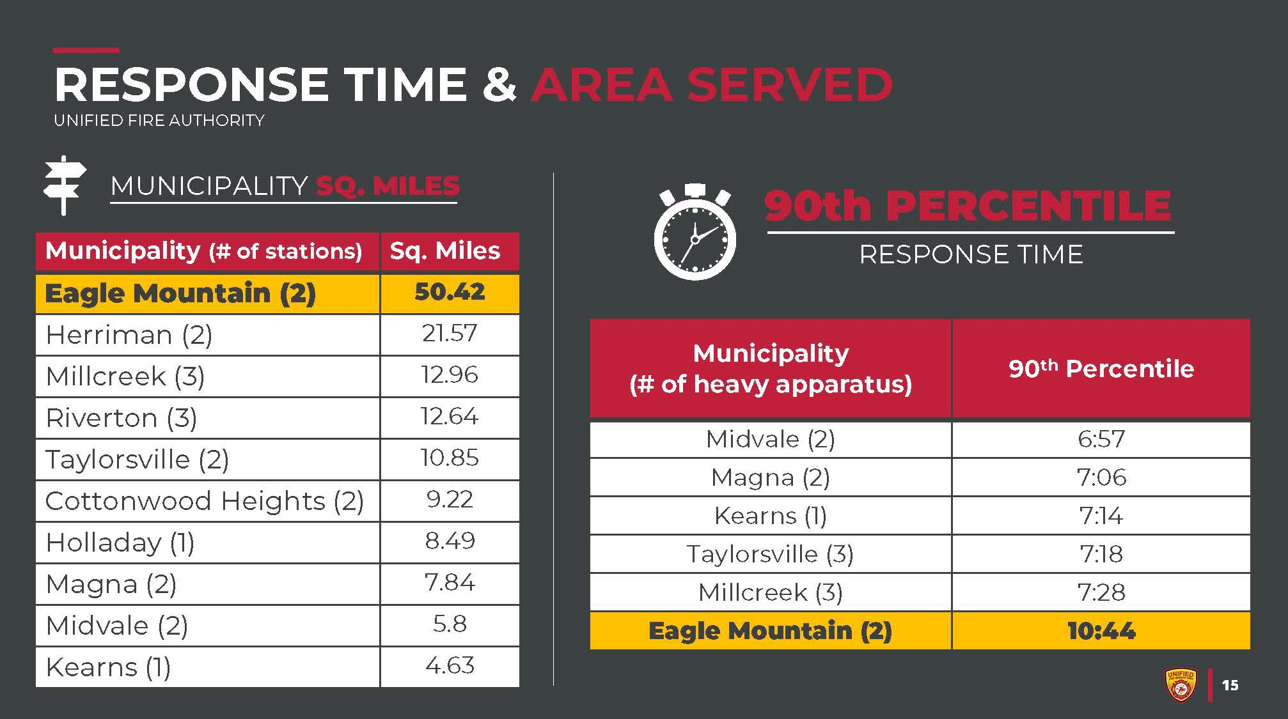
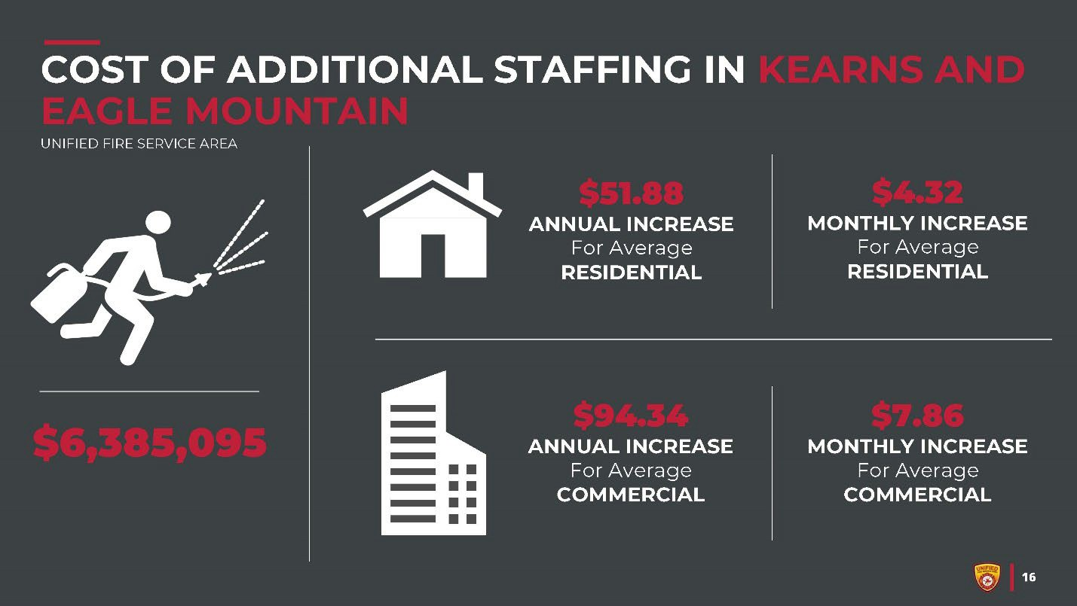

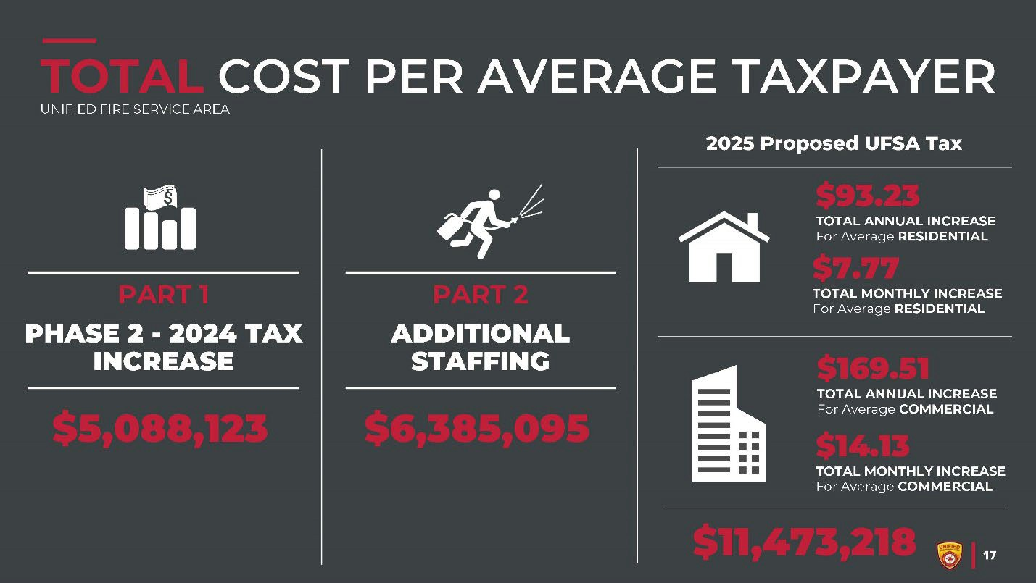
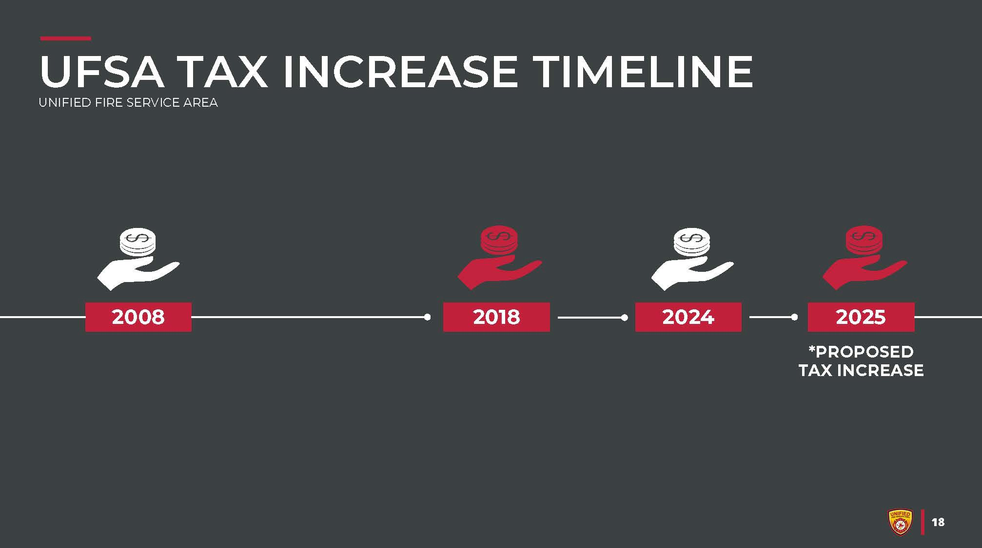

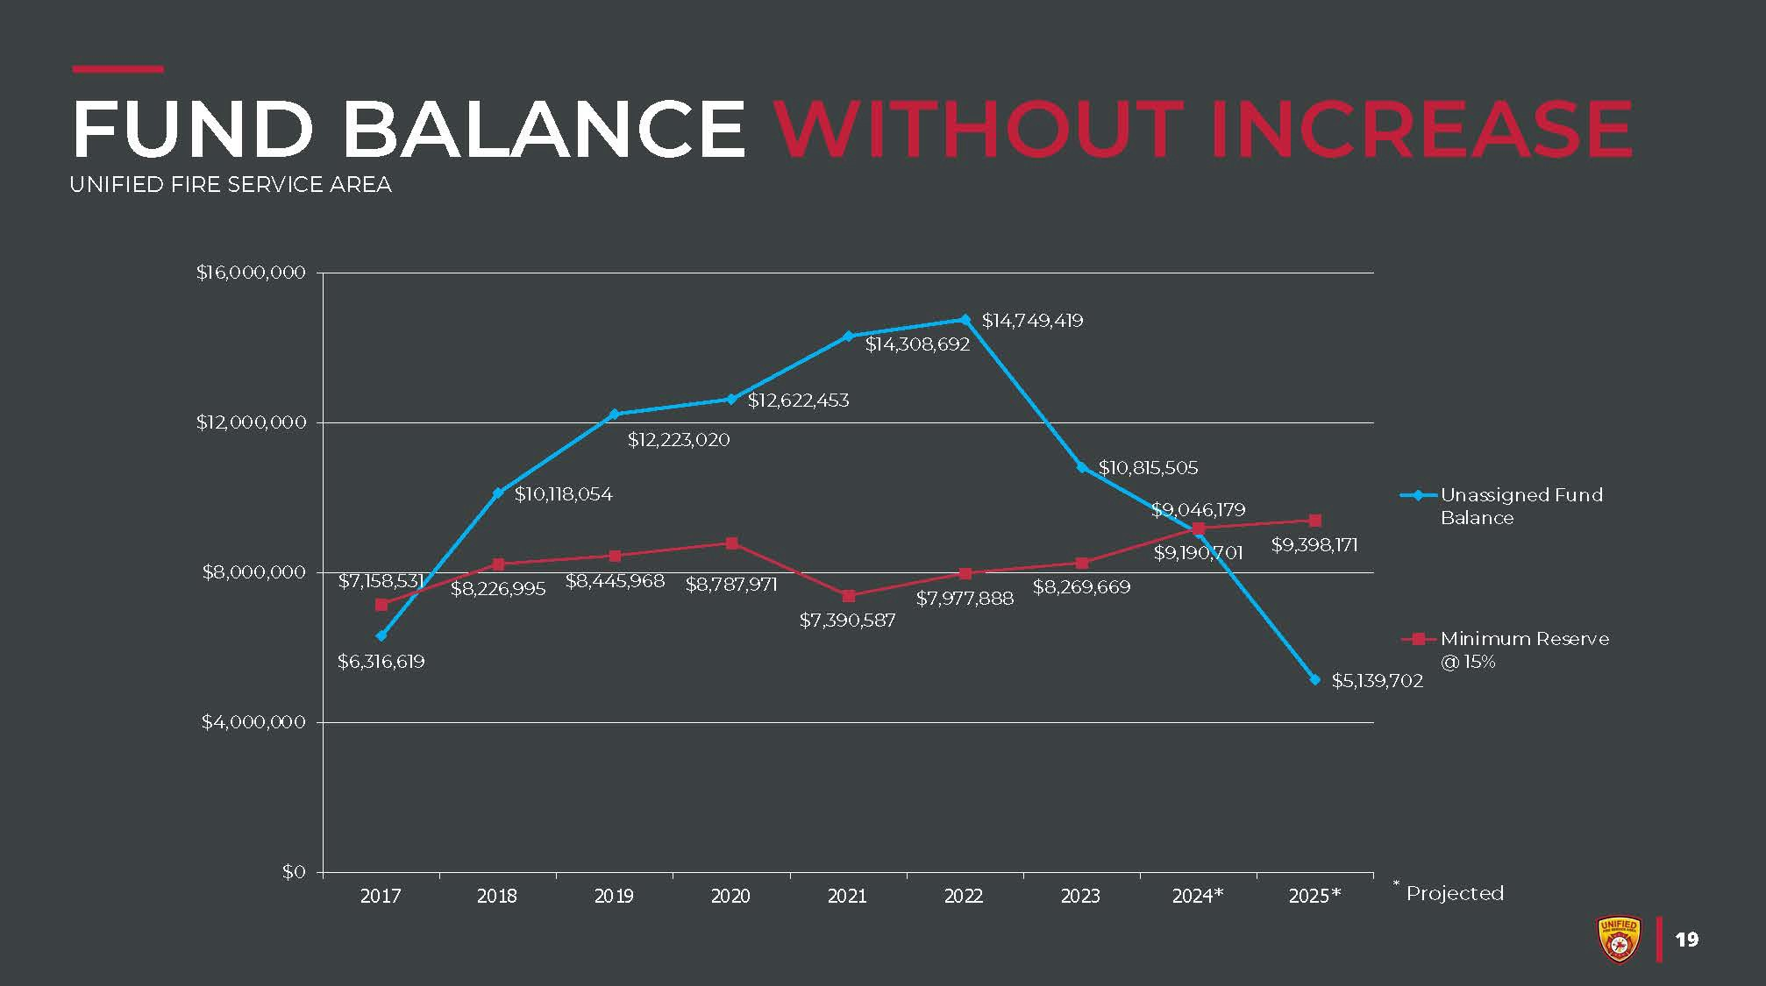
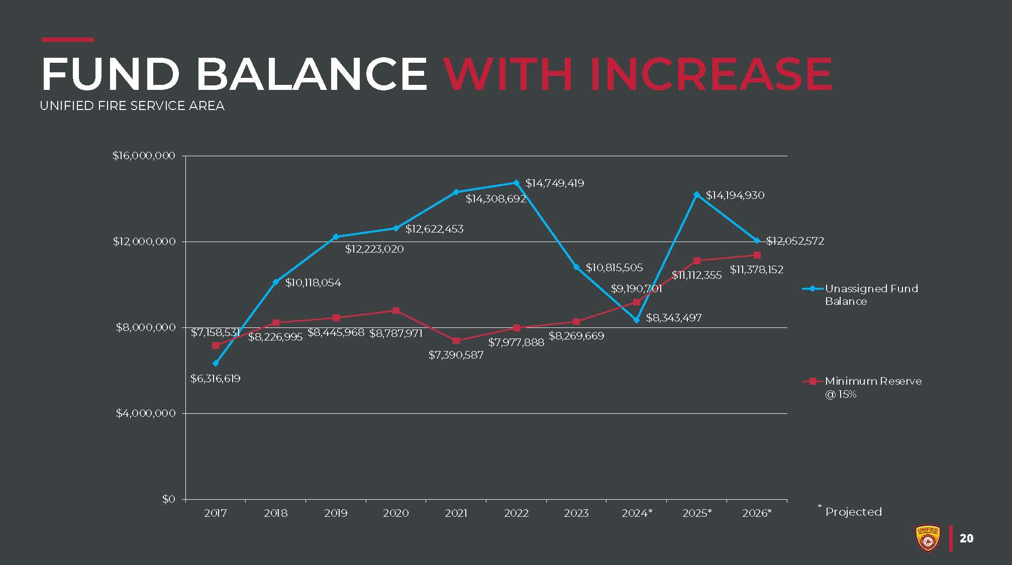

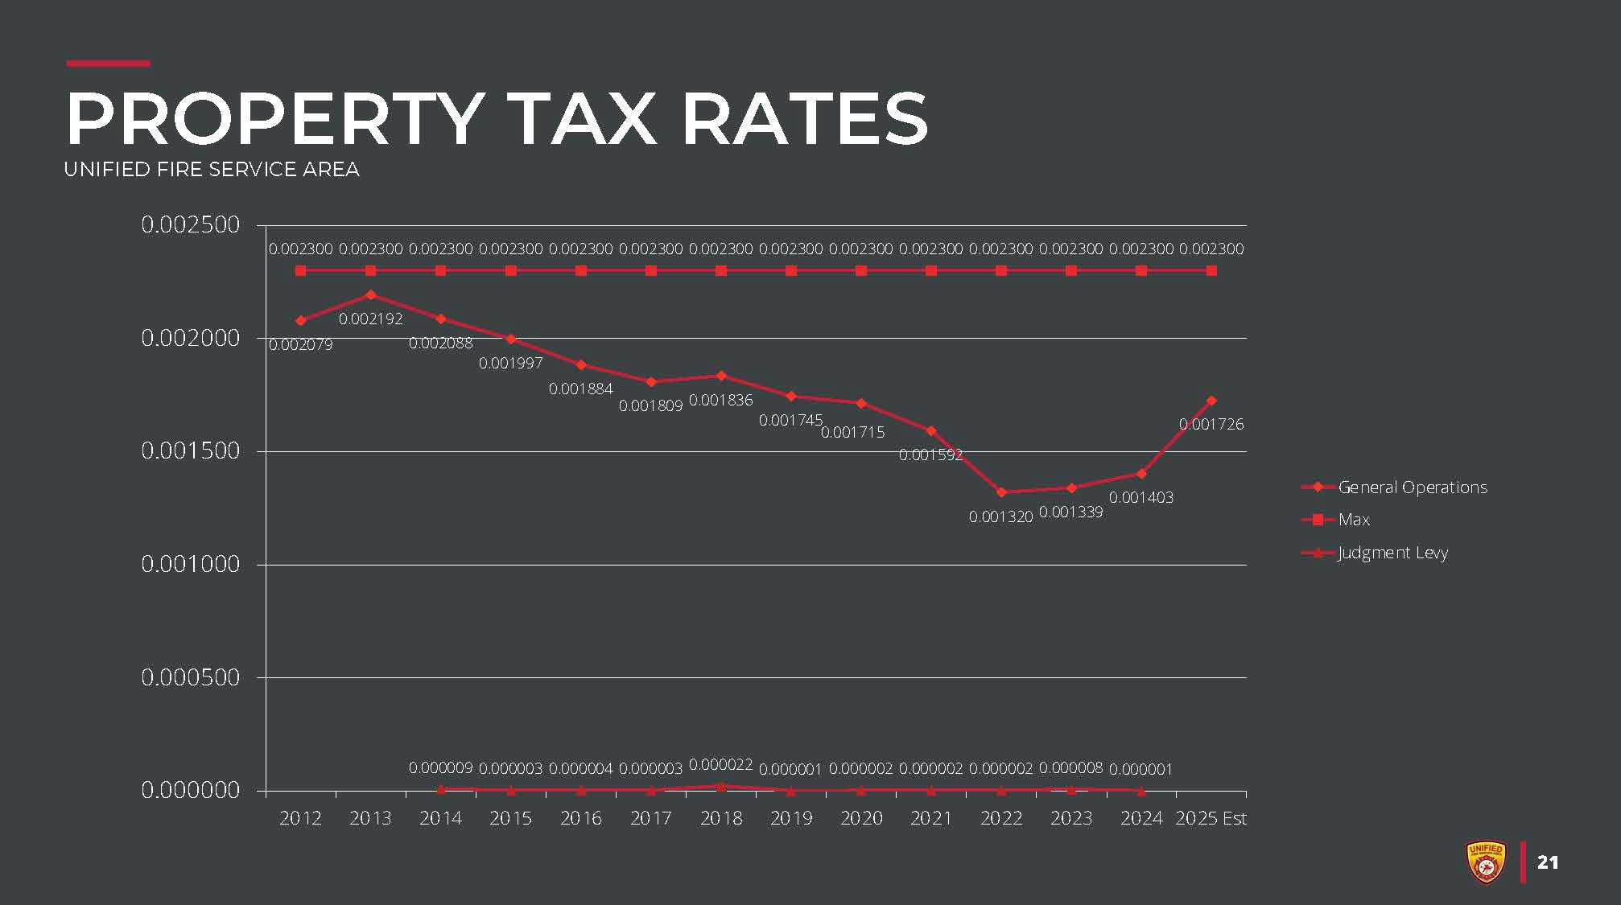
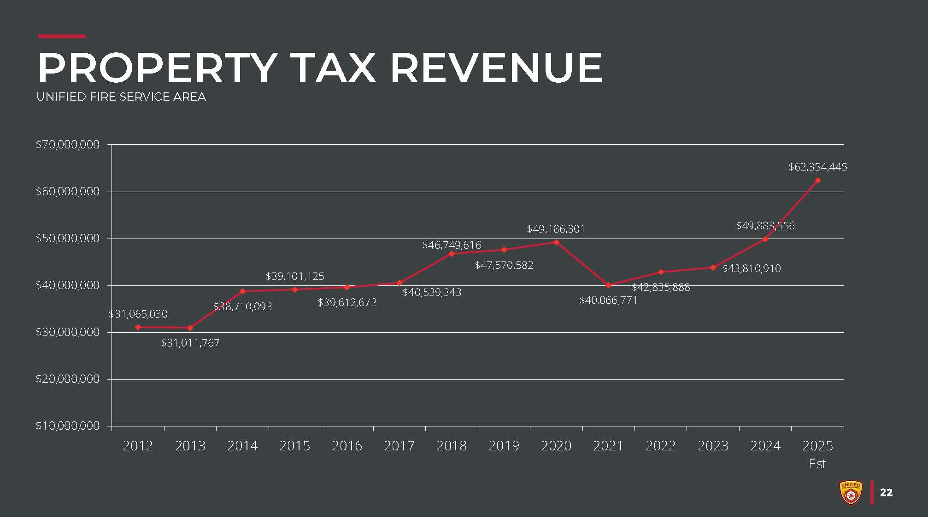



6:30 p.m. – REGULAR MEETING

Mayor Marcus Stevenson called the business meeting to order at 6:30 p.m.

GENERAL BUSINESS
  - Welcome and Pledge of Allegiance

  - Roll Call - Council Members Heidi Robinson, Dustin Gettel, Bryant Brown, and Paul Glover were present at roll call. Council Member Bonnie Billings was excused.

  - Recognition of Ayat Alsabsabi and Olivia
Mayor Stevenson recognized Ayat Alsabsabi and Olivia who were both instrumental in calling 911 about a shed fire in their neighborhood. These two young girls saved property and lives. Mayor Stevenson recognized both girls with a certificate of appreciation for their dedicated service.

  - Unified Police Department Report – [Chief April Morse]
Chief Morse said she was wearing a pink shirt in support of Breast Cancer Awareness Month, and other uniformed officers will be wearing pink or purple patches in support as well. The pink patches are for Breast Cancer Awareness Month and the purple patches are for Domestic Violence Awareness month.
Chief Morse reported the call volume of September was at 2789 with 924 total cases, which is an average of 100 calls per officer. For the shared services there are currently 209 open cases with 10 new cases for the month of September and 6 total call outs.

There were 40 canine responses in Midvale and 1 drone response. The Special Victims Unit reported 96 open cases with 10 new cases for the month of September. The citations total for September was 375, 32 were warnings and 343 were penalty citations.
Chief Morse reported that in the first week of October there was a Swat call out at an apartment building on Center Street, which was a hostage situation with an abduction. Due to the quick response of a rapid deployment team, the suspect was arrested, and the victim was rescued unharmed.

PUBLIC COMMENTS
There was no one who desired to speak.

MAYOR REPORT
Mayor Marcus Stevenson said he is a representative of the Shelter Cities on the Utah Homeless Services Board. He reported that last week there was a meeting that included talk about possibly shifting from the previous “Scatter Model” back to the “Campus Model” which includes more onsite services. They are looking for three potential locations across the Wasatch front. There have been rumors that the “Scatter Model” is being abandoned in favor of the “Campus Model”. Mayor Stevenson said he understands that if a new shelter were to open, the existing shelters would move to a medium/high barrier entry and not an emergency shelter.

COUNCIL REPORTS
  - Council Member Bonnie Billings – Excused from meeting.

  - Council Member Paul Glover – said he attended the Zions Bank mural presentation, and it was an honor to be there. Zions Bank gave the Boys and Girls Club
$5000.

  - Council Member Heidi Robinson - Invited residents to visit all the murals in Midvale.

  - Council Member Bryant Brown – said the Zions Bank mural will be the most viewed mural in Midvale. He would like to see this mural lit up since it’s a gateway to the other murals. He said El Pollo Loco is offering free food to first responders and government employees on Thursday, October 17, 2024. There are locations nearby in Sandy and West Jordan.

  - Council Member Dustin Gettel – said he attended the unveiling of the Zions Bank mural; it’s amazing and money well spent. He wanted to remind everyone that ballots are being mailed this week, Midvale has a drop box in the parking lot and Midvale City hall will be a vote center on election day.

CITY MANAGER REPORT

Matt Dahl said because of the election, the next council meeting will be November 12. Laura Magness has sent out possible dates for the legislative breakfast. He asked the Council to please respond with the dates that work best with their schedule.
Adam Olsen, along with Planning Commission members Shane Liedtke and Candy Tippetts, announced two awards that were presented to Midvale City from the Utah Chapter of the American Planning Association. Midvale was awarded the Outstanding Plan Award for the Bingham Junction Station Plan, and the Beehive Award of Excellence. The Beehive Award of Excellence is the highest award a city can receive. Midvale received this award for the impressive work and improvements made to reinvigorate Main Street.

Shane Liedtke said he was very excited about winning the Beehive Award explaining that the cities are not able to nominate or vote for themselves for this award. The Nevada Association of Planners nominated Midvale City for the award.

CONSENT AGENDA
  - Consider Minutes of October 1, 2024

  - Consider Resolution No. 2024-R-45 Adopting the 2024 Midvale City Water Conservation Plan

MOTION: Council Member Paul Glover MOVED to Approve the Consent Agenda. The motion was SECONDED by Council Member Heidi Robinson. Mayor Stevenson called for discussion on the motion. There being none, he called for a roll call vote. The voting was as follows:

Council Member Bonnie Billings Excused Council Member Paul Glover Aye Council Member Heidi Robinson Aye Council Member Bryant Brown Aye Council Member Dustin Gettel Aye
The motion passed unanimously.

ACTION ITEMS
  - CONSIDER RESOLUTION NO. 2024-R-46 APPROVING CDBG SUBRECIPIENT AGREEMENT BETWEEN SALT LAKE COUNTY AND MIDVALE CITY.
Meggie Troili said in July 2024, Midvale City was awarded a $100,000 Community Development Block Grant (CDBG) from Salt Lake County for the Redevelopment Agency’s Home Repair Loan Program (HRLP). This funding will support the HRLP for the current 2025 fiscal year. This follows an awarded $100,000 CDBG grant for the HRLP for fiscal year 2024, of which $96,876 remains unspent due to contract delays. This remaining funding will be rolled over into 2025 fiscal year funding for a total of $196,876. Resolution No. 2023-R-46 authorizes the mayor to enter into an agreement with Salt Lake County for these CDBG funds.

FISCAL IMPACT: An additional $196,876 in grant funding to support the Redevelopment Agency’s Home Repair Loan Program
Staff recommended suspending the rules in consideration of Resolution No. 2024-R-46, approve entering into an agreement with Salt Lake County for Community Development Block Grant funds to support the Redevelopment Agency Home Repair Loan Program.

MOTION: Council Member Heidi Robinson MOVED to Suspend the Rules and Approve RESOLUTION NO. 2024-R-46 Approving the CDBG Subrecipient Agreement between Salt Lake County and Midvale City. The motion was SECONDED by Council Member Dustin Gettel. Mayor Stevenson called for discussion on the motion. There being none, he called for a roll call vote. The voting was as follows:

Council Member Bonnie Billings Excused Council Member Paul Glover Aye Council Member Heidi Robinson Aye Council Member Bryant Brown Aye Council Member Dustin Gettel Aye
The motion passed unanimously.

CONSIDER RESOLUTION NO. 2024-R-47 CONFIRMING THE APPOINTMENT OF MIKE WILLIAMS AS THE 2025 CHAIR OF THE HARVEST DAYS FESTIVAL COMMITTEE.
Erinn Summers said the Harvest Days Festival Committee was established on March 15, 2022, to provide leadership, planning, and staffing for the Annual Harvest Days Festival. The Committee consists of up to 5 community members, appointed by the Mayor. The Chair appointment also requires approval from the City Council. The term of each Committee member is one year.

Mike Williams has served on the Harvest Days Festival Committee 2022, 2023, 2024, being reappointed by Mayor Stevenson each year. Over the past three years, Mr. Williams has been dedicated to making the Harvest Days Festival a success – taking on the tasks requested of him, being creative and innovative to expand community involvement and programming while staying within the budget available and managing the Harvest Days Bingo game. During Mr. Williams’ time as a committee member, the Harvest Days Festival has grown significantly, and the Committee has established best practices and processes to ensure a successful festival.

This upcoming year, the Harvest Days Festival Committee will have new committee members. Mr. Williams’ in-depth knowledge of the Harvest Days preparation and day-of tasks will make him an asset for new members as they get acclimated to the event planning process. Additionally, Mr. Williams is active in the community and has a wealth of experience in committee leadership.

Given Mr. Williams’ experience and leadership on the Harvest Days Festival Committee and within the community, Mayor Stevenson has chosen to appoint Mike Williams to the position of Harvest Days Festival Chair for 2025. City Council approval of Mayor Stevenson’s appointment is required to confirm the appointment.

Staff requested suspension of the rules to allow the start of the planning process for Harvest Days 2025 with the new Committee.
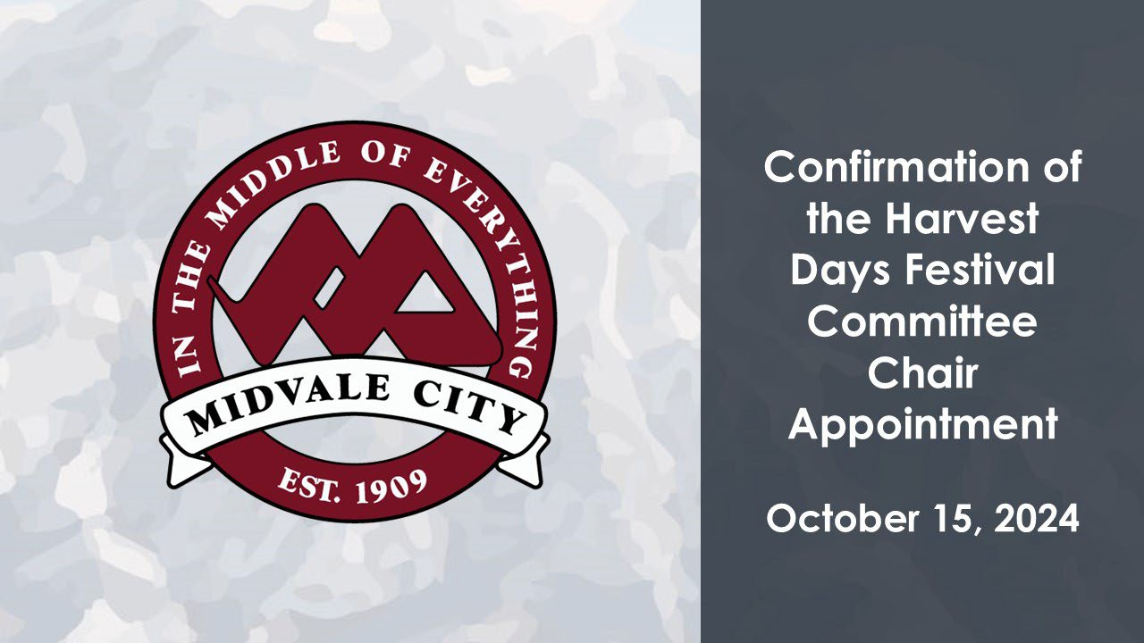

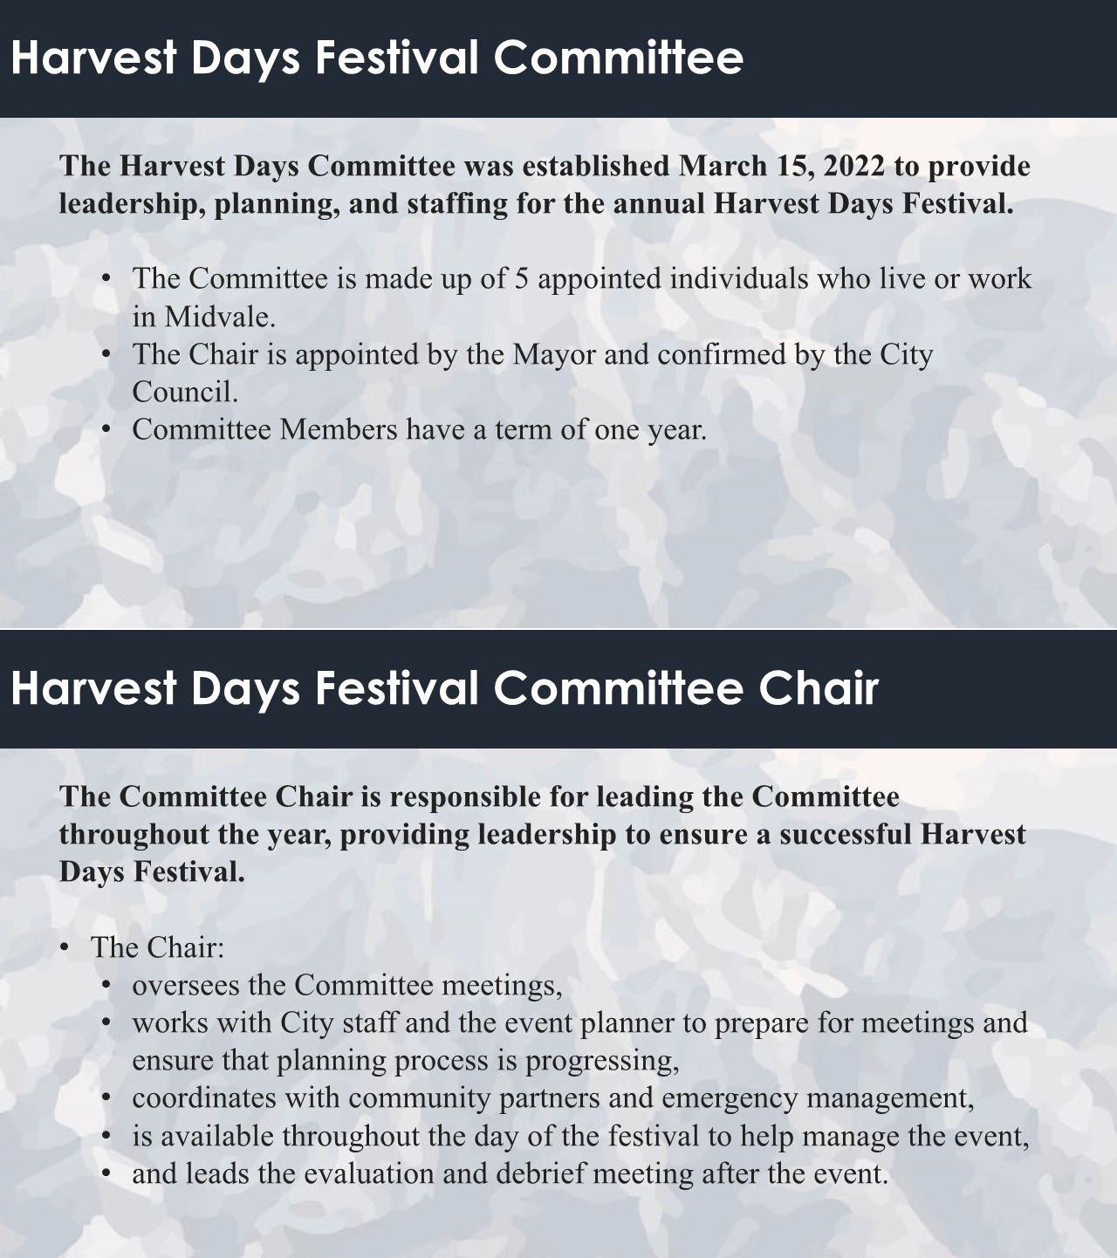

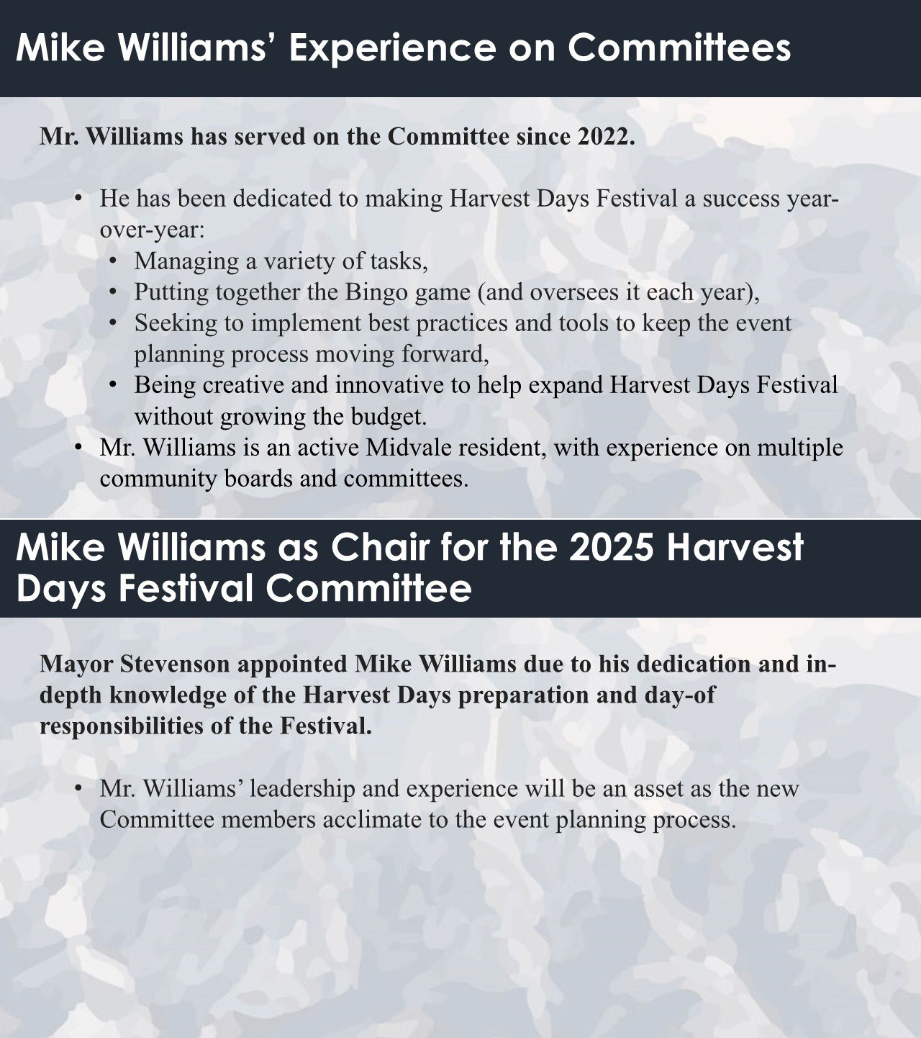

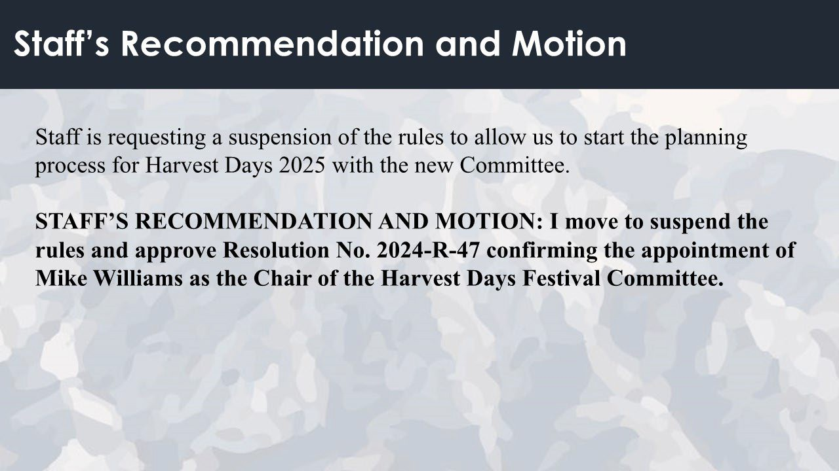
Mayor Stevenson said that Mike Williams has been a dedicated member of the Harvest Days Committee for the past three years and is grateful that he is willing to continue working with the committee; he will do a great job.

Council Member Dustin Gettel said he appreciates Mike Williams staying active in this and other activities with the city.

Council Member Bryant Brown said he is pleased that Mike Williams wants to continue with the Harvest Days Committee and knows he will do a great job.

Council Member Heidi Robinson said she is excited to see what ideas Mike Williams will bring to the table in the future.

Council Member Paul Glover said he is also happy with Mike Williams’ appointment.

MOTION: Council Member Dustin Gettel MOVED to Suspend the rules and Approve Resolution No. 2024-R-47 Confirming the Appointment of Mike Williams as the 2025 Chair of the Harvest Days Festival Committee. The motion was SECONDED by Council Member Heidi Robinson. Mayor Stevenson called for discussion on the motion. There being none, he called for a roll call vote. The voting was as follows:
Council Member Bonnie Billings Excused Council Member Paul Glover Aye Council Member Heidi Robinson Aye Council Member Bryant Brown Aye

Council Member Dustin Gettel Aye The motion passed unanimously.

CONSIDER RESOLUTION NO. 2024-R-48 AMENDING THE HARVEST DAYS FESTIVAL COMMITTEE BYLAWS.
Erinn Summers said Harvest Days, a longstanding Midvale tradition, was originally started by the city's farming community as a celebration of the fall harvest. The local Midvale Kiwanis Club sponsored the first Harvest Days in 1938. Supported by other civic organizations and the cooperation of surrounding towns, the Midvale Kiwanis Club organized a parade, queen contest, car raffle and fireworks show. More than 85 years later the Midvale Harvest Days celebration is enjoyed by thousands of residents from Midvale and surrounding communities.

Prior to the creation of the Harvest Days Festival Committee (Committee) in March of 2022, the Harvest Days Festival (Festival) experienced changes to leadership, schedule, and programming almost every year. Over the past three years, the Festival has been planned and executed by the Harvest Days Festival Committee. The Committee has established an effective planning process, expanded the Festival programming, and grown the size and attendance of the Festival. In addition, community interest in participating in the Festival has also grown. Each year, we have seen an increase in the number of residents looking for more ways to be involved in the planning process for Harvest Days.

Under the current Harvest Days Festival Committee Bylaws (Bylaws), the Committee is made up of individuals who live or work in Midvale. It consists of up to 5 members, appointed by the Mayor, and a Committee Chair who is appointed by the Mayor and confirmed by the Council. The Committee members and Chair work with ex officio members, including the City Manager, City staff, up to 2 City Council members, and an event planner. Only Committee members are able to vote on Committee actions. These Bylaws were developed by Midvale City staff after researching best practices and structures used by other communities, and adapting them for what made sense for Midvale City at the time.

However, in addition to a growing number of residents who want to be involved in the Harvest Days planning, the Committee has experienced challenges in ensuring a quorum in their meetings throughout the year. The Committee members volunteer their time toward the planning of Harvest Days starting in October, meeting at least monthly until the Festival in August. The Committee has experienced a handful of instances where the meeting had to be moved or adjusted to ensure that they are able to meet the quorum needed to make decisions and secure the vendors and programming wanted for the Festival. Additionally, in past years, the Committee has had one of the members step down from the Committee during the planning process, which led to less flexibility for the Committee in having a quorum each meeting.

Since Midvale has seen an increase in the number of residents who desire to join the Committee and the Committee members have needed more flexibility in meeting the

quorum requirements for each meeting, City staff have drafted amendments to the Bylaws to address these changes whiles adhering to known best practices for festival committees. City staff propose to amend the Bylaws to allow for the Mayor to appoint “up to 2 alternate members” in addition to the 5 existing Committee members (Section 3, subsection “Membership”). Alternate members would be able to participate in the meetings, but would not be able to vote unless a Committee member is absent:

“In order to take a vote, the Committee must have met a quorum, requiring at least
3 voting members present. Alternates only have the authority to vote when members are absent. In the event only one member is absent, the Chair has the authority to select which alternate will be able to vote for that meeting,” (Section 3, subsection “Voting and Attendance”).

This amendment to the Bylaws will allow for more community members to actively participate in planning the Harvest Days Festival each year, allow the Committee to more easily meet the quorum requirements, and keep the committee at a manageable size for effective decision making.

A resolution and updated Bylaws draft has been prepared for City Council consideration.
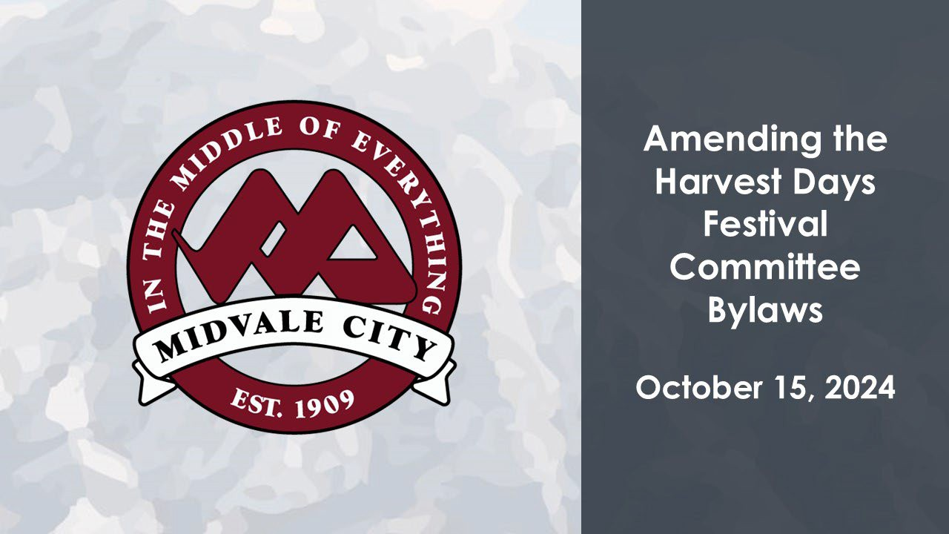

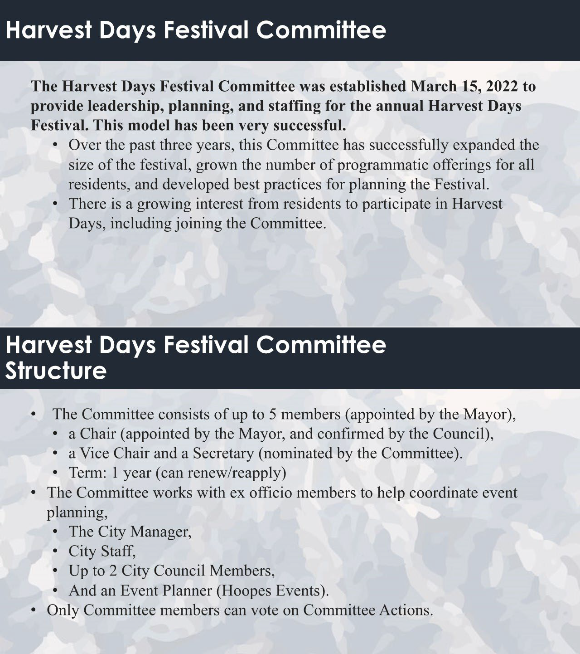

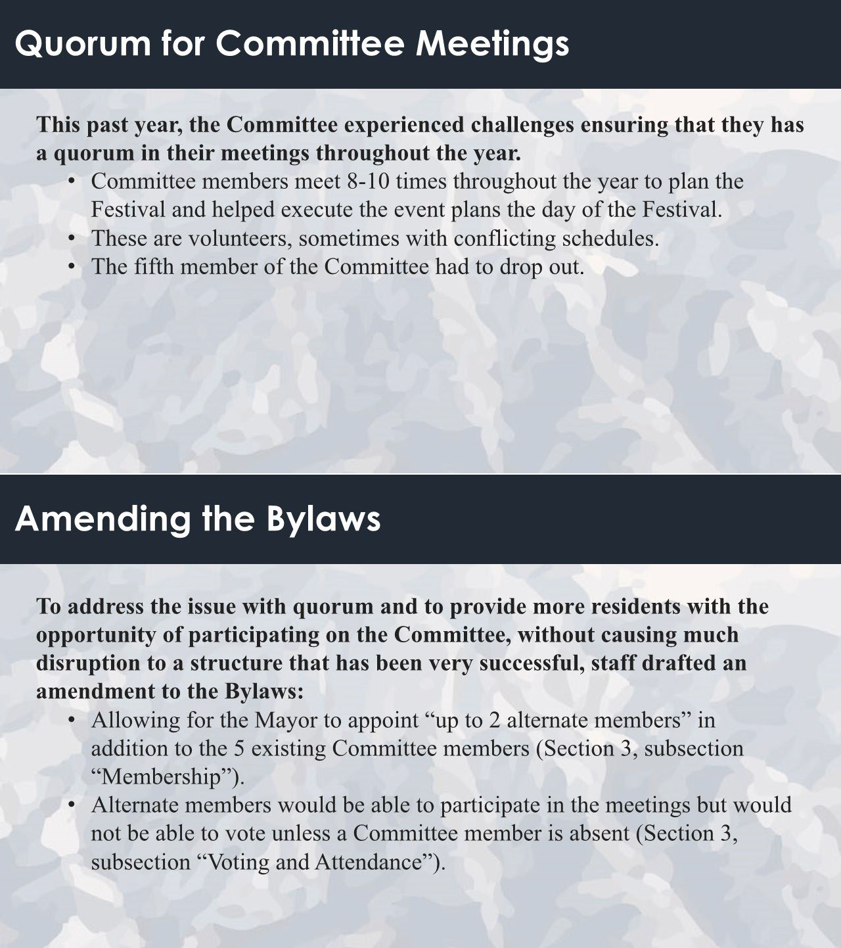

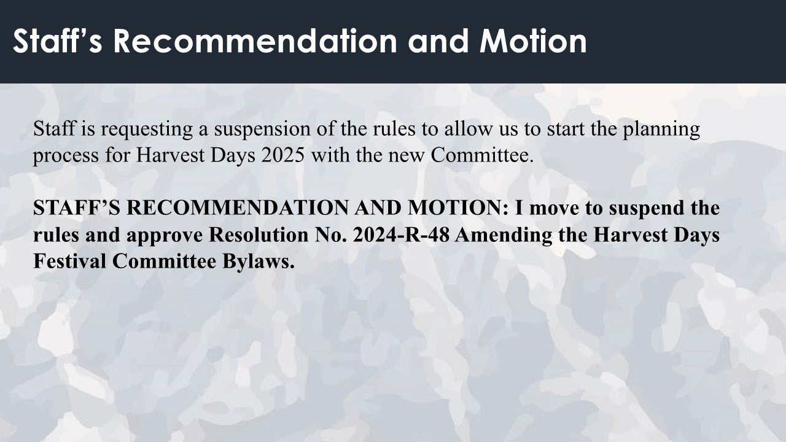
Council Member Dustin Gettel said he wants to make sure that the veto power of the City Manager is not absolute. He would like to see some checks and balances of that power.

Erinn Summers said the way it is structured now the Council has the ability to override a decision if necessary.

Garrett Wilcox agreed with Erinn Summers, stating that the reason the City Manager has the veto power is because the City Manager knows the budgetary restraints and liability issues the City may face.

Matt Dahl said he would be comfortable with a change of veto power if that is what is wanted. He explained that keeping the veto power as is does help expedite the decision- making process for the committee.

Council Member Dustin Gettel said he appreciates Matt Dahl’s attitude about the veto, if Matt Dahl is not using the veto, he would like to see it go away.

Mayor Stevenson said the way the veto is set up the Council does have a say if an activity is rejected.

Garrett Wilcox explained that the City Manager can veto but would have to show that the activity is not in the best interest of the City, or it doesn’t meet the safety requirements of the City.

Council Member Bryant Brown shared his personal history with Harvest Days and said he and other community members feel like it is on the upswing in popularity from some

previous dismal years. He doesn’t want the veto power to be abused by a future City Manager.
Council Member Dustin Gettel said residents have expressed concerns about fireworks and he would not like to see a future City Manager cancel fireworks based on a few concerns.

Council Member Bryant Brown said he would like to talk about this more in possibly a workshop with the Harvest Days Committee and the Council.

Matt Dahl agreed with Council Member Bryant Brown. He said this is a topic that can be worked on with the Harvest Days Committee and the Council.

Council Member Paul Glover said there should be a way written into the bylaws to challenge an unpopular decision.

MOTION: Council Member Heidi Robinson MOVED to Suspend the rules and Approve Resolution No. 2024-R-48 Amending the Harvest Days Festival Committee Bylaws. The motion was SECONDED by Council Member Bryant Brown. Mayor Stevenson called for discussion on the motion. There being none, he called for a roll call vote. The voting was as follows:
Council Member Bonnie Billings Excused Council Member Paul Glover Aye Council Member Heidi Robinson Aye Council Member Bryant Brown Aye Council Member Dustin Gettel Aye
The motion passed unanimously.

CONSIDER RESOLUTION NO. 2024-R-49 APPOINTING CITY COUNCIL MEMBER DUSTIN GETTEL AS THE REPRESENTATIVE ON THE UTAH LEAGUE OF CITIES AND TOWNS LEGISLATIVE POLICY COMMITTEE.
Matt Dahl said Midvale City is actively involved with several interlocal, non-profit, and governmental organizations. Each year, the Mayor and City Council carefully consider and appoint representatives to serve on the various governing boards and committees of these organizations. Recently, Mayor Stevenson was appointed to the Utah League of Cities (ULCT) Board of Directors, creating a vacancy for a voting member representing Midvale on the Legislative Policy Committee.

During the October 1, 2024 City Council Meeting, the City Council discussed adding Council Member Dustin Gettel to the ULCT Legislative Policy Committee. A resolution has been prepared along with the updated Boards and Committees List, including Council Member Gettel’s appointment.

MOTION: Council Member Heidi Robinson MOVED to Approve Resolution No. 2024-R-49 Appointing City Council Member Dustin Gettel as the

Representative on the Utah League of Cities and Towns Legislative Policy Committee. The motion was SECONDED by Council Member Paul Glover. Mayor Stevenson called for discussion on the motion. There being none, he called for a roll call vote. The voting was as follows:
Council Member Bonnie Billings Excused Council Member Paul Glover Aye Council Member Heidi Robinson Aye Council Member Bryant Brown Aye Council Member Dustin Gettel Aye
The motion passed unanimously.

ADJOURN

MOTION: Council Member Paul Glover MOVED to adjourn the meeting. The motion was SECONDED by Council Member Dustin Gettel. Mayor Stevenson called for discussion on the motion. There being none, he called for a vote. The motion passed unanimously.


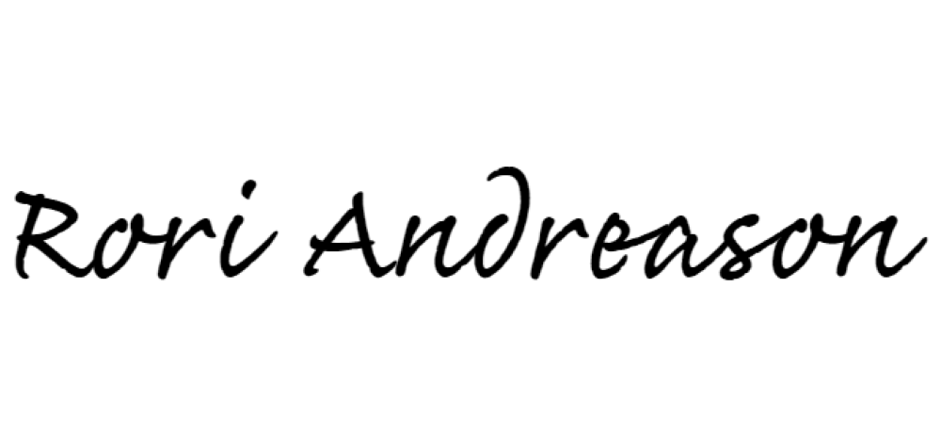
The meeting adjourned at 7:23 p.m.

Rori L. Andreason, MMC

H.R. DIRECTOR/CITY RECORDER

Approved this November 12, 2024

