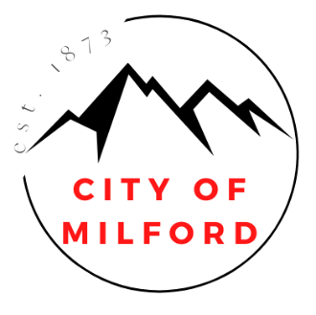
REQUEST FOR PROPOSALS
SEEKING MANAGER TO OPERATE TEMPORARY RV PARK
REOPENED NOVEMBER 20, 2024
DEADLINE: DECEMBER 12, 2024 at 2 pm

Mayor City Administrator
Nolan Davis Makayla Bealer
City Council
Russell Smith
Ian Spaulding
Scott Symond
Les Whitney
Terry Wiseman

The City of Milford, Utah, is requesting sealed proposals for the following:
A PRIVATE ENTITY OR INDIVIDUAL THAT CAN MANAGE AND OPERATE A TEMPORARY RV PARK ON APPROXIMATELY 3.5 ACRES OF CITY-OWNED PROPERTY THROUGH A LEASE AGREEMENT WITH THE CITY OF MILFORD FOR TWELVE (12) MONTHS.
MINIMUM BID: $5000.00 per month to lease the land from Milford City.
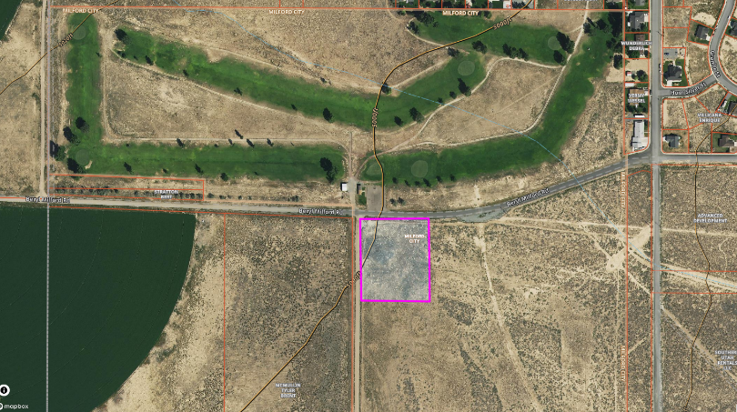
Note: The initial lease will be for 3.5 ACRES however Milford City owns more land and expansion of the RV spot may happen if the need arises.
PROJECT/REASON FOR LEASING CITY-OWNED LAND: Milford City Council wants to lease city-owned land south of the Milford Municipal Golf Course to house RVs in connection with the FERVO Project and other construction jobs in the Milford Area. This will be a “temporary use” to help bridge the gap while other privately owned RV parks are developed with all required improvements in approved zoning districts within Milford, Utah.
Milford City Council understands the importance of keeping the construction workers in Milford to help boost our local economy as well as assist with supporting our local businesses.
PROPOSALS must be submitted in a sealed envelope before 2 pm THURSDAY, December 12th, 2024 to:
City of Milford.
Attn: Makayla Bealer, City Administrator
P.O. Box 69
26 South 100 West
Milford, UT 84751

Each sealed envelope containing a PROPOSAL must be plainly marked on the outside with Temporary RV Park.

Proposals can be submitted in the following ways:
- Mail to PO Box 69, Milford, UT 84751. Mail will be checked at 2:00 pm on December 12, 2024. Anything received after that will be REJECTED.
- Hand Deliver to the front desk at City Hall (26 South 100 West, Milford, Utah).
- Utilize the drop box located on the west side of City Hall (26 South 100 West, Milford, Utah). (This is on surveillance and will mark the time of submission)

Please note that late submissions will NOT be accepted.

The City Council will open proposals on December 12th, 2024 at 2 pm
in the Council Chambers located at 26 South 100 West, Milford, Utah.

To obtain the proposal documents, click the Google Doc link https://docs.google.com/document/d/1ICRVRDmdjj5zcP7Tyb0aqZ9i5a2MFVKe9g21mky-kxc/edit?usp=sharing or please email mbealer@milford.utah.gov stating you would like the proposal documents for the Temporary RV Park.

The City of Milford reserves the right to reject any or all submissions or waive any formality or technicality in the City's best interest.
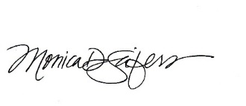
CERTIFICATE OF DELIVERY & POSTING
I, Monica D. Seifers, duly appointed and acting City Recorder do hereby certify that the above Request for Proposal was posted in three public places within the Milford City Limits on this 20th day of November, 2024. These public places being 1) Milford City Office; 2) U.S. Post Office; and 3) Milford Public Library and posted on https://www.utah.gov/pmn and linked to www.milfordcityutah.com and the Milford City Facebook page.

Monica D Seifers, City Recorder

