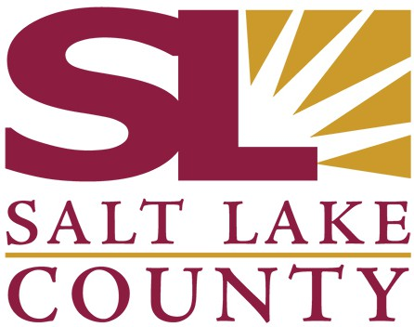

SALT LAKE COUNTY
2001 South State Street Salt Lake City, UT 84114
(385) 468-7500 TTY 711

Meeting Minutes

Tuesday, November 5, 2024

1:45 PM

Room N2-800

Board of Equalization

Board of Equalization Meeting Minutes November 5, 2024

Board of Equalization Meeting Minutes November 5, 2024

CALL TO ORDER

Present

Call In

PUBLIC COMMENT
There was no public comment
Chair Laurie Stringham, Board Member Suzanne Harrison, Board Member Jim Bradley, Board Member Arlyn Bradshaw, Board Member Dave Alvord, Board Member Aimee Winder Newton, Board Member Sheldon Stewart, and Vice Chair Dea Theodore
Board Member Ann Granato

APPROVAL OF BOE MINUTES
  - Acceptance of BoE minutes for October 29, 2024 24-2286
Attachments: 102924 BoE minutes Presenter: Chris Harding, Auditor
A motion was made by Board Member Harrison, seconded by Board Member
Bradshaw, that this agenda item be approved. The motion carried by a unanimous vote.

APPROVAL OF ASSESSOR AND HEARING OFFICER RECOMMENDATIONS
  - Approval of Assessor and Hearing Officer Recommendations 24-2288
Attachments: 110524 Weekly Counts
110524 BoE Weekly Report 110524 BoE Value Adjustments
Presenter: Brad Neff, Tax Administrator
A motion was made by Board Member Bradshaw, seconded by Board Member Harrison, that this agenda item be approved. The motion carried by a unanimous vote.

APPROVAL OF SIGNIFICANT ADJUSTMENTS

