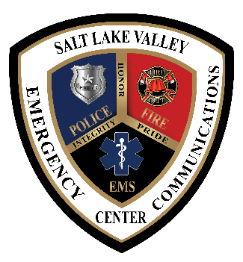
SALT LAKE VALLEY EMERGENCY COMMUNICATIONS CENTER
5360 South Ridge Village Drive, West Valley City, UT 84118

Wednesday, November 20, 2024, at 2:00 P.M.

NOTICE OF PUBLIC MEETING/PUBLIC HEARING

Notice is hereby given that The Salt Lake Valley Emergency Communications Center Board of Trustees will be holding its monthly meeting on Wednesday, November 20, 2024, at 2:00 P.M.

This meeting will be held in person or virtually via ZOOM.

Topic: VECC Board of Trustees Meeting
Time: November 20, 2024, 02:00 PM Mountain Time (US and Canada)
https://us02web.zoom.us/j/81814590872?pwd=sRuol3mMy8wbIYOb9Bq7ze71cYanB8.1

Meeting ID: 818 1459 0872
Passcode: 282723

*** Public comments may be submitted to SLVECC by email at info@vecc911.com or jmorris@vecc911.com up to 15 minutes prior to the start of the meeting at 1:45 P.M., MDT. Comments received after the start of the meeting will be forwarded to the Board of Trustees, but not read into the meeting record or addressed during the meeting. ***

Notice of Special Accommodations:

NOTICE OF SPECIAL ACCOMMODATION DURING PUBLIC MEETINGS In compliance with the Americans with Disabilities Act, individuals needing special accommodations (including auxiliary communicative aids and services) during this meeting should notify Jodi Morris at 801-840-4498.

