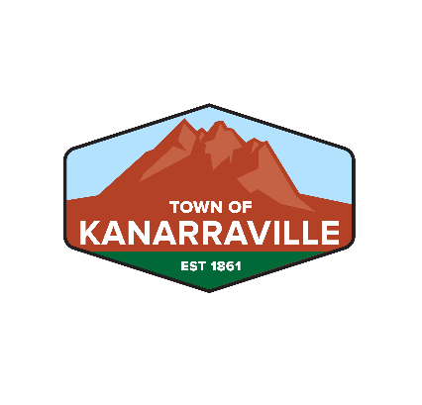
KANARRAVILLE TOWN CORPORATION
40 South Main Street, HC 65 Box 148
Kanarraville UT 84742
(435) 867-1852

KANARRAVILLE PLANNING & ZONING MEETING
Kanarraville Town Hall, 40 S. Main St.
October 3, 2024, 7 pm

GUESTS IN ATTENDANCE: Randy Williams, David Ence
PLANNERS PRESENT: Kim Ward, Brenda Pugh, Chris Archibald, Bret Allred
1. CALL TO ORDER: Chairwoman Ward called the room to order.
2. PLEDGE OF ALLEGIANCE: Led by Chairwoman Kim Ward.
3. APPROVAL OF MINUTES FROM SEPTEMBER 5, 2024 PLANNING & ZONING MINUTES: Chairwoman Ward asked for a motion to approve the Minutes from September 5, 2024. Brenda Pugh moved to approve the Minutes from September 5th. Chris Archibald seconded the motion. All were in favor.
4. RANDY WILLIAMS - WATER CONNECTION AT 75 N. 100 E.: Randy Williams said he is requesting a water connection at 75 North 100 East. It is for the half lot his shop is on, between him and David Ence. The lot is already split and taxed separately. His shop is already plumbed for a toilet, and he needs the water connection for that. Bret Allred moved to approve a water connection for Randy Williams at 75 N. 100 E. Chris Archibald seconded the motion. All were in favor.
5. DAVID ENCE - NEW FLOOD PLAIN MAPS AND PROPOSED ORDINANCE: David Ence said FEMA has issued new flood plain maps for Iron County and Kanarraville and showed the map on the tv screen. Phase One is complete, and Phase 2 will be done in 5 years. These are the latest maps based on LYDAR fly overs and on the ground surveys. FEMA wants municipalities and counties to be stricter when people come and want to build in a flood zone. The Kanarraville map shows Kanarraville having one problem which is the dike south of town and one area for future study which is 200 North from the mouth of Kanarra Canyon down. The maps show areas that are at high risk for flooding. They have also asked that we put in place ordinances that make it mandatory that residents carry flood insurance and raise their property levels so many feet above the street as necessary. They have also changed some of the flooding terms: They no longer refer to a 100-year flood. That name is misunderstood as it implies that it only comes every 100 years. It is now called a 1% event which means that every year there is a 1% chance of a big flood. They are calling the flooding we had in 2021 a 10% event. Ence told everyone that the maps are now available online.

6. ANNOUNCEMENTS: Heidi Loveland stated that the meeting on town boundaries with Reed Erickson has been changed to November 14th due to hunting season. Everyone is invited to that. There were no further announcements.
7. ADJOURN: Chairwoman Ward asked for a motion to adjourn. Brenda Pugh moved to adjourn. Bret Allred seconded the motion. All were in favor.
The meeting adjourns at 7:10 pm.
Submitted by:

Heidi Loveland, Kanarraville Town Clerk

