

SALT LAKE COUNTY
2001 South State Street Salt Lake City, UT 84114
(385) 468-7500 TTY 711

Meeting Minutes

Tuesday, October 22, 2024

1:15 PM

Room N2-800

Board of Equalization

Board of Equalization Meeting Minutes October 22, 2024

CALL TO ORDER
Present

Excused Call In

PUBLIC COMMENT

Chair Laurie Stringham, Board Member Jim Bradley, Board Member Dave Alvord, Board Member Ann Granato, Board Member Sheldon Stewart, and Vice Chair Dea Theodore
Board Member Suzanne Harrison
Board Member Arlyn Bradshaw, and Board Member Aimee Winder Newton

There was no public comment.

APPROVAL OF BOE MINUTES
  - Acceptance of BoE minutes for October 15, 2024 24-2245
Attachments: 101524 BoE Minutes Presenter: Chris Harding, Auditor
Board Member Bradshaw was absent for the vote.
A motion was made by Board Member Granato, seconded by Board Member Bradley, that this agenda item be approved. The motion carried by a unanimous vote.

APPROVAL OF ASSESSOR AND HEARING OFFICER RECOMMENDATIONS
  - Approval of Assessor and Hearing Officer Recommendations 24-2246
Attachments: 102224 Weekly Counts
102224 BoE Weekly Report 102224 BoE Value Adjustments
Presenter: Brad Neff, Tax Administrator

Board Member Bradshaw and Board Member Alvord were absent for the vote.

A motion was made by Board Member Granato, seconded by Vice Chair Theodore, that this agenda item be approved. The motion carried by a unanimous vote.

APPROVAL OF SIGNIFICANT ADJUSTMENTS

  - Significant Adjustment 24-2247
Attachments: 102224 Significant Adj Image Presenter: Brad Neff, Tax Administrator
Chair Stringham, asked who was the significant adjustment.

Mr. Brad Neff, Tax Administrator, explained it was for Row 1700 LLC. This was reverted back to a cost approach upon finding it was not 100% complete as originally assessed.

Board Member Bradshaw and Board Member Alvord were absent for the vote.

A motion was made by Board Member Granato, seconded by Board Member Stewart, that this agenda item be approved. The motion carried by a unanimous vote.

PERSONAL PROPERTY APPEALS

  - Personal Property Recommended Actions 24-2238
Attachments: 102224 Personal Property Recommended Actions Presenter: Brad Neff, Tax Administrator
Action Requested: Approve attached list

Board Member Bradshaw and Board Member Alvord were absent for the vote.

A motion was made by Board Member Bradley, seconded by Vice Chair Theodore, to approve the attached list. The motion carried by a unanimous vote.

INFORMATIONAL ITEMS
  - Presentation of 2023 Annual BoE Report 24-2241
Attachments: 2023 Annual BoE Report Presenter: Chris Harding, Auditor

ADJOURN
THERE BEING NO FURTHER BUSINESS to come before the Board of Equalization at this time, the meeting was adjourned.

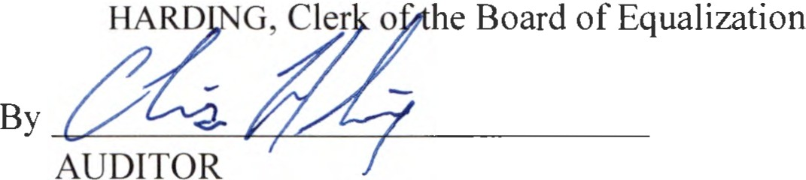
CHRIS

