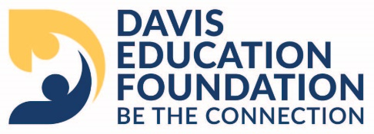
Davis Education Foundation Board of Directors Minutes
September 27, 2024
Catalyst Center
1265 Sportsplex Dr Kaysville, UT 84037

Present: Jodi Lunt, Amber Greenwell, Angela Mitchell, Angie Osguthorpe, Arrika Von, Becky Wooten, Brian Hunt, Brian Slagle, Chad Hunt, Colleen Johnson, Dan Pratt, Dave Anderson, Diana Windley, Heidi Murdock, Jennifer Whitworth, Keri Masson, Kyle Brostrom, Marie Stevenson, Shannon Anderson, Shelly Van Noy, Tami Tran, Tami Olsen, Terry Capener
Excused: Burke Bess, Chad Horne, Chris Johnson, Cory Watson, Denise Willmore, Dr Daniel Linford, Dean Adam, Doug Dahl, Emily Price, Jason Lund, Jason Smith, Jeanne Jackson, Jenny Freeman, John Zurbuchen, Jonathan Ostler, Jon Asay, Josh Dunyon, Kathleen Chronister, Oliver Young, Scott Ellenson, Scott Mortensen, Spencer Carver, Terra Cooper
Welcome:
Brian Slagle welcomed everyone.

Check presentations:
Rocky Mt Power presented the Catalyst Center’s Tech Hers program with a $5000.00 check
Entrepreneurial Association presented the Catalyst Center’s Project Playground with a check for $7000.00

Consent Items:
Keri Masson made a motion to approve the consent items
Tami Young seconded the motion to approve
The motion was unanimously upheld

Board Business:
The Davis Education Foundation’s board leadership was changed. Jodi Lunt thanked Brian Slagle for serving as the board president for the last 2 years. Keri Masson was voted in as the new Foundation president. Shelly Van Noy was nominated as President Elect.
Diana Windley made a motion to approve
Angie Osguthorpe seconded the motion to approve.
The motion was unanimously upheld
Arrika Von was nominated as the new executive board member.
Brian Slagle made a motion to approve Arrika as the new executive board member.
Amber Greenwell seconded the motion to approve.
The motion was unanimously upheld
The change will be in effect as of September 27, 2024
The Teen Living Center had their ribbon cutting on September 12, 2024. A MOU with Davis School District and Switchpoint was signed 09/03/2024

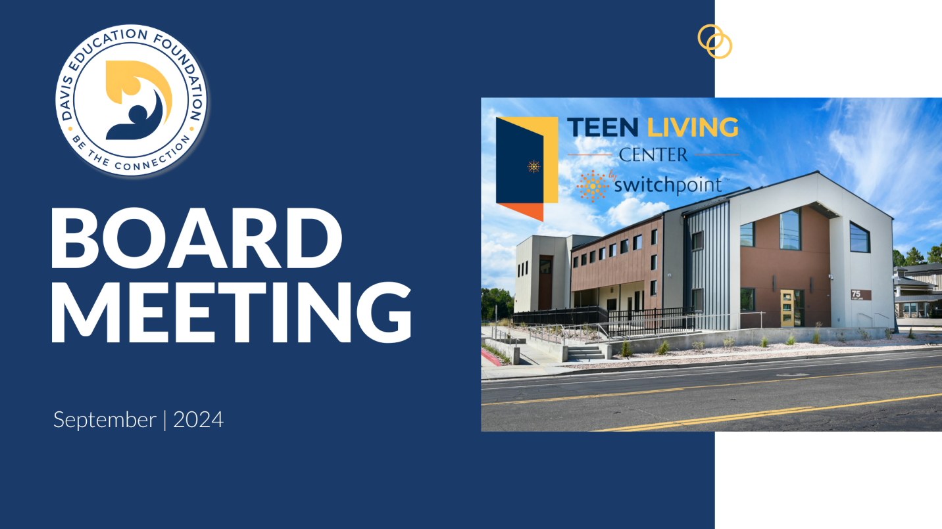



If you are interested in sponsoring a TLC student, please contact the Davis Education Foundation.
It is election time, know your candidates and remember to vote.

Shelly Van Noy asked Board Members to represent the Foundation at the Davis School District Board Meetings, to share why they support the Foundation. The meetings are held the 1st Tuesday of every month, sign up is at 5:30, the meeting starts at 6:00. If you are interested in participating, please contact Shelly Van Noy.

Sherry requested each board member to write a testimonial of trust that can be used on the planned giving page. These testimonials will be used on the website under “Donor Stories” and will be highlighted in our newsletter.
https://forms.office.com/Pages/ResponsePage.aspx?id=dPKcPX5U9UqN3gGmNuC2B7soJOLbm71IqGfZSI1H20VUQU1MRDMyNDkwUlZQSlJaR01RRjNMSjFaWC4u

Foundation Highlights:
North Layton Jr High principal Corby Eason and Asst Heather Bauer reported on the Life Sports program the Foundation sponsored.

Heidi and Tyson Murdock are sponsoring a new program, Excellence in Education, where the Foundation, School District and the Foundation Board will recognize 4 outstanding teachers each month. The teachers will be awarded a gift bag and a $200.00 scholarship, they can present to a student of their choice.

Review of Strategic Plan and Budget
The Strategic Plan and Budget was sent for review. If you have any questions, please feel free to reach out to Jodi Lunt.

Board Workshop
CTSO Hardship Grant Brainstorming Session

Calendar:
FHS Teen Center Ribbon Cutting September 30
Unified Ambassadors Program October 24
Young Trunk of Treat October 26

Adjourn

Next Meeting October 25

