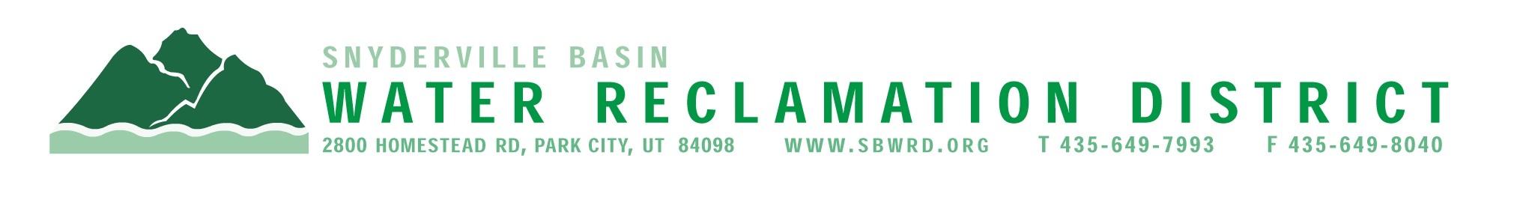
BOARD OF TRUSTEES MEETING

AGENDA

October 21, 2024
** District Office**
5:00 p.m.

** The meeting is open to the public and will also be
conducted electronically using Microsoft Teams**

** For information on how to connect to the meeting, please call 435.649.7993 or email
Dan Olson @ dolson@sbwrd.org by 4:30 p.m. on Monday, October 21, 2024**

I. CALL TO ORDER

II. CONSENT AGENDA
- Approval of Board Meeting Minutes for September 23, 2024
- Final Project Approval – Park East III
- Escrow Fund Reduction Approval
  - Park East III– Retain 10%
  - National Ability Center Mountain Center – Retain 0%
  - Moonshadow – Retain 0%

III. PUBLIC INPUT

IV. APPROVAL OF EXPENDITURES – Bills in the Amount of $1,111,397.81

V. SUBDIVISION PROJECTS
Estimated LEA REs Year to Date: # Above Splitter 4; # ECWRF 89; # SCWRF 290.68; Total 383.68
Proposed this Meeting: # Above Splitter 0; # ECWRF 0; # SCWRF 0; Total 0

VI. DISTRICT MANAGER
- Discussion Items – Review 2025 Tentative Budget
- Action Items – Consideration for adoption Resolution No. 151 authorizing
the issuance and sale of not more than $13,000,000 aggregate principal
amount of Sewer Revenue Refunding Bonds: and related matters
- Information Items
- Financial Statement
- Impact Fee Report

VII. FUTURE AGENDA ITEMS
- Projects
- Operations
- Finance
- Governmental Matters

VIII. ADJOURN
If you are planning to attend this public meeting and due to a disability require reasonable accommodation in understanding, participating in or attending the meeting, please notify the District twenty-four or more hours in advance of the meeting, and we will try to provide whatever assistance may be required. Board members may appear telephonically.

