Carbon Water Conservancy District

Back in 2019 I had asked Jeremy Humes (District’s Attorney at the time) for information on any Bylaws, Mission Statement, etc. The only guiding document that I had, which I was told still governs today are the original formation documents. Per the “Finding, Order and Decree” from October 6, 1942, for the Carbon Water Conservancy District;
The purpose of which said district is established [is to]
- to exercise all powers conferred upon such District by law
  - Jeremy said to see separate statute from Utah Code
    - 17B-2a-1002 – Legislative intent – Purpose of water conservancy districts.
    - 17B-1-103 – Special district status and powers -- Registration as a limited purpose entity
    - 17B-2a-1004 – Additional water conservancy district powers – Limitation on water conservancy districts.
- to conserve, develop, and stabilize supplies of water for domestic, irrigation, power, manufacturing, and other beneficial uses;
- to reconstruct or cause to be reconstructed what is commonly known as the Scofield Reservoir in Carbon County, Utah, to safeguard life and property in Carbon County, Utah which are now in danger because of the unsafe condition of Scofield Reservoir Dam;
- to make domestic water available for communities and inhabitants of Carbon County, Utah; [and]
- to acquire, construct, repair, alter or relocate all such ditches, pipelines, conduits, canals, and laterals as may be necessary or desirable for use in connection with said reservoir or otherwise.

DRAFT DOCUMENT
Upper Price River Project
Proposed Ownership and Operation

Draft document was generated by Horrocks and J&T Engineering based on local experience with Emery Water Conservancy District

Ownership of the Project
- Will the Carbon Water Conservancy District own the water in the lower reservoir, or who will the water shareholders be?
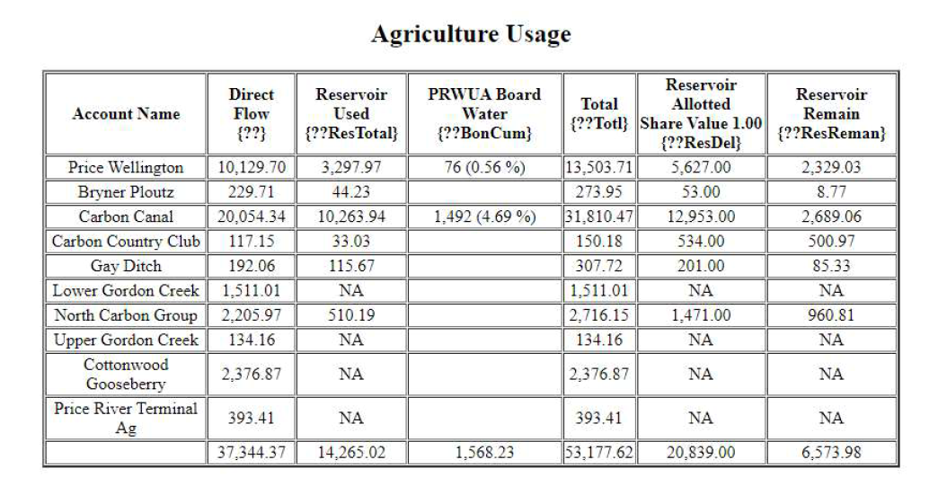
- Scope boundaries – if CWCD takes on the project including the new diversion, piping to reservoir, and reservoir including outlet structure, should CWCD also take on the main lines with PRVs and meters that are specific to two canal companies? (Note, these 2 canal companies are 85% of Ag water use) EWCD does not own all main lines for Canal Companies, but does contract for O&M. What about other canal companies in Carbon County? There should be a good reason for the taxpayers to support 2 Canal Companies while the others are stand alone.
- How would this project impact or benefit Gay Ditch water users as a portion of that project would benefit them? Are they interested in a assessment to cover District costs for Capital as well as O&M?
- Will NRCS have any future involvement with the project after it is built?

Conserved Water and Efficiency Gain
- What is the expected water savings or efficiency improvement from the Lower Basin Reservoir project and piping the Carbon and Price/Wellington Canals?
- Once the project is complete and efficiency improved for irrigation, what happens to the conserved water? Should the excess water be title transferred to CWCD and used elsewhere (maybe sold down river for the short term) to help offset tax and assessments?
  - Ultimately used of the conserved water should be for the future development of Carbon County?
- How do we ensure instream flows in the Price River?
  - What is that target instream flow?
  - Whose water will be secured for that instream flow?

Financing of the Project
- Who and when will a financial study or model be completed? We will need to know more about:
  - Impacts to taxes
    - District tax rev has been reduced by County by 12% over the past 10 years
    - Current 0.000122 ($271,110) EWCD is 0.000419 or 3.5X (approx. $800K)
    - Max tax rates at 0.0004 but possibly an additional 0.0001 if required
  - Impacts to assessments
    - What would the assessment be to:
      - Cover O&M
      - Start to make repayment obligations for project
    - EWCD assessments approx. $1.5M (66% of revenue)
  - Other funding sources including grants and long term, low interest loans.

O&M
- What are the anticipated operation and maintenance costs for the project (reservoir including diversion and main pipeline, as well as Carbon Canal and Price/Wellington Canal)? Keep in mind these additional costs are in addition to current obligations including the O&M for Scofield.
- Do provisions need to be made to protect reservoirs from large rain evens and sediment being carries in from the areas to the west of the proposed site? I learned that EWCD had to do an additional project to protect Adobe Reservoir.
- Once canals are enclosed, what about all of the large trees and habitat that wildlife has relied as a result of open canals and seepage for the past 80 years?
- NRCS will fund the flood protection once the canals are enclosed. Who is responsible for flood protection facility O&M (weeds, sediment, etc.)?
- Any advantages to see about making this a Reclamation Project?

CWCD Board
- It appears that Carbon County cannot have both a Special Services District and CWCD that would serve the same purpose for the same area.
- CWCD currently has five (5) Trustees based on geography. In the past, the canal companies were active on the CWCD Board. If the Board is expanded/restructured, we would have to follow State Law for Water Conservancy Districts and Special Service Districts (Utah Code 17B). Board Members would be appointed by Commissioners, not a shoo-in based on position for a local entity or canal company.
- What is required to change the Board structure and boundaries originally defined in the original formation documents (circa 1942)?

Staff & District Reorganization
- As the District would now need employees, what policies and procedures need to be in place for having full time employees?
- Who helps develop policies procedures, employee handbooks, etc.?
- Can the District rely on Carbon County for Policies and Employee Handbook?
- Who develops posting, interviews, hires and ultimately manages staff?
- Can the District utilize Carbon Counties support resources (HR, labor, equipment, employees, etc.)?

Schedule
- What is the latest timeline for:
  - Draft EIS
  - Draft Watershed Agreement
  - Final (executed) Watershed Agreement
  - Final EIS
  - Record of Decision
- When does a Sponsoring Organization need to be identified?
- Once the ROD is issued, when does engineering start?
- How long will engineering take?
- At what point does the district need to be re-organized and hire GM to support the project?

What other items are critical in the process
- Who develops MOUs (concept agreements) for the affiliated parties
  - Storage right owners
    - Transfer ownership of water rights to CWCD
    - Price City getting storage rights in Scofield
  - Canal companies for assessments (some canal companies may pay a higher fee).
  - If the project allows for same farming, but saves water, what happens to saved water?
  - Landowners (private and public)
  - Carbon County (roads, other required facilities, etc.)
  - Recreation (BLM / State Parks) – May be some continuity to use State Parks as that is who operates recreation at Scofield?
  - Sponsoring Own/Operate/Maintain Entity with better definition on scope and obligations
- When is the State Engineers office brought into discussions for storage right exchanges and transfer (Price City, PRWUA, Reclamation, CWCD)?
- What about change applications from current diversions to new diversions, reservoir and enclosed canal? How much of a haircut will be required?
- How can we encourage or get commitment from water users for saving conserved water from this project to be put back into the Price River Draining and Carbon County or deeded to CWCD to offset project repayment and O&M? There is concern that due to improved efficiency, some may see this as an opportunity to begin farming on barren or previously unirrigated lands.

