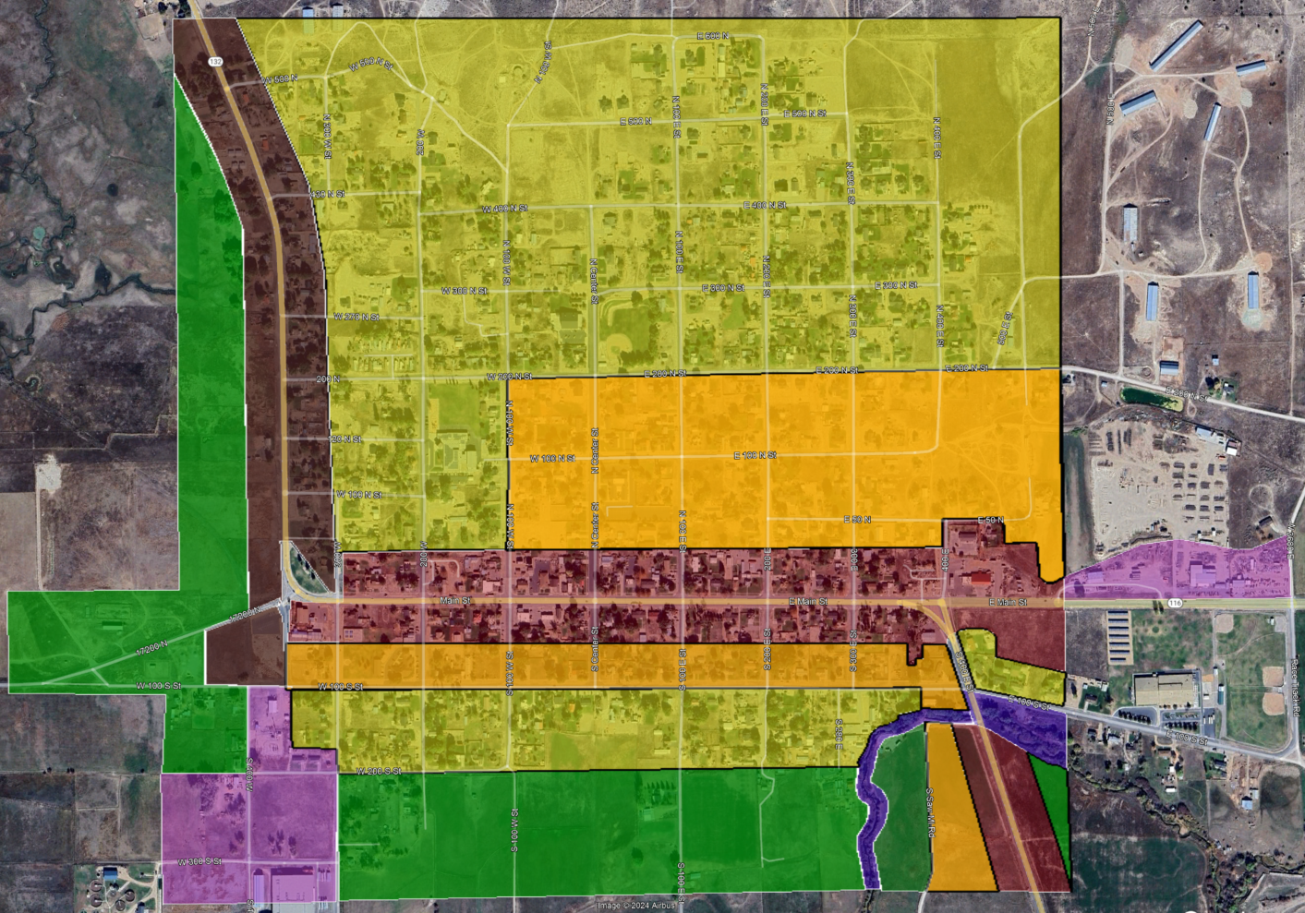
Yellow - Single Family Residential (R1)
Orange - Medium Density Residential (R)
Green - Residential Agricultural (RA)
Lt Brown - Central Commercial (C1)
Dk Brown – Mixed Use Commercial (C2)
Pink - Manufacturing (M)
Purple - Sensitive Lands (SL)

