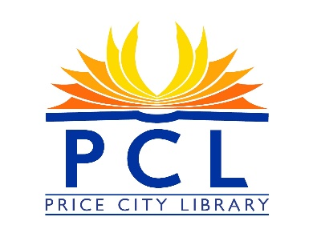

PRICE CITY LIBRARY BOARD MEETING AGENDA
Monday October 15th 2024
Price City Hall room 106
4:00 P.M.

- Call to Order
- Roll Call
- Approval of Minutes
- Approval of Program Reports/Monthly Statistics
- Board Members informational comments on pertinent items not on the agenda.
- Public Comments/Questions (3-5 minutes)

- Unfinished Business
- Friends of the Price City Library
- Board Member’s Terms

- New Business
Quality Library Designation

- Agenda Items for the Next Meeting
- Adjournment

Next Library Board Meeting: Monday November 11th 2024

Monthly Circulation summary

September 2024 Totals
Circulation 1658
Internet total usage 226
Books used 828
Story time 66
Take & Make 6
Off-Site Programs 0
Off-Site Program Attendance 0
Programs 0
Programs Attendance 0
YA Programs 0
YA Programs Attendance 0
Reference 111
Patrons 2886
August 2024 Totals
Circulation 1303
Internet total usage 216
Books used 994
Story time 87
Take & Make 9
Off-Site Programs 0
Off-Site Programs Attendance 0
Programs 0
Programs Attendance 0
YA Programs 0
YA Programs Attendance 0
Reference 129
Patrons 3086
July 2024 Totals
Circulation 1900
Internet total usage 163
Books used 989
Story time 108
Take & Make 132
Off-Site Programs 0
Off-Site Programs Attendance 0
Programs 3
Programs Attendance 84
YA programs Attendance 57
Reference 87
Patrons 2955

