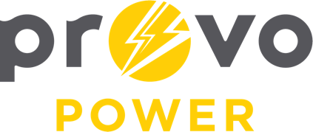
AGENDA
ENERGY BOARD MEETING
PROVO POWER
251 W 800 N
Monday, October 7, 2024
4:00 P.M.

- Welcome & Introductions – Chairman Gary Winterton
- Review & Approval of Minutes – May 6, 2024 and September 16, 2024
- CIP Project Report – Titus Bills
- APPA Conference Reports – Erin Hernandez and Charlie Little
- Financial & KPI Reports – Charlie Little
- Solar Proposal Report – Scott Bunker and Charlie Little
- Manager Report – Scott Bunker
- Calendar & Scheduling
  - Next Board Meeting: November 4th
  - Provology: November 13th
  - Thanksgiving Luncheon: November 13th
  - Christmas Luncheon: December 11th

A copy of the agenda was posted in the Civic Center, and the Provo City Library, on October 2, 2024, and also delivered to the Mayor,
City Council Members, required news media, and adjacent cities in
compliance with the Utah Code 52-4-202

