SALT LAKE VALLEY LAW ENFORCEMENT SERVICE AREA
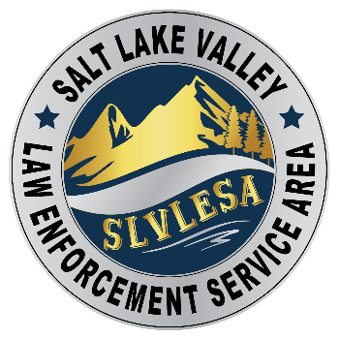
1330 E CHAMBERS AVENUE, MILLCREEK, UT 84106 (385) 468-9662

NOTICE OF MEETING OF THE BOARD OF TRUSTEES OF THE
SALT LAKE VALLEY LAW ENFORCEMENT SERVICE AREA
(SLVLESA)

Thursday, September 19, 2024, at 10:00 a.m.
at the Unified Police Department Millcreek Precinct Building,
1330 E Chambers Ave., City Council Chambers, Millcreek, UT 84106

The SLVLESA Board of Trustees will hold a meeting on Thursday, September 19, 2024, at 10:00 a.m. at the Unified Police Department Millcreek Precinct Building, 1330 E Chambers Ave., City Council Chambers, Millcreek, Utah 84106. Members of the Board may be present in person or participate electronically.

The public may physically attend and monitor the open portions of the meeting. Members of the public may also join the open portions of the meeting by calling 1-720 707-2699 and entering Meeting ID 92301763844# and Password 259919#. The public will be allowed to listen to all open portions of the meeting. Public comment will be allowed during the Public Comment portion of the meeting which will start no sooner than 10:00 a.m. For those participating by phone, please mute your phone when you are not making public comment.

Reasonable accommodations (including auxiliary communicative aids and services) may be provided upon receipt of a request with at least three working days’ notice. For assistance, please contact Marcie Kay, SLVLESA Clerk, MKay@updsl.org or by calling (385) 468-9662. TTY users should call 711.
Board members and persons participating by phone will be able to hear all discussions.

AGENDA

1. Call to Order and Roll Call.

2. Public Comment.
This is a time for members of the public to comment to the Board on any issue regarding SLVLESA. For those participating electronically, the SLVLESA clerk will need to take calls in an orderly manner. The SLVLESA clerk will advise a caller when it is the caller’s turn to speak. Callers should have their call on the mute function until it is their turn to speak. Comments will be limited to 3 minutes.

3. Approve Minutes for the August 15, 2024, Board Meeting.
Presenter: Rachel Anderson, SLVLESA Administrator and Legal Counsel
Action Required: Motion, Second, and Vote.

4. Expenditures for the Month of August 2024, and Other Financial Information.
Presenter: Richard Moon, SLVLESA Treasurer.
Action Required: Motion, Second, and Vote.

5. Intent to Pursue a 2025 Property Tax Increase
- The approximate amount of the increase is 12.87% in the amount of $3,276,076
- The purpose of the increase is to continue to appropriately fund law enforcement through our payments to the UPD and Salt Lake County Sheriff, respond to inflationary pressures, and maintain required minimum fund balances.

6. Update on the Unified Police Department.
Presenter: Chief of Police Jason Mazuran or designee.

7. Update on the Salt Lake County Sheriff’s Law Enforcement Bureau.
Presenter: Sheriff Rosie Rivera or designee.

8. Adjourn.

I certify that on September 17, 2024, the following notice was provided:

This notice was posted to the Utah Government Transparency Website.
This notice was posted to the Salt Lake Valley Law Enforcement Service Area Website.
A copy of this notice was mailed electronically to the Salt Lake Tribune and the Deseret News.
A copy of this notice was posted at the Unified Police Department Millcreek Precinct Building.

/s/________________________________________
Marcie Kay, SLVLESA Clerk

