OPEB Board Meeting
Thursday, August 10 – 10:30 AM – 11:30 AM
WebEx – Electronic Meeting Only
Meeting video/audio (log in first)

- Roll Call – Darrin Casper
Trustees Present:
Darrin Casper, Deputy Mayor of Finance and Chief Financial Officer
K. Wayne Cushing, County Treasurer
Lori Okino, Fiscal Administrator, Community Services
David Delquadro, Council Fiscal Manager
Other Attendees:
Shanell Beecher, Director of Accounting, Mayor’s Financial Administration
Brett Carlson, ESR Accounting Manager, Mayor’s Financial Administration
Greg Folta, Finance and Payroll Director, Mayor’s Financial Administration
Mari Vellido, Internal Services Manager, Mayor’s Financial Administration
NEW for this Meeting:
Becky Timothy, Budget Benefits Administrator
Absent:
No members of the public attended.

Mr. Casper amends the agenda slightly and asks for a motion to encompass the recommendations on the minutes from 4/20/22 and 7/14/2022 so they can be approved. The vote on the motion passes unanimously.

- Review Financials – Brett Carlson
Finished 2022 with revenues exceeding expenses at just under $800,000. In 2023, revenues are tracking to be over expenditures by almost $1.2m. Mr. Casper asks if the $788,000 includes the $250,000 minimum reserve. Mr. Carlson shared the Balance Sheet showing the current Moreton balance of $12,968,805.57 and the adjusted Moreton balance of $15,983,192.36. The balance on the county books is $3,014,3863.79. Mr. Carlson states if we move $2.7m, there would be $314,386.79 left on our books.
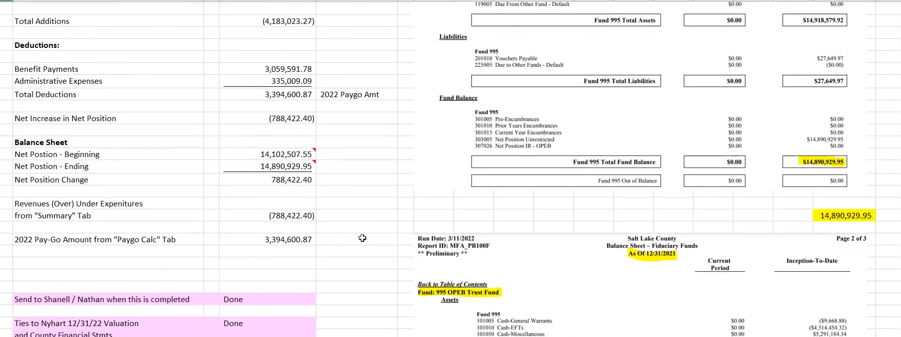

Mr. Casper is concerned that inflation since the last discussion on this topic is outpacing the amount of revenues going into the operating account. It is discussed that the increases that were made have been sufficient to outpace the inflation. If projections come out, we will probably be up another $200,000-$300,000 in August, over the $1.2m we are at now. Inflation hasn’t really impacted this trust.
Mr. Casper says inflation is happening and asks if the number of participants is being reduced. Mr. Carlson states the number of participants hasn’t been counted but we have had the plan for about 10 years. He believes there are less people retiring before 65 and we’ve got people that are on medication longer. Mr. Carlson states it may be worth having NyHart review what’s happening. We are due for the next actuarial this year.
Mr. Casper asks Ms. Beecher what our total liability is at this stage since she just finished the financial statements. While waiting for her to return, Mr. Delquadro asks if we increased the OPEB contribution rate in June. Mr. Carlson explains we increased it in June 2022 by 17.5% but left it the same in June 2023.
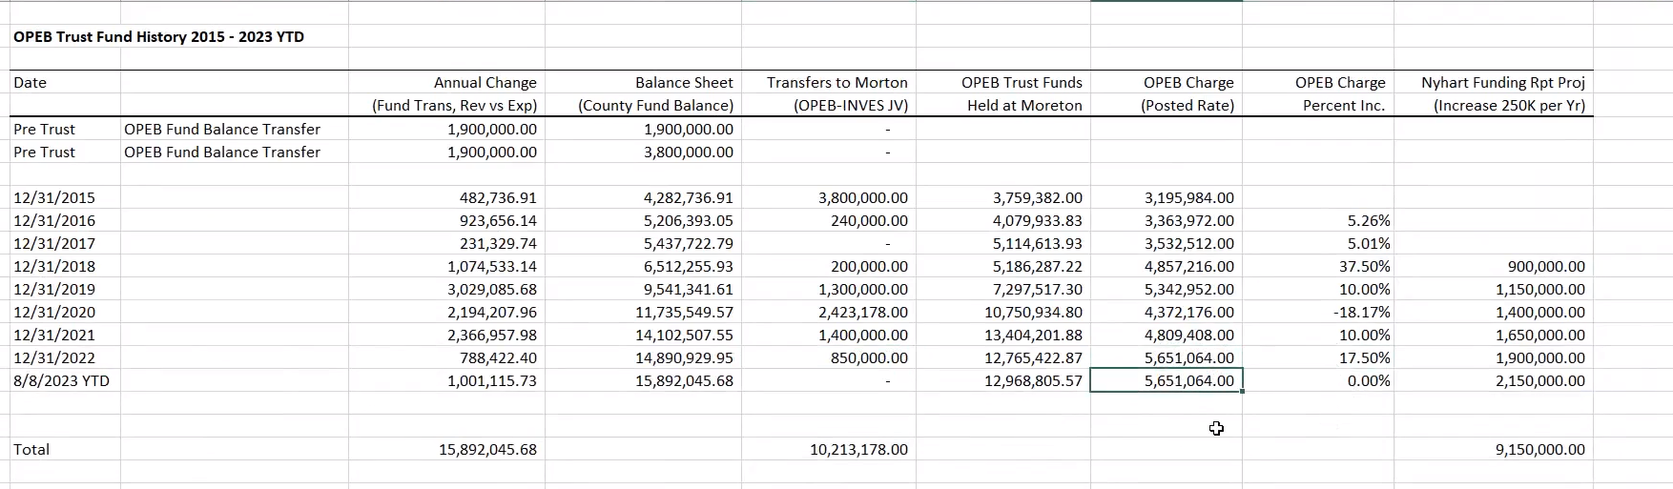
Ms. Okino brings up the issue of retirees only taking dental. She asks if the change was made so they have to be on the medical in order to get the dental and if there was any impact. Mr. Carlson hasn’t analyzed that yet but confirms they do have to pick up the medical now and they can make changes during open enrollment to the spouse and dependents.
Ms. Beecher returns with the net, which is the liability with the fiduciary net position is $89.5m. Mr. Casper verified this is the Moreton balance plus the total. Ms. Beecher confirms. Mr. Casper then asks what the Annual Required Contribution (ARC) is. Ms. Beecher replies with about $6.67m this last year. Mr. Casper refreshes that our goal was to continue increasing the revenue until we match the ARC, at which point the OPEB would be essentially solved. He points out that things are continuously changing, inflation’s going up, and ARC will likely go up as well. Mr. Casper suggests planning to increase the OPEB contribution by this fall to continue moving towards the goal of matching our revenues with the annual required contribution. Once that is met, we can start drawing.
Mr. Delquadro asks if there was an increase in the Medicare Supplement and if so, what, because that’s been low relative to what we are experiencing on health insurance. He was advised that as soon as we get the 2024 Medicare Supplement Rates, Ms. Timothy can report on the increase, but they have been trending less than our medical plan. Mr. Casper states there are a lot of issues that could have a material impact such as standing up the law enforcement bureau. It is unclear to what extent there will be long term tier 1 employees rejoining the county. Ms. Delquadro states that even if they return, they are not eligible for the benefit because they left the county.
Mr. Folta asked a clarifying question regarding the increase to the Moreton account. It was clarified that because we missed the June increase, we need to increase it this fall to meet the goal of getting the OPEB charge equal to the ARC. Mr. Folta stated that it was reviewed and determined that it was fine as is. Mr. Casper responded that the actuarial is going to have the healthcare cost outpacing our current revenue collection because we are low on collections. He continues with we need to keep steady progression as this has essentially solved the OPEB liability issue.
Mr. Delquadro asks if we want to go halfway to what we need to be at the full amount, to which Mr. Casper responds that he thinks that is more than reasonable given the projection that this will be a difficult budget year.
Mr. Casper calls for a motion to transfer money in and asks for an amount. Mr. Delquadro suggests we retain the $250,000 and transfer the residual with the assumption we will have a good August. A discussion takes place about what was sent in prior years for MSD and based on that it was suggested we send $2.7m to Moreton and have some left for the uncertainties with inflation. Mr. Casper calls for a vote on transferring $2.7m to Moreton which passes unanimously and confirmed to be the largest transfer since the initial transfer. This is great news considering inflation and post COVID. It didn’t hit the OPEB trust like it did the employee plan.
Mr. Cushing is curious about the changes in number of participants over the years that this has been looked at. It’s discussed that people are working past the age of 65 and the use of Rx is longer, which impacts the cost. Mr. Casper asks Mr. Carlson about his thoughts regarding people retiring later. Mr. Carlson states he thinks it’s because of inflation and market correction that people have delayed leaving. Mr. Carlson offered to run something to show counts since doing this.
Mr. Carlson says Becky will be reaching out to NyHart in the next couple of months so if anyone wants something to be looked at outside of the normal evaluation to let her know. It is clarified that the upcoming actuarial is for the end of 2023 and will be more extensive than 2022 and should look at these questions. This should be done around March 2024.
Mr. Casper requests Ms. Beecher to take the lead in plugging new numbers into the annual report. Ms. Beecher responds that she is already working on it and will email it out when it’s done. He believes that within 2 years we’ll be able to come very close to solving the issue. We set out with goals, and we are marching towards achieving those goals.
Mr. Casper welcomes Ms. Timothy who will be taking Mr. Carlson’s place. He states it will be helpful to read through the annual report in detail so she can see what decisions the committee have made to make its goal. It’s stated that Ms. Timothy is taking Mr. Carlson’s place due to him retiring in about 3 weeks. Mr. Folta states the job title has been slightly changed from Budget Administrator to Benefits Budget Administrator because the OPEB portion was not in the job description until now.
Mr. Cushing updates the board on his conversation with Morton regarding our equity fixed ratios seemed a little low on the equity side. He explains that because we are seeing the 5% and above fixed instruments available, they are grabbing those when things mature. The other reason is they anticipate a market correction on the equity side. They want to re-enter the market after it has made the adjustment. Mr. Cushing did not know the amount we were going to send them, so he will have another discussion with them on how they want the $2.7m; with the understanding that any money in their sweep accounts is making 5.2%. Mr. Casper states there are no concerns and maybe Morton can be at the next meeting.
Mr. Casper asks if there is any other business, there is none. He then initiates a motion to adjourn. Mr. Folta asks about setting a date for the next meeting.
Mr. Folta states at least a month, Mr. Casper states he doesn’t believe we need to meet for a quarter. Mr. Casper states we are going into budgets so he would be fine with December unless anyone thinks it more pertinent to meet earlier. Ms. Okino asks about the potential of increasing the contribution in the fall and if that needs to be done now, before the budget process is complete, or fall 2024.
Mr. Casper responds this is something we would put in immediately, and potentially another adjustment in June. He then asks the board their thoughts on possibly 10%. Mr. Folta clarifies that we would put it in Sherpa in the fall budget process to be effective January 1, 2024, and then we could look at truing it up again in June 2024. Mr. Casper confirms and states we are tracking well, but the goal is still to get up to that arc. Ms. Timothy clarifies the increase to be 10%; Ms. Okino asks if there is an idea incrementally how much 1% change would potentially increase our revenue. Mr. Casper states each 1% is about $56,000, so 10% would be another $560,000 it pumps up to about $6m. Mr. Casper iterates that he is giving only rough numbers. Conceivably, if we did 10% now, and the budget was stable, we could solve it in June. At that point, we will have the new arc. Mr. Folta asks how much the arc went up from the previous year, it’s stated it went down from about $7m.
Mr. Carlson asks about retirement comebacks. If they are told they are not eligible, are we sure they’re not going to fight it? If they got pulled back in, that would really change the demographics of the arc. Mr. Casper states he’s not sure, but it would increase the arc for sure because the retirement age of public safety is 20 years of service.
Ms. Okino asks if they come back, wouldn’t they need to self-fund their previous portion so we’re not picking up things that wasn’t our liability? Mr. Casper responds that he doesn’t have the answer, and explains that he has been hearing employees are concerned about minor things such as their sick leave, which is considerably less of an expense then, for example, an OPEB benefit.
Mr. Delquadro gives his individual standpoint: if you’re planning to retire at an earlier age, you’re more interested in the sick leave payout than Medicare because it has a more present value than Medicare that is still 10 years away. Mr. Delquadro then states, if they did come back, they would have to take health insurance for those 10 years. Mr. Casper then states they don’t have accumulated fund balance like the county does. Mr. Delquadro asks if we would be responsible for their accumulated sick leave if we allowed that to come over, Mr. Carlson confirms.
Mr. Folta asks Mr. Casper about how many employees there are, Mr. Casper says it’s about 200. They are the base model but it’s uncertain if it will pass through our council. Right now, it’s about 150, but that’s not including Kearns, Magna, or Emigration Canyon. If those also come over, it could be 150+. It would have to be a contract model is his understanding with the new law. There’s a lot unknown right now, but it could be substantial.
Mr. Carlson asks what date this would be effective, Mr. Casper states July 1, 2024, as the target date. Mr. Carlson clarifies that it won’t affect this year’s valuation with NyHart, it would affect 2024. Mr. Casper confirms. It’s then stated that if they do come back, then it would affect 2024, and the 2025 NyHart valuation would be subject to that change. Depending on the circumstances, it’s very possible that NyHart would want to do another full evaluation. Mr. Casper asks how long is our contract with NyHart and when do we do another RFP? Ms. Timothy believes it is June 2025.
Mr. Casper asks if there are any other comments, because there is a motion on the table to adjourn.

- Schedule next OPEB meeting - All
Mr. Folta states December was suggested, everyone agrees for the second week of December. December 11th at 11:30am was proposed for the next meeting. Mr. Folta suggests 11:00am instead.
Next meeting is scheduled for December 11, 2023 at 11:00am.

