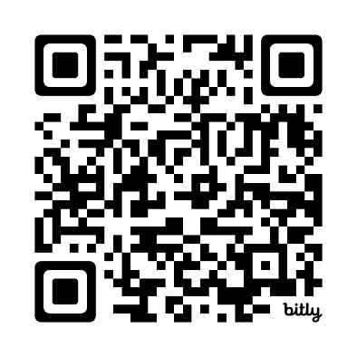
OPEB Board Agenda
In Person Location: 2001 S. State St. N4-600
Electronic Meeting via Webex: bit.ly/OPEB091824
Date: Wednesday, September 18, 2024
Time: 1:30 PM

Agenda Items

- Roll Call Darrin Casper
- Approve Prior Meeting Minutes Darrin Casper
- Review Annual OPEB Report Becky Timothy, Shanell Beecher
- Fund 995 Becky Timothy
- Update on OPEB Finances K. Wayne Cushing or Moreton
- OPEB Rate for 2025 Darrin Casper



