The Eagle Mountain Redevelopment Agency
Triple Tail Community Reinvestment Project Area (CRA)

Notice of Adoption of Ordinance 0-35-2024
Pursuant to Sections 17C-5-109 and 17C-5-110 of the Utah Code Ann., the Eagle Mountain City Council (the “City Council”) is providing this notice with respect to Ordinance O-35-2024 which was passed by the City Council on August 20, 2024, adopting the official Triple Tail Community Reinvestment Project Area Plan (the “Official Plan”), as approved by the Redevelopment Agency of Eagle Mountain City (the “Agency”) on the same date, and directing that notice of adoption of the Official Plan be given as required by law. Ordinance 0-35-2024 and the Official Plan shall become effective upon publication of this notice, at which time the Agency may proceed to implement the Official Plan. The Official Plan is available for public inspection at Eagle Mountain City Hall, 1650 E Stagecoach Run, Eagle Mountain, Utah during regular office hours.

For a period of 30 days after the date of adoption of the Official Plan, any person in interest may contest the Official Plan or the procedure used to adopt it if the Official Plan or procedure fails to comply with applicable statutory requirements. After expiration of that 30-day period, no person may contest the Official Plan or procedure used to adopt it for any cause.

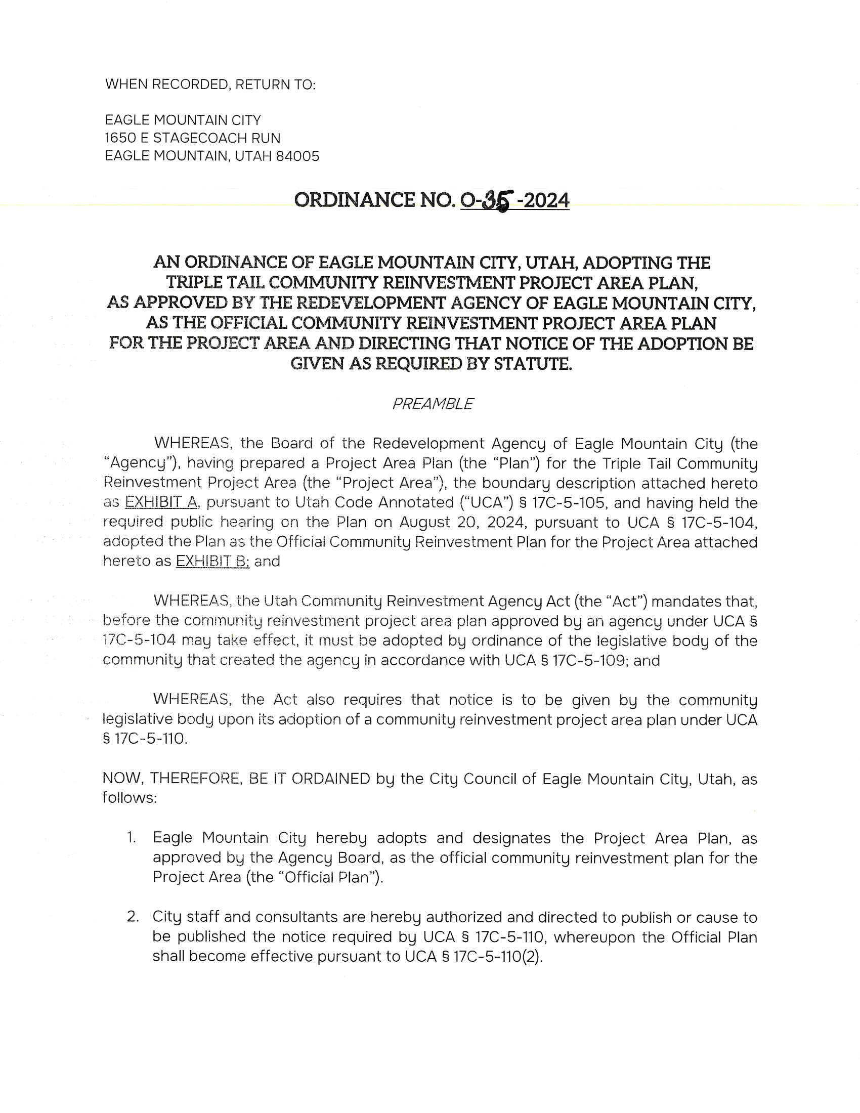

EAGLE MOUNTAIN CITY COUNCIL ORDINANCE ADOPTING THE CRA PROJECT AREA PLAN

