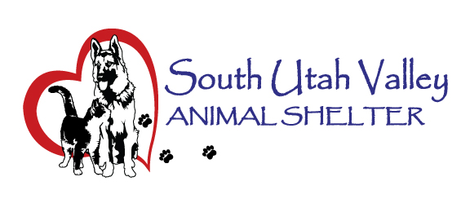
South Utah Valley Animal Special Service District
Board Meeting Minutes Tuesday July 9, 2024
South Utah Valley Animal Shelter Conference Room
582 W 3000 N Spanish Fork UT 84660
Board Member Attendance
Lt. Larsen Kayson Shepherd* @RandiLyn Warner*
Chief Lance Haight Chief John Jackson* @Dr Bott
Chief Brad James* Chief Brad Bishop @Legal-not filled
Shawn Carter Kevin Oyler Kari Malkovich
(*Absent / @ At large)
Phil Christensen was here for Salem and Mike Wall was here for Santaquin. Also present was Kierstan Munford (SUVAS Executive Director) and Carrie Ward who took the minutes.
10:30 AM the meeting was called to order by Chairman Bishop.
- Approve minutes of Board Meeting held 5/14/2024. “I move to approve the minutes of the meeting held on May 14, 2024.” 1st Kevin Oyler, 2nd Chief Haight. Motion approved unanimously.
- Review Fraud Risk Assessment. Chairman Bishop thought that the Board Member are complying with the #4 item. Board Members can do an online training if they missed the in person so SUVAS is compliant with that.
- Review D&I Report Period Ending 06/30/2024. Kierstan presented the Deposit and Investment Report. There is concern about the need for a larger shelter. There were ideas about how to make this happen. There is no sure path forward about how to get this going. Kevin Oyler has asked Kierstan to get on the Commission Agenda to start the process. Chief Bishop will speak with the Sheriff to see what it would take to get this process going. Chief Bishop will also speak with the Public Works (Richard) to see if it would be possible to add more to this Shelter location.
- Shelter Report by Kierstan Munford. The new license system is up and running, it is secure. Kierstan will send out links if anyone is interested in looking at it. Kierstan gave animal numbers in care 125 dogs and 130 cats. There was a dog that tested positive for Parvo and was contained this to one dog. It was still in its holding period. Dr Bott gave a rundown about how contagious it is and that treatments are limited to supportive care. Kierstan gave numbers for the most recent clinics and listed the upcoming ones. Chief Haight has looked up some designs for other kennels to reduce stress on the dogs.
- Financial Report by Kierstan Munford. July begins the new Budget year. End of the last Budget year was presented. Kierstan started working with the Auditor so she is hopeful the financial report will be done sooner. Chief Haight asked if county wide impact fees would be possible to help get the next shelter built. Kari Malkovich reported that the state is thinking of reducing impact fees. A study would have to be done first. Kari also brought up if there is a tax, would it be user fee for pet owners or under public health that would tax everyone? Keirstan also asked about licensing cats? The Board wants the shelter to start here first. Any cat being adopted will be licensed.
- To set a date, time and location for a closed meeting to discuss the character, professional competence or physical or mental health of an individual. No business.
Pubic Forum. Justin Stewart from Best Friends attended the meeting but had no input.
Next meeting will be September 10, 2024 at 10:30 AM.
“Motion to adjourn.” 1st Kevin Oyler, 2nd Chief Haight. Motion passed.

