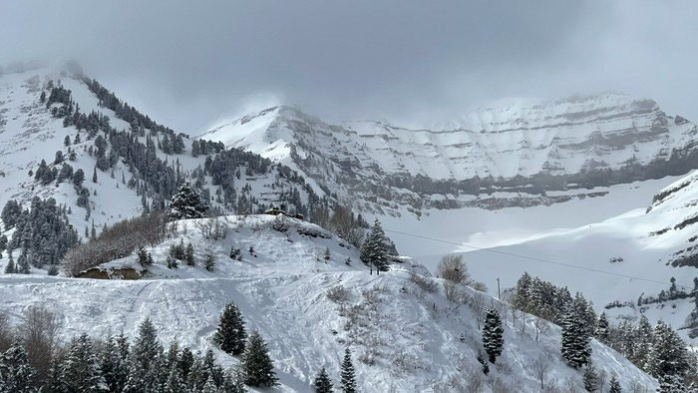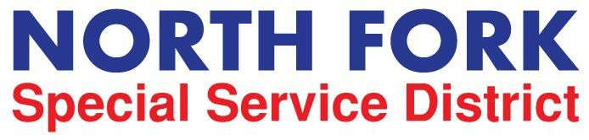
REQUEST FOR STATEMENTS OF QUALIFICATIONS
District Engineering Consulting Services for Wastewater and Water treatment projects

Issue Date:
August 16th, 2024

Qualification Due Date and Time:
Received by August 27, 2024, 2:00 pm (Mountain Time)

Mailing/Hand Delivery Address (hard copies):
Ardurra Group
Attn: Ryan Taylor
2175 West 3000 South Ste 200
Heber City, UT 84032 (435) 503-4123

Electronic Submission:
Email to: rtaylor@ardurra.com
Subject line: NFSSD Engineering RFQ Submission

Contact:
Emily Johnson, District Clerk 801-225-7263 admin@nfssd.org

or
Ryan Taylor, District Engineer 435 503 4123 rtaylor@ardurra.com

SUMMARY

North Fork Special Service District (“District”) is requesting proposals from qualified engineering firms who are well-versed in water and wastewater treatment design and construction. Responders should be qualified and have experience with design and construction of various treatment technologies including membranes, sand filters, reverse osmosis etc. and be able to provide comprehensive feasibility and design services as well as provide on site construction management, weekly meetings, field observations, review of submittals, change orders, and pay requests. As well as facilitate and manage startup and commissioning of new equipment. The selected consultant will work with the district engineer on specific projects. This Request for Statements of Qualifications is issued consistent with the Utah Procurement Code for Design Professional Services (Utah Code Title 63G, Chapter 6a, Part 15) and the District’s Purchasing Policy.

ABOUT THE DISTRICT

The District was formed in 1977 to provide fire, sewer, water, and garbage services to members of the Sundance mountain community. The District is governed by a Board of seven trustees (“Board”) appointed by the Utah County Commissioners. The majority of District operating funds come from user fees. The District also utilizes grants awarded from Federal, State, and County entities to assist in funding capital projects.

DISTRICT LOCATION

The District’s service area is located approximately fourteen (14) miles East of Provo, Utah along SR-92. The District serves 223 residential water connections, 66 condominium connections, two commercial entities, 29 connections on standby, 666 sewer connections, fire, and EMS services as well as garbage services to a population of approximately 500 with both private and publicly owned resort areas in the Provo Canyon area, also known as Sundance.

PROPOSAL REQUIREMENTS AND CONTENTS

Proposals submitted for this project are to follow the outline described below and must address all requested information. Any additional information that the firm wishes to include that is not specifically requested should be included in an appendix to the proposal. Firms are encouraged to keep the proposals brief and to the point, but sufficiently detailed to allow evaluation of the proposal approach.

- Preference will be given to firms with extensive water systems and wastewater engineering experience and familiarity with high elevation mountain utilities and operations. The District reserves the right to withdraw this RFQ at any time without prior notice and reject all proposals submitted without indicating any reasons. Any award of contract for services shall be made to the firm most qualified and responsive in the opinion of the District.
- Proposals may, at the District’s option, be rejected if they contain any alterations, additions, conditional or alternatives, are incomplete, or contain erasures or irregularities of any kind.
- The District expressly reserves the right to postpone submittal opening for its convenience.
- The selected firm must agree to indemnify and hold harmless the District, its officers, agents and assigns from any liability or loss resulting from suits, claims, or actions brought against the District which result directly or indirectly from the wrongful or negligent actions of the consultant or company in the performance of the contract.
- The selected firm will be required to comply with all existing State and Federal labor laws including those applicable to equal opportunity employment provisions.
- The District reserves the right to negotiate unique requirements and proposed service levels using the selected proposal as a basis.
- All responses to this RFQ shall become the property of the District and will be retained or disposed of accordingly.
- No amendments, additions or alternates shall be accepted after the submission date and time.
- All documents, records, designs, and specifications developed by the selected firm while providing services for the District shall be the property of the District.
- Anything considered to be proprietary should be designated by the firm.
- Acceptance by the District of any proposal submitted pursuant to this RFQ shall not constitute any implied intent to enter a contract for services.
- The District reserves the right to issue a written notice in the same manner as the original notice of any change in the proposal requirements or submission schedule should the District determine, in its sole discretion, that such changes are necessary.
- All services provided by the firm shall be in accordance with Federal, State, County, and District standards.

SECTION 1 – OVERVIEW OF RESPONDING FIRM

Provide a narrative description of your firm and your firm’s experience with the following:
- Public entities.
- Grant identification, application, success, and management.
- The firm’s familiarity with the District’s area.
- Water treatment projects.
- Wastewater treatment projects.
- Identify any unique approaches or strengths that your firm may have related to the provision of District Engineer services.

SECTION 2 – DISTRICT ENGINEER TEAM

A responsible District Engineer shall be identified and associated responsible personnel should also be identified. A project team organization diagram and a brief resume of each team member shall be included. Any sub- consultants should be listed. Full resumes may be included in an appendix. Include client names, addresses and telephone numbers for the District to check references.

SECTION 3 – CONFLICTS OF INTEREST

Firms must disclose any actual, apparent, direct or indirect, or potential conflicts of interest that may exist with respect to the firm, management, or employees of the firm or other persons relative to the services to be provided under the agreement for engineering services to be awarded pursuant to this RFQ.

SECTION 4 – PROPRIETARY INFORMATION

Firms must provide a statement that nothing contained in the submitted proposal will be proprietary. All proposals shall become the property of the District once submitted.

SECTION 5 – INSURANCE AND OTHER REQUIREMENTS

The District will require the selected responder to maintain general liability, automobile, workers’ compensation, and errors and omissions insurance. The contract will contain provisions requiring the selected firm to indemnify the District and provide that the District Engineer is an independent contractor serving at the will of the District. Other required provisions will include the District’s right to terminate the agreement, at its sole discretion, upon the provision of notice. Other required provisions will include the District’s right to terminate the agreement, at its sole discretion, upon the provision of notice.

SECTION 6 – COMPENSATION

The SOQs shall be used as a basis for negotiating and finalizing compensation that is fair and reasonable in compliance with Utah Code Ann. Section 63G-6a-1505.

SECTION 7 – SIGNATURE AND ACCEPTANCE OF CONDITIONS

The proposal shall be signed by an official authorized to bind the consulting firm and shall expressly state the proposal is valid for 90 days. Additionally, this section will be a statement offering the firm’s acceptance of all conditions listed in the RFQ document. Any exceptions or suggested changes to the RFQ of any contractual obligations, including the suggested change, the reasons therefore and the impact it may have on any considerations on the firm’s behalf must be stated in the proposal. Unless specifically noted by the firm, the District will assume that the proposal is in compliance with all aspects of the RFQ.

PROPOSAL DEADLINES AND START DATE FOR SERVICES

August 16th 2024: Posting of Request for Qualifications and beginning of period to accept Proposals.
August 27, 2024, 2:00 PM: Deadline for Proposals.
August 27, 2024: Opening and evaluating proposals.
August 28, 2024: Official award of the contract by the Board will be at a Board Meeting. Promptly thereafter: Completion of contract negotiations and commencement of services.

PROPOSAL TERMS AND CONDITIONS

The District will not pay any costs incurred by the firm in preparing or submitting the proposal. The District reserves the right to modify or cancel, in part or in its entirety, this RFQ. The District reserves the right to reject any or all proposals, to waive defects, irregularities, or informalities, and to offer to contract with any firm in response to any RFQ. This RFQ does not constitute any form of offer to contract.
During the evaluation process, the District reserves the right, where it may serve the District’s best interest, to request additional information or clarification from proposers, or to allow corrections of errors or omissions. At the discretion of the District, firms submitting proposals may be requested to make oral presentations as part of the evaluation process.

The District reserves the right to retain all proposals submitted and to use any idea(s) in the proposal regardless of whether that proposal is selected. Submission of a proposal indicates acceptance by the firm of the conditions contained in the request for proposals and of the Districts standards terms and conditions for professional services, unless clearly and specifically noted in the proposal submitted and confirmed in the contract between the District and the firm selected.

RIGHT OF REFUSAL

The District reserves the right to reject any and all proposals without cause. Proposals will be evaluated in their entirety. The District reserves the right to negotiate specific requirements and costs using the selected proposal as a basis.

SELECTION PROCEDURES

Written proposals submitted by the deadline will be evaluated based upon qualifications, experience, ability to perform, and understanding of specific services to be provided.
In reviewing the proposals for ranking, the District will carefully weigh the following:

Experience in similar mountainous environments | 20%
Prior experience with NFFSD | 15%
Culinary water treatment design experience | 25%
Proximity of the consultant’s office to NFSSD | 25%
References | 15%
Total | 100%

AWARD OF CONTRACT

The Board shall designate three individuals to serve as the Evaluation Committee for purposes of this RFQ.
After taking into consideration the District’s Evaluation Committee’s recommendations based on qualifications, experience, ability to perform and understanding of specific services provided. The Board shall award the contract to one or more of the top-ranked Proposers or may elect to reject all proposals. In making its decision, the Board shall determine which proposal or proposals is in the best interest of the District, after considering all applicable factors.
The Board may make the awarding of a contract subject to further negotiations and modifications deemed to be in the best interest of the District, and the award of contract shall be subject to the District and the proposer entering into a contract acceptable to the District. A separate contract will be required for each selected proposer.

