MINUTES
Weber School Foundation Board Meeting
4/18/2024 12:00 PM | Meeting held at Weber School District Office and called to order by Jen Dunyon

Attendance
Present: Craig Adams, Dave Andersen, Bryan Benard, Lindee Bess, Barry Beus, Gina Butters, Flora Cassity, Michelle Darrington, Craig Dearden, Scott Dixon, Jeremy Dunn, Jen Dunyon, Jamie Ellison, Bryan Hurst, Brett Karras, Steve Kier, Phillip Mickey, Ryan Olsen, Emily Oyler, Kathy Saunders, Josh Skidmore & Angie Towns
Excused: Mark Adams, Jenna Andrascik, Matt Bell, Dave Broadbent, Jan Burrell, Tyler Buxton, Tony Divino, Kori Ann Edwards, Kimberli Green, Brandi Hammon, Branden Hansen, Rich Hendrickson, Matt Jensen, Ashley Loftus, Clyde Moore, Jake Talbot & Jennie Taylor.
Guests: Natalie Wilson & Fremont High Pro Start Class

Welcome
President Jen Dunyon welcomed everyone to the meeting and introduced Natalie Wilson-Fremont High School Pro Start Teacher. Natalie introduced her students Ella and Gus and explained that Pro Start is an advanced culinary class where students have the opportunity to not only learn cooking skills but learn about catering with hands on experience. They competed in the State Competition last month. Thank you for catering our lunch today!
Our condolences go out to board member and Assistant Superintendent Clyde Moore who recently lost his older brother.

Approval of Minutes
Kathy Saunders made a motion to approve the minutes from the March 21, 2024 meeting with a second from Craig Dearden. The minutes were unanimously approved.

Share our Story
WSD Art Show Awards-Jamie Ellison reported on the Weber School District Art Show Awards that was held on Thursday, April 11, 2024. The student’s art is hung on display at the Eccles Art Center for a short time where the public can walk through and observe. The Foundation provides the award money for these awards. The talent showcased from our students is absolutely amazing! It was a wonderful evening celebrating their talents!
Sea Perch-Maggie Huddleston, K-12 District Science Teacher Leader gave a short video presentation on SeaPerch and the International Science Fair. We have four teams attending the International SeaPerch competition in Maryland on June 1, 2024. The SeaPerch program is a curriculum designed program that teaches students basic skills in ship and submarine design and encourages students to explore naval architecture and marine and ocean engineering concepts. 14 students will be attending. 5 projects were chosen this year to represent Weber School District at the International Science Fair which will be held in Los Angeles, May 12-17, 2024. 7 students will be attending.

Committee Reports
Special Needs—Flora Cassity reported since our last meeting we have received 9 Special Needs Requests. The requests consist of: 5 Ipad requests with apps and cases, 1 request for app and case, 1 request for Bilateral Orthotics, 1 request for an adaptive stethoscope and 1 request for a Rifton Freedom Concepts Bike. These requests total $10,095.74. Barry Beus made the motion to approve these projects with a second from Steve Kier. The board unanimously approved.
Finance-Craig Adams reported that the Finance Committee will be meeting with our new Investment Advisor Soltis soon. Our money has been moved from Peterson Wealth to Soltis. We are happy to start working with these new advisors.
Projects-Kathy Saunders reported that we are nearing the end of our grant cycle for this school year! Since our last meeting we have received an additional School Grant request for Majestic Elementary for Chromebook Carts for $2,600.00 that when combined with the earlier request totals the $5,000.00 limit. We received 7 Class Grant requests all funded through DonorsChoose. From the 7 SPED Class Grants, 4 SPED have been funded through DonorsChoose and 3 are non DonorsChoose for approval. Steve Kier made the motion to approve these projects with a second from Craig Dearden. The Board unanimously approved. The grant portals will be closing on April 30, 2024.
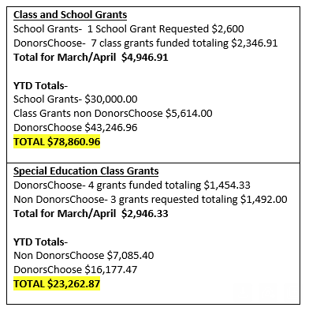
Teen Center-Steve Kier reported that the Teen Centers are coming along nicely! The Bonneville High Teen Center should be completed by the end of May with the Ribbon Cutting in June. The Roy Teen Center won’t be complete until August but they are hoping to have the Food Pantry completed by the end of June. The Weber and Fremont Teen Centers are both in the final planning stages. The Teen Center Newsletter was sent out last week.
Budget for each Teen Center:
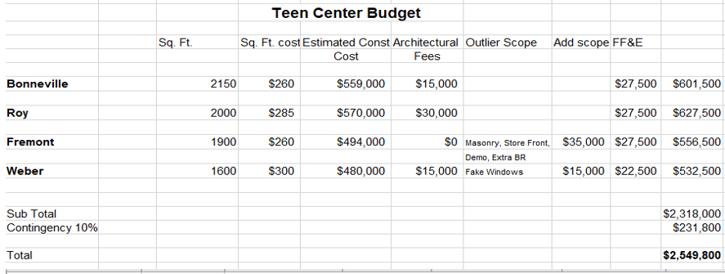
Teen Center Income and Potential Income:
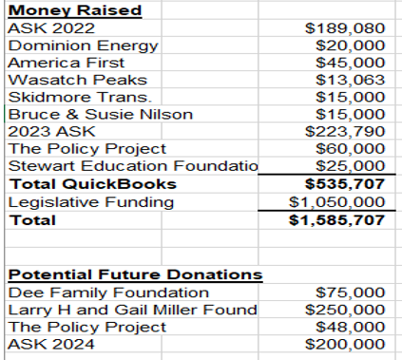

Director’s Report
Profit & Loss-Emily reviewed the Profit & Loss with the board comparing July-April from last year to this current year. (Attached at the end of the minutes with Balance Sheet)
Partners in Education Awardees-Emily informed the board that the nominees this year for the Partners in Education Appreciation Breakfast from Weber School District are:
Sue Westinskow Award-The Policy Project
Community Partner Award-Design West Architects
Secondary Partner Award-Sean Iverson-The Insurance Center
Elementary Partner Award-Sean Jennings-Les Schwab Tire Center
These businesses and individuals were nominated by our principals in the district and will be recognized at the breakfast on April 25, 2024 at the Ogden Weber Technical College Event Center.
LEAP Festival Recap-This year’s LEAP Festival was held on March 28, 2024 at the Ogden Eccles Conference Center. 740 students from 11 schools attended. It was another huge success! We partner with our Student Access Department for this great event. Emily shared some THANK YOU letters from teachers who attended. A video was shown of Native American Hoop Dancers. We hope to be able to continue to offer this cultural field trip in the future.
Ratification-Sea Perch & International Science Fair Funding-Emily reported that Maggie Huddleston-K-12 District Science Teacher Leader is requesting $2,975.00 for student registration fees for 7 students to attend the International Science Fair in Los Angeles May 12-17, 2024. She is also requesting $2,050.00 for 14 students’ registration fees to attend the Sea Perch International Competition in Maryland on June 1, 2024. Total for both requests are $5,025.00. We budget for this each year and take this out of Curriculum Projects. Kathy Saunders made the motion to approve these requests with a second from Craig Dearden. The Board unanimously approved.
Golf Update-Michelle sent out the volunteer Google Form yesterday. We are updating our signage this year with a new logo. We are one team over and even though we increased our sponsorship levels we still have a waiting list. Jamie is collecting raffle items. We are excited for the tournament on Monday, June 10, 2024 at the Ogden Golf & Country Club.
National Conference Take a Way’s-Emily and Michelle attended the National Association of Public-School Foundations in Tampa, Florida. Michelle thanked the board for the chance to attend the conference. Some of the take a ways were; Opportunity Fund, Legal and Compliance with 990 Updates, Gift Acceptance, New Raffle Compliance and AI. It was a very informative conference.
President’s Award Banquet RSVP-The President’s Award Banquet will be held on Tuesday, May 7, 2024 at the Timbermine. Please RSVP to Jamie by May 1st with your food selection. This is our last meeting for this school year.
Other Business-Emily informed the board of an exciting event put on by the Major Brent Taylor Foundation called the BT5 Leadership Seminar. It will discuss Passion, Resilience, Confidence, Communication and Decision Making. It will be held at Weber High School on Saturday, May 4, 2024 from 10am-2pm.

Next Meeting
August 2024
Date TBD

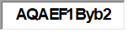  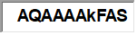 |  |  |  |  |  | July ‘22-April ‘23 | July ‘23-April ‘24
Permanently Restricted Funds
 |  |  |  | 41000 · Permanently Restricted Income
 |  |  |  |  | 41010 · Perm – Corporations/Foundations | 73,947.86 | 5,330.24
 |  |  |  |  | 41020 · Perm – Individuals | 135,970.00 | 17,350.00
 |  |  |  | Total 41000 · Permanently Restricted Income |  | 209,917.86 | 22,680.24
Temporarily Restricted Funds
 |  |  |  | 42000 · Temporarily Restricted Income
 |  |  |  |  | 42010 · Pass thru Donations | 433,540.32 | 389,402.81
 |  |  |  |  | 42020 · Project Donations | 361,584.79 | 669,715.96
 |  |  |  |  | 42200 · Temp – Grant Received | 8,000.00 | 8,000.00
 |  |  |  |  | 42070 · Temp – Gifts In Kind
 |  |  |  | Total 42000 · Temporarily Restricted Income |  | 803,125.11 | 1,067,118.77
 |  |  |  | 52000 · Temp Restricted Expense
 |  |  |  |  | 52010 · Pass thru Expense | 431,740.32 | 402,802.81
 |  |  |  |  | 52020 · Project Expense | 329,434.40 | 373,812.29
 |  |  |  |  | 52070 · Temp-Gift in Kind
 |  |  |  | Total 52000 · Temporarily Restricted Expense |  | 761,174.72 | 776,615.10
 |  |  |  | Temp Restricted Net |  | 41,950.39 | 290,503.67
Unrestricted Funds
 |  |  |  | 43000 · Unrestricted Income
 |  |  |  |  | 43010 · Corporate/Foundation | 7,282.25 | 12,902.81
 |  |  |  |  | 43020 · Individual Contributions | 2,072.36 | 1,537.08
 |  |  |  |  | 43050 · United Way of Northern Utah | 660.00 | 0.00
 |  |  |  |  | 43055 · Employee Designated | 17,788.50 | 14,060.00
 |  |  |  |  | 43070 · Gifts in Kind
 |  |  |  |  | 43500 · Christmas Jubilee Income | 543,263.03 | 571,837.22
 |  |  |  |  | 43600 · Golf Classic | 79,600.00 | 83,100.00
 |  |  |  | Total 43000 · Unrestricted Income |  | 461,586.14 | 398,236.90
 |  |  |  | 53000 · Unrestricted Expenses
 |  |  |  |  | 53070 · Unrestricted-Gift in Kind
 |  |  |  |  | 53100 · Grants | 132,668.57 | 132,683.11
 |  |  |  |  | 53200 · Christmas Tree Jubilee Expenses | 112,633.22 | 104,783.39
 |  |  |  |  | 53300 · Golf Classic Expenses | 225.23 | 997.50
 |  |  |  |  | 53400 · Business Expenses | 26,148.84 | 30,883.51
 |  |  |  |  | 53500 · Contract Services | 36,052.96 | 40,399.90
 |  |  |  |  | 53600 · Operations | 13,708.24 | 16,184.97
 |  |  |  |  | 53700 · Other Types of Expenses | 1,234.00 | 2,063.00
 |  |  |  |  | 53730 · Reconciliation Discrepancies | 0.00 | 0.00
 |  |  |  |  | 53800 · Ogden Raptors Night-Expenses | 0.00 | 165.69
 |  |  |  | Total 53000 · Unrestricted Expenses |  | 322,671.06 | 334,161.07
 |  |  |  | Unrestricted Net |  | 138,915.08 | 64,075.83
Total Funds
 |  |  | Total Income |  |  | 1,474,629.11 | 1,488,535.91
 |  |  | Total Expense |  |  | 1,083,845.78 | 1,110,776.17
 | Net Ordinary Income |  |  |  |  | 390,783.33 | 377,759.74
 | Other Income/Expense
 |  | Other Income
 |  |  | 60000 · Interest and Dividends Revenue |  |  | 133,798.46 | 149,018.18
 |  |  | 61000 · Capital Gains |  |  | 0.00 | 0.00
 |  | Total Other Income |  |  |  | 133,798.46 | 149,018.18
 | Net Other Income |  |  |  |  | 133,798.46 | 149,018.18
Net Income |  |  |  |  |  | 524,581.79 | 526,777.92

Apr 16, 24
ASSETS
Weber School District Balance Sheet
As of April 16, 2024

Current Assets
Checking/Savings
10000 · Wasatch Peaks CU Checking 316,180.26
10010 · Wasatch Peaks CU Savings 936.01
10202 · Raymond James Cash Account 9,075.95
10700 · Bank of Utah 1,136,925.98
Total Checking/Savings 1,463,118.20
Accounts Receivable
11001 · Accounts Receivable 26,088.20
Total Accounts Receivable 26,088.20
Other Current Assets
11020 · Raymond James Investment Acct. 3,570,084.62
12001 · Undeposited Funds 25,150.00
12510 · Certificate Wasatch Peaks CU 21,812.43
13000 · Gifts in kind 41,521.06
Total Other Current Assets 3,658,568.11
Total Current Assets 5,147,774.51
Fixed Assets
13010 · Storage Shed 11,662.50
13020 · Accumulated Depreciation -7,138.20
Total Fixed Assets 4,524.30
Other Assets
15100 · Land - Strawberry 6,000.00
18600 · Other Assets 15,751.06
Total Other Assets 21,751.06
TOTAL ASSETS 5,174,049.87
LIABILITIES & EQUITY
Liabilities
Current Liabilities
Credit Cards
10440 · Wastach Peaks Visa 5,646.48
Total Credit Cards 5,646.48
Other Current Liabilities
23000 · Deferred Liabilty -0.37
Total Other Current Liabilities -0.37
Total Current Liabilities 5,646.11
Total Liabilities 5,646.11
Equity
31300 · Perm. Restricted Net Assets 1,780,549.76
31500 · Temp. Restricted Net Assets 529,010.53
31800 · Unrestricted Net Assets 287,410.00
31900 · Unrealized Gain/Loss on Inv. 178,555.50
32000 · Retained Earnings 1,866,100.05
Net Income 526,777.92
Total Equity 5,168,403.76
TOTAL LIABILITIES & EQUITY 5,174,049.87

