Present: Zachary Posner (Information Technology), Chris Harding (Auditor), Lisa Ashman-online (District Attorney), Hoa Nguyen-online (Council), Megan Hillyard-online (Administrative Services), Talia Butler-online (Public Works), Will Kocher-online (Recorder), Phil Conder (Treasurer), Katy Fleury-online (Mayor Administration), Reid Demman (Surveyor), Chris Stavros (Assessor), Robin Chalhoub-online (Community Services), Kelly Colopy-online (Human Services)
Representation Absent: Clerk, Sheriff
Staff Present: Tony Jolley-online, Rina Shipley, Cindy Beck, Andrew Dudley-online, Corey Hess-online, Dean Bullock-online, Lee Wilstead-online, Mark Miller, Mike Bailey-online, Kira Moody, Hillary Boccagno-online, Trevor Hebditch, Cherie Root, Ben Thompson-online, Brandon Allgier-online, Jon Thelen-online, Thomas Yeung-online, Sam Sedivec-online, Kimball Ball-online, Valina Eckley-online
TOPIC | POINTS OF INTEREST
Welcome & Remote Meeting Instructions | Chris Stavros opened the meeting.  Trevor Hebditch shared the following slide:  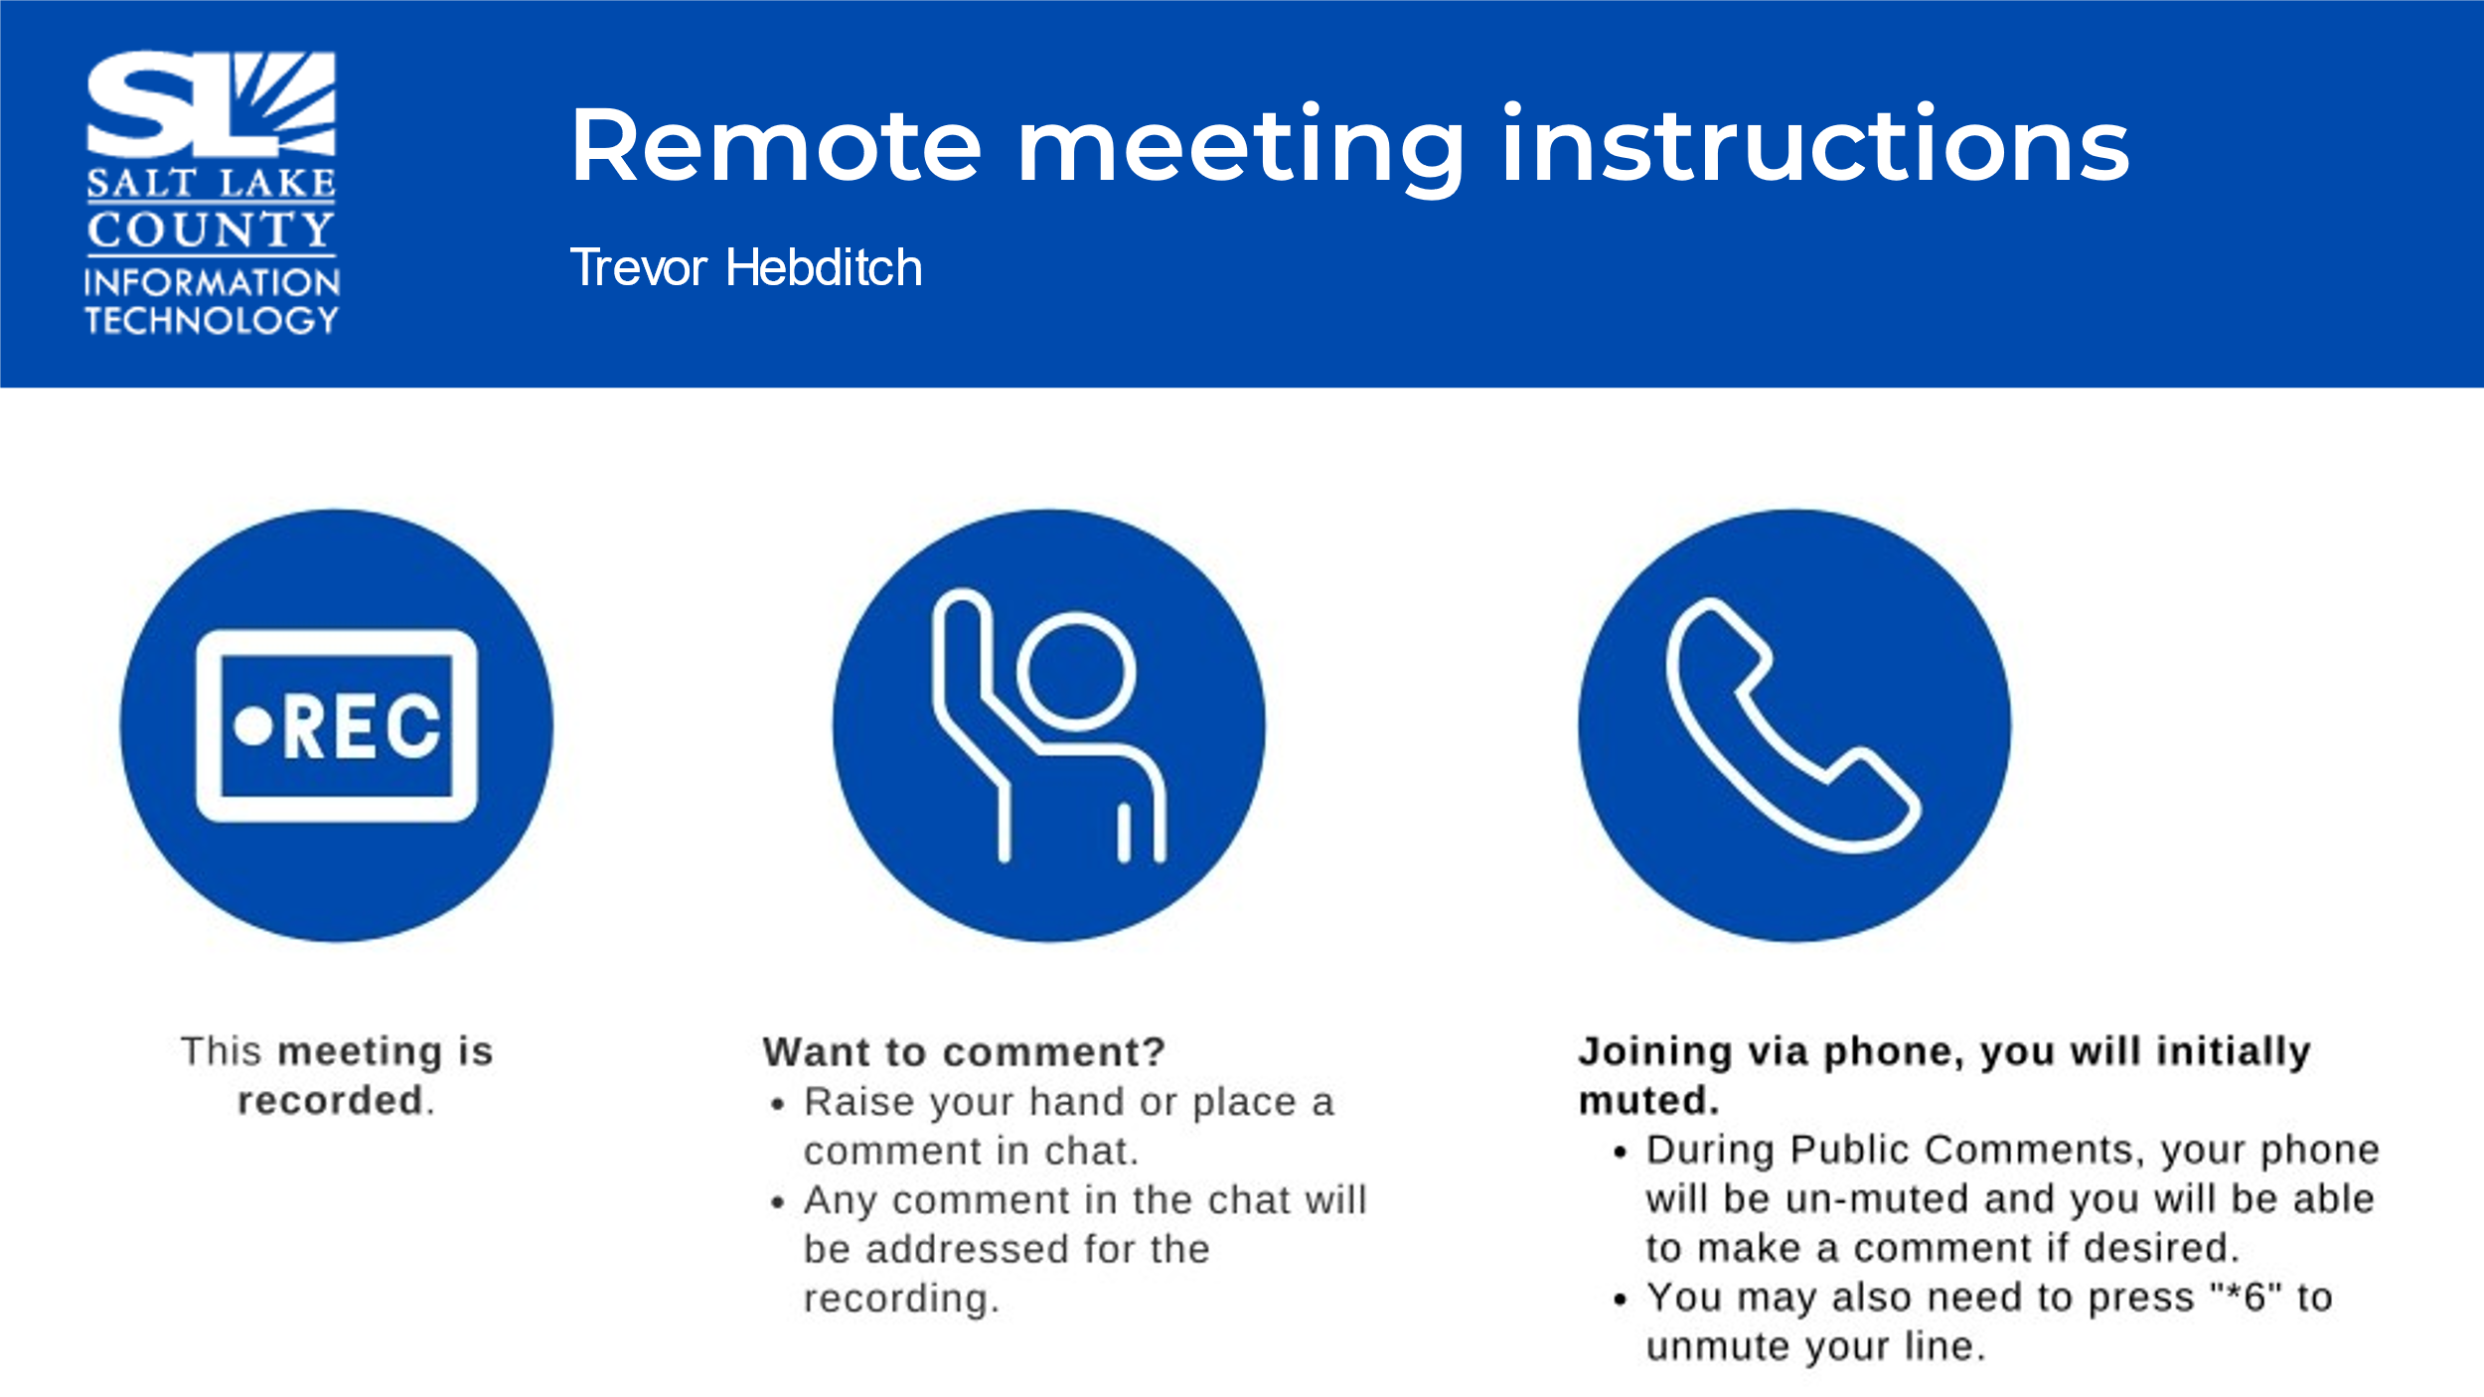
Public Comments  (Chris Stavros) | None.
Approval of minutes from April 25th, 2024, meeting | Motion to approve the minutes by Reid Demman, Phil Conder seconds the motion. No discussion.  Motion passed unanimously.
Open and Public Meeting Training  (Dianne Orcutt)  Open and Public Meeting Training (cont.)  (Dianne Orcutt)  Open & Public Meetings Act Training (OPMA)  *TAB Members are required to complete the annual. | 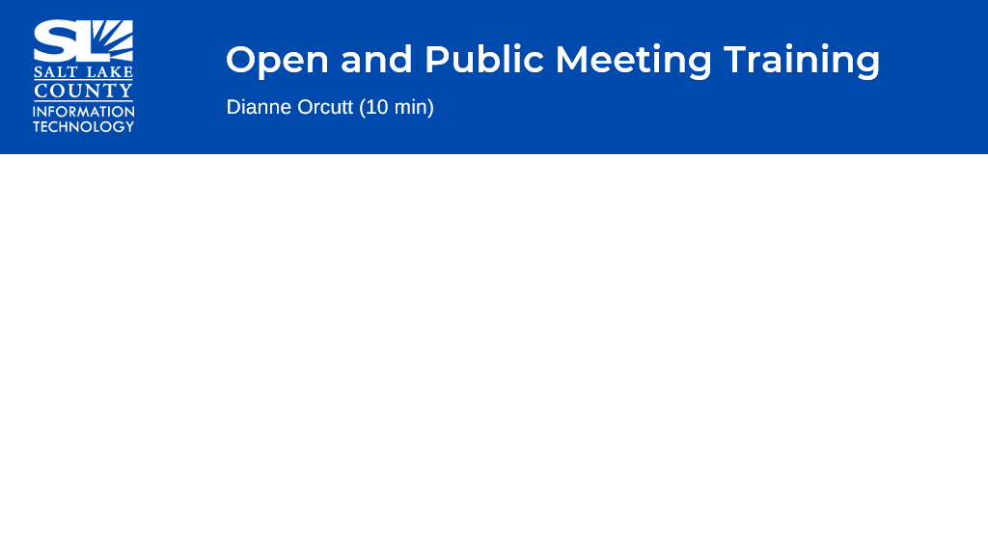  - Public Policy Statement: The County/TAB exists to aid in the conduct of the people’s business.  - TAB should: take its actions openly & conduct its deliberations openly.  - All TAB members are subject to completing the annual statutory compliance training.  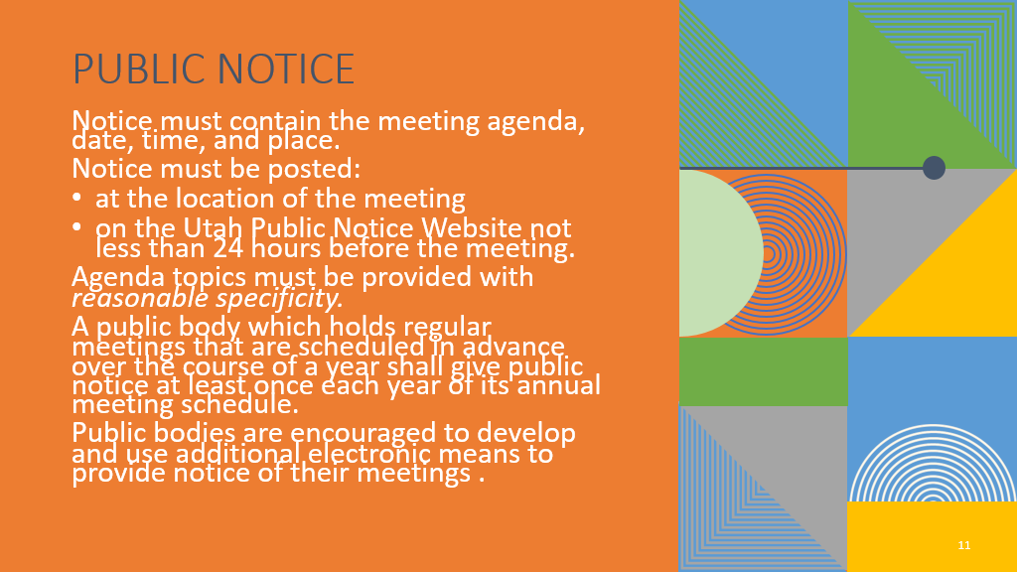  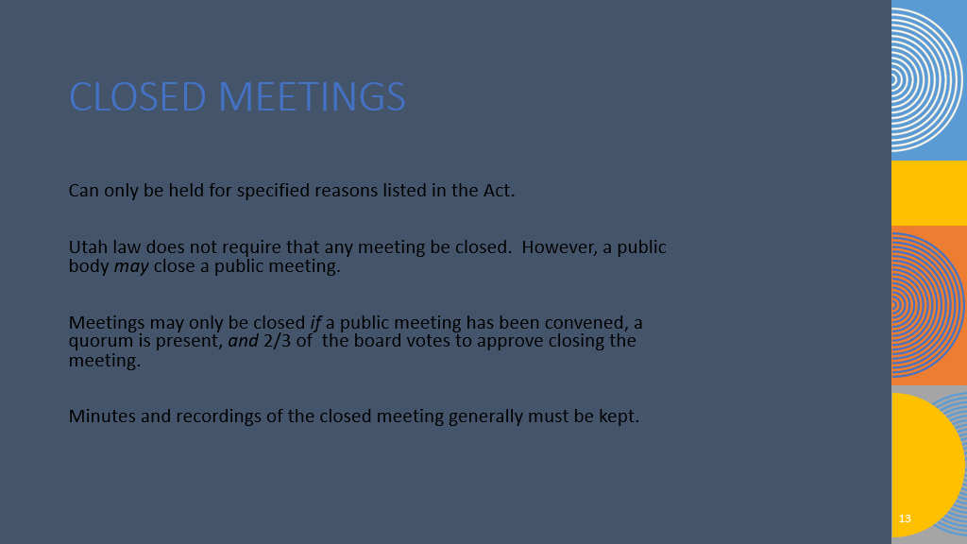  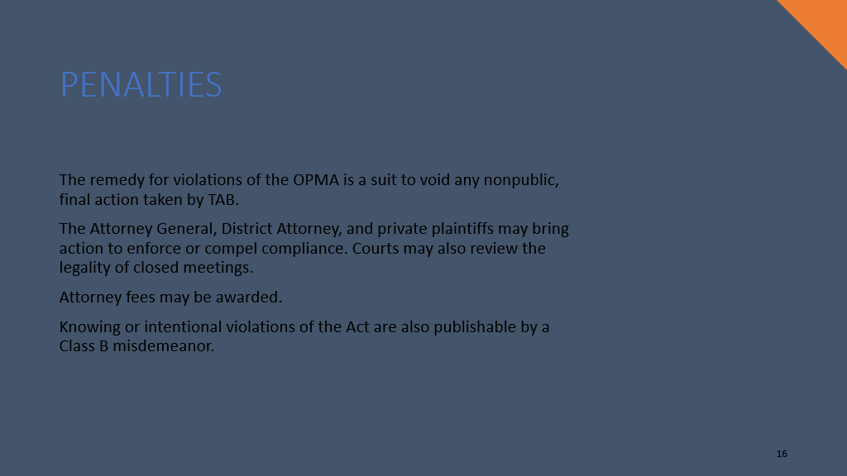
Follow-Up Items (Cherie Root) | 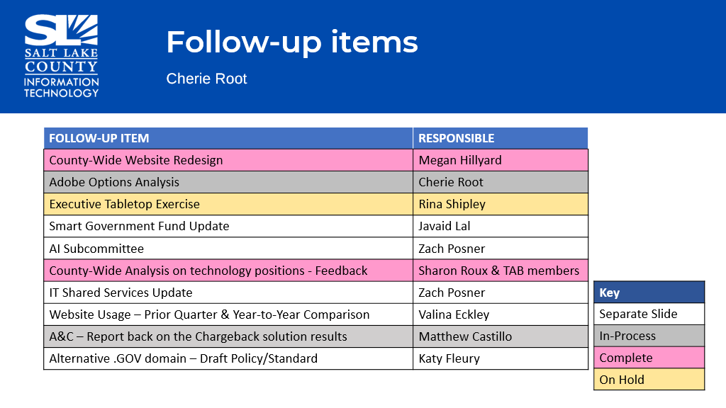
IT Shared Services Model (Zach Posner)  *Reminder*  The framework that has been built will assist in the decision-making process around where services should live within a centralized framework vs within the agency.  Having a common set of frameworks & standards will help clear up confusion and push back that can occur.  There are excellent resources within some of these agencies that the rest of the County should have access to. | 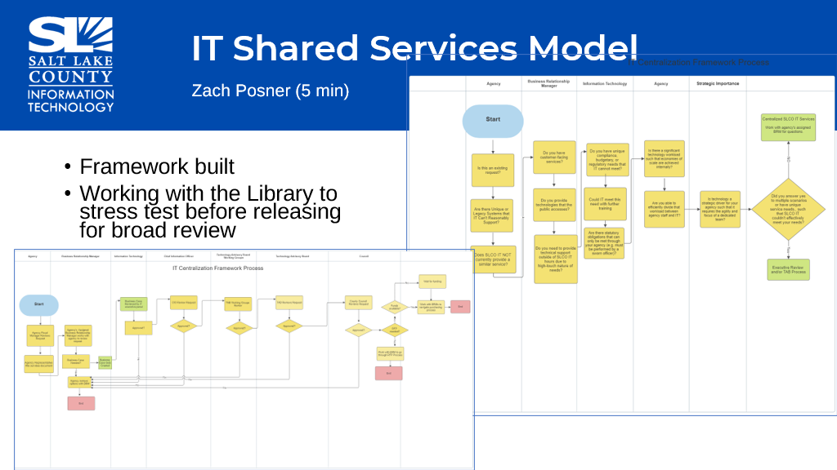  - Starting with the Library and stress testing to make sure the framework makes sense.  - Then, we will work it through the Mayor’s portfolio to see how it goes and what we discover.  - At a future date, the results will be brought back to TAB to determine to move forward and standardize these things around the County.  - An important point is there are good reasons why some agencies have developed their own IT resources based on the type of business that agency is a part of.
AI Policy Group (Zach Posner)  It was noted the following people volunteered to be a part of this group: Lisa Ashman, Phil Conder, Kelly Colopy, & Reid Demman. | 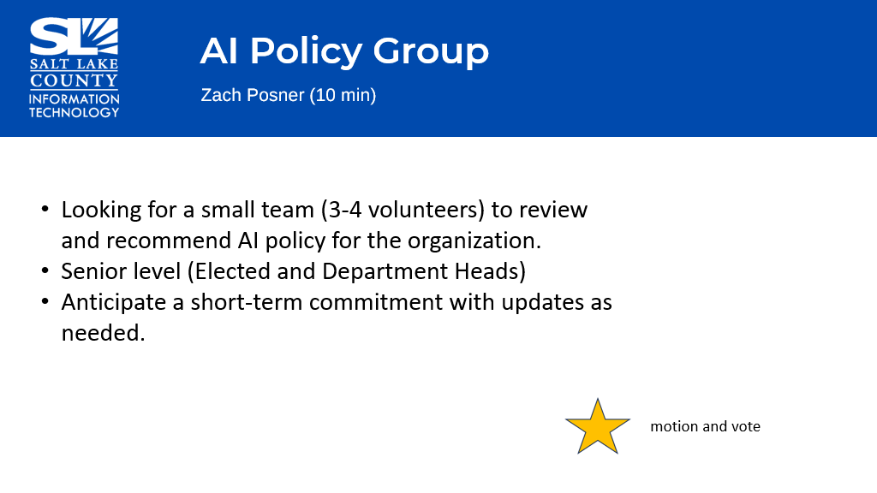
Approval of AI Policy Group Volunteers | Motion to approve the volunteers for the AI Policy Group, by Megan Hillyard, Chris Harding seconds the motion. No discussion.  Motion passed unanimously
Working Group Milestones  (Tony Jolley)  Web Oversight Working Group  (Valina Eckley)  The revisions to the standard are to make sure all content being published for public use shall be made available only on County provisioned CMS systems.  Updates to the standard located in section 2.0 Definitions & Terms, section 3.0 Standard Guidance, specifically 3.1 and 3.3, 3.7, and 3.8. | 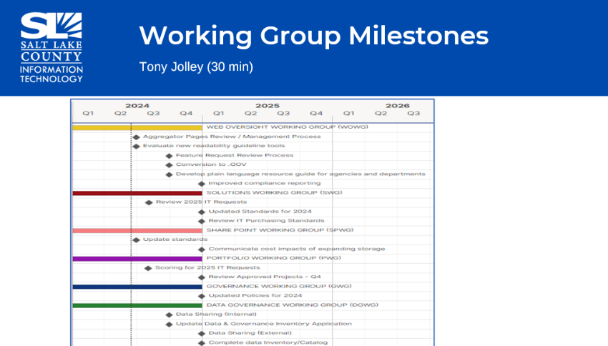  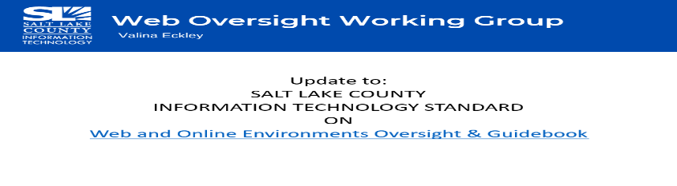  - Added text to the standard: 2.0 Definitions and Terms  “Provisioned Content Management System”: A CMS that has been approved for County use by TAB, IT, County Management, or other official channel.  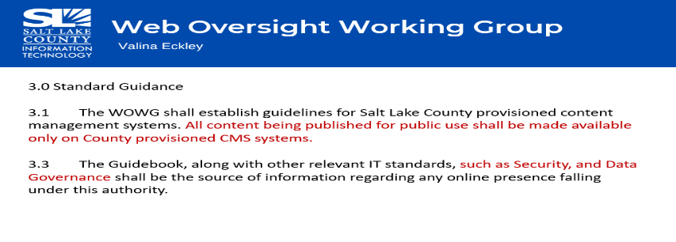  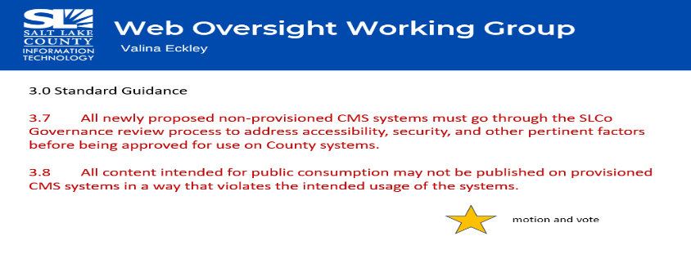
Approval of Updates to Standard on Web and Online Environments Oversight & Guidebook | Motion to approve the updates to the Standard on Web and Online Environments Oversight & Guidebook, as presented other than using “shall” instead of “must” and “may” in 3.7 and 3.8, by Reid Demman, Phil Conder seconds the motion. No discussion.  Motion passed unanimously.
Web Oversight Working Group  (Valina Eckley) | 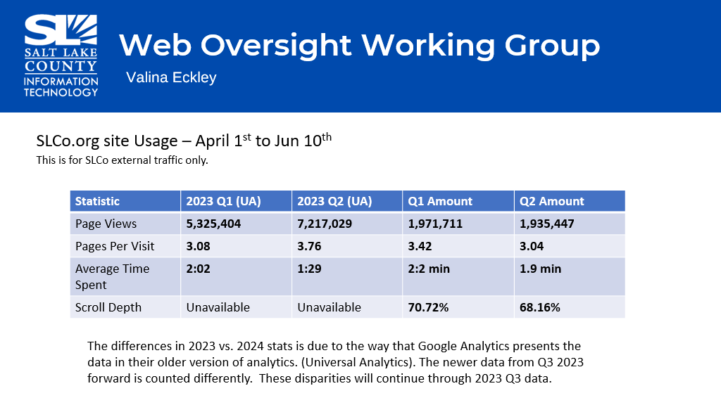  - Reviewed the statistics regarding external traffic to the slco.org site.
Portfolio Working Group – Projects for 2025 (Tony Jolley)  The Business Relationship Managers-Mark Miller & Lee Wilstead reviewed the business cases.  *2025 Request Forms are due by July 1st. | 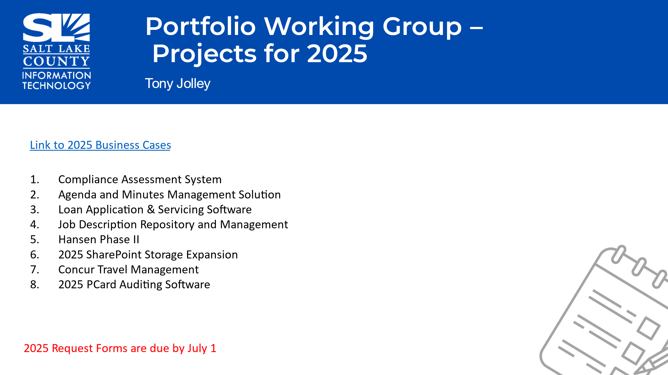
Solutions Working Group  (Rina Shipley)  Update to the Regular & Service Accounts Standard | - This standard is the document that describes the purpose of these accounts (regular & service) and how they are requested, created, and off boarded.  - The update to this standard was to better explain to our partner agencies what happens when an account is off-boarded, as there was some confusion.  - The standard specifies in detail what happens when an off-boarding request is received.  - Some of the changes included minor grammatical and punctuation edits but the bulk of the updates are in the account termination process (off-boarding).
Approval of Updates to Regular and Service Account Standards | Motion to approve the updates to Regular and Service Account Standards by Phil Conder, Kelly Colopy seconds the motion. No discussion.  Motion passed unanimously.
SharePoint Working Group (SPWG) (Hillary Boccagno) | 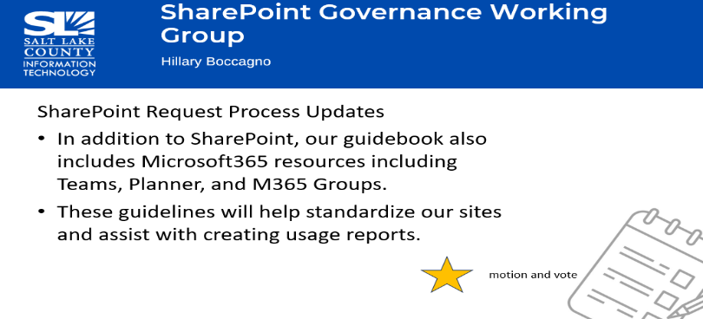
Approval of Updates to SharePoint Guidebook | Motion to approve the updates to the SharePoint Guidebook by Reid Demman, Megan Hillyard seconds the motion. No discussion.  Motion passed unanimously
Data Governance Working Group (Javaid Lal)  The State already has privacy policies. | 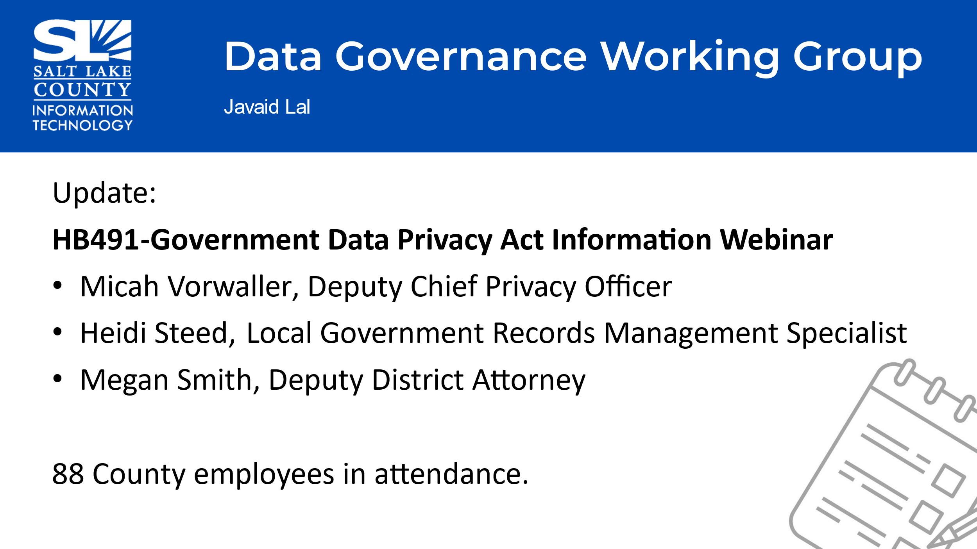  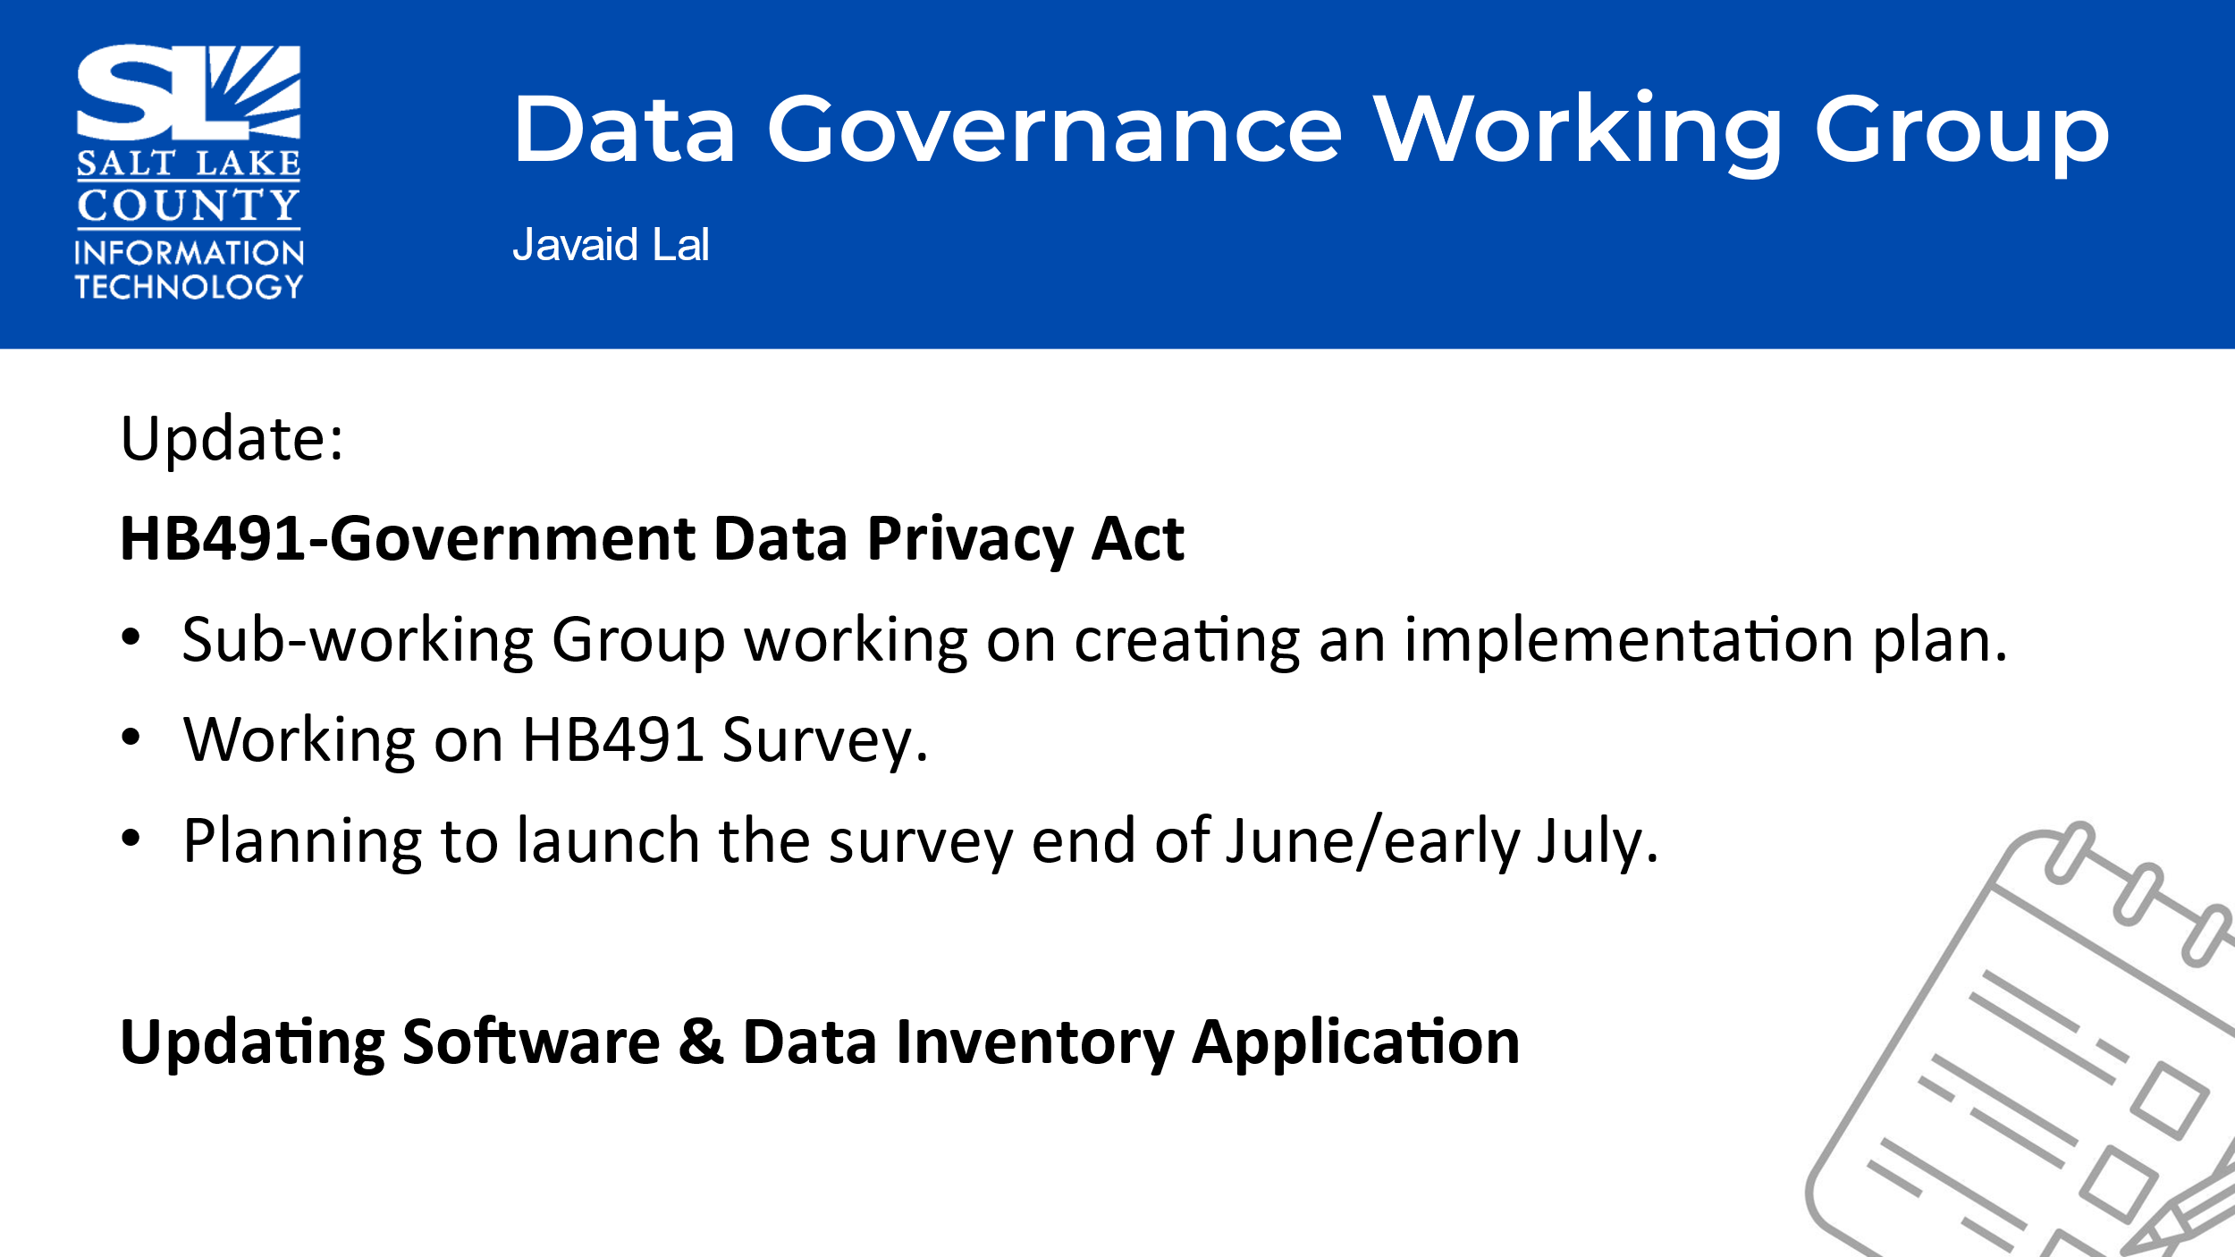
Smart Government Fund Update (Javaid Lal)  *Project submissions to the committee can be made anytime. The committee meets once in June and then in the fall.  A total of 7 Projects has been funded through the Smart Government Fund.  The 3 most recently funded projects.  The 4 projects that are in “flight”. A link to the dashboard has been provided to show the progress that has been made in each of the projects. | 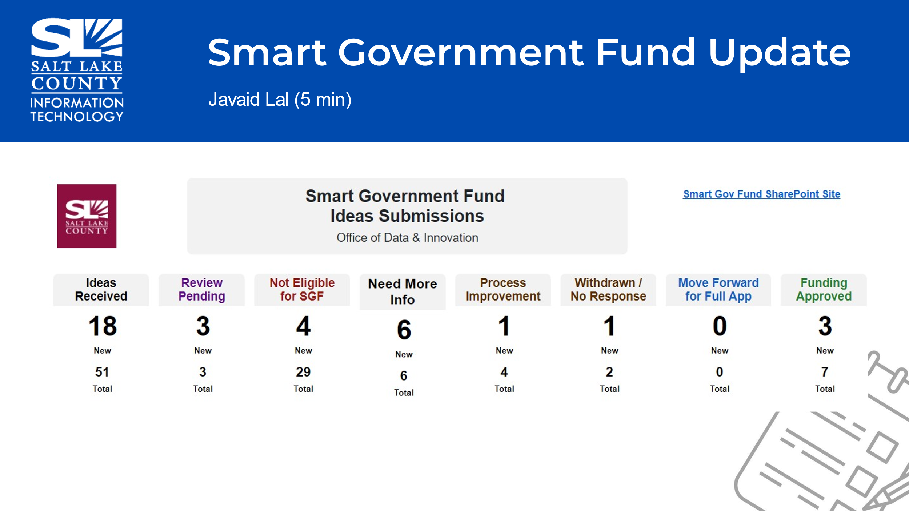  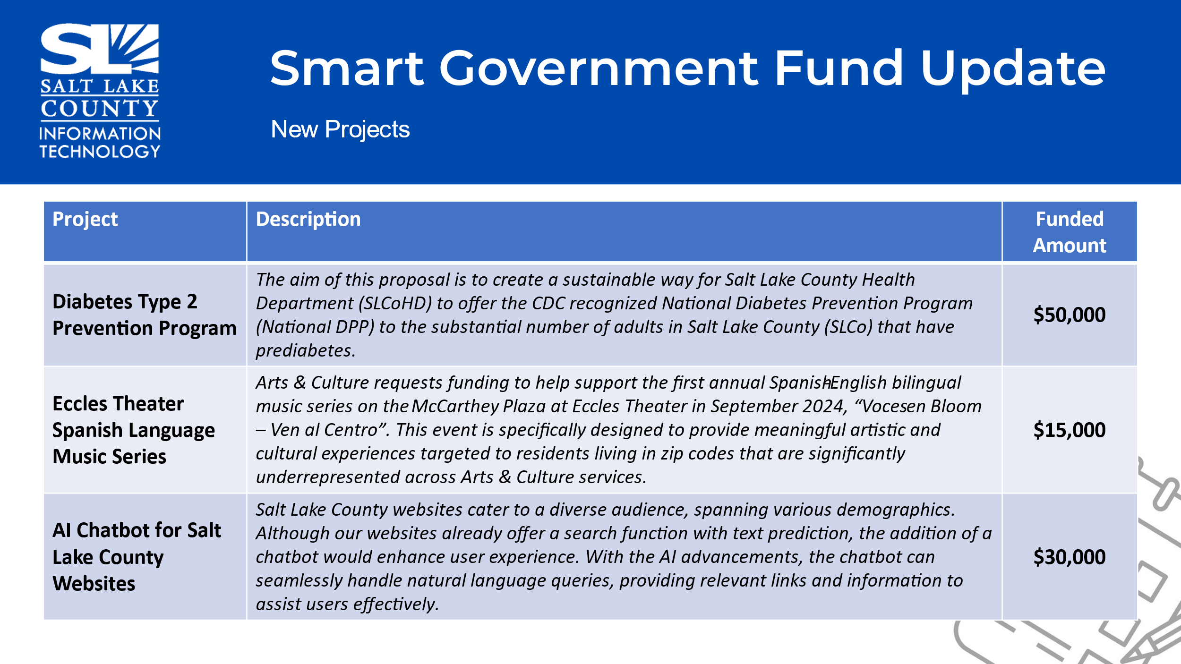  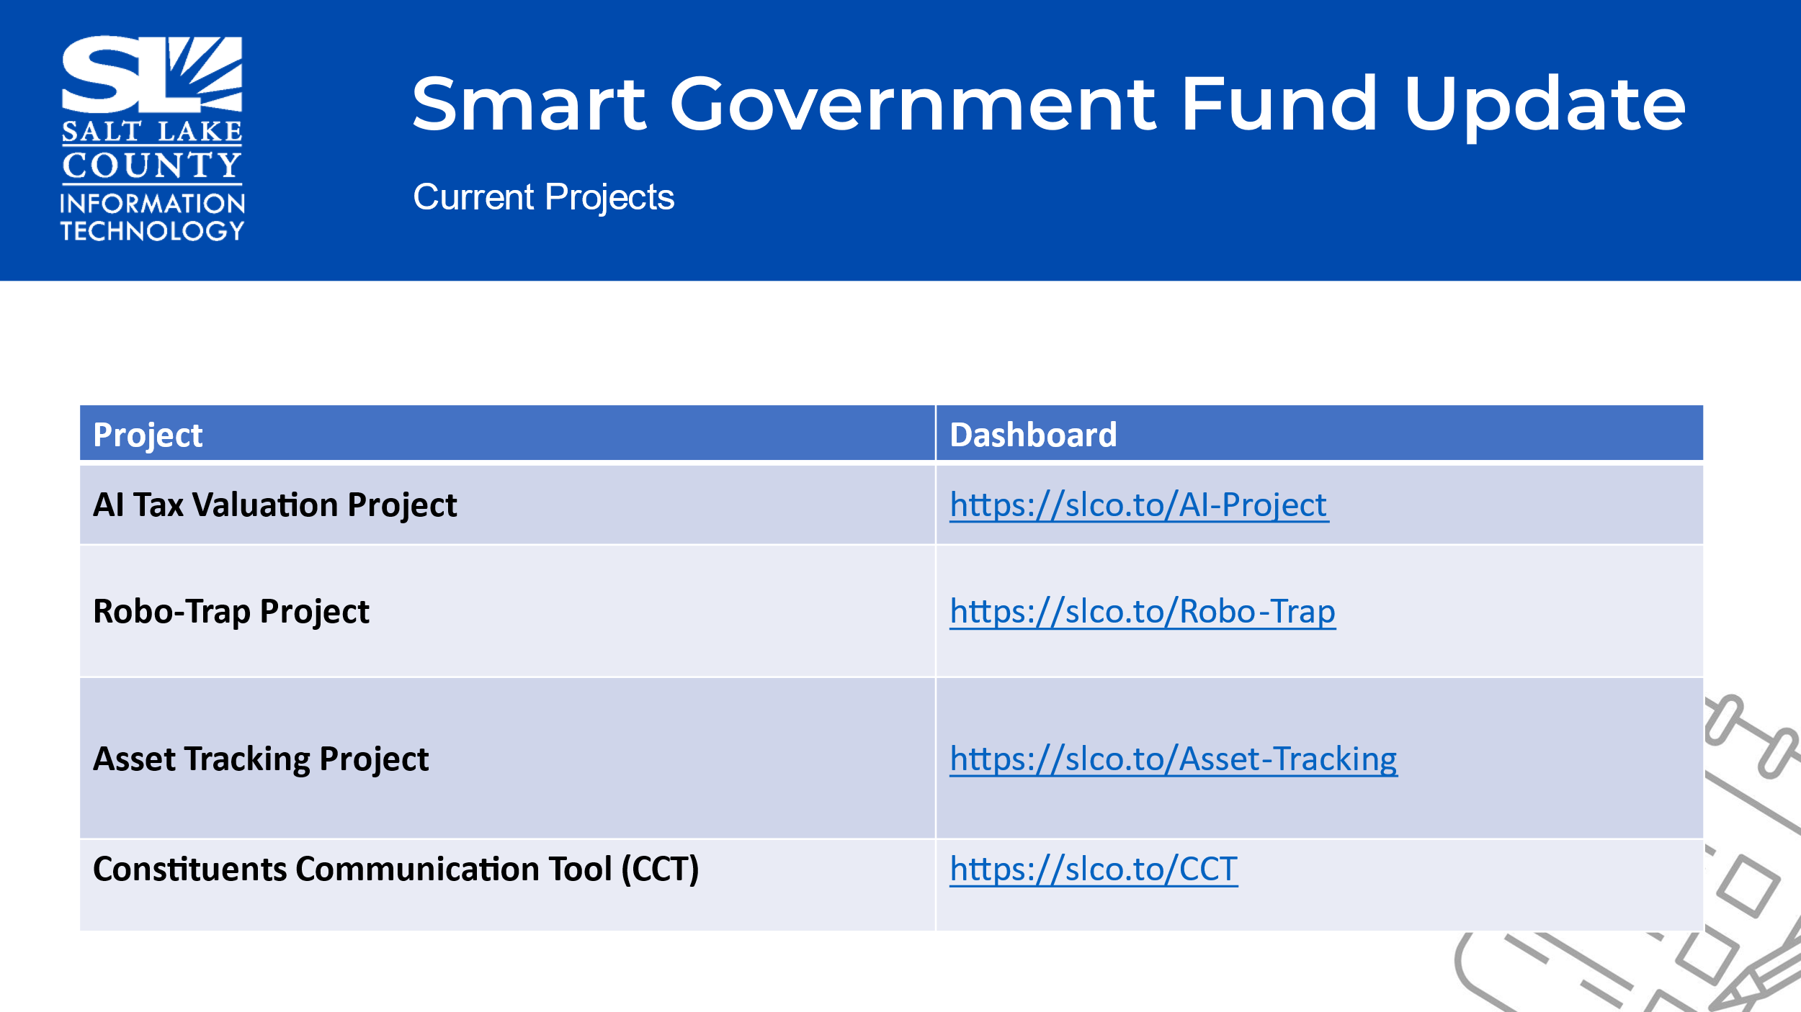
Alternative .gov Domains (Katy Fleury)  Purpose: To create a (draft) standard on email and website domains to build uniformity.  URL Exceptions:  Commercial Use  Established .ORG URLS  Established .GOV URLS  Established Vanity URLS | 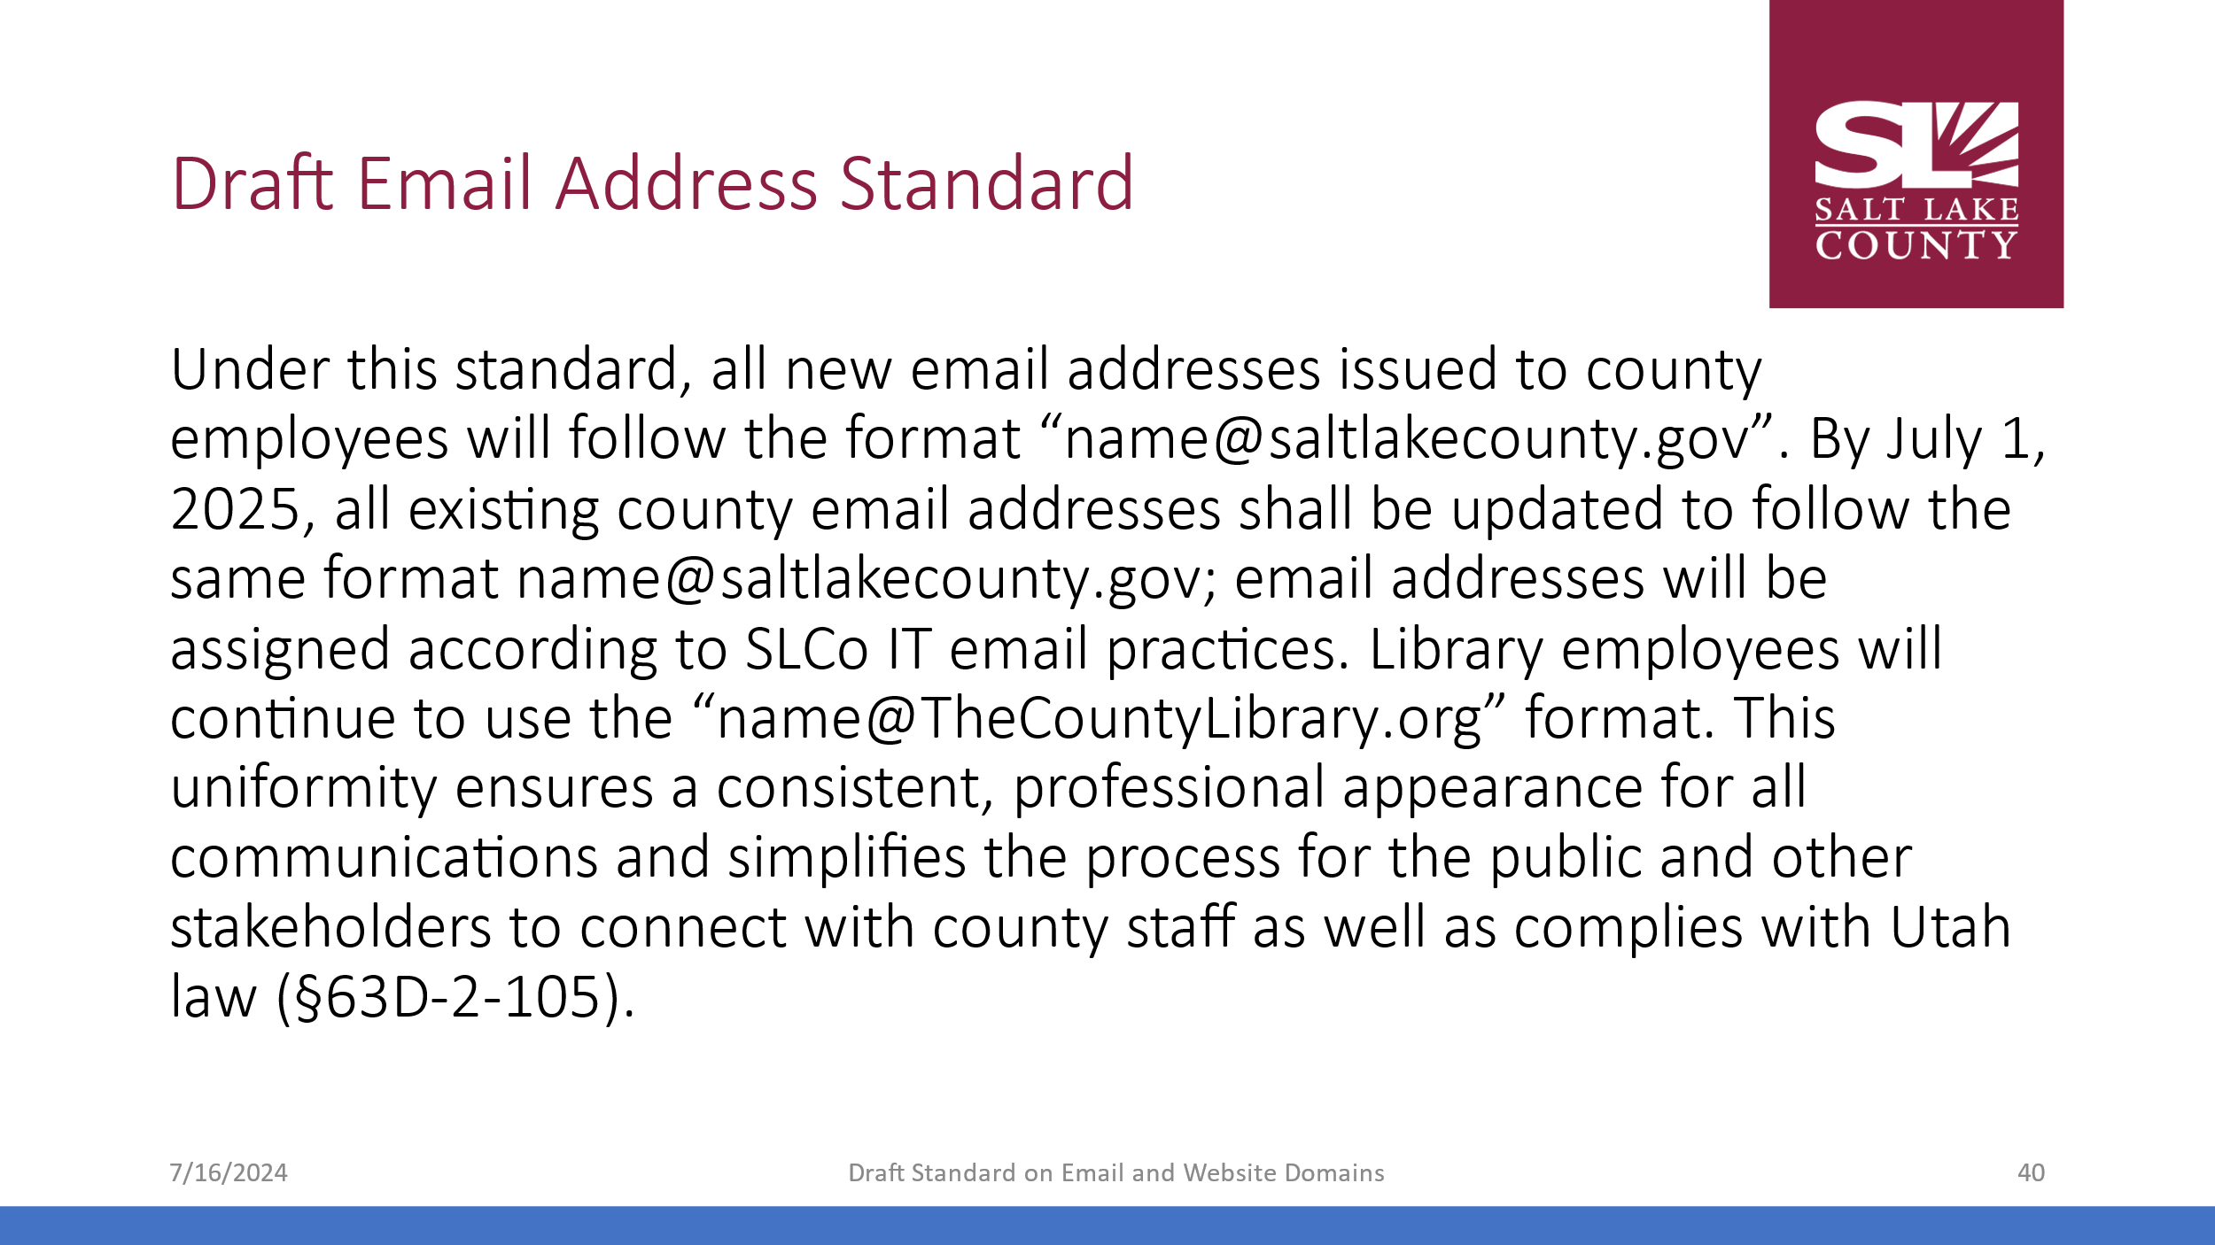  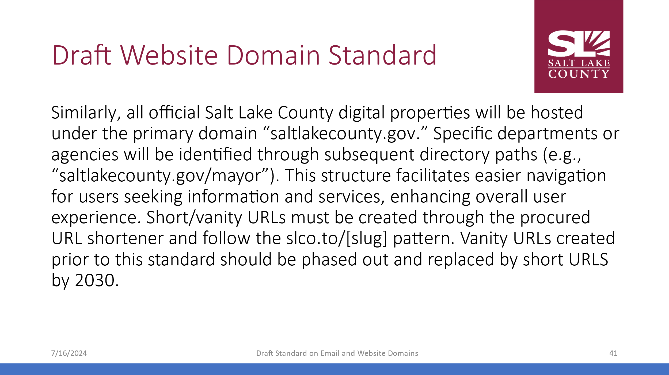  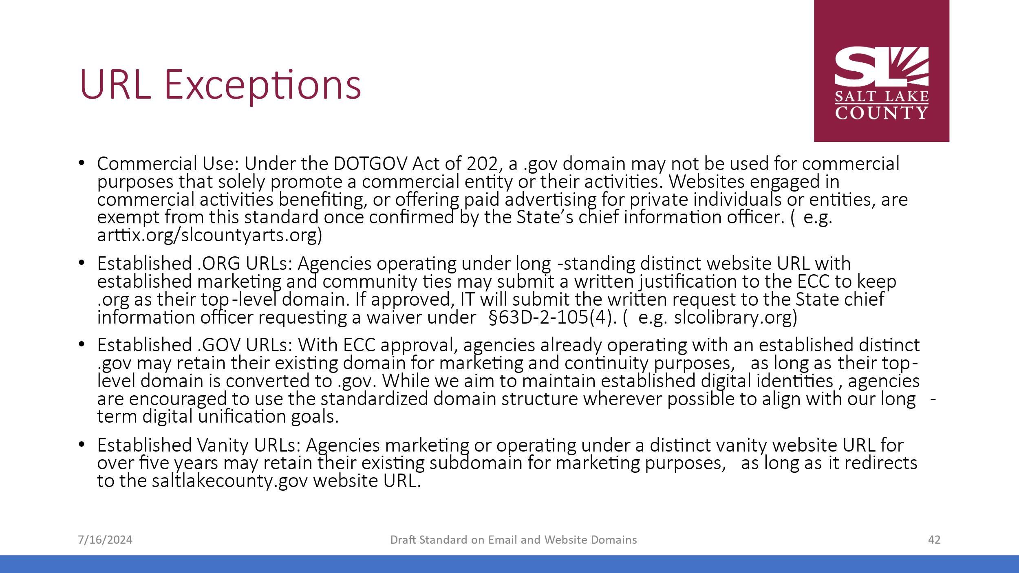  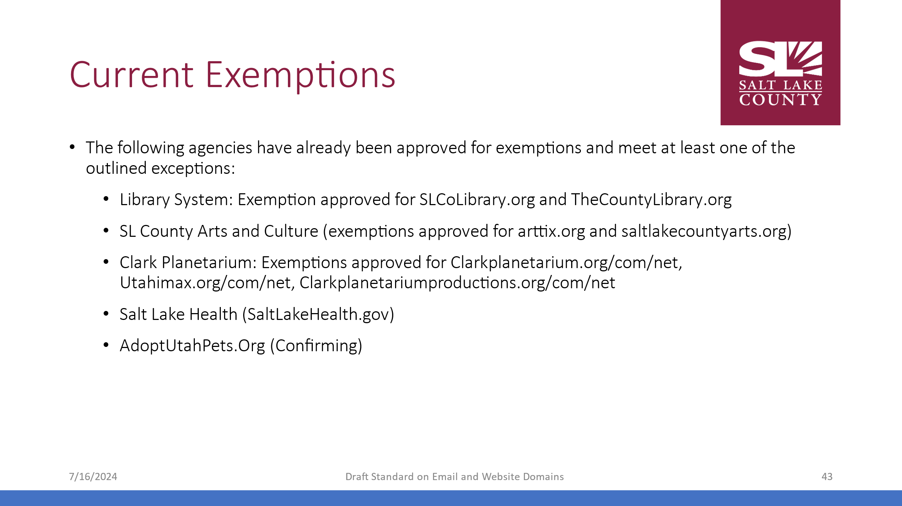
IT Security Update (Closed Session) | Motion to enter a closed session to discuss deployment of security personnel, devices, or systems by Reid Demman, Phil Conder seconds the motion. No discussion.  Aye: Administrative Services, Assessor, Auditor, District Attorney, Human Services, Mayor Administration, Public Works, Recorder, Surveyor, Treasurer  Nay: None  Roll Call: Absent Community Services, Clerk, Sheriff  Motion passed unanimously.  Motion to exit the closed session by Phil Conder and Chris Harding, seconds.  Motion passed unanimously.
Upcoming Meeting Schedule (Cindy Beck)  *Please note the August sessions are the combined TAB Meeting with GIS Steering Committee. | 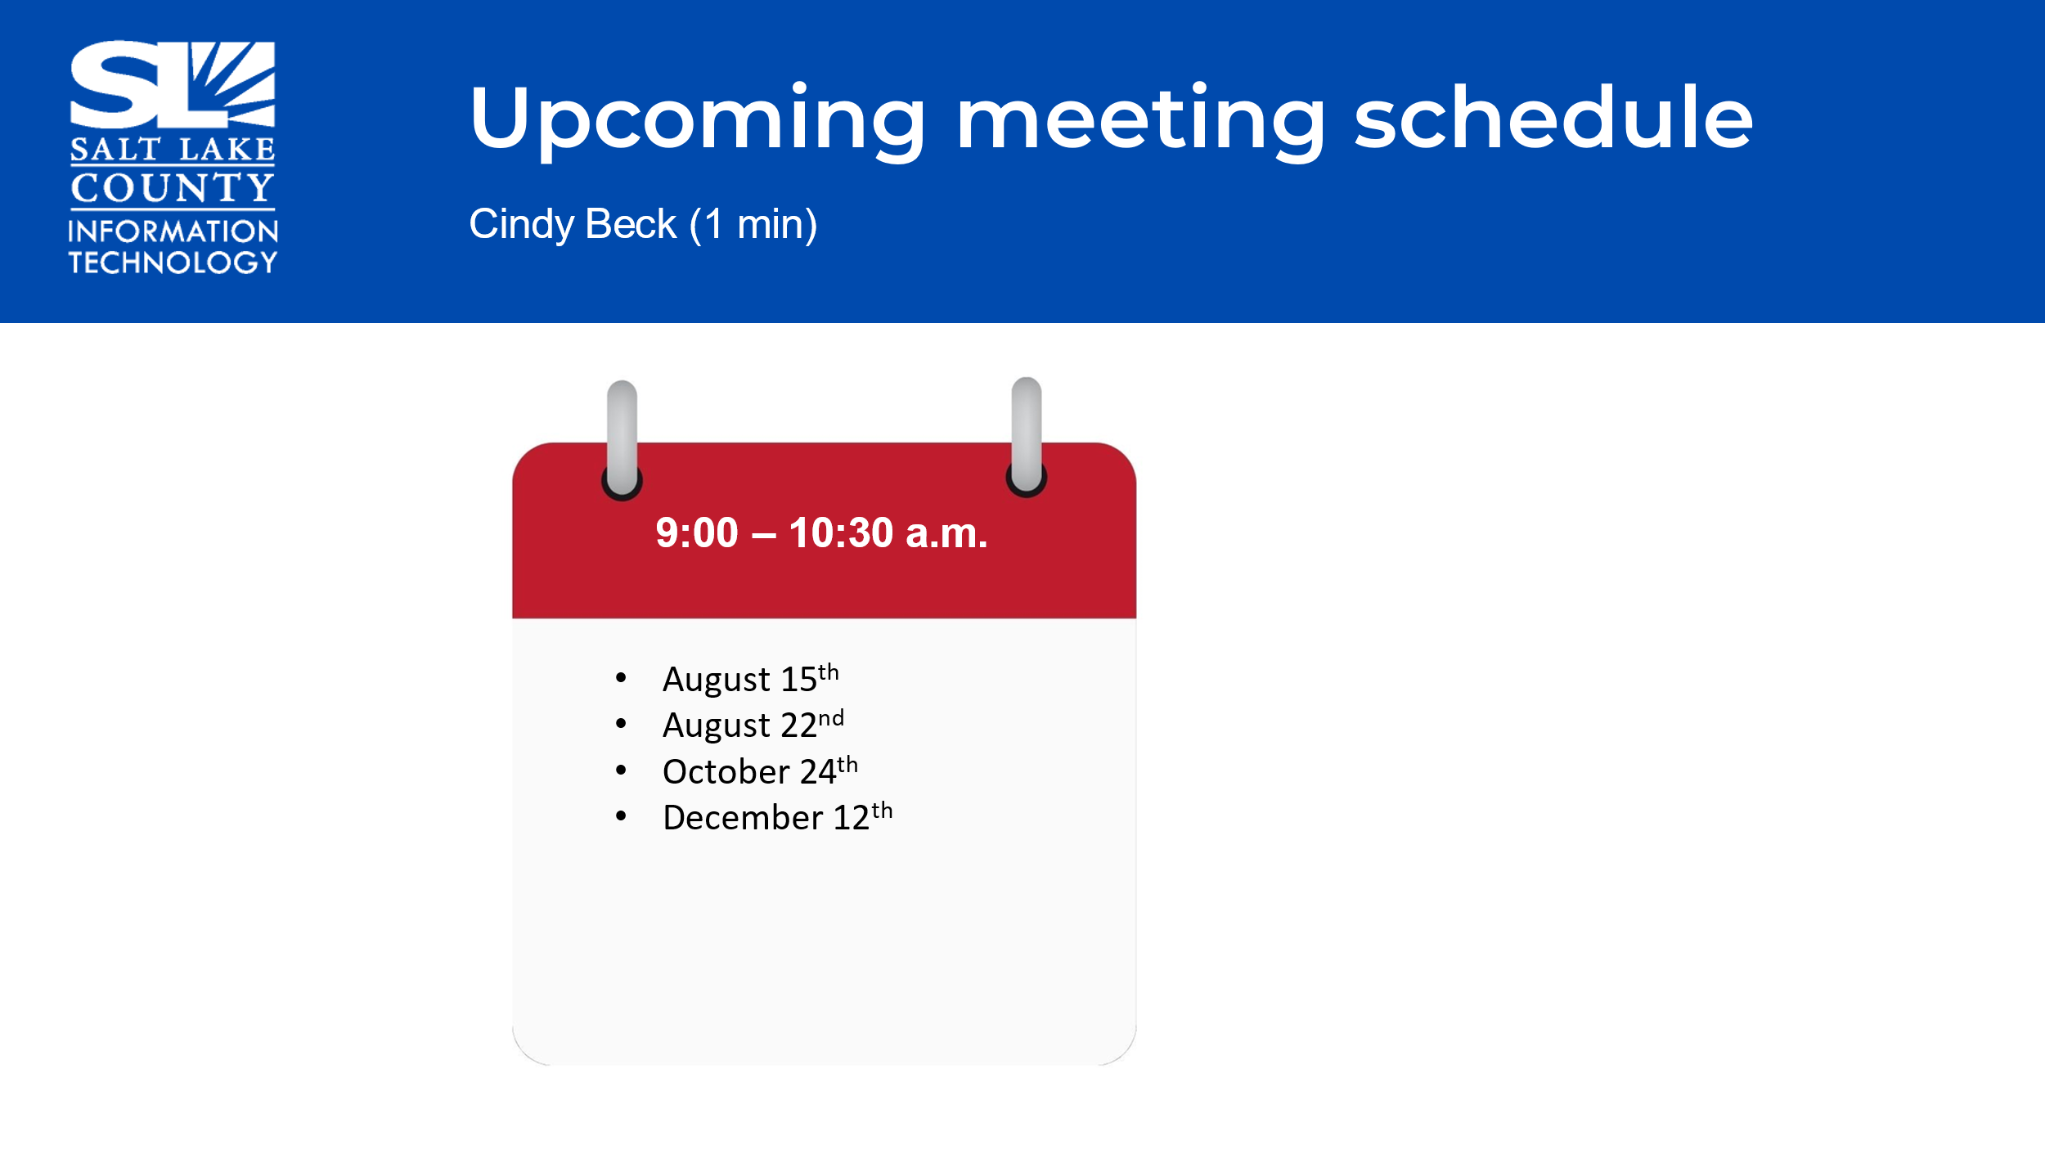
Review Action Items (Cindy Beck)  Four Action Items |   - Dianne Orcutt will verify the TAB requirements as it relates to posting the approved minutes.  - Valina Eckley will investigate why the numbers have decreased with regard to external traffic to the Salt Lake County website from Q1 2023 to Q1 2024.  - Valina Eckley will do a demo of screen readers  - Absent TAB members to review OPMA training and report completion to Chair.
End of Session | - Motion to adjourn the meeting by Reid Demman. No objections. Meeting adjourned. So moved.
Next TAB Meeting August 15th, 2024. | 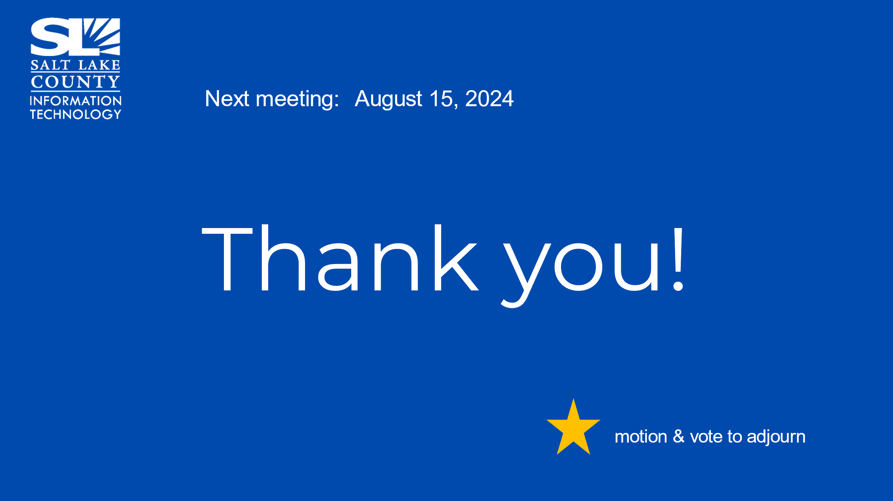
Next Meeting | August 15, 9:00 – 10:30 AM
Submitted by Cindy Beck

