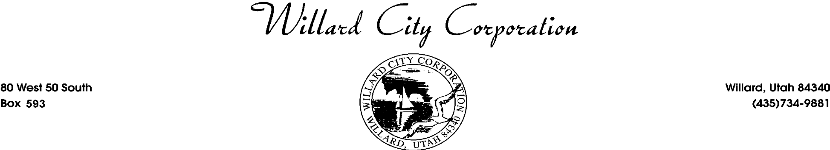

AMENDED MEETING (4D)
The Willard City Council of Willard City Corporation will hold a City Council meeting on Thursday, August 8, 2024. The meeting will be held at the Willard City Offices 80 W 50 S. The meeting will begin promptly at 6:30 p.m. The agenda will be as follows:

6:30 p.m.

1. Call to Order
- Invocation
- Pledge of Allegiance
- Conflict of interest declaration
6:30 p.m.
- Open Comment Period (Individuals have three minutes for open comments. If required, items may be referred to department heads for resolution. Items requiring action by the City Council will be placed on the agenda for a future meeting.)

3. Planning Commission Report

4. Presentations and New Business
a. Discussion and Approval of Resolution 2024-12 Amending the Willard City Personnel Policy relating
to sick and vacation leave to include donation of sick and vacation leave.
b. Discussion and Approval of Resolution 2024-13 to approve the Water Conservation Plan.
c. Discussion and Approval of Ordinance 2024-09 allowing Short Term Rentals.
d. Discussion for Water right requirements for rezones and subdivisions.

5. Minutes
a. Approval of June 27, 2024, Minutes
b Approval of the July 25, 2024, Minutes

6. Financial
a. Warrants, Vouchers, Reports

7. Department Reports
- Public Works
- Police Department
- Fire Department

8. Council Member Reports
- Jacob Bodily
- Rod Mund
- Mike Braegger
- Rex Christensen
- Jordan Hulsey
9. Next agenda items August 22, 2024

10. Mayor’s General Correspondence and Information

11. City Manager’s Report

12. City Planners Report
13. Consideration of Motion to Enter a Closed Session (if necessary) pursuant to UCA §52-4-205 (a) except as provided in Subsection (3), discussion of the character, professional competence, or physical or mental health of an individual; (b) strategy sessions to discuss collective bargaining; (c) strategy sessions to discuss pending or reasonably imminent litigation; (d) strategy sessions to discuss the purchase, exchange, or lease of real property, including any form of a water right or water shares (e) strategy sessions to discuss the sale of real property, including any form of a water right or water shares; (f) discussion regarding deployment of security personnel, devices, or systems; or (g) investigative proceedings regarding allegations of criminal misconduct.

14. Adjourn
/s/ Susan Obray
City Recorder, Willard City
Posted August 5, 2024

