Meeting Minutes
Southwest Technical College
Board of Trustees Meeting
Thursday, March 7, 2024; 12:00 – 2:00 p.m.
Southwest Tech Boardroom

Board of Trustees
Chairperson: Darin Gifford, Kristie McMullin, Roger Howard, Eric Packer, Garrett Cottam, Sharon Corry, Paul Terry, Beverly Burgess, Jarad Brinkerhoff, Dave Staheli, and Myron Cottam

Southwest Tech: Brennan Wood, James Mullenaux, Scott Leavitt, Clarissa Crosby, Neal Mason, and Gail Goodman

USHE Guests: Interim Commissioner Geoffrey Landward, Assistant Attorney General Eric Petersen

I. Agenda Items by Darin Gifford, Chairperson
- Call to order 12:02pm
A quorum was confirmed. Chair Gifford called the meeting to order at 12:02pm.

- Pledge of Allegiance
Chair Gifford led the Pledge of Allegiance.

- Approval of the Agenda
Chair Gifford asked for a motion to approve the agenda. Paul Terry motioned to approve the meeting minutes. Kristie McMullin second the motion, and the motion passed unanimously.

- Approval of the January 4, 2024 Minutes
Chair Gifford asked for a motion to approve the January 4, 2024 meeting minutes. Jarad Brinkerhoff motioned to approve the meeting minutes. Roger Howard seconded the motion, and the motion passed unanimously.

II. Action Items:
- Approval of Fiscal Year 24 - 25 Board Meeting Schedule - Shari Feehan

Brennan Wood opened the discussion by proposing the approval of the fiscal year 24-25 Board of Trustees meeting schedule. He highlighted its alignment with previous years’ practices. Myron Cottam raised a concern regarding potential conflicts with an educator conference in Salt Lake City in January. Brennan acknowledged the concern and suggested monitoring the situation as the date approaches. After a brief discussion, the team reached a consensus to proceed with the proposed schedule.

Kristie McMullin motioned to approve the proposed meeting schedule, and Myron Cottam seconded the motion.

Motion passed unanimously.

- Approval of New Foundation Board Member: Levi Larson - Brennan Wood

Brennan Wood presented Levi Larson as the recommended new Foundation Board member, highlighting his qualifications and alignment with the Foundation’s goals. The recommendation was supported by the existing Foundation Board members. A vote was taken, and the vote was unanimously approved.

Motion passed unanimously.

- Ratification of Budget Adjustment - Brennan Wood

Brennan outlined the details of the budget adjustment, emphasizing strategic spending decisions in response to legislative fiscal analysis. The modification included investments in equipment and vehicles for CDL program and fleet use, as well as branding initiatives. Brennan provided insights into the rationale behind the spending decisions and projected outcomes. After a thorough discussion, including questions about the lifecycle of the purchased vehicles and the progress of the CDL program, Darin Gifford requested a motion to ratify the Executive Committee’s decision regarding the budget adjustment.
Sharon Corry motioned to approve the ratification of budget adjustment, and Garrett Cottom seconded the motion.

Motion passed unanimously.

- Approval of Updated Strategic Plan (2024-2028) - Brennan Wood

Brennan Wood provided an overview of the strategic plan update, highlighting that the management team recently reviewed it to ensure its relevance and active status. Minor adjustments were made to the tactics, with some items removed and language changes implemented. The strategic plan remains largely consistent with the previous year’s version.

Discussions emphasized the importance of maintaining an active document rather than letting it gather dust on a shelf. The upcoming retreat in June will serve as a comprehensive review of the plan’s implementation.

Roger Howard motioned to approve the updated strategic plan, and Paul Terry seconded the motion.

Motion approved unanimously.

- Approval of FY24 High School Fees - Scott Leavitt

Scott Leavitt presented a proposal regarding high school fees, providing detailed information on the breakdown of fees for secondary students. The current fee for high school students is $20. There was deliberation about potentially increasing the fee to $25. Factors considered included affordability for students, the impact on funding sources, and the potential for future adjustments.

Feedback from attendees highlighted the need to balance revenue generation with the institution’s mission of accessibility and support for students. Ultimately, it was decided to maintain the fee at $20 for the upcoming year, with a possibility of revisiting the issue in the future.

Myron Cottom motioned to approve the item, and Kristie McMullin seconded the motion.

Motion passed unanimously.

- Approval of Program Changes - Scott Leavitt

Scott Leavitt provided an overview of programmatic changes, focusing on alignment and efficiency within various programs. changes included adjustments to clock hours and credit hours to meet state mandates and improve program effectiveness. Paul inquired about the standard ratio of credit hours to clock hours, and Scott clarified that it’s 30 hours per credit for lectures or labs and 45 hours per credit for work-based learning opportunities. Specific changes were highlighted for programs such as automotive technician, software development, and professional truck driving. Additionally, four programs were identified for removal due to shifts in demand and resources allocation.

Roger Howard addressed questions regarding the status of Smithfield, explaining the recent changes in operations and workforce reductions. Details were provided regarding the impact on employees and contractors, as well as the transition of operations to California. The college expressed willingness to support training needs if demand arises in the future.

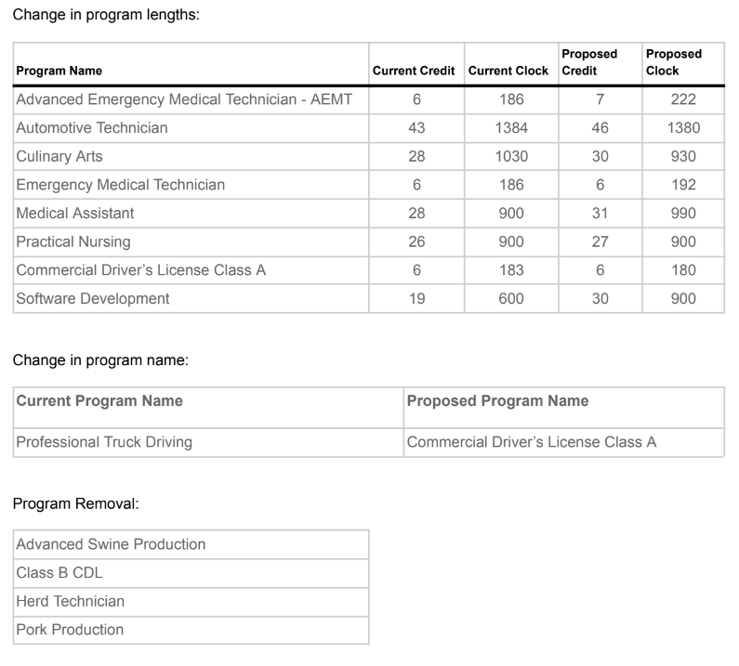
Jarad Brinkerhoff motioned to approve the program changes as presented, and Kristie McMullin seconded the motion.

Motion passed unanimously.

- Approval of Consent Agenda Items - Darin Gifford

Brennan Wood proposed the creation of three new positions: a student services position, a recruiter, and a full-time fundraiser and PR specialist. Funding for these positions was approved in the new budget cycle, with sufficient funds available for the current budget cycle as well. Discussion focused on the role of the fundraiser position and its relationship with the college’s foundation. Brennan clarified that while the Foundation primarily focuses on scholarships the new position would facilitate grant writing, relationship building and fundraising efforts.

Garrett Cottom made a motion to approve the consent agenda items, and Roger Howard seconded the motion.

The motion passed unanimously.

III. Discussion Items:
- Tour of New NA and Surgical Technology Labs

Gail Goodman led the group on a tour of the new Nursing Assistant and Surgical Technology labs.

- Investment Report - Clarissa Crosby

Clarissa presented the current investment report.

- Data Update - Neal Mason

Neal Mason presented an update on performance funding measures, focussing on access, timely competition, and high yield goals. He explained the criteria for timely completion and highlighted the challenges in meeting goals, particularly in high-wage, high-demand areas. Brennan expressed concerns about benchmarks and spoke about performance-based incentives The discussion explored cohort tracking, goal setting, and strategies for improving competition rates. Scott emphasized the importance of strategic planning and data analysis to achieve performance goals.

- Student of the Year - James Mullenaux

James Mullenaux announced the upcoming Student of the Year Dinner event. He shared plans for recognizing outstanding students and showcased a video highlighting student achievements. The event is scheduled for the night of March 20th, 2024.

IV. Adjourn: Chair Gifford concluded the meeting and adjourned at 1:44pm.

Next Board Meeting: May 2, 2024; at 12:00 p.m., in the Southwest Technical College boardroom.

