Newton Planning Commission Meeting
June 13, 2024, 7:00 P.M.
Newton Town Hall, 51 South Center, Newton UT
Meeting Agenda
- Call to Order/Roll Call
- Opening Ceremony – Justin Cooley
- Approval of May 2024, minutes
- Final plan approval for a Minor Subdivision of parcel 13-030-0009, into 2 lots, Autumn Dabb/Brad Griffin. The proposed lots are located at 291 South 300 West and approximately 209 South 300 West, Newton
- Nephi Jones: Conditional permitting of an accessory apartment
- Hyde Park City Building Permit Fees Increase July 2024
- New Water Impact Fee Effective July 8, 2024
- Flood plain development permitting review
- Adjourn

Minutes:
1. Call to Order/Roll Call
Members in Attendance:
Jadd Shelton, Cass Bleazard, Justin Cooley, and Martin Empey. Nicole Kunzler - recorder
Absent: Holly Call
Others present: Brett Petersen (Town Council representative), Nephi Jones
2. Opening Ceremony-Justin Cooley

3. Approval of May 2024 Minutes
Justin- motion to approve minutes, Cass 2nd, All approve May 2024 minutes.

4. Final plan approval for a Minor Subdivision of parcel 13-030-0009, into 2 lots, Autumn Dabb/Brad Griffin.
No one was here to represent Autumn Dabb/ Bradd Griffin
Jadd- Discussed how the lot size was different than what was shown on documents. As Brad was trying to acquire aunts property he had inherited and been paying property taxes on but needed to change ownership.
Jadd & Justin discussed the septic system and Bear River Health Dept. will decide location and if lot size is acceptable.

5. Nephi Jones: Conditional permitting of an accessory apartment
Nephi- Wants to buy Norma Jones Property and was wondering about the zoning for an accessory apartment. It currently has a walkout basement with its own entrance.
Martin- Newton Land use ordinance 11-7-2 Sec D.
Accessory Apartments: The following requirements shall apply to all accessory apartments.
1.No accessory apartment shall be constructed on a lot prior to the construction of a single family dwelling;
2.the apartment shall be attached to or within an existing single-family dwelling or the garage associated with the existing single family dwelling;
3.the apartment must be subordinate in size to the single-family dwelling; and
4. the accessory apartment and the single-family dwelling shall share an appropriately sized septic system.
5. commercial zone: accessory apartments in the commercial zone shall be attached or within an existing, approved commercial business.

Justin- has the septic tank been looked at
Nephi-yes, I was told it was old and possibly abandoned
Martin- How many bedrooms
Nephi- there are 4 bedrooms and a kitchenette already existing in the basement
Justin- new law passed regarding the shared utilities, would need to look into what the current code is about accessory apartments and the wording of only family/ relatives.
Martin- In the past it was an issue of renting to only family/relatives but believes code was changed.
Justin- There is the issue of location and zoning, is it single family?
Martin- that is something we would need to look into changing zoning
Brett- In changing zoning you can drastically change a community, consider short term/long term rentals and even things like Air BNBs
Council – all discussed and agreed we need to find out what current code is
Nicole will have Karla, Town Clerk look into this along with contacting Town Attorney for more info. Nephi will follow up with Planning & Zoning Commission next month.

Nephi- Questions regarding a Right – of – Way, where do I find out who has a right of way on a road
Martin- You have to go to the County to see what is recorded

6. Hyde Park City Building Permit Fees Increase July 2024
Nicole presented to Council members:
Hyde Park City Building Permit Fees
Effective: July 2024
Building Valuation Data – February 2024 for valuations
Plan review fees
SFD - $250.00
Townhouse plan reviews - 40% to 65% of building permit fee. Approval from BO required.
Residential remodel or alterations - $75.00.
Residential Accessory buildings - $75.00.
Solar plan review- residential - $75.00 (additional plan review for resubmittal $75.00 each review).
Commercial plan reviews - 40% to 65% of building permit fee. Approval from BO required.
Standard Permit Fees
Residential solar permit fees - $300.00 (without batteries) + $75.00 plan review.
Residential solar permit fees – with battery system - $400.00 + $75.00 plan review.
Residential battery system added on after initial solar permit- $100.00 + $50.00 plan review.
Residential generator system - $100.00 + $50.00 plan review.
Residential electrical service upgrade -*$75.00 (plan review not required).
Residential furnace replacement/upgraded *$100.00 (no review, this also includes a gas line inspection).
Residential water heater replacement *$75.00 (no review required unless upgrading gas line).
Residential water heater upgrade with gas line upgrades *$100.00.
Residential Gener-Link permit - *$75.00 (plan review not required).
Commercial solar fees - over $400k valuation - $2000.00 permit fee $600.00 plan review fee.
Commercial signs – Monument or pole with electrical - $250.00 + $75.00 plan review fee.
Commercial signs – Monument or pole without electrical - $150.00 + $75.00 plan review fee.
Commercial signs- Wall attached electrical sign - $200.00 + $75.00 plan review fee.
Business license and previously permitted inspections (contracted cities) - *$60.00 per inspection.
Plan review fees and fees with* are not part of the city contractual split. The fees will stay with the building department to cover inspection costs.

7. New Water Impact Fee Effective July 8, 2024
Nicole Presented to Council Members:
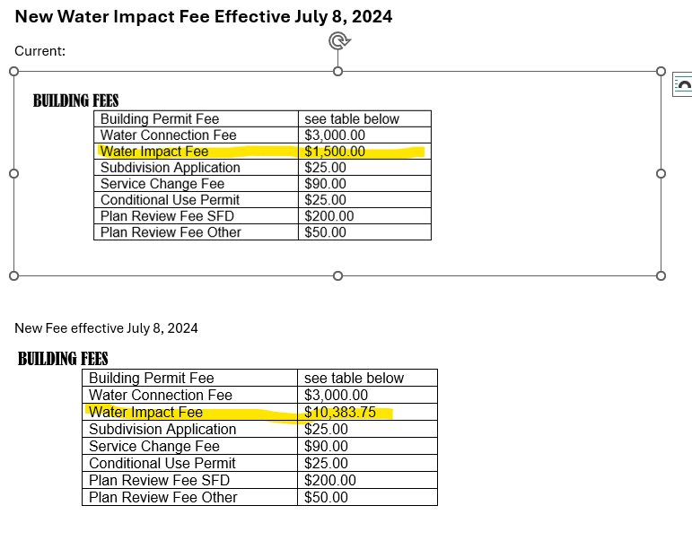

8. Flood plain development permitting review , Nicole Presented to Council Members: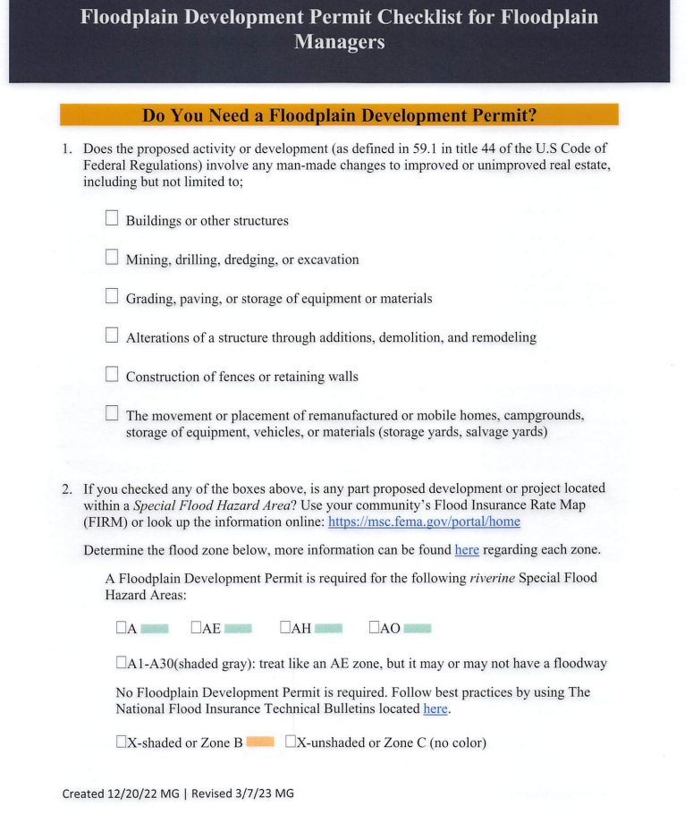 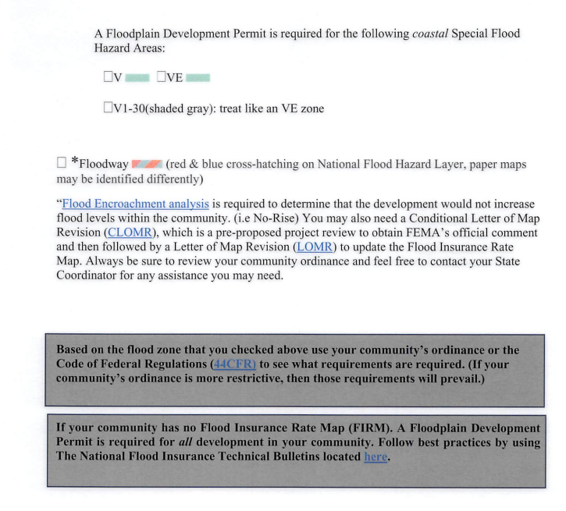 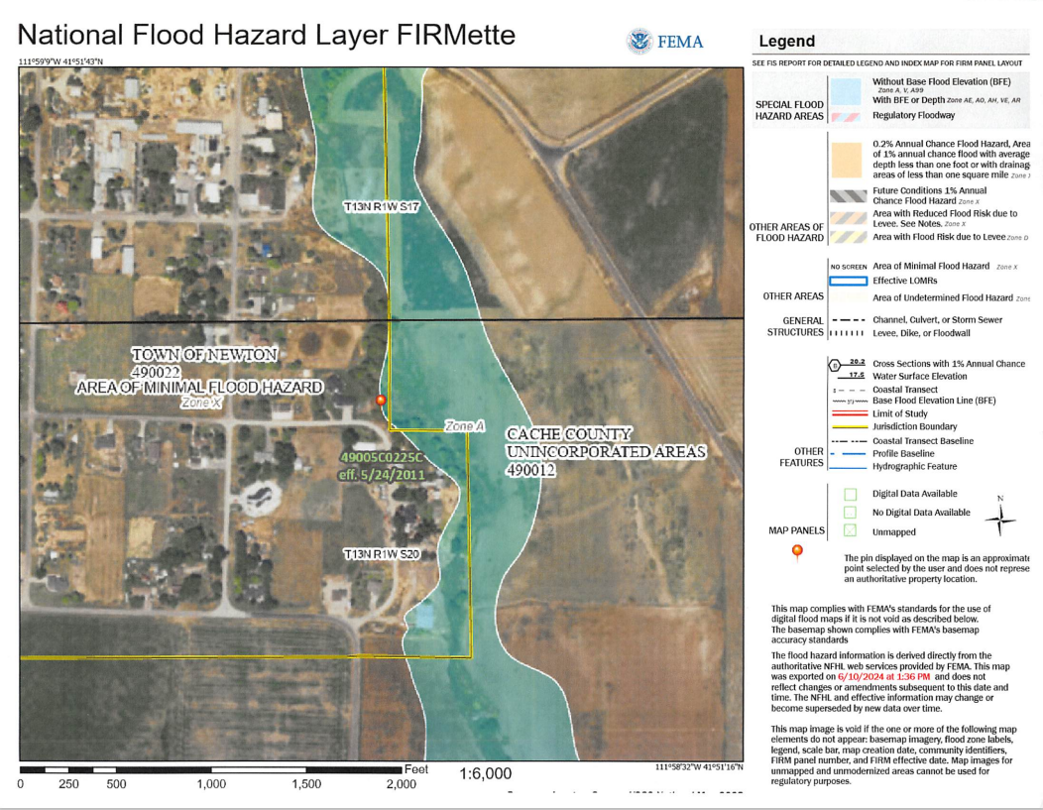 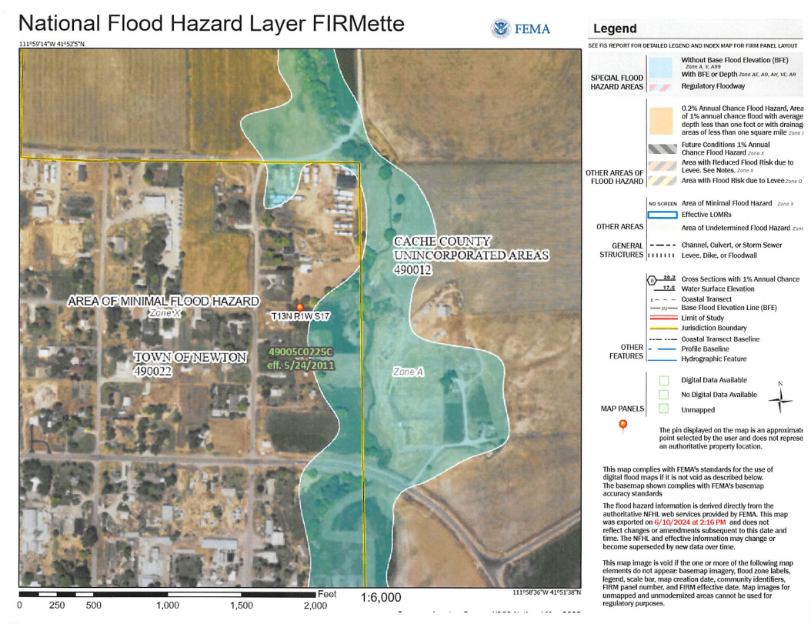 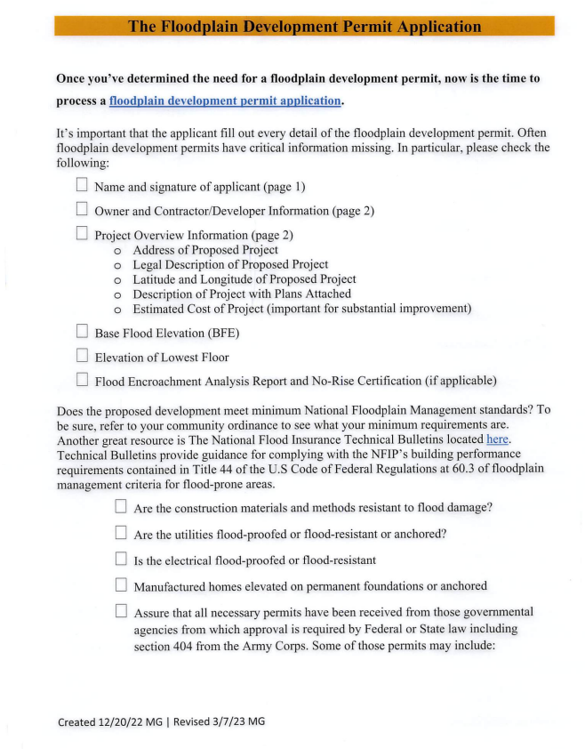 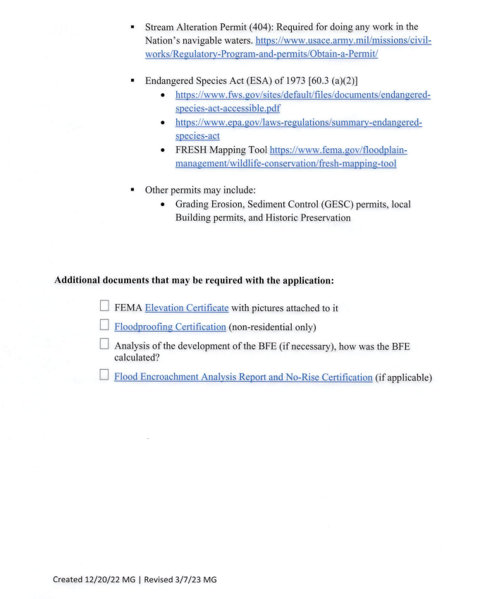

9. Adjourn
Meeting adjourned 8:00pm

Minutes prepared by: ____________________________________ _____________________
Nicole Kunzler, Assistant Town Clerk Approval Date

