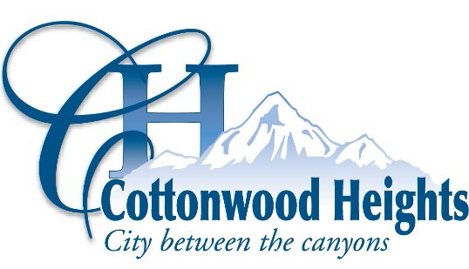

NOTICE OF MEETING CANCELLATION

ARCHITECTURAL REVIEW COMMISSION

Notice is hereby given that the Cottonwood Heights Architectural Review Commission will not hold its regularly scheduled public meeting on Thursday, July 25, 2024 due to a lack of agenda items.

On July 1, 2024, a copy of the foregoing notice was posted in conspicuous view in the front foyer of the Cottonwood Heights City Offices, Cottonwood Heights, Utah. A copy of this notice was also emailed to various public entities, posted on the City’s website at www.cottonwoodheights.utah.gov, and the State Public Meeting Notice website at http://pmn.utah.gov.

DATED THIS 1ST DAY OF JULY, 2024
Paula Melgar, City Recorder

