Present: Zachary Posner (Information Technology), Tyler Andrus-online (Assessor), Chris Harding (Auditor), Joey McNamee (Community Services), Lisa Ashman-online (District Attorney), Hoa Nguyen-online (Council), Megan Hillyard (Administrative Services), Talia Butler-online (Public Works), Will Kocher-online (Recorder), Phil Conder (Treasurer), Katy Fleury-online (Mayor Administration), Kari Huth (Sheriff), Reid Demman (Surveyor), David Delquadro-online (Council)
Representation Absent: Clerk, Human Services
Staff Present: Tony Jolley-online, Rina Shipley, Cindy Beck, Andrew Dudley-online, Corey Hess-online, Dean Bullock-online, Lee Wilstead-online, Mark Miller, Mike Bailey-online, Kira Moody, Hillary Boccagno-online, Trevor Hebditch, Cherie Root, Ben Thompson-online, Brandon Allgier-online, Jon Thelen-online, Thomas Yeung-online, Sam Sedivec-online

TOPIC | POINTS OF INTEREST
Welcome & Remote Meeting Instructions | Reid Demman opened the meeting.  Trevor Hebditch shared the following slide:  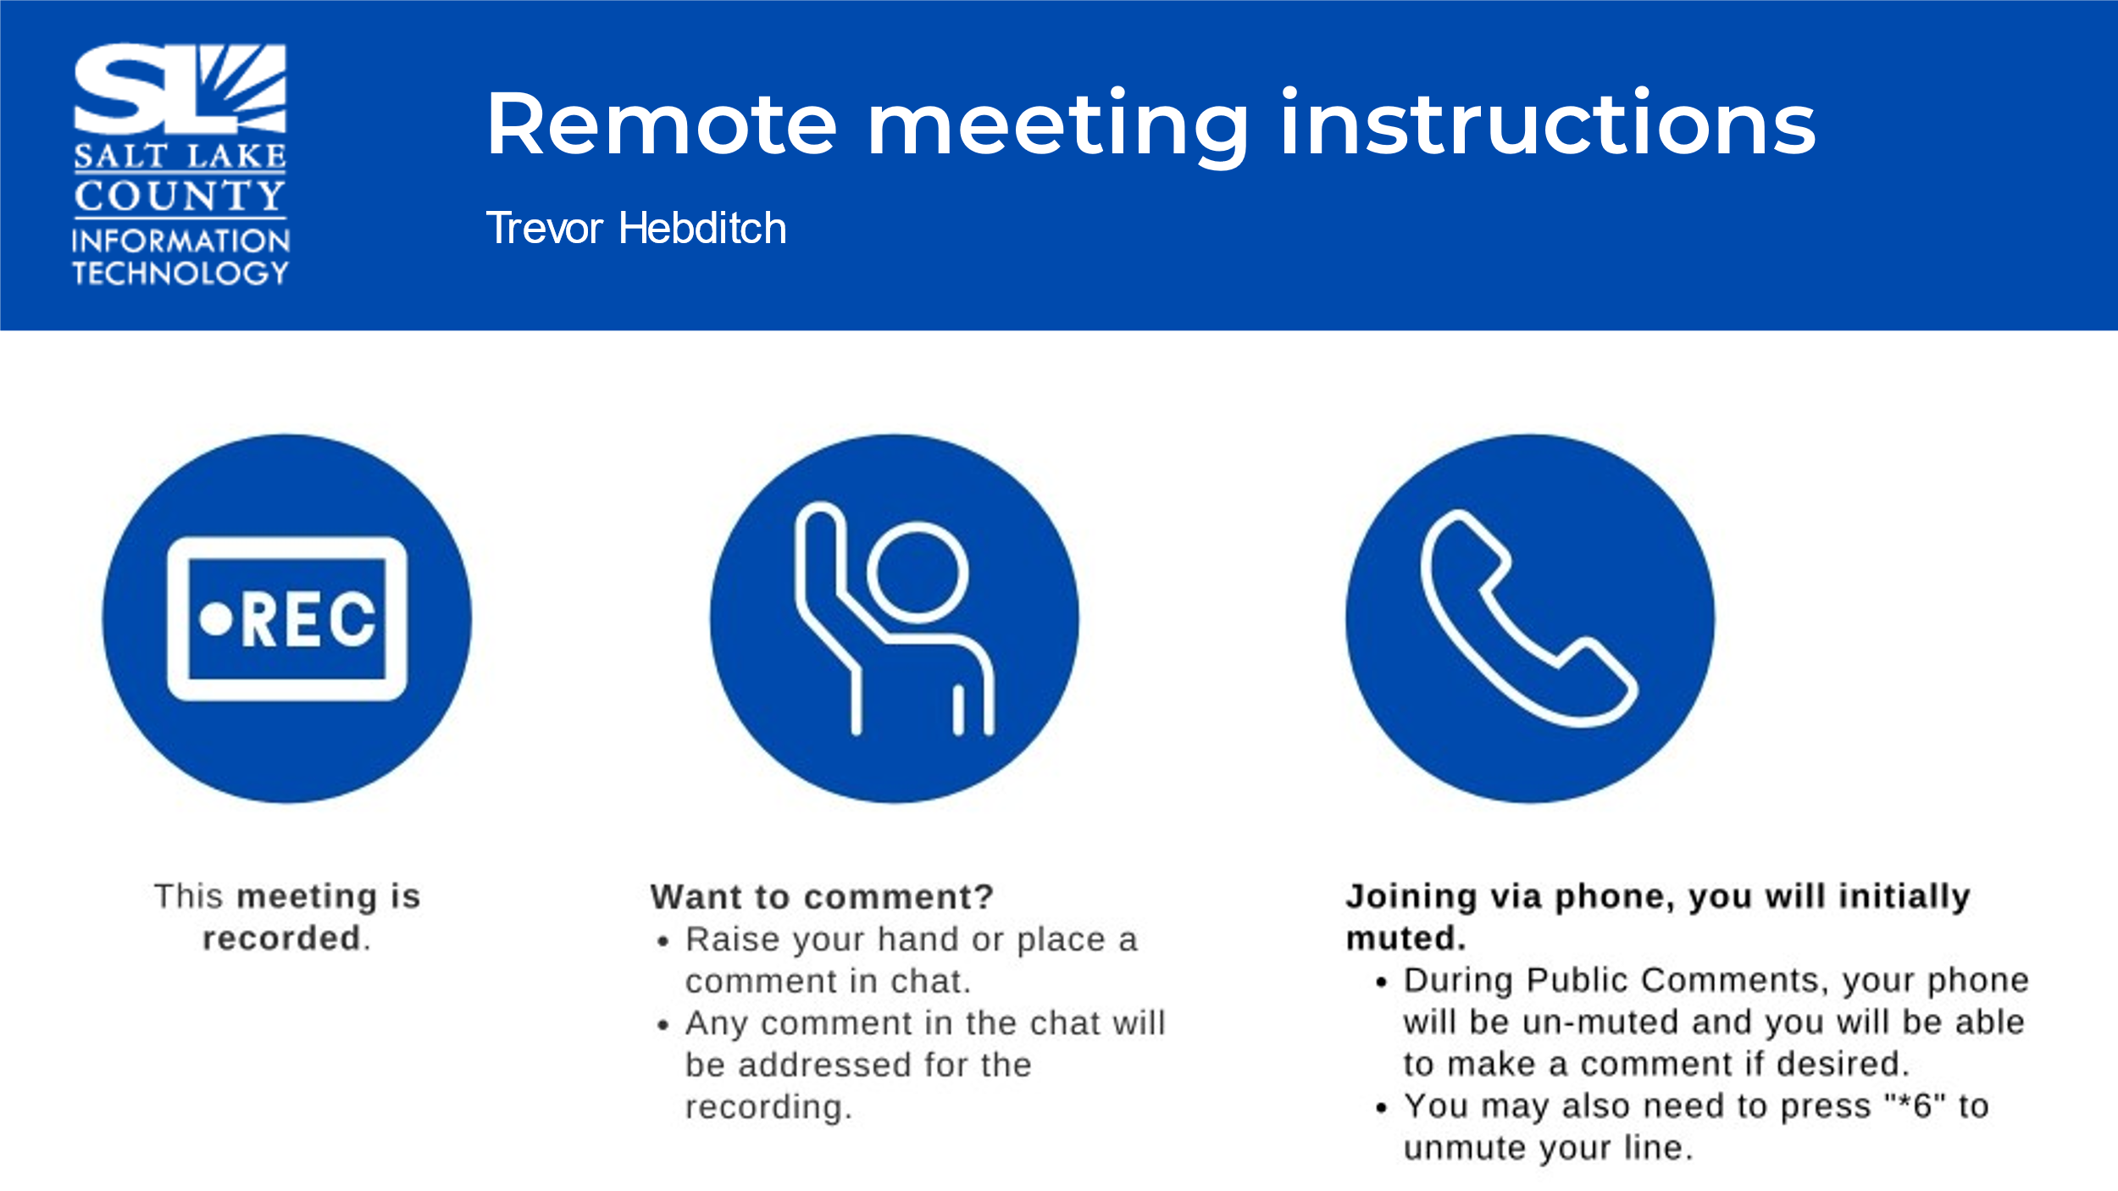
Public Comments  (Reid Demman) | None.
Approval of minutes from March 7th, 2024, meeting | Motion to approve the minutes by Phil Conder, Megan Hillyard seconds the motion. No discussion.  Motion passed unanimously.
Follow-up items  (Cherie Root)  *Brief comment on AI Subcommittee-Most likely TAB to vote on this in June TAB.  Website Redesign Update (Megan Hillyard) | 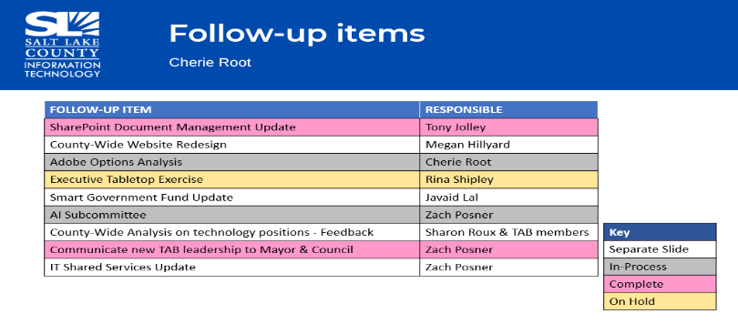  - Policy Subcommittee for AI – To accomplish this may require a change in our bylaws to get that level of involvement without having those working meetings being public meetings. Working with Dianne Orcutt.    - Wrapping up and completing the final sites  - Going forward this update may be in the form of “functionality” or highlights for awareness.
Technology Positions County-wide (Nick Loomans) | 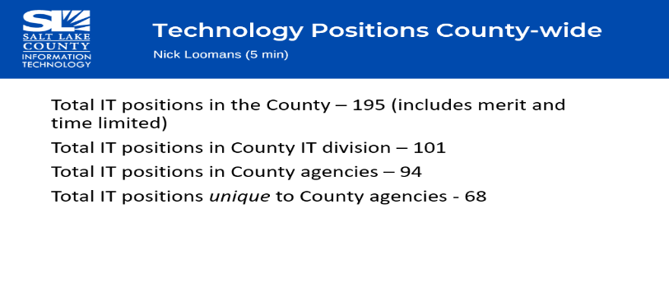
IT Shared Services Model (Zach Posner) | 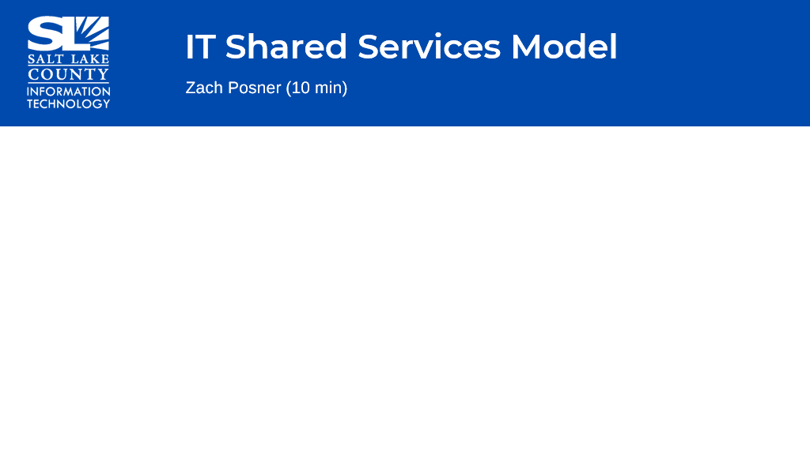  - Created a scoping document that revealed three areas we want to look at starting with the Mayor’s portfolio: Security Operations, Collaboration in terms of systems and processes, and Efficiencies across the board.  - Currently working on building the framework. The framework assists in the decision-making process around where services should live within a centralized framework vs within the agency.
Working Group Milestones  (Tony Jolley)  Working on Milestones for Q2.  Web Oversight Working Group  (Thomas Yeung)  Q1 2024 Website Traffic Report 1-1-24 thru 3-31-24 | 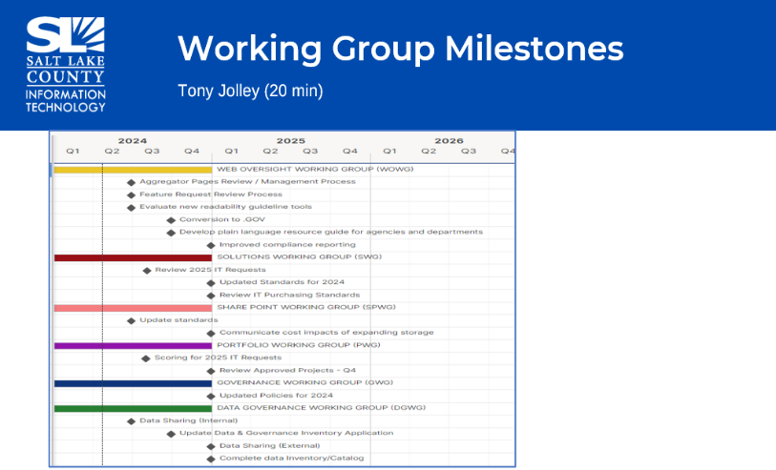  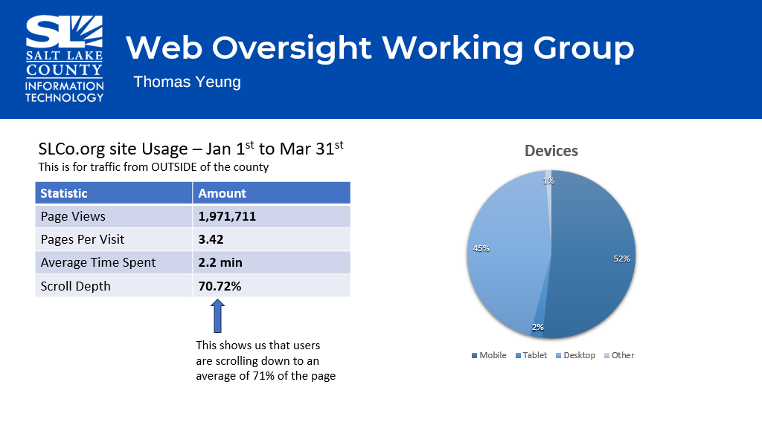  - Used Google Analytics and Microsoft Clarity to gather website traffic information.  - The traffic shown is OUTSIDE of the county.  - Scroll depth is how far the user is scrolling down on the website.
Web Oversight Working Group (cont.)  (Thomas Yeung)  Sites with most page views during this time frame: 1/1/24-3/31/24 | 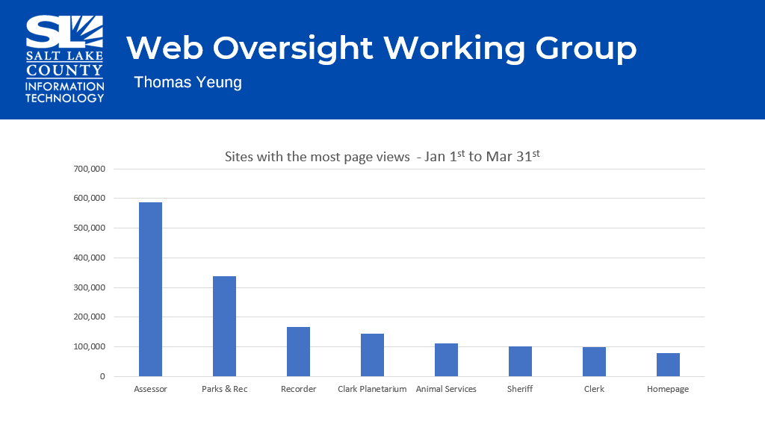
Web Oversight Working Group (cont.)  (Thomas Yeung)  SLCoLibrary.org site Usage | 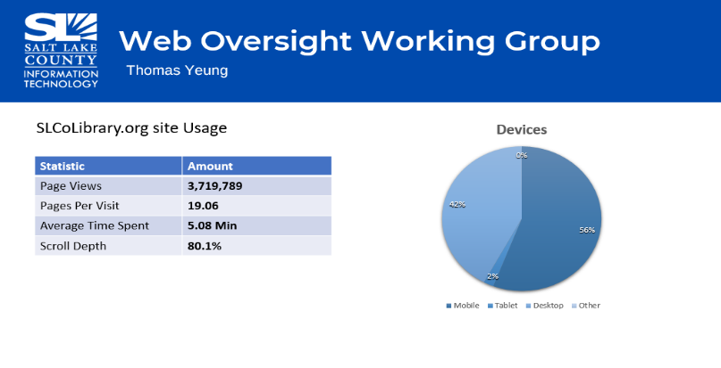  - Once the redesign is complete – will create a survey to see how we are performing with new design.
Portfolio Working Group – Projects Approved for 2024 (Tony Jolley)  IAPro for Sheriff using existing funds and does not need to be prioritized. |   - Two new projects that were added for TAB to review (IAPro for Sheriff & Arts & Culture RFP for Credit Card Fraud & Chargeback solution)  - Reviewed the TAB Projects that were approved for 2024.  - Matt Castillo (Arts & Culture) Division Director- RFP for Credit Card Fraud & Chargeback Solution  - Manages the ticketing system for the county (Abravanel Hall, Eccles and Capital Theatre, etc.). Over the past couple of years there has been an uptick in fraud and chargebacks.  - Looking for a solution to mitigate the fraud theatres have seen and to have a solution in place before the 5-week run of Hamilton.  - Earned revenue across the Arts & Culture Division will fund this solution. No additional ask of funding for this request.  - TAB members would like feedback prior to renewing the contract to see how the solution worked out (benefits, scaling to other agencies or not, etc.).
Data Governance Working Group (DGWG) (Javaid Lal)  Impacts of amendment for HB 491 as it relates to data privacy/sharing practices.  Included in this bill:  Bill effective on May 1st, 2024. Implement full program by May 1st, 2025. | - Due to the new privacy amendment for HB 491 the Internal Data Sharing Template is on hold until we fully understand HB 491.  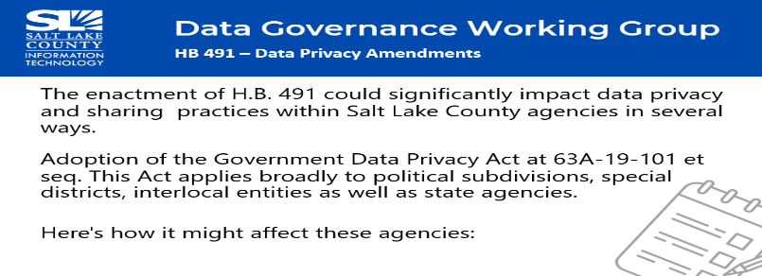  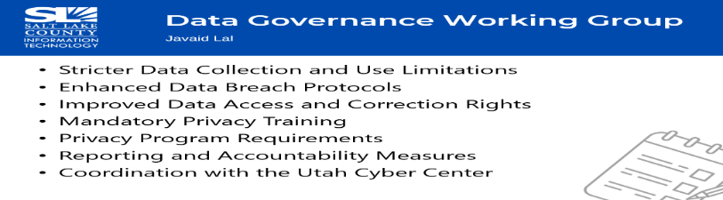  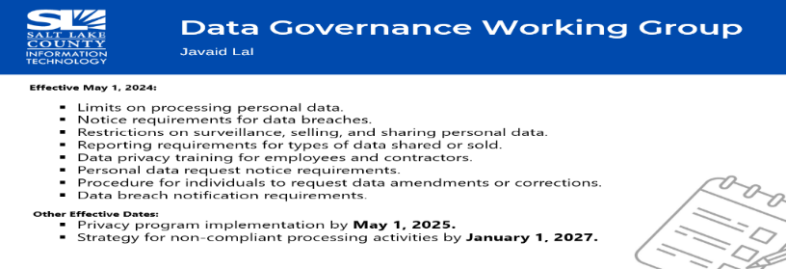
Smart Government Fund Update (Javaid Lal)  Three projects have been funded. | 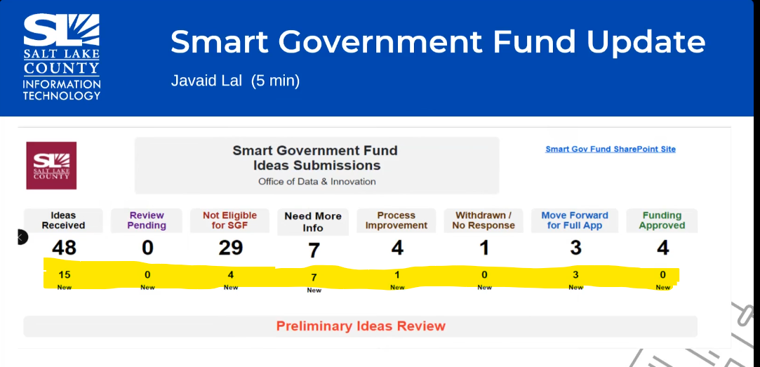  - Received 15 ideas this year (18 last year). We verify the submission meets the parameters of the smart government fund. Currently, three submissions have received the green light to move forward with full application. This is NOT a funding decision it is merely looking at the idea.  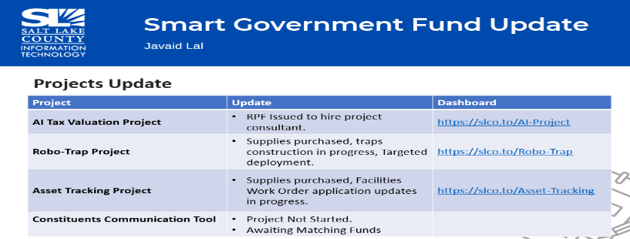
Alternative .gov Domains (Megan Hillyard/Zach Posner)  How to handle domains in general from a branding and technical perspective?  Having uniformity creates a level of trust with our constituents and less confusion. | - Who can have a .gov domain?  - A domain with “.gov” is a top-level domain which is ONLY given to U.S. based government organizations and is monitored by Cybersecurity & Infrastructure Security Agency (CISA).  - How should the “.gov” domains be constructed?  - Should “county” be in the name? Should they be constructed differently?  - From a branding perspective, should it have uniformity, so it is CLEAR to the user the “.gov” domain is part of the (Salt Lake) County (i.e. Not the State of Utah).  - Public domain vs Security domain  - An example of a public domain: your email, your website, etc.  - An example of a security domain is the internal barriers that we have when an individual logs into the county.  - Looking for TAB to recommend a standard as it relates to domains.  - Example of requests that have come in: saltlakecountysurveyor.gov or surveyor.saltlakecounty.gov (using this agency ONLY as an example).  - Certain agencies (health department) may need to make a case and provide justification for how their agency domain needs to be listed.  - An example of a website that was denied the .gov extension was ArtTix.org due to its commercial business.  - Katy Fleury offered to develop a standard (with some exceptions) for .gov domains that makes the process clear to each agency and feels fair to everyone.
Motion for Katy Fleury creating the draft standard for the .gov process. | Motion to accept Katy Fleury creating recommendations and draft standard/policy for .gov domains and exceptions to come back for future TAB approval vote by Phil Conder, Joey McNamee seconds the motion.  Motion passed unanimously.
Security Update (Rina Shipley) | - Due to TAB meeting running past 10:30, it was agreed the Security Update would forego for this meeting and will be presented at the next TAB meeting in June.
Other Business  (TAB Members)  Communication Items (Chair & CIO) |   - No other business to discuss currently.    - No additional items for discussion.
Upcoming Meeting Schedule (Cindy Beck)  *Please note the August sessions are the combined TAB Meeting with GIS Steering Committee. | 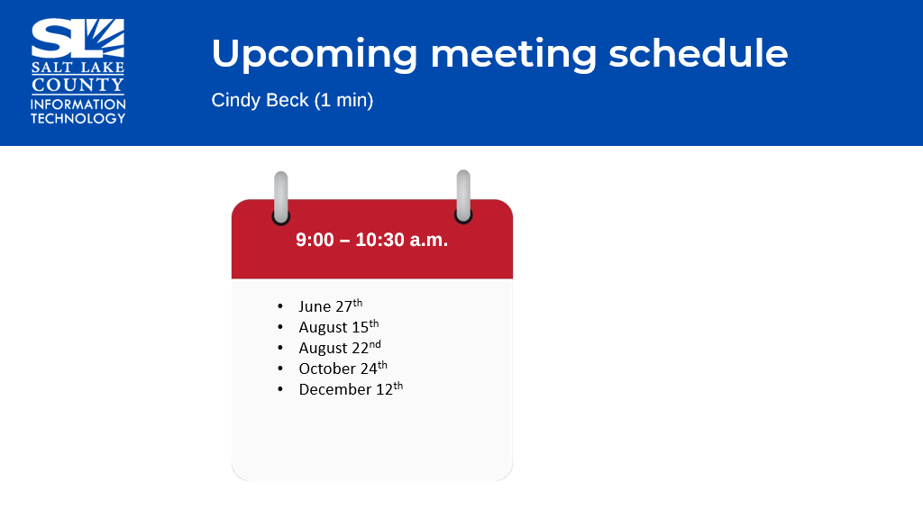
Review Action Items (Cindy Beck)  Three Action Items |   - Web Oversight Working Group (WOWG) to present data/analytics comparing prior quarter and year to year at the next TAB meeting in June.  - Create a formal process for alternatives to .gov domains from a branding and policy perspecitve. Katy Fleury has offered to work on this and present at next TAB session and/or following sessions as needed.  - Board would like feedback at a later TAB meeting from Arts & Culture regarding the RFP for Credit Card Fraud & Chargeback Solution on how it is working out.
Next TAB Meeting June 27th, 2024. | 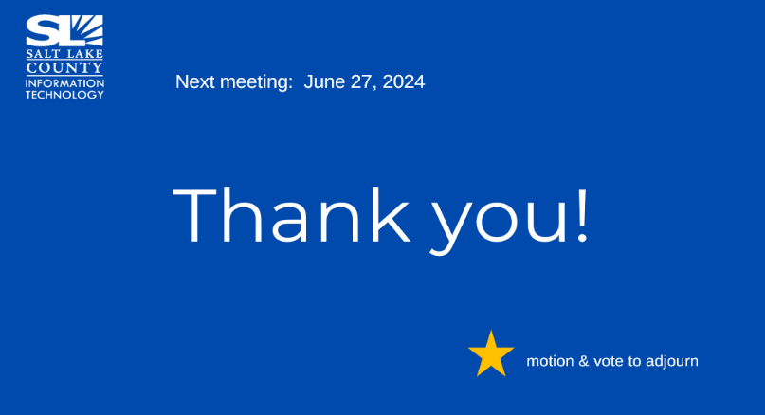
End of Session | . Meeting adjourned by Reid Demman.
Submitted by Cindy Beck

