CITY OF OREM
PLANNING COMMISSION MEETING MINUTES
June 5, 2024

The following items are discussed in these minutes:
- Preliminary plat - Approval of the Preliminary Plat for Carrara Villas, Plat E located generally at 1090 North 400 East in the R8 zone - Approved
- Preliminary Plat – Approving the preliminary plat of View West, Plat G located generally at 1479 South 360 West in the R8 zone - Approved

STUDY SESSION

Place: City Council Conference Room

At 3:30 p.m. Chair Komen called the Study Session to order.

Those present: Gerald Crismon, James Hawkes, Helena Kleinlein, Madeline Komen and Murray Low, Planning Commission members; Cheryl Vargas and Ailin Leon, Associate Planners; Grant Allen and Matt Taylor, Senior Planners; Taggart Bowen, City Engineer; John Dorny, Transportation Engineer; Gary McGinn, Legal Counsel and David Spencer, City Council Liaison

Those excused: Mike Carpenter and Haysam Sakar, Planning Commission members; Ryan L. Clark, Assistant City Manager/ Development Services Director; Jason W. Bench, Assistant Development Services Director

Emma Tenney, Planning Intern, made a presentation on residential and commercial zones. John Dorny, Traffic Engineer, made a presentation on the traffic calming toolbox. The Commission and staff briefly reviewed agenda items and minutes from the May 15, 2024 meeting and adjourned at 4:28 p.m. to the City Council Chambers for the regular meeting.

REGULAR MEETING

Place: Orem City Council Chambers

At 4:31 p.m. Chair Komen called the Planning Commission meeting to order and asked Mr. Low, Planning Commission member, to offer the invocation.

Those present: Gerald Crismon, James Hawkes, Helena Kleinlein, Madeline Komen and Murray Low, Planning Commission members; Cheryl Vargas and Ailin Leon, Associate Planners; Grant Allen and Matt Taylor, Senior Planners; Taggart Bowen, City Engineer; John Dorny, Transportation Engineer; Gary McGinn, Legal Counsel and David Spencer, City Council Liaison

Those excused: Mike Carpenter and Haysam Sakar, Planning Commission members; Ryan L. Clark, Assistant City Manager/ Development Services Director; Jason W. Bench, Assistant Development Services Director

Chair Komen asked Ms. Leon to introduce Agenda Item 3.1:

Agenda Item 3.1 is a request by Brad Mackay, Ivory Homes, for the Planning Commission to approve the preliminary plat of Carrara Villas Located generally at 1090 North 400 East in the R8 zone.
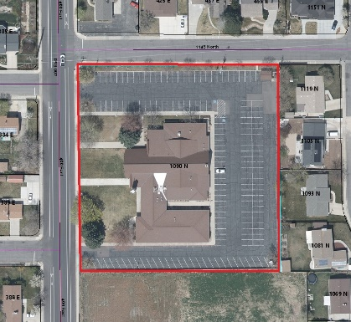
Staff Presentation: The lot is currently a church site. The applicant is proposing to build Six single family homes. In the R8 zone the minimum lot size requirement is 8,000 square feet, lot sizes will range from 14,195 square feet to 19,531 square feet.

Recommendation: The Development Review Committee determined this request complies with the Orem City Code. Staff recommends the Planning Commission approve the preliminary plat of Carrara Villas Located generally at 1090 North 400 East in the R8 zone.

Chair Komen asked if the Planning Commission had any questions for Ms. Leon.

Chair Komen invited the applicant to come forward. Brad Mackay, Ivory Development, introduced himself. Ivory is not trying to maximize density on this project, just trying to get some nice lots for this development.

Chair Komen asked if the Planning Commission had any more questions for the applicant or staff. When none did, she called for a motion on this item.

Planning Commission Action: Mr. Low moved to approve the preliminary plat of Carrara Villas Located generally at 1090 North 400 East in the R8 zone. Mr. Hawkes seconded the motion. Those voting aye: Gerald Crismon, James Hawkes, Helena Kleinlein, Madeline Komen and Murray Low. The motion passed unanimously.

Chair Komen asked Ms. Leon to introduce Agenda Item 3.2:

Agenda Item 3.2 is a request by Stephanie Salmon for the Planning Commission to approve the preliminary plat of View West, Plat G located generally at 1479 South 360 West in the R8 zone.
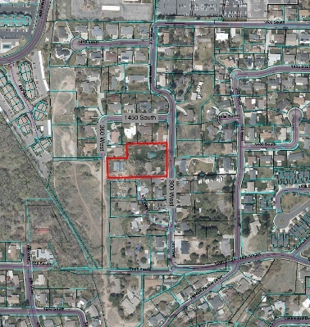
Staff Presentation: The applicant is proposing to subdivide a large lot, which is a lot of record, into two separate lots. The one large lot has two homes on it, so each home will now be on a separate lot. Each home is currently connected to the City’s water and sewer systems.

Each lot meets the minimum R8 zone requirements for lot size. Lot 1 will be 19,964.00 square feet and Lot 2 will be 18,211 square feet.

Recommendation: The Development Review Committee determined this request complies with the Orem City Code. Staff recommends the Planning Commission approve the preliminary plat of View West, Plat G located generally at 1479 South 360 West in the R8 zone.

Chair Komen asked if the Planning Commission had any questions for Ms. Leon.

Chair Komen invited the applicant to come forward. Stephanie Salmon introduced herself. They are subdividing the property that the siblings currently live on.

Chair Komen asked if the Planning Commission had any more questions for the applicant or staff. When none did, she called for a motion on this item.

Planning Commission Action: Ms. Kleinlein moved to approve the preliminary plat of View West, Plat G located generally at 1479 South 360 West in the R8 zone. Mr. Hawkes seconded the motion. Those voting aye: Those voting aye: Gerald Crismon, James Hawkes, Helena Kleinlein, Madeline Komen and Murray Low. The motion passed unanimously.

Minutes: The Planning Commission reviewed the minutes from the previous meeting. Chair Komen then called for a motion to approve the minutes of May 15, 2024. Mr. Hawkes moved to approve the meeting minutes for May 15, 2024. Ms. Kleinlein seconded the motion. Those voting aye: Those voting aye: Those voting aye: Gerald Crismon, James Hawkes, Helena Kleinlein, Madeline Komen and Murray Low. The motion passed unanimously.

Adjourn: Chair Komen called for a motion to adjourn. Mr. Hawkes moved to adjourn. Mr. Crismon seconded the motion. Those voting aye: Those voting aye: Those voting aye: Gerald Crismon, James Hawkes, Helena Kleinlein, Madeline Komen and Murray Low. The motion passed unanimously.

Adjourn: 4:41 p.m.

Ryan L. Clark
Planning Commission Secretary

Approved: June 19, 2024

