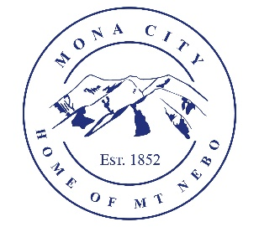
Mona City
435-623-4913
www.monacity.gov
20 West Center Street Mona, Utah

Mona City Council Meeting Agenda
Tuesday, June 11, 2024
Mona City Building – 20 West Center
7:00 p.m.

- Pledge
- Prayer
- Approval of May 28, 2024, City Council Meeting Minutes
- Action Items:
  - Approval of Ordinance 2024-4: Regulation of the Use of Mona City Driveways and Parking Lots for Events
  - Approval of Resolution 2024-5: Privacy Space Compliance Plan
- Secretary:
  - Mowing of 400 South 200 East
- Planning & Zoning:
  - Justin Christiansen – Accessory Building Permit – 639 South 200 East
  - Jason & Krista Steiner – Building Permit – 670 South 300 East
  - Herman Young & Sons – Building Permit – 242 East 300 North
- Director of Finance:
  - Approval of Finances
  - Presentation of Mona City 2025 Budget, and amendment of 2024 Budget, with public hearing to follow on June 25, 2024
- Gas & Water & Roads:
- Sewer:
- Recorder:
- Council Reports:
- Public Comment:
- Adjournment

CERTIFICATE OF POSTING
This agenda is hereby properly advertised this 10th day of June, 2024, through posting of copies of this agenda in the following places: the Mona City Office, at the United States Post Office Mona City Branch, and on the Utah Public Notice Website at www.utah.gov/pmn/index.html.

_____________________________________
Alicia Hills, Mona City Recorder

Upon Request, in compliance with the Americans with Disabilities Act, reasonable accommodations for individuals with disabilities will be provided. For assistance, please call 435-623-4913.

