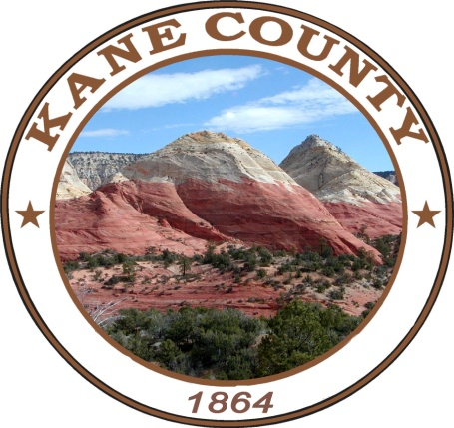
Notice of Election

ATTENTION
Kane County Voters
Primary Election
June 25, 2024
7:00 a.m. to 8:00 p.m.

Last day a voter can register to vote for the Primary Election by mailing a
Registration form, Online or in-person is June 11, 2024
The Kane County Clerk’s Office is open from 8:00 a.m. to 5:00 p.m Mon-Thur, 8:00 a.m to 4:00p.m Friday.
Public Logic & Accuracy Testing will take place on June 03, 2024 at 10:00 a.m.
Board of Canvassers will meet on July 09, 2024 at 2:00 p.m.

*****************************************
The 2024 Primary Election will be held on Tuesday, June 25, 2024. Ballots will be mailed out to eligible voters starting on June 04, 2024. Voters must be of legal voting age, citizens of the United States, and reside in the precinct in which they are registered.

Early Voting will be held on June 11, 12, 13, 14, 18 ,19 ,20 &21 2024, from 9:00 a.m. to 3:00 p.m. at the County Clerk’s Office, 76 North Main Street.
All Voters will need a photo ID

*****************************************
If you choose not to vote your "Absentee/By Mail" Ballot you may vote in person at the "Kanab Election Center" located at the "Kane County Courthouse" 76 North Main Street on Election Day or at the "Valley Vote Center" located at the "Kane County North Event Center" located at 475 East State Street on Election Day. You will need to bring in your "By Mail Ballot" to the election center with you where you will be issued a "PAPER BALLOT". An individual with a disability who is not able to vote a manual (paper) ballot by mail, may obtain information on voting in an accessible manner by contacting the County Clerk’s Office at 435-644-2458.

You can also choose to vote early in person at the Kane County Clerk/Auditor's Office by bringing in your "By Mail Ballot" to cast your vote in person on a "PAPER BALLOT".

Ballot Drop Box Locations: 76 N Main St in Kanab; 11 1st W ST in Alton; 60 Aaron Burr in Big Water; 90 E Center St in Glendale & 425 E State St in Orderville. Ballot Drop Box’s will be available beginning June 04, 2024 at 8:00 A.M and Closing June 25, 2024 at 8:00 P.M.

Voters can verify their party affiliation, registration status, and view a sample ballot online at www.vote.utah.gov or Contact Kane County Clerk’s office at 435-644-2458.

For more information visit https://kane.utah.gov/gov/dept/clerk-auditor/ or vote.utah.gov or call 435-644-2458. Any changes to polling locations will be listed on these websites.
*****************************************
SAMPLE BALLOT
Races that will be on the Primary Election

Republican Party County Wide Federal Office Races | Republican Party County Wide State Office Races | Republican Party County Wide  State Office Races
Republican for U.S Senate  Vote for One | Republican for Attorney General  Vote for One | Republican for State School Board District 15  Vote for One
JOHN CURTIS | DEREK BROWN | JOANN BRINTON
JASON J. WALTON | FRANK DEMCY MYLAR | KRISTAN L. NORTON
BRAD WILSON | RACHEL TERRY | Republican Party County Wide  County Office Races
TRENT STAGGS | Republican for State Auditor  Vote for One | Republican Party County Wide  County Office Races
Republican for U.S. House District 2  Vote for One | Republican for State Auditor  Vote for One | Republican for Kane County Commissions Seat C  Vote for One
Republican for U.S. House District 2  Vote for One | TINA CANNON | Republican for Kane County Commissions Seat C  Vote for One
COLBY C. JENKINS | RICKY HATCH | GWEN BROWN
CELESTE MALOY | Republican for State House | WADE HEATON
Republican Party County Wide  State Offices Races | District House 69  Vote for One | Nonpartisan Local School Board  Precincts: KA2:A-B, CW:B, BU
Republican for Governor and Lieutenant Governor | District House 69  Vote for One | Kane County School Board District 1  Vote for One
Republican for Governor and Lieutenant Governor | LYNN JACKSON | Kane County School Board District 1  Vote for One
SPENCER J. COX  DEIDRE M. HENDERSON | LOGAN JAMES MONSON | JOHN C REESE
SPENCER J. COX  DEIDRE M. HENDERSON |  | ADAM S ROGERS
PHIL LYMAN  NATALIE CLAWSON |  | MITCHELL GLAZIER

