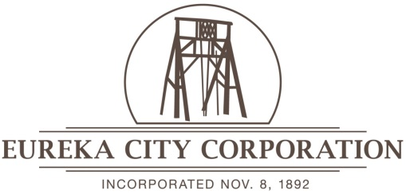

NOTICE AND AGENDA

Notice is hereby given that the Eureka City Council will convene on Wednesday, May 29, 2024, 15 North Church Street, Eureka, Utah.

This meeting is a closed meeting for the purpose of discussing an individual’s character or competence as part of a job interview process.

DATED THIS 28th DAY OF MAY 2024
Patricia Bigler
CITY RECORDER

